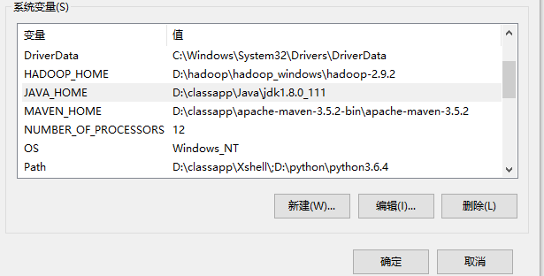

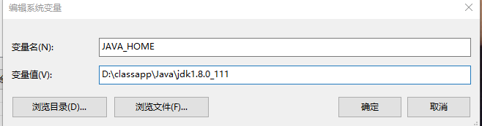

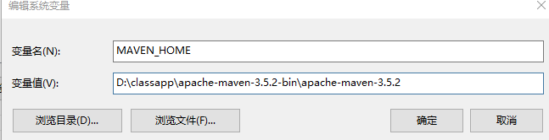

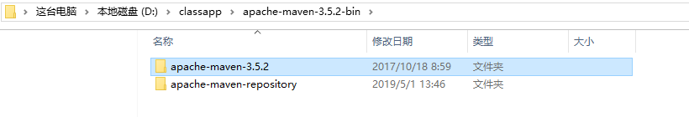

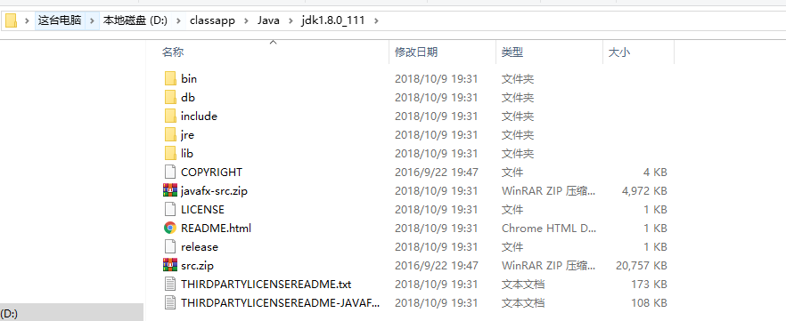

Maven查依赖的地址：<https://mvnrepository.com/>

**D:\classapp\apache-maven-3.5.2-bin\apache-maven-3.5.2\conf 下 settings.xml**

<settings xmlns="http://maven.apache.org/SETTINGS/1.0.0"

xmlns:xsi="http://www.w3.org/2001/XMLSchema-instance"

xsi:schemaLocation="http://maven.apache.org/SETTINGS/1.0.0 http://maven.apache.org/xsd/settings-1.0.0.xsd">

<!-- localRepository

| The path to the local repository maven will use to store artifacts.

|

| Default: ${user.home}/.m2/repository

<localRepository>/path/to/local/repo</localRepository>

-->

<localRepository>D:\classapp\apache-maven-3.5.2-bin\apache-maven-repository</localRepository>