SMART WALKER

SYSTEM REQUIREMENTS DOCUMENT

**MECHATRONICS 4TB6**

**GROUP 2**

NATHAN FUJIMOTO

PRAKHAR GARG

JOSH GILMOUR

AARON JASS

TYLER JASS

FAUZIA KHANUM

JACK LIU

GAGAN SINGH

Table of Contents

Revision History 3

Table of Tables 4

Table of Figures 4

1 Introduction 5

1.1 Purpose 5

1.2 Project Scope 5

2 Overall Description 6

2.1 System Overview 6

2.2 System Functionality 6

2.3 Operating Environment 6

2.4 Assumptions and Dependencies 8

2.5 Functional Decomposition and Variables 8

2.5.1 Autonomous Mode 11

2.5.2 Manual Mode 12

2.5.3 Phone App 12

2.5.4 Docking Station 13

3 Specific Requirements 14

3.1 Functional Requirements 14

3.1.1 Autonomous Mode 14

3.1.2 Manual Mode 14

3.1.3 Phone App 15

3.1.4 Docking Station 15

3.1.5 Other Requirements 15

3.2 Non-Functional Requirements 15

Citations 19

# Revision History

|  |  |  |  |  |
| --- | --- | --- | --- | --- |
| **Rev** | **Author(s)** | **Description of Change** | **Peer Reviewed** | **Date** |
| - | T.Jass | Original Document | A.Jass | 10-Oct-2017 |
| A | N.Fujimoto  P.Garg J.Gilmour  A.Jass T.Jass F.Khanum J.Liu G.Singh | Original document was blank with just a layout. This revision adds content to the document. | N.Fujimoto  P.Garg J.Gilmour  A.Jass T.Jass F.Khanum J.Liu G.Singh | 01-Nov-2017 |

# Table of Tables

Table 1 - Monitored Variables 10

Table 2 - Controlled Variables 11

# Table of Figures

Figure 1 - Hospital Patient Room 8

Figure 2 - Google Maps Image of a Hospital and Surrounding Area 8

Figure 3 - Functional Decomposition Diagram 9

Figure 4 - Autonomous Mode Diagram 12

Figure 5 - Manual Mode Diagram 13

Figure 6 - Phone App Diagram 13

Figure 7 - Docking Station Diagram 14

# 1 Introduction

## 1.1 Purpose

The standard medical walker or walking aid helps to improve stability and balance of its user while they are walking. The objective of this project is to modify a standard medical walker to include various mechanical and electrical components; autonomous features, in order to improve the user experience. The modified walker, called the SmartWalker, will involve designing and developing an autonomous and safe system while keeping all original functions of the standard medical walker.

This document defines the project scope, outlines the system overview and highlights the main functional and nonfunctional requirements of the SmartWalker.

## 1.2 Project Scope

The scope of this project is to design a walker with autonomous abilities to operate within a specific environment (refer to section **2.3 Operating Environment**). The SmartWalker will feature:

* Autonomous driving between a ‘home’ location and the user within an indoor room, and vice-versa. The ‘home’ location is a docking station with charging capabilities.
* Autonomous obstacle avoidance when driving to and from the user.
* Assistive walking when using the SmartWalker normally, this includes assistive powering when going up ramps, and active braking when going down ramps.
* Emergency braking in any situation if approach a steep drop in elevation.
* Global Position System (GPS) tracking within the environment.

This project will not include (out of scope) the following items:

* Autonomous usage in multiple indoor environments, simultaneously (autonomous movement between multiple rooms).
  + Autonomous features in an entire hospital.
* Exact GPS tracking while walker is indoors.
* Wheelchair capabilities (primary seat usage, limited walking capabilities).

The end result of this project will demonstrate the students’ cumulative learning through their academic career via a demonstration of the SmartWalker’s autonomous ability in a predetermined location.

# 2 Overall Description

## 2.1 System Overview

The SmartWalker is an original idea by the Modern Mobility group, within the capstone course of the Computing and Software Department, 4TB6, at McMaster University. The focus of the SmartWalker project is to increase the utility of a standard medical walker by implementing various autonomous and electric features. Full system details and functionalities are explained below.

## 2.2 System Functionality

The SmartWalker has two main functionalities (or modes): autonomous mobility and manual driving.

* *Autonomous Mobility*: The ability to move out of the way of the user whenever requested to a designated home location as well as return to the user when requested.
* *Manual Driving*: The ability to operate like a standard medical walker, with added smart features like assisted braking and assisted driving.

These core functions are supported by two sub-functions: a smartphone application and a docking station. The smartphone application is used as an avenue to capture user-specific monitored variables, while the docking station is used to support the autonomous mobility function by acting as a home location.

## 2.3 Operating Environment

The operating environment of the SmartWalker is a typical hospital. This environment is divided into two areas: the patient’s room, and the hospital hallways/common rooms and outside grounds. Manual mode will be available in all environments (patient room, hospital corridors, hospital grounds etc.) while Autonomous mode will only be available in the patient room that contains its corresponding docking station.

**Figure 1** below indicates a sample patient room in a hospital. The docking station would be located next to a wall plugged into an electrical outlet ready to charge the walker at any moment. The docking station will not be in the way of medical equipment and medical personnel such as doctors, nurses, and caregivers. **Figure 2** below indicates a sample hospital and it’s surrounding outside grounds that the SmartWalker can be implemented in. [GPS CAPABILITY USING THE MAP, CAN’T SHOW FLOOR]

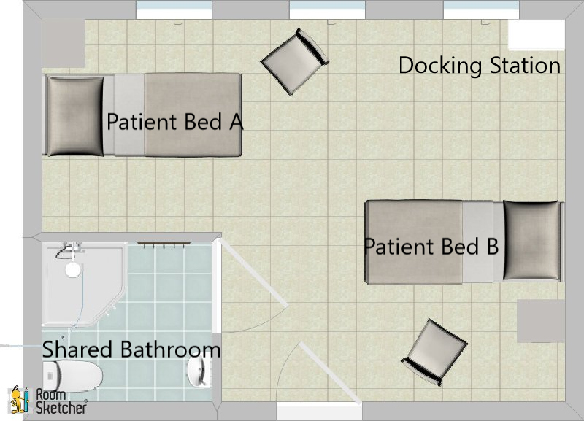

Figure 1 - Hospital Patient Room

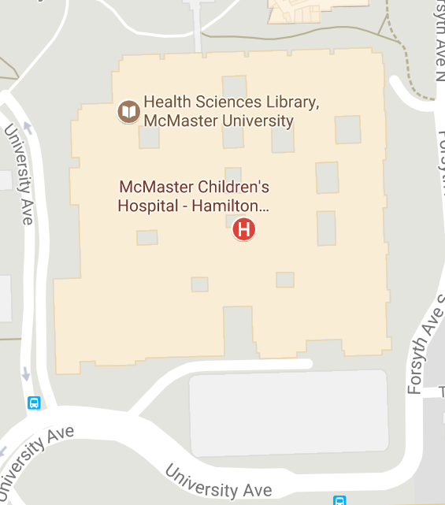

Figure 2 - Google Maps Image of a Hospital and Surrounding Area

## 2.4 Assumptions and Dependencies

The following are the assumptions that we will be working with:

Environmental: The SmartWalker will be used in patient rooms that have enough room for wheelchairs to move about, therefore enough room for the SmartWalker to autonomously move about. It is assumed that the farthest the SmartWalker will be taken will the hospital grounds.

Functional: We will be using a structurally sound market walker as the basis for the SmartWalker. The SmartWalker battery will be charged via the docking station and no other method.

User Expectations: It is assumed the user of the SmartWalker has little experience interacting with technology such as smartphones and smartphone applications.

## 2.5 Functional Decomposition and Variables

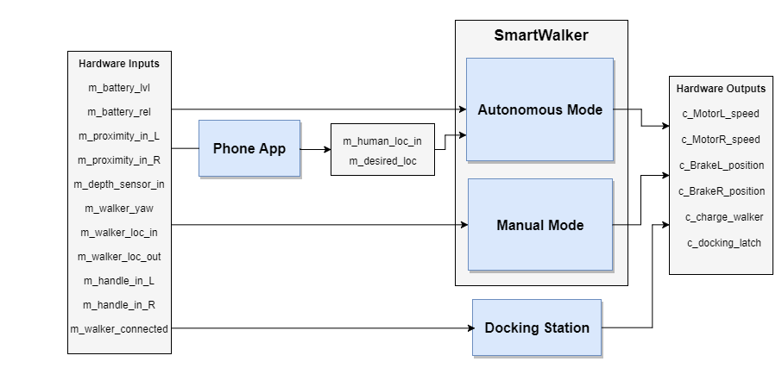

Figure 3 - Functional Decomposition Diagram

Table 1 - Monitored Variables

|  |  |  |  |
| --- | --- | --- | --- |
| **Variable** | **Description** | **Units** | **Range** |
| m_battery_lvl | Power level of battery. | Battery Sustain of Charge (%) | [0, 100] |
| m_battery_rel | Reliability of the battery. | Battery Health (%) | [0, 100] |
| m_proximity_in_L | Proximity to any environment objects (front-left side). | Distance (m) | [0, 1] |
| m_proximity_in_R | Proximity to any environment objects (front-right side). | Distance (m) | [0, 1] |
| m_depth_sensor_in | Depth of the ground with respect to the walker. | Distance (m) | [-2, 0] |
| m_walker_yaw | Orientation of the walker (yaw) with respect to the walker’s z-axis. | Angle (deg) | [0, 360] |
| m_walker_loc_out | Global location of the walker. | [Longitude (deg), Latitude (deg)] | [-180, 180; -90,90] |
| m_walker_loc_in | Location of the walker inside the patient room, with respect to a preset coordinate system. | [x,y] on room map | Custom |
| m_human_loc_in | Location of the human based on their phone, with respect to a preset coordinate system. | [x, y] on room map | Custom |
| m_desired_loc | Desired location the user selects for the walker in autonomous mode. | Enum | GoDocking, GoHuman |
| m_handle_in_L |  | Force (Nm) |  |
| m_handle_in_R |  |  |  |

Table 2 - Controlled Variables

|  |  |  |  |
| --- | --- | --- | --- |
| **Variable** | **Type** | **Description** | **Units** |
| c_motorL_speed | Controlled | Motor L speed | deg/s |
| c_motorR_speed | Controlled | Motor R speed | deg/s |
| c_brakeL_position | Controlled | Brake L position (engage, partially engaged, not engaged) |  |
| c_brakeR_position | Controlled | Brake R position (engaged, partially engaged, not engaged) |  |
| c_charge_walker | Controlled | Walker plugged in to charge | Boolean |
| c_docking_latch | Controlled | Walker latched at docked | Boolean |

### 2.5.1 Autonomous Mode

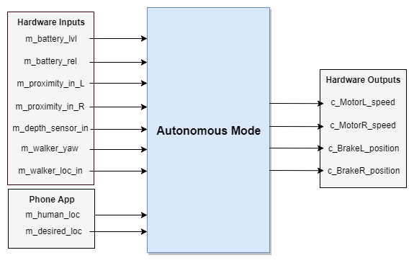

Figure 4 - Autonomous Mode Diagram

### 2.5.2 Manual Mode

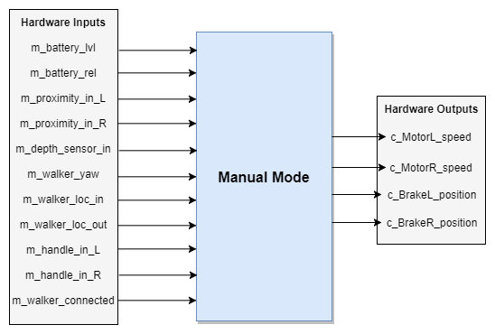

Figure 5 - Manual Mode Diagram

### 2.5.3 Phone App

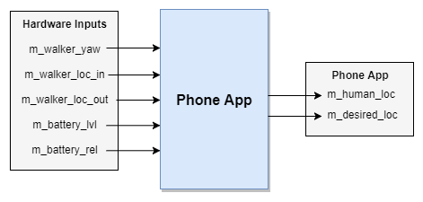

Figure 6 - Phone App Diagram

### 2.5.4 Docking Station

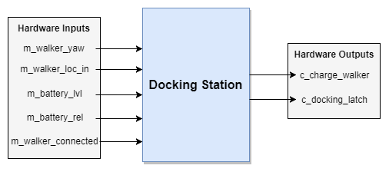

Figure 7 - Docking Station Diagram

# 3 Specific Requirements

## 3.1 Functional Requirements

### 3.1.1 Autonomous Mode

* Autonomous Mode shall not be possible if there is no power drawn from the onboard battery
* When requested via phone app, the SmartWalker shall navigate by itself to and from the user’s phone and docking station as per the request
* The SmartWalker shall detect obstructions in its path using proximity sensors
* The SmartWalker shall use a depth sensor to detect how far away objects/targets in its path are
* The SmartWalker shall receive its orientation and location information from an external source
* The SmartWalker shall receive the phone location and desired location from the phone app
* The SmartWalker shall obey the same drive/brake logic as specified in the Manual Mode section, however the hardware inputs will be replaced with software input commands

### 3.1.2 Manual Mode

* The SmartWalker shall have its <drive inputs> in the neutral state by default
* The SmartWalker’s left wheel shall be inactive and roll freely when the left-hand <drive input> is in its neutral state
* The SmartWalker’s left wheel shall be active and drive forward when the left-hand <drive input> is in its forward state
* The SmartWalker’s left wheel shall be active and drive backward when the left-hand <drive input> is in its backward state
* The SmartWalker’s right wheel shall be inactive and roll freely when the right-hand <drive input> is in its neutral state
* The SmartWalker’s right wheel shall be active and drive forward when the right-hand <drive input> is in its forward state
* The SmartWalker’s right wheel shall be active and drive backward when the right-hand <drive input> is in its backward state
* The SmartWalker’s linear speed shall be proportionally related to the deflection of the drive input that controls it
* The SmartWalker’s <drive inputs> shall not drive the motors if there is no power drawn from the onboard battery
* The SmartWalker shall have its brakes unapplied by default
* The SmartWalker shall decelerate and stop when the brakes are applied
* The SmartWalker shall allow its wheels to roll freely when the e-brake is in the released position
* The SmartWalker shall lock its wheels in place when the e-brake is in the unreleased position
* The SmartWalker shall detect the angle of the floor/ground beneath it
* The SmartWalker will detect a rapid change in elevation in its path

### 3.1.3 Phone App

* The phone application shall receive the SmartWalker’s orientation
* The phone application shall receive the SmartWalker’slocation
* The Phone application shall receive the SmartWalker’s desired location
* The Phone application shall receive the battery’s reliability
* The Phone application shall receive the battery’s level
* The phone application shall communicate the user’s location to the SmartWalker
* The phone application shall communicate the desired location to the SmartWalker
* The Phone application shall communicate the battery’s reliability
* The Phone application shall communicate the battery’s level

### 3.1.4 Docking Station

* The docking station shall charge the on-board SmartWalker battery when it is docked
* The docking station shall lock in the SmartWalker when it is docked

### 3.1.5 Other Requirements

* The SmartWalker shall be defaulted to Manual Mode on startup
* The SmartWalker shall switch to Auto Mode when given an Auto Mode request
* The SmartWalker shall switch back to Manual Mode when the Auto Mode request is completed or failed
* The user shall turn the walker on or off using a <switch/button>
* The SmartWalker shall function as standard non-electric walker there is no power drawn from the onboard battery, or power is disabled

## 

## 3.2 Non-Functional Requirements

**3.2.1 Look and Feel Requirements**

* The walker shall look as close to a standard walker as possible
* All functional components (electronics, motors) shall be enclosed and hidden from view

**3.2.2 Usability requirements**

* Braking shall be possible for those with physical ailments that limit the functionality and dexterity of their hands
* The walker shall be easily autonomously summoned by users with physical ailments that limit the functionality and dexterity of their hands
* Users not familiar with technology shall be able to learn to use the walker in under an hour
* The text size in any phone application can be varied by the user to aid those with poor eyesight
* The walker shall not weigh more than 150 pounds

**3.3.3 Performance Requirements**

* **Speed requirements**
  + It shall not take the walker more than five seconds to begin moving to it’s destination when the user commands the walker to come to them or return to the docking station
  + The walker’s digital user interface shall not take more than one second to respond to user input
  + When applied fully, the walker’s braking system shall bring the walker to a complete stop in a safe amount of time
* **Safety critical requirements**
  + The walker shall not run into people or objects while autonomously navigating
  + The walker shall not drive off of staircases while autonomously navigating
  + The walker shall not accelerate excessively while in use by the user
  + Moving components such as disk brakes, servo motors, and induction motors shall be enclosed to prevent injury
  + The moving component enclosures shall be tough enough that they do not sustain significant damage from minor impacts
* **Precision requirements**
  + The walker shall autonomously navigate into the docking station from any location in the room where there is a suitable path to the docking station
  + The walker shall eventually come within half a meter of the user after being commanded to navigate to the user when there is a suitable path
* **Reliability and availability requirements**
  + The walker shall take at most an hour to charge
  + On a full charge, the walker shall have enough battery for twenty minutes of standard usage
* **Capacity requirements**
  + The product shall be able to support the weight of a single user that weighs at most 300 pounds

**3.3.4 Operational Requirements**

* **Expected physical environment**
  + The walker is to be used by the elderly or mobility challenged individuals while standing up in an indoor, single-floor environment
  + The walker is to be used in environments where there are no doors between the walker and destinations the walker will be summoned too
* **Expected technological environment**
  + The walker must be able to interface with any modern android smartphone

**3.3.5 Maintainability and Portability Requirements**

* The application for communicating with the walker is expected to run on Android smartphones

**3.3.6 Security Requirements**

* Only registered caregivers, family, and significant others in a caregiving role shall be given the ability to use the GPS tracking feature of the walker

**3.3.7 Legal Requirements**

* GPS tracking functionality must be easily removed to facilitate sale in areas where such functionality is illegal or may become illegal
* As a medical device, the walker must meet Canada’s Medical Devices Regulations as outlined in SOR/98-282 <http://laws-lois.justice.gc.ca/eng/regulations/SOR-98-282/index.html>

**3.3.8 Open Issues**

* Investigation into the suitability of Google’s Eddystone technology for walker localization is not yet complete
* Investigation and testing of the suitability of using a single a Raspberry Pi for all system processing is not yet complete
* Investigation into whether the second version of the Microsoft Kinect is suitable for use with Linux and ROS is ongoing

**3.3.9 Off-the-Shelf Solutions**

* The ‘Robot Operating System’s’ Navigation library and it’s related libraries can be used for the autonomous navigation aspect
* Estimote Location Beacons from Estimote Inc. can be used for walker and user localization for indoor environments
  + Several other companies have similar technologies but Estimote Inc.’s product is what will likely be used
* Several smart walker technologies already exist with features that have been considered or could be considered for Modern Mobility’s walker
  + Cornell engineering students developed a smart walker with electronic brakes and automatic braking when the user grabs the walker handgrips [1].
  + Researchers at National Taiwan University created a smart walker named Johnnie that can autonomously navigate to the user. It also has a rehabilitation mode for helping the elderly to walk smoothly and safely
  + ETH Zurich created a smart walker called SmartWalker that can autonomously navigate to the user, and use electric motors to assists the user in walking. The pace of the walker adjusts to the user’s walking pace automatically.

# Citations

|  |  |
| --- | --- |
| [1] | “Engineers invent 'Smart Walkers' for elderly,” Phys.org - News and Articles on Science and Technology, 25-Jun-2010. [Online]. Available: https://phys.org/news/2010-06-smart-walkers-elderly.html. [Accessed: 31-Oct-2017]. |
| [2] | Y. Kuan-Ting, “An Interactive Robotic Walker for Assisting Elderly Mobility in Senior Care Unit ,” IEEE, rep., 2010. |
| [3] | P. Ruegg, “A smart walking aid,” ETH Zurich, 26-Feb-2016. [Online]. Available: https://www.ethz.ch/content/main/en/news-und-veranstaltungen/eth-news/news/2016/02/smart-walker.html. [Accessed: 31-Oct-2017]. |