SMART WALKER

SYSTEM REQUIREMENTS DOCUMENT

**MECHATRONICS 4TB6**

**GROUP 2**

NATHAN FUJIMOTO

PRAKHAR GARG

JOSH GILMOUR

AARON JASS

TYLER JASS

FAUZIA KHANUM

JACK LIU

GAGAN SINGH

Table of Contents

Revision History 4

Table of Tables 5

Table of Figures 5

1.1 Introduction 6

1.1 Purpose 6

1.2 Project Scope 6

2 Overall Description 7

2.1 System Overview 7

2.2 System Term Definitions 7

2.3 System Behaviour 8

2.4 Operating Environment 9

2.5 Assumptions 11

2.5.1 Environmental Assumptions 11

2.5.2 Functional Assumptions 11

2.5.3 User Assumptions 11

2.6 Functional Decomposition and Variables 12

2.6.1 Autonomous Mode 16

2.6.2 Manual Mode 17

2.6.3 Phone App 17

2.6.4 Docking Station 18

3 Specific Requirements 19

3.1 Functional Requirements 19

3.1.1 SmartWalker - Autonomous Mode 19

3.1.2 SmartWalker - Manual Mode 19

3.1.3 Phone Application 19

3.1.4 Docking Station 20

3.1.5 Driving and Braking Requirements 20

3.1.6 Other Requirements 20

3.2 Non-Functional Requirements 21

3.2.1 Look and Feel Requirements 21

3.2.2 Usability requirements 21

3.3.3 Performance Requirements 21

Safety Critical Requirements 21

Precision Requirements 21

Reliability and availability requirements 22

Capacity requirements 22

3.3.4 Operational Requirements 22

Expected physical environment 22

Expected technological environment 22

3.3.5 Maintainability and Portability Requirements 22

3.3.6 Security Requirements 22

3.3.7 Legal Requirements 23

3.3.8 Open Issues 23

3.3.9 Off-the-Shelf Solutions 23

3.3 Requirements Subject to Change 24

Citations 25

# Revision History

|  |  |  |  |  |
| --- | --- | --- | --- | --- |
| **Rev** | **Author(s)** | **Description of Change** | **Peer Reviewed** | **Date** |
| - | T.Jass | Original Document | A.Jass | 10-Oct-2017 |
| A | N.Fujimoto  P.Garg J.Gilmour  A.Jass T.Jass F.Khanum J.Liu G.Singh | Original document was blank with just a layout. This revision adds content to the document. | N.Fujimoto  P.Garg J.Gilmour  A.Jass T.Jass F.Khanum J.Liu G.Singh | 01-Nov-2017 |
| B | N.Fujimoto  P.Garg J.Gilmour  A.Jass T.Jass F.Khanum J.Liu G.Singh | Edited Functional Requirements, functional decomposition diagrams and variables, non-functional requirements.  Added Systems Definitions and Requirements Subject to Change Sections. | N.Fujimoto  P.Garg J.Gilmour  A.Jass T.Jass F.Khanum J.Liu G.Singh | 06-Nov-2017 |

# Table of Tables

Table 1 - System Term Definitions 7

Table 2 - Monitored Variables 13

Table 3 - Controlled Variables 15

Table 4 - Requirements Subject to Change 24

# Table of Figures

Figure 1 - SmartWalker Axes and Orientation 8

Figure 2 - Hospital Patient Room 9

Figure 3 - Google Maps Image of a Hospital and Surrounding Area 10

Figure 4 - Functional Decomposition Diagram 12

Figure 5 - Autonomous Mode Diagram 16

Figure 6 - Manual Mode Diagram 17

Figure 7 - Phone App Diagram 17

Figure 8 - Docking Station Diagram 18

# 1.1 Introduction

## 1.1 Purpose

The standard medical walker or walking aid helps to improve the stability and balance of its user while they are walking. The objective of this project is to modify a standard medical walker to include various mechanical/electrical components and autonomous features in order to improve the user experience. The modified walker, called the SmartWalker, will involve designing and developing an autonomous and safe system while keeping all original functions of the standard medical walker.

This document defines the project scope, outlines the system overview and highlights the main functional and nonfunctional requirements of the SmartWalker.

## 1.2 Project Scope

The scope of this project is to design a walker with autonomous abilities to operate within a specific environment (refer to section ***2.4 Operating Environment***). The SmartWalker will feature:

* Autonomous driving between a docking location and the user within an indoor room, and vice-versa. The dock is a temporary storage location with charging capabilities.
* Autonomous obstacle avoidance when driving to and from the user.
* Assistive walking when using the SmartWalker normally, this includes assistive powering when going up ramps, and active braking when going down ramps.
* Emergency braking in any situation if approaching a steep drop in elevation (staircase).
* Global Position System (GPS) tracking within the environment.

This project will not include (out of scope) the following items:

* Autonomous usage in multiple indoor environments simultaneously (autonomous movement between multiple rooms).
  + Autonomous features in an entire hospital.
* Exact GPS tracking while walker is indoors.

The end result of this project will demonstrate the students’ cumulative learning through their academic career via a demonstration of the SmartWalker’s autonomous ability in a predetermined location.

# 2 Overall Description

## 2.1 System Overview

The SmartWalker is an original idea by the Modern Mobility group, within the capstone course of the Computing and Software Department, 4TB6, at McMaster University. The focus of the SmartWalker project is to increase the utility of a standard medical walker by implementing various autonomous and electric features. Full system details and functionalities are explained below.

## 2.2 System Term Definitions

**Table 1 - System Term Definitions**

|  |  |
| --- | --- |
| **Term** | **Definition** |
| X-axis | Forward direction relative to the SmartWalker. |
| Y-axis | Left direction relative to the SmartWalker. |
| Z-axis | Upward direction (normal to the SmartWalker’s XY-plane). |
| Yaw | Angle from the X-axis going counter-clockwise about the Z-axis in the XY-plane. |
| Pitch | Angle from the Y-axis going counter-clockwise about the X-axis in the YZ-plane. |
| Roll | Angle from the Z-axis going counter-clockwise about the Y-axis in the XZ-plane. |
| Docking Station | The device that charges the SmartWalker. This is considered the SmartWalker’s Home. |
| UI | User Interface. |
| Phone App (Phone Application) | Refers to an application on a person’s smartphone device. Often simply called an “App”. |

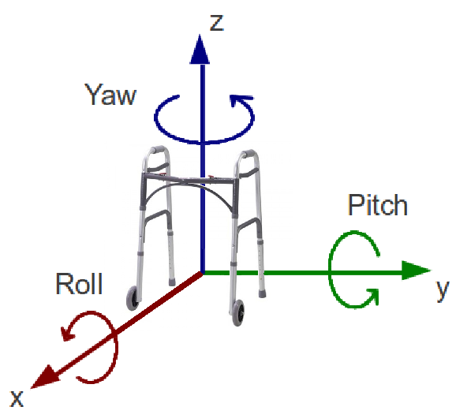

Figure - SmartWalker Axes and Orientation

## 2.3 System Behaviour

The SmartWalker has two main functionalities (or modes): autonomous mobility and manual driving.

* *Autonomous Mode*: The ability to move out of the way of the user whenever requested to a designated home location as well as return to the user when requested.
* *Manual Mode*: The ability to operate like a standard medical walker, with added smart features like assisted braking and assisted driving.

These core functions are supported by two sub-functions: a phone application and a docking station. The phone app is used as an avenue to capture user-specific monitored variables, while the docking station is used to support the autonomous mobility function by acting as a home location.

## 2.4 Operating Environment

The operating environment of the SmartWalker is a typical hospital. This environment is divided into two areas: the patient’s room, and the hospital hallways/common rooms and outside grounds. Manual mode will be available in all environments (patient room, hospital corridors, hospital grounds etc.) while Autonomous mode will only be available in the patient room that contains its corresponding docking station.

***Figure 2*** below indicates a sample patient room in a hospital. The docking station would be located next to a wall plugged into an electrical outlet ready to charge the walker at any moment. The docking station will not be in the way of medical equipment and medical personnel such as doctors, nurses, and caregivers. ***Figure 3*** below indicates a sample hospital and its surrounding outside grounds that the SmartWalker can be implemented in.

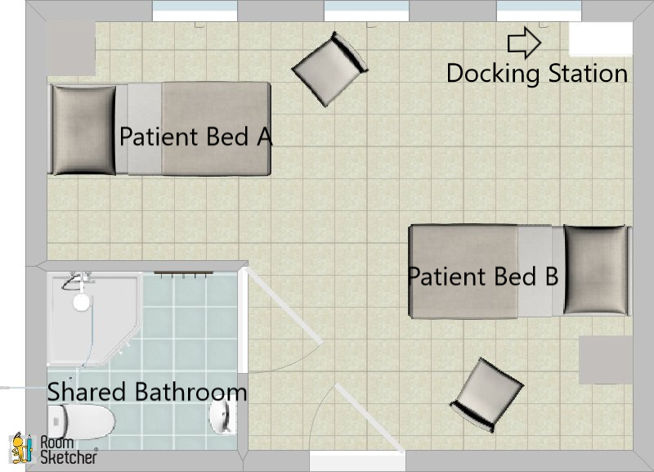

Figure - Hospital Patient Room

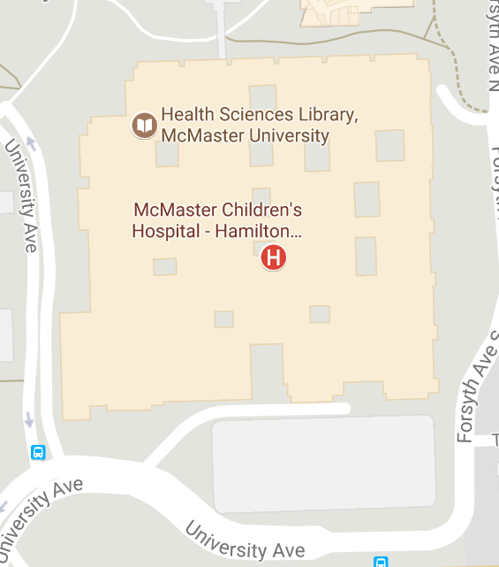

Figure - Google Maps Image of a Hospital and Surrounding Area

## 2.5 Assumptions

### 2.5.1 Environmental Assumptions

* The SmartWalker will be used in patient rooms that have enough room for wheelchairs to move about, therefore enough room for the SmartWalker to autonomously move about
* It is assumed that the farthest the SmartWalker will be taken will the hospital grounds.

### 2.5.2 Functional Assumptions

* An structurally sound off the shelf walker will be used as the basis for the SmartWalker
* The SmartWalker battery will be charged via the docking station and no other method.

### 2.5.3 User Assumptions

* The user of the SmartWalker will have little experience interacting with technology such as phone applications.
* The user owns a phone that runs on Android OS.

## 2.6 Functional Decomposition and Variables

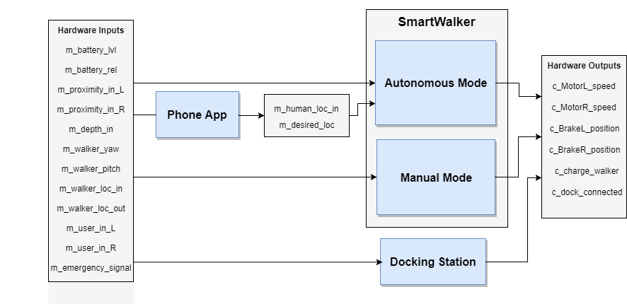

Figure - Functional Decomposition Diagram

**Table 2 - Monitored Variables**

|  |  |  |  |
| --- | --- | --- | --- |
| **Variable** | **Description** | **Units** | **Range** |
| *m_battery_lvl* | Power level of battery. | Battery Sustain of Charge (%) | [0, 100] |
| *m_battery_rel* | Reliability of the battery. | Battery Health (%) | [0, 100] |
| *m_proximity_in_L* | Proximity to any objects in the environment (front-left side). | Distance (cm) | [0, 500] |
| *m_proximity_in_R* | Proximity to objects in the environment (front-right side). | Distance (cm) | [0, 500] |
| *m_depth_in* | Depth of the upcoming ground with respect to the bottom of the walker. | Distance (cm) | [-100, 0] |
| *m_walker_yaw* | Orientation of the walker (yaw) with respect to the walker’s z-axis. | Angle (deg) | [-180, 180] |
| *m_walker_pitch* | Orientation of the walker (pitch) with respect to the walker’s y-axis. | Angle (deg) | [-45, 45] |
| *m_walker_loc_out* | Global location of the walker. | [Longitude (deg), Latitude (deg)] | [-180, 180; -90,90] |
| *m_walker_loc_in* | Location of the walker inside the patient room, with respect to a preset coordinate system. | [x,y] on room map | [0, 100; 0, 100] |
| *m_human_loc_in* | Location of the human based on their phone, with respect to a preset coordinate system. | [x, y] on room map | [0, 100; 0, 100] |
| *m_desired_loc* | User selected desired location for the walker in autonomous mode | Enum (states) | GoDocking, GoHuman |
| *m_user_int_L* | Desired forward assisted movement for the user, for the left motor. | Custom | [-100,100] |
| *m_user_in_R* | Desired forward assisted movement for the user, for the left motor. | Custom | [-100,100] |
| *m_emergency_signal* | Signal for monitoring an emergency situation. | Boolean | 0, 1 |

**Table 3 - Controlled Variables**

|  |  |  |  |
| --- | --- | --- | --- |
| **Variable** | **Description** | **Units** | **Range** |
| *c_motorL_speed* | Left motor speed. | Angular velocity ( deg/s) | [0, 50] |
| *c_motorR_speed* | Right motor speed. | Angular velocity (deg/s) | [0, 50] |
| *c_brakeL_position* | Left brake position. | Brake Position (%) | [0, 100] |
| *c_brakeR_position* | Right brake position. | Brake Position (%) | [0, 100] |
| *c_charge_walker* | Charge the walker. | Boolean | 0, 1 |
| *c_dock_connected* | Walker physically connected to the docking station. | Boolean | 0, 1 |

### 2.6.1 Autonomous Mode

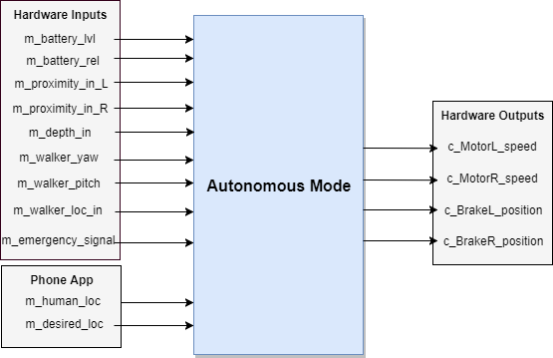

Figure - Autonomous Mode Diagram

### 2.6.2 Manual Mode

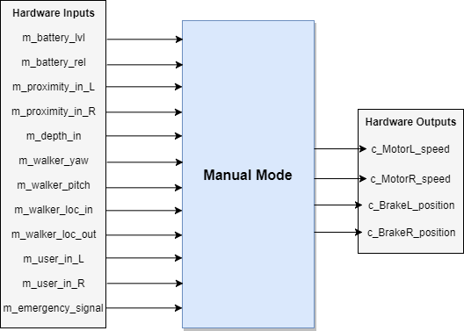

Figure - Manual Mode Diagram

### 2.6.3 Phone App

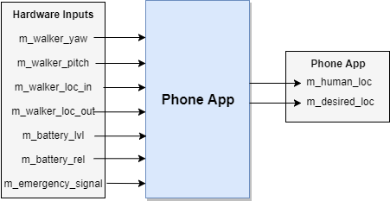

Figure - Phone App Diagram

### 2.6.4 Docking Station

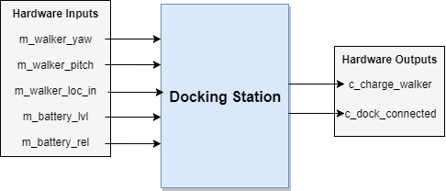

Figure - Docking Station Diagram

# 3 Specific Requirements

*Requirements Subject to change in sections 3.1 and 3.2 are denoted with a “*” at the end of the sentence. These requirements are mentioned again in section 3.3.*

## 3.1 Functional Requirements

### 3.1.1 SmartWalker - Autonomous Mode

1. Autonomous Mode shall not be possible if there is no power drawn from the onboard battery.
2. When requested via the phone app, the SmartWalker shall navigate independently to and from the user’s phone location and docking station location.
3. The SmartWalker shall receive its orientation and location information from inputs.
4. The SmartWalker shall receive the phone location and desired destination location.
5. The SmartWalker shall detect how far away objects are in its path.
6. The SmartWalker shall avoid objects in its path.
7. The SmartWalker shall detect the angle of the floor/ground beneath it.
8. The SmartWalker shall detect a rapid change in elevation (e.g. a step) in its path.
9. The SmartWalker shall avoid falling due to changes in its environment.

### 3.1.2 SmartWalker - Manual Mode

1. The SmartWalker shall allow its wheels to roll freely when the e-brake is in the released position.
2. The SmartWalker shall lock its wheels in place when the e-brake is applied.

### 3.1.3 Phone Application

1. The phone application shall receive the SmartWalker’s orientation.
2. The Phone application shall receive the SmartWalker’slocation.
3. The Phone application shall receive the SmartWalker’s desired location.
4. The Phone application shall receive the battery’s reliability.
5. The Phone application shall receive the battery’s level.
6. The phone application shall communicate the user’s location to the SmartWalker.
7. The phone application shall communicate the desired location to the SmartWalker.
8. The Phone application shall display the battery’s reliability.
9. The Phone application shall display the battery’s level.
10. The Phone application shall receive a notification if a request failed. *

### 3.1.4 Docking Station

1. The docking station shall charge the on-board SmartWalker battery when it is docked.*
2. The docking station shall lock in the SmartWalker when it is docked.*

### 3.1.5 Driving and Braking Requirements

1. The SmartWalker’s left wheel shall be inactive and roll freely when no request has been made.
2. The SmartWalker’s left wheel shall be active and drive forward when a request has been made.
3. The SmartWalker’s left wheel shall be active and drive backward when a request has been made.
4. The SmartWalker’s left wheel shall only continue moving if a request is continually made.
5. The SmartWalker’s right wheel shall be inactive and roll freely when no request has been made.
6. The SmartWalker’s right wheel shall be active and drive forward when a request has been made.
7. The SmartWalker’s right wheel shall be active and drive backward when a request has been made.
8. The SmartWalker’s right wheel shall only continue moving if a request is continually made.
9. The SmartWalker’s wheel’s linear speeds shall be proportional to the input request.
10. The SmartWalker shall have its brakes released by default.
11. The SmartWalker shall decelerate and an eventual stop when the brakes are requested.
12. The SmartWalker shall come to a complete stop in a safe amount of time when the brakes are requested.
13. The SmartWalker shall not take the walker more than five seconds to begin moving to its destination when requested.

### 3.1.6 Other Requirements

1. The SmartWalker shall be defaulted to Manual Mode on start-up.
2. The SmartWalker shall switch to Auto Mode when given an Auto Mode request.
3. The SmartWalker shall switch back to Manual Mode when the Auto Mode request is completed or failed.
4. The SmartWalker shall turn on when requested.
5. The SmartWalker shall turn off when requested.
6. The SmartWalker shall function as standard non-electric walker there is no power drawn from the onboard battery, or power is disabled.
7. The SmartWalker’s digital UI shall not take more than one second to respond to user input.

## 

## 3.2 Non-Functional Requirements

### 3.2.1 Look and Feel Requirements

1. The walker shall look as close to a standard walker as possible to not draw potentially unwanted attention to the user.
2. All functional components (electronics, motors) shall be enclosed and hidden from view to improve the aesthetics of the walker.

### 3.2.2 Usability requirements

1. Braking the walker shall be possible for those with physical ailments that limit the functionality and dexterity of their hands.
2. The walker shall be easy to autonomously summon by users with physical ailments that limit the functionality and dexterity of their hands.
3. The walker shall be easy to learn to use for elderly unfamiliar with modern technology.
4. The text size in any digital interface can be varied by the user to aid those with poor eyesight because a significant portion of the target market of the walker has poor eyesight.
5. The walker shall not weigh more than 150 pounds to limit the load on the battery from moving the walker. *

### 3.3.3 Performance Requirements

#### Safety Critical Requirements

1. The walker shall not accelerate excessively while in use by the user to ensure safety.
2. Moving components such as disk brakes, servo motors, and induction motors shall be enclosed to prevent injury.
3. The moving component enclosures shall be tough enough that they do not sustain significant damage from minor impacts. This is necessary to ensure user safety throughout the life of the walker.

#### Precision Requirements

1. The walker shall be able to autonomously navigate into the docking station from any location in the room where there is a suitable path to the docking station.
2. The walker shall eventually come within half a meter of the user after being commanded to navigate to the user when there is a suitable path. This will ensure that the walker is close enough to the user that they can reach it.

#### Reliability and availability requirements

1. The walker shall take at most an hour to charge to limit the time where the user cannot use the walkers advanced features.*
2. On a full charge, the walker shall have enough battery for at least twenty minutes of standard usage.*

#### Capacity requirements

1. The product shall be able to support the weight of a single user that weighs at most 300 pounds. This will ensure that the majority of the population can use the walker.*

### 3.3.4 Operational Requirements

#### Expected physical environment

1. The walker is to be used by the elderly or mobility challenged individuals while standing up in an indoor, single-floor environment.
2. The walker is only to autonomously navigate inside environments where doors and other obstructions do not separate the walker from the destination.

#### Expected technological environment

1. The walker must be able to interface with any modern android phone to ensure a large portion of users with phones can utilize the walkers advanced features.*

### 3.3.5 Maintainability and Portability Requirements

1. The application for communicating with the walker is expected to run on Android phones.

### 3.3.6 Security Requirements

1. Only registered caregivers, family, and significant others in a caregiving role shall be given the ability to use the GPS tracking feature of the walker to protect the user's privacy.*

### 3.3.7 Legal Requirements

1. GPS tracking functionality must be easily removed to facilitate sale in areas where such functionality is illegal or may become illegal
2. As a medical device, the walker must meet Canada’s Medical Devices Regulations as outlined in SOR/98-282

### 3.3.8 Open Issues

1. Investigation into the suitability of Google’s Eddystone technology for walker localization is not yet complete.
2. Investigation and testing of the suitability of using a single a Raspberry Pi for all system processing is not yet complete.

### 3.3.9 Off-the-Shelf Solutions

1. The Robot Operating System’s Navigation library can be used for the autonomous navigation aspect of the walker’s functionality. [5]
2. Estimote Location Beacons from Estimote Inc. can be used for walker and user localization for indoor environments [4].
3. Several smart walker technologies already exist with features that have been considered or could be considered for Modern Mobility’s walker.
   1. Cornell engineering students developed a smart walker with electronic brakes and automatic braking when the user grabs the walker handgrips [1].
   2. Researchers at National Taiwan University created a smart walker named Johnnie that can autonomously navigate to the user. It also has a rehabilitation mode for helping the elderly to walk smoothly and safely [2].
   3. ETH Zurich created a smart walker called SmartWalker that can autonomously navigate to the user, and use electric motors to assists the user in walking. The pace of the walker adjusts to the user’s walking pace automatically [3].

## 3.3 Requirements Subject to Change

**Table 4 - Requirements Subject to Change**

|  |  |
| --- | --- |
| **Requirement** | **Justification** |
| 3.1.4, 1 | The Docking Station may not be necessary for charging, eliminating the need for this requirement. |
| 3.1.4, 2 | The Docking Station may not be necessary for charging, eliminating the need for this requirement. |
| 3.1.3, 10 | The phone app may not receive notifications if a request was failed. |
| 3.2.2, 5 | Components have not yet been sourced and so what is a realistic final weight of the walker is not yet known. |
| 3.3.3, 6 | A study of charging times of batteries feasible for this application has not yet been done. |
| 3.3.3, 7 | This is an estimation; a more realistic requirement will be enforced upon further investigation. |
| 3.3.3, 8 | A study of how much weight a standard walker can support has not been done. |
| 3.3.4, 3 | The walker may ultimately not have an associated phone application at all. If it does, it could potentially be an iOS application as opposed to an Android. The requirement may also be extended to include both Android and iOS devices. |

# Citations

|  |  |
| --- | --- |
| [1] | “Engineers invent 'Smart Walkers' for elderly,” Phys.org - News and Articles on Science and Technology, 25-Jun-2010. [Online]. Available: https://phys.org/news/2010-06-smart-walkers-elderly.html. [Accessed: 31-Oct-2017]. |
| [2] | Y. Kuan-Ting, “An Interactive Robotic Walker for Assisting Elderly Mobility in Senior Care Unit ,” IEEE, rep., 2010. |
| [3] | P. Ruegg, “A smart walking aid,” ETH Zurich, 26-Feb-2016. [Online]. Available: https://www.ethz.ch/content/main/en/news-und-veranstaltungen/eth-news/news/2016/02/smart-walker.html. [Accessed: 31-Oct-2017]. |
| [4] | Estimote Inc. Available: https://estimote.com/ |
| [5] | Navigation Stack. Robot Operating System. Available: http://wiki.ros.org/navigation |