PROOF OF CONCEPT

TEST REPORT DOCUMENT

**MECHATRONICS 4TB6**

**GROUP 2**

NATHAN FUJIMOTO

PRAKHAR GARG

JOSH GILMOUR

AARON JASS

TYLER JASS

FAUZIA KHANUM

JACK LIU

GAGAN SINGH

Table of Contents

Revision History 3

Document References 4

Table of Tables 4

Table of Figures 4

1 Required Knowledge 5

1.1 Image of Kinect 5

1.2 Terminology 5

2 Procedure 6

3 Results 7

# Revision History

|  |  |  |  |  |
| --- | --- | --- | --- | --- |
| **Rev** | **Author(s)** | **Description of Change** | **Peer Reviewed** | **Date** |
| - | T.Jass | Original Document | N. Fujimoto | 19/11/2017 |

# Document References

N/A

# Table of Tables

N/A

# Table of Figures

N/A

# 1 Required Knowledge

## 1.1 Image of Kinect

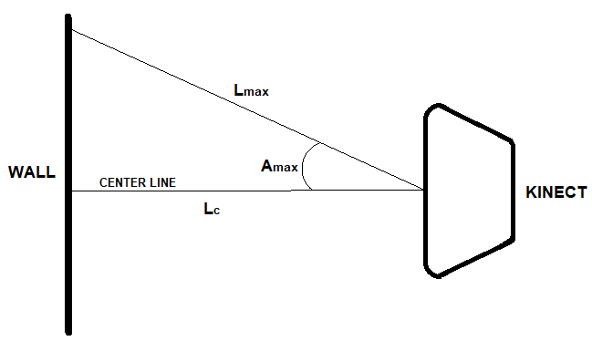

## 1.2 Terminology

|  |  |
| --- | --- |
| **Term** | **Definition** |
| Kinect | Microsoft’s Kinect Camera |
| Wall | Flat wall surface used in testing |
| Center Line | Line of sight going straight (angle of 0 degrees) to the wall |
| Amax | Maximum angle from the centre line the Kinect can detect |
| Lmax | Length from the Kinect’s Camera to the wall at an angle of Amax |
| Lc | Length from the Kinect’s Camera to the wall along the center line |

# 2 Procedure

1. Faced Kinect toward the wall, ensuring that the line of sight going straight was perpendicular to the wall.
2. Physically measured using a measuring tape and positioned the Kinect so that Lc = 50cm.
3. Recorded the Lc value measured by the Kinect.
4. Physically measured using a measuring tape the Lmax value.
5. Recorded the Lmax value measured by the Kinect.
6. Repeated steps 2 to 5 for Lc = 75cm, 100cm, and 125cm.
7. Repeated steps 2 to 3 for Lc = 192cm and 213cm.

# 3 Results

<Insert Graphs and excel table data>