Power BI – Athena Integration & Data Visualization Summary
Objective
Connect Power BI with AWS Athena data, load datasets, and create a shared workspace so the team can collaboratively build and modify dashboards.

✅ Work Completed (Step-by-Step Summary)
- AWS Athena Connection Setup
  - Configured Athena access using ODBC connection.
  - Ensured team members received necessary IAM policies and credentials.
  - Verified Athena catalogs and tables were accessible.
  - Loaded required datasets into Power BI Desktop.

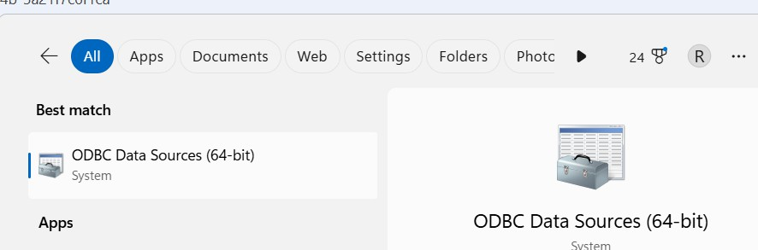

Dataset Loading in Power BI
  - Connected Power BI Desktop to Athena via ODBC.
  - Loaded analytics tables required for dashboards.
  - Verified tables and columns loaded correctly.
  - Previewed and validated data before loading.

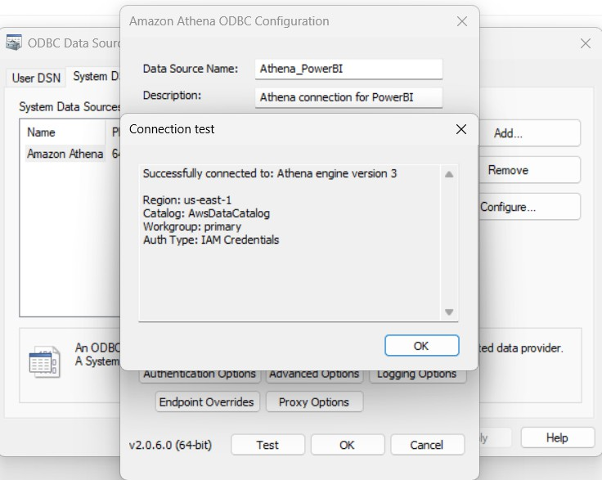

Data Transformation & Validation
  - Opened Power Query Editor.
  - Loaded transformed data successfully into Power BI model.

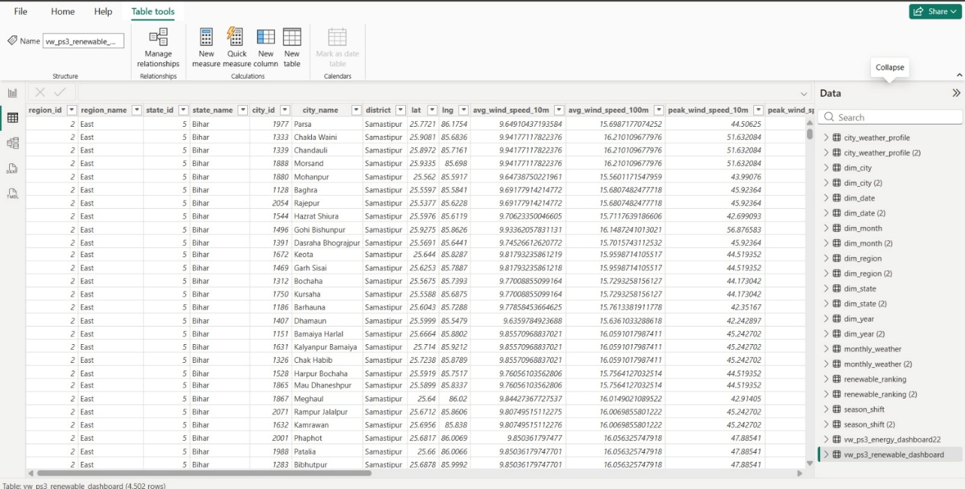

Dashboard File Integration
  - Opened already created dashboard file shared by teammates.
  - Confirmed visuals and tables were available.
  - Linked dashboards to Athena dataset.

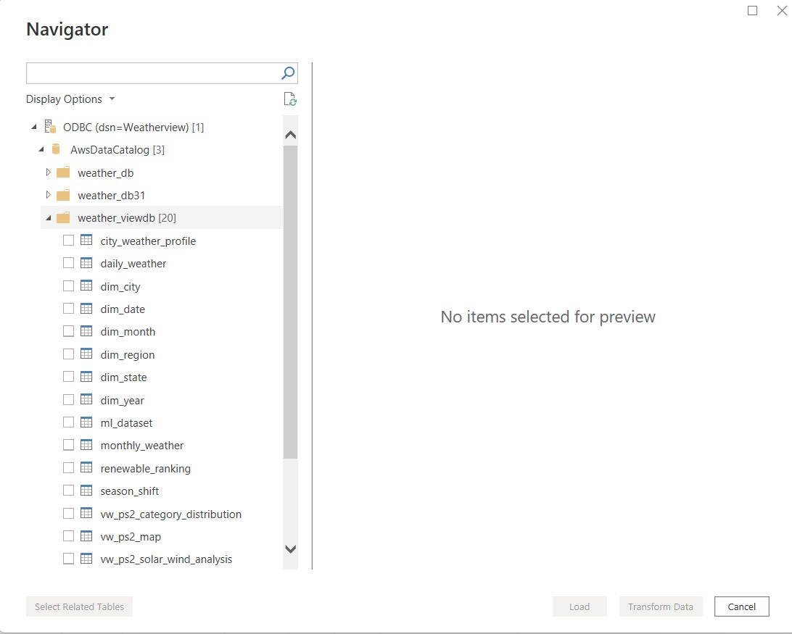

Dataset Finalization
  - Verified all visuals functioned correctly with loaded dataset.
  - Decided to keep date format unchanged to avoid rework.
  - Ensured dataset was usable for dashboard development.

View :

CREATE OR REPLACE VIEW vw_ps3_renewable_dashboard AS
SELECT

-- Geography
rr.region_id,
dr.region_name,

rr.state_id,
ds.state_name,

rr.city_id,
dc.city_name,
dc.district,
dc.lat,
dc.lng,

-- Renewable Metrics
rr.avg_wind_speed_10m,
rr.avg_wind_speed_100m,

rr.peak_wind_speed_10m,
rr.peak_wind_speed_100m,

rr.avg_cloud_cover,

rr.avg_wind_10m_score,
rr.avg_wind_100m_score,

rr.avg_solar_score,
rr.avg_solar_proxy,

rr.renewable_index,
rr.renewable_rank,

rr.renewable_category,
rr.greenhouse_wind_suitability,
rr.recommended_energy_type

FROM renewable_ranking rr

INNER JOIN dim_city dc
ON rr.city_id = dc.city_id

INNER JOIN dim_state ds
ON rr.state_id = ds.state_id

INNER JOIN dim_region dr
ON rr.region_id = dr.region_id;

Dashboard:

