- Introduction

  - An overview of project
The project involves developing a blog webpage that is user-friendly, efficient, and adaptable. It aims to address current challenges like navigation issues, slow loading speeds, and a suboptimal user experience by leveraging advanced technologies such as React.js, Node.js, and MongoDB.
  - Mission of project
The mission is to create a blog platform that provides an engaging, scalable, and secure experience for both users and administrators. It focuses on delivering high-performance, intuitive navigation, robust security features, and seamless content management, ensuring the platform meets user needs effectively.
  - Background study
The background study highlights the importance of system analysis in understanding and optimizing the structure and workflows of a blog webpage. It identifies common issues like poor usability and inefficient content management and explores solutions through modern technologies and best practices in design and development.
    - A study of the existing system
The current system struggles with slow loading speeds, difficult navigation, and limited features. These issues reduce accessibility and create a less satisfying experience for users. Addressing these problems involves streamlining the design and ensuring smooth, easy access for all users.

2. System Analysis
System analysis is the process of understanding a system’s structure, components, and workflows to identify problems and suggest improvements. It is a problem-solving approach used in fields like business and technology to enhance the efficiency, effectiveness, and reliability of systems.
System analysis is used in blog webpages to enhance their functionality, usability, and efficiency. By analyzing the structure, components, and processes of the webpage, system analysis helps identify issues like slow loading times, navigation problems, or poor user experience. It also aids in optimizing the design, improving content management systems, and ensuring better integration with SEO and other tools. In which, it ensures the webpage meets user needs effectively while maintaining performance and reliability.
2.1 A Study of the Proposed System
The proposed system for the blog webpage aims to enhance user experience, performance, and functionality. It focuses on a user-friendly interface, fast loading times, and accessibility across devices. Features include content management, analytics tools, and a responsive layout. Technical upgrades ensure security, reliability, and efficiency while reducing downtime. This system is designed to simplify administration and attract more visitors, making the blog adaptable and user-focused.

2.2 User Requirement Specification
2.2.1 Major Modules
1. User Roles & Requirements
- Blog-page User’s: Explore topics of interest, information, entertainment, inspiration, content like articles, tutorials and reviews.
- Administration: Manage and organize content, publish and edit posts, monitor user interactions, maintain website security, analyze performance analytics, implement SEO strategies, resolve technical issues, ensure smooth website operation.

2. System Requirements
- Secure Authentication and Authorization: Utilize Firebase Authentication for secure role-based access control for users and administrators.
- Efficient Data Management: Manage posts, comments, and user preferences efficiently using MongoDB as the database.
- Scalable and Responsive Design: Develop a scalable architecture with ReactJS and Tailwind CSS, ensuring a responsive interface across all devices.
- Content Management System (CMS): Implement custom content management features using ReactJS and ExpressJS for seamless content creation and updates.
- Database Management: Employ MongoDB for structured, efficient, and scalable data storage.
- Server Requirements: Use NodeJS with ExpressJS to handle server-side operations effectively.
- Administrative Tools: Build custom tools with ReactJS and Firebase to monitor user activities and optimize blog performance.
- Security Features: Ensure secure connections and data protection through Firebase and other advanced security protocols.
2.2.2 Sub-Modules
- Authentication Module: Facilitates secure user login, registration, and role-based access control, ensuring privacy and data security for users and administrators.
- Blog Search Module: Allows users to search for blog posts with filters such as categories, tags, and popularity, enhancing content discoverability.
- Content Management Module: Enables users to create, edit, and manage their blog posts, ensuring a seamless and efficient publishing process.
- Comment Management Module: Provides users the ability to add, edit, and moderate comments, fostering community interaction and engagement.
- Likes Management Module: Allows users to like blog posts, reflecting audience appreciation and helping content creators identify popular topics.
- Admin Dashboard Module: Provides tools for managing posts, monitoring user activities, and overseeing system performance, ensuring smooth platform operations.

2.3 Software Requirement Specification
- Frontend: React.js is utilized to create a dynamic and responsive user interface, ensuring an engaging and seamless user experience.
- Backend: Node.js with Express.js is implemented to handle API requests, manage business logic, and ensure efficient server-side operations.
- Authentication: JSON Web Token (jsonwebtoken) is employed to enable secure user authentication, ensuring data integrity and user privacy.
- Database: MongoDB serves as the database system, providing scalable and flexible storage for structured and unstructured data. MongoDB Atlas is used as a cloud-based storage solution to ensure data accessibility and scalability.
2.4 System Specification
2.4.1 React.js
- React.js is implemented to develop the frontend of the blog webpage.
- Utilizes a component-based framework to create modular, reusable, and efficient UI elements.
- Facilitates an engaging and responsive user interface with smooth state management.
2.4.2 Node.js
- Functions as the runtime environment for the backend of the blog webpage.
- Employs an asynchronous, event-driven model to efficiently handle multiple client requests and processes.
2.4.3 Express.js
- Serves as a minimalist framework built on Node.js to simplify API development and server-side functionality.
- Efficiently handles routing, middleware execution, and request-response cycles with optimized workflows.
2.4.4 MongoDB
- A NoSQL database system utilized for scalable and flexible data storage for the blog.
- Effectively manages and secures content, user information, comments, and related metadata.
2.5 Hardware Configuration
- Processor: AMD Ryzen 5 7520U with Radeon Graphics 2.80 GHz
- RAM: 16GB
- Storage: 512 GB
- System Type: 64-bit operating system, x64-based processor

2.6 Software Configuration
- Operating System: Windows 11 Home Single Language
- Development Tools: VS Code, Postman, Git, and MongoDB Compass
- Frontend Dependencies: React.js, Redux, Axios, React Router
- Backend Dependencies: Node.js, Express.js, Mongoose
- Database: MongoDB Atlas for cloud-based storage
- Version Control: Git and GitHub for source code management

3. System Design and Development
System design and development involve planning, creating, and implementing a system to achieve specific goals. Design focuses on defining the architecture, components, and interfaces, ensuring functionality and usability. Development covers coding, integration, testing, and deploying the designed system.
To ensure a high-performing blog page, it is essential to focus on a responsive and visually appealing interface, smooth navigation, and efficient content management. The system must be scalable to handle growing traffic, integrate robust security measures, and ensure technical reliability with seamless interaction between the frontend (React.js) and backend (Node.js, MongoDB). Customization for user and admin needs, along with future-proofing for evolving technologies, ensures the blog remains adaptable and optimized.

3.1 Design Notations
Design notation is a way of representing ideas, structures, or workflows using diagrams, symbols, or text to make them easy to understand and communicate. In software development, it helps describe systems visually, such as using flowcharts, UML diagrams, or wireframes. This ensures clear communication among developers, designers, and stakeholders, making complex processes simpler to plan and implement effectively.
3.1.1 System structure chart
A system structure chart is a hierarchical diagram that visually represents the components or modules of a system and their relationships. It is used to design and document the structure and flow of a system's functionality. In a blog website, a system structure chart can be used to outline modules like user profiles, blog posts, comments, admin dashboard, and tutorials. It helps define how these components interact, such as linking the frontend UI with backend APIs or database operations. This chart ensures clarity in development, simplifies debugging, and aids in planning future extensions of the website.

3.1.2 System flow diagram
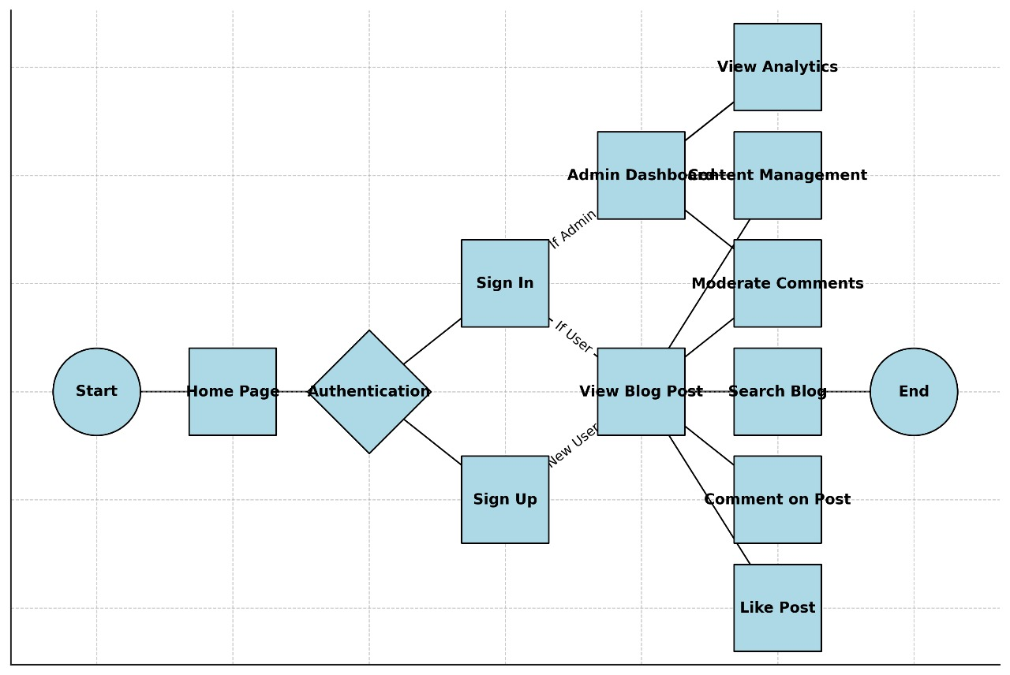
A system flow diagram visually represents the flow of data, processes, and interactions within a system. In a blog website, it shows how user actions, like viewing a blog post, move through the frontend, backend, and database. It helps design workflows such as user registration or content management efficiently.

3.1.3 Data flow diagram/ UML
A Data Flow Diagram (DFD) or UML diagram visually represents the flow of data, processes, and relationships within a system. In a blog website, these diagrams map processes like user registration, blog creation, admin dashboard operations, or data retrieval, showing how data flows between the frontend, backend, and database. This ensures clear communication and simplifies system design for efficient functionality.

3.2 Design process
3.2.1 Software Architecture
The Blog Website utilizes a three-tier architecture consisting of:
- User Interface Layer: Frontend developed using React.js, Firebase, and Tailwind, ensuring a dynamic and engaging user experience.
- Application Logic Layer: Backend built with Node.js and Express.js, responsible for processing requests and executing core functionalities.
- Database Layer: MongoDB deployed for seamless storage and retrieval of user information, blog content, and comments.
3.2.2 Data Structure
The database schema employs a NoSQL document-based format in MongoDB, optimizing the storage and retrieval of diverse data. This includes user profiles, blog posts, comments, and administrative records like dashboard analytics and categorized content. The flexible and scalable schema supports complex queries, ensures fast data operations, and accommodates the dynamic needs of the blog platform.
3.2.3 Software Procedure
Software procedures define the logical sequence of actions executed by various modules, ensuring smooth integration between components. For example, user registration triggers processes in both the frontend and backend, storing data securely in the database. Similarly, post creation and comment moderation follow defined workflows to maintain consistency and data integrity. These procedures ensure seamless communication across layers, providing a reliable and user-friendly experience.

Database Design
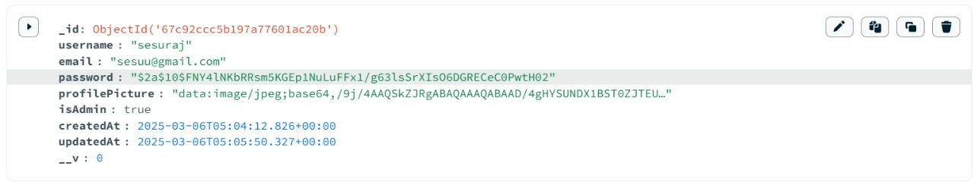
The database is designed using MongoDB collections to efficiently store structured and unstructured data. Collections include Users, Posts, Comments, and Likes, each optimized with indexing to ensure fast and reliable data retrieval for seamless functionality and user experience on the blog platform.
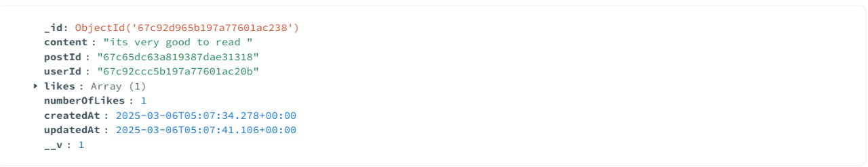
Fig.3.3.1 User Database Design
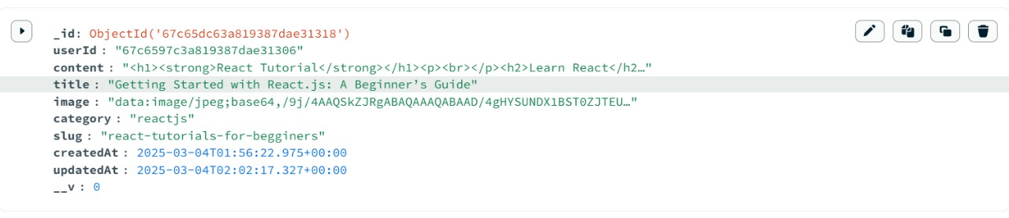
Fig.3.3.2 Post Database Design
Fig.3.3.3 Comment Database Design

3.4 Table Design
Users Table
UserID | Name | Email | isAdmin | Password | Created At | Updated At
001 | Sesuraj | sesu@gmail.com | Admin | ******* | 25/2/6 | 25/2/6
002 | Prem | prem@gmail.com | Regular User | ******* | 25/2/25 | 25/2/25
003 | Akira | akira@gmail.com | Content Creator | ******* | 25/3/5 | 25/3/5

Comments Table:
PostID | UserID | Content | Likes | Created At | Updated At
101 | 002 | “It is very good to read” | 51 | 7/2/25 | 9/2/25
102 | 003 | “The content is very neat and clear” | 32 | 25/2/25 | 28/2/25
103 | 002 | “The difference is explained very neatly” | 41 | 10/3/25 | 15/3/25

Post Table:
CommentID | PostID | UserID | Comment  Content | Created At | Updated At
501 | 101 | 002 | “Great introduction to react” | 7/2/25 | 9/2/25
502 | 102 | 003 | “SEO tips are very helpful” | 25/2/25 | 28/2/25
503 | 103 | 002 | “A balanced comparison, thanks” | 10/3/25 | 15/3/25

3.5 Input design
Input design focuses on how users provide data to the system, ensuring clarity, ease, and efficiency.
- User Management: Admins manage user accounts by creating, updating, deleting profiles, and assigning roles for seamless user management.
- Post Management: Admins create, edit, and delete blog posts, ensuring organized and high-quality content.
- Comment Management: Admins review, approve, edit, or remove comments to maintain a positive discussion space.
- Like Management: Users can like or unlike posts, and these actions are instantly reflected in the system to encourage interactive user engagement.
- Admin Dashboard: Provides insights into users, posts, comments, and likes for efficient website management.
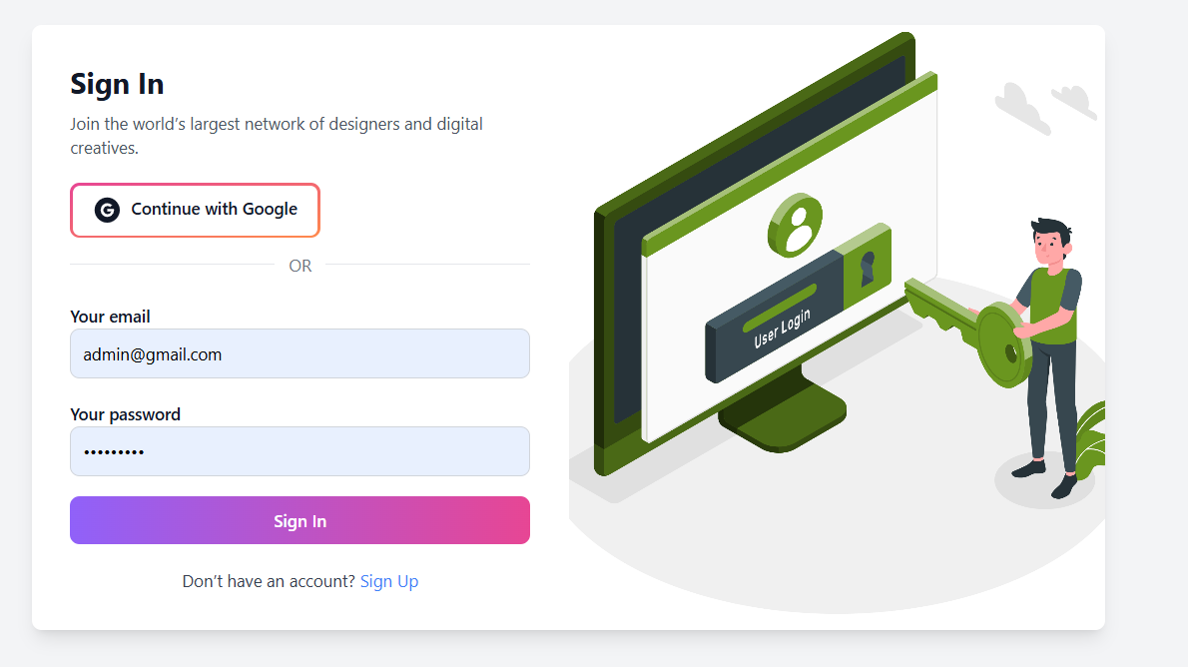
Fig.3.5 Sign-In Form

3.6 Output design
Output design deals with presenting processed information back to users in an understandable and actionable format.
- User Management: Actions such as user creation or deletion are accompanied by success messages and database updates.
- Post Management: Post actions trigger success notifications and are reflected across the website for real-time user experience.
- Comment Management: Displays success messages for moderation actions, ensuring that changes are properly saved in the database.
- Like Management: Actions like adding or removing likes are confirmed through notifications, and updates are synced instantly across user interfaces.
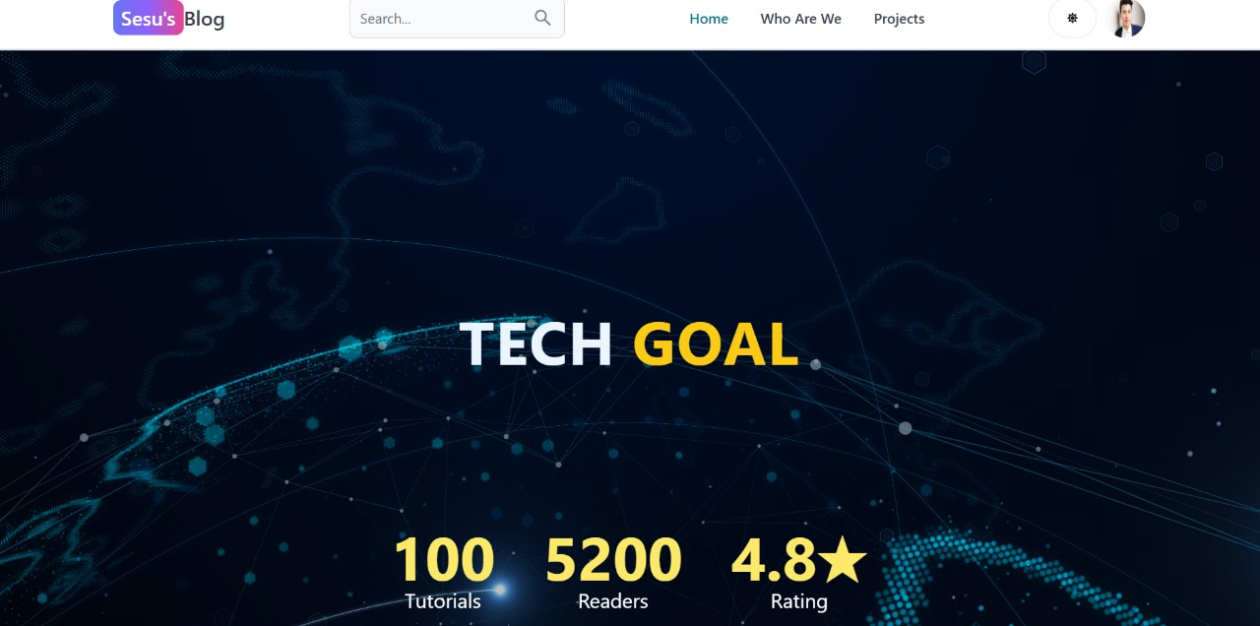
- Admin Dashboard: Ensures dynamic updates and actionable insights for real-time monitoring and management.

Fig.3.6 Home Page

3.7 Development approach
The Blog Website is developed using an Agile methodology, incorporating:
- Iterative Development: Regular updates and improvements based on user feedback and evolving requirements.
- Version Control: Managed through Git and GitHub to enable efficient tracking of code changes and seamless team collaboration.
- Testing and Debugging: Continuous integration supported by automated and manual testing to ensure the stability and reliability of the platform.

4. Testing and Implementation
4.1 Testing
Testing is an essential phase of the software development lifecycle (SDLC), aimed at identifying and resolving defects before deployment. It ensures that the system functions effectively under diverse conditions. The Blog Website undergoes thorough testing to validate its performance, security, and usability.
4.1.1 System testing
System testing ensures that all modules of the Blog Website - authentication, user management, post management, comment moderation, profile management and admin functionalities - work seamlessly together. The following aspects are evaluated:
- Functionality Testing: Verifies that all features, such as user registration, post creation, and comment moderation, perform their intended tasks accurately.
- Performance Testing: Assesses response time and system efficiency under varying loads, ensuring smooth performance.
- Security Testing: Identifies and resolves vulnerabilities, ensuring secure authentication, password protection, and preventing duplicate email usage.
- Compatibility Testing: Ensures the website functions smoothly on different browsers and devices.

4.1.2 White box testing
White box testing is carried out at the code level to validate logical correctness, structure, and security. It includes:
- Code Coverage Analysis: Ensures that all sections of the code are executed at least once.
- Path Testing: Examines all possible execution paths to detect errors in the logic flow.
- Data Flow Testing: Verifies correct handling of user input, data processing, and output across various functions.

4.1.3 Unit testing
Unit testing focuses on validating individual components of the Blog Website before integration. The following modules undergo unit testing:
- Authentication Module: Tests secure user and admin login, password validation, and prevention of duplicate email registrations.
- User Management Module: Verifies user creation, role assignment, and activity tracking.
- Post Management Module: Tests post creation, editing, and deletion functionality.
- Comment Moderation Module: Confirms appropriate review, approval, and deletion of comments.
- Admin Dashboard: Ensures accurate reporting of statistics and streamlined management of users, posts, and comments.
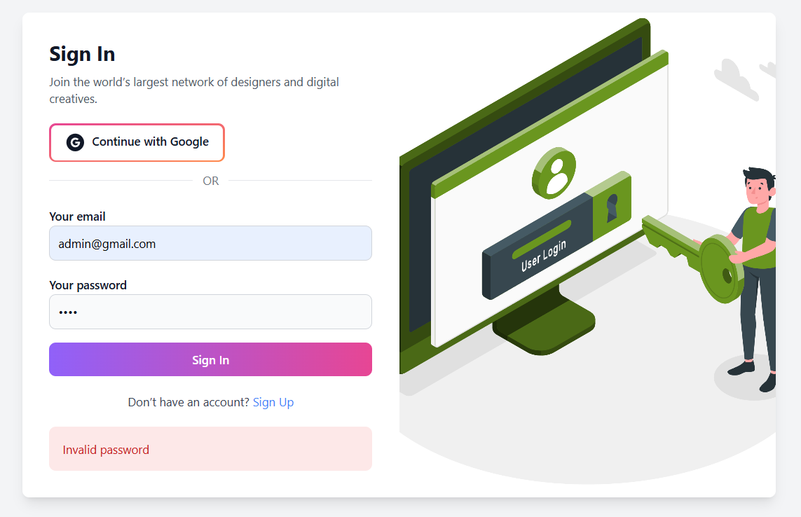
Fig.4.1.3.1 Password Authentication

4.2 System implementation
The system implementation phase involves deploying the Blog Website into a live environment, making it accessible to users and administrators.
4.2.1 System Maintenance
Post-deployment, continuous monitoring and maintenance are required to ensure smooth operation. The maintenance process includes:
- Bug Fixes and Updates: Identifying and resolving issues encountered after deployment.
- Performance Enhancements: Improving response time and operational efficiency based on user feedback.
- Security Patches: Applying regular updates to protect against emerging security threats.
- Feature Upgrades: Adding new functionalities, such as enhanced admin tools or user experience improvements, to keep the website engaging and efficient.
By following a well-structured testing and implementation approach, the Blog Website ensures a secure, user-friendly, and robust platform for administrators and users alike.

5 CONCLUSIONS
The Blog Website successfully delivers a comprehensive blogging platform, integrating modern web technologies for an engaging and efficient user experience. By leveraging the MERN stack, the system ensures seamless post creation, content management, comment moderation, and administrative oversight. The platform enhances the blogging process by offering secure authentication, responsive design, and efficient user interaction features.
The project effectively addresses the challenges of traditional blogging platforms by providing a unified, user-friendly solution with robust backend support. Rigorous system testing and continuous maintenance ensure stability, security, and scalability, making the Blog Website a reliable platform for users and administrators alike.
5.1 Directions for future enhancements references
While the current version of the Blog Website meets essential blogging needs, future enhancements could further improve functionality and user experience. Potential upgrades include:
- AI-Based Content Recommendations: Implementing AI to analyse user preferences and suggest personalized blog posts.
- Advanced Comment Moderation Tools: Adding AI-powered tools to filter spam and inappropriate comments automatically.
- Real-Time Chat Support: Integrating a chatbot or live assistance system to address user queries instantly.
- Multi-Language Support: Expanding language options to make the platform accessible to a global audience.
- Offline Content Access: Allowing users to save blog posts for offline reading.
- Interactive Media Integration: Incorporating features like embedded videos or interactive graphics to enhance content presentation.

These enhancements would further elevate the blog website’s usability, ensuring a dynamic, engaging, and user-focused blogging experience.

6.BIBLIOGRAPHY
Book References
1."Full-Stack React and Node" – David Choi
2. "MongoDB: The Definitive Guide" – Shannon Bradshaw, Eoin Brazil, Kristina Chodorow
3. "Node.js Design Patterns" – Mario Casciaro, Luciano Mammino
4. "JavaScript: The Good Parts" – Douglas Crockford
5. "Software Engineering: A Practitioner’s Approach" – Roger S. Pressman
6. "Web Development with Node and Express" – Ethan Brown
Bibliography
• MongoDB Official Documentation (https://www.mongodb.com/docs/)
• React.js Official Documentation (https://react.dev/)
• Node.js Official Documentation (https://nodejs.org/en/docs)
• Express.js Official Guide (https://expressjs.com/)
• GitHub Repositories and Open-Source Contributions

ANNEXURE-A- Output design
Home Page
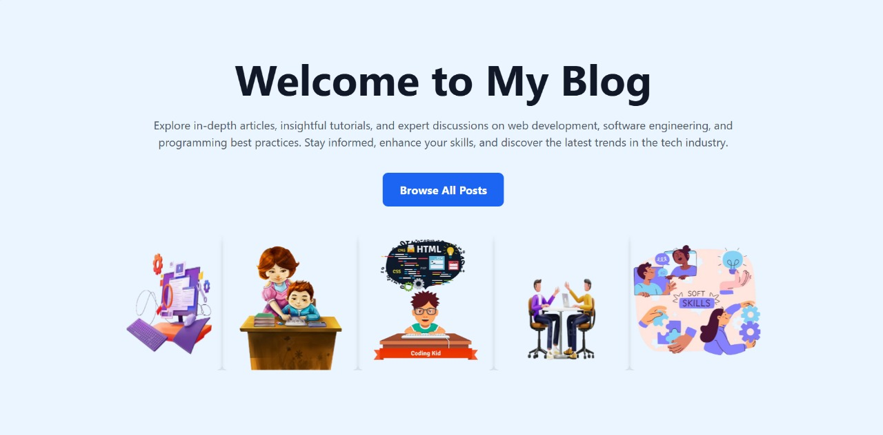
Welcome Page

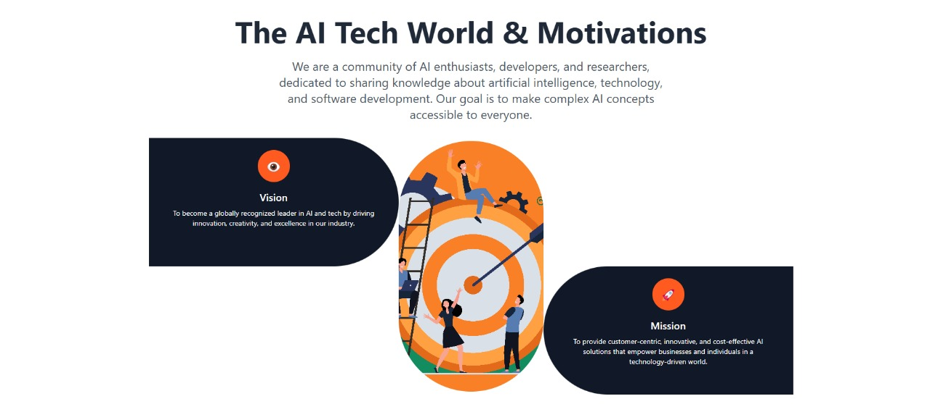
Mission And Vision
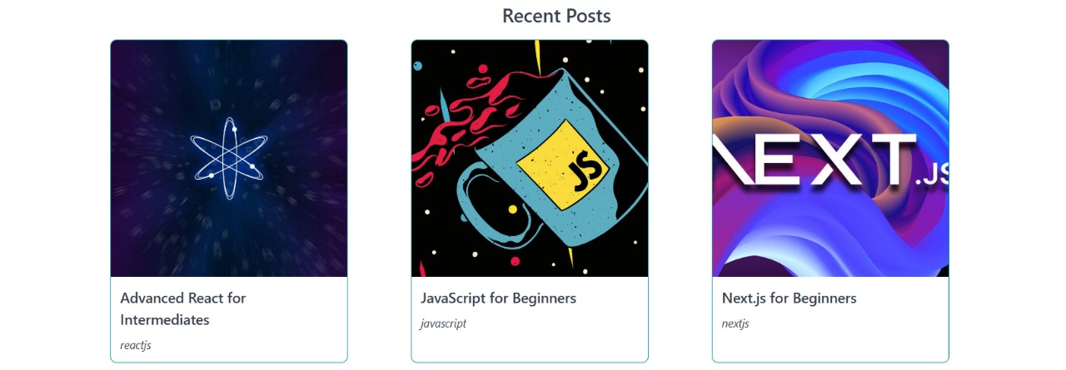
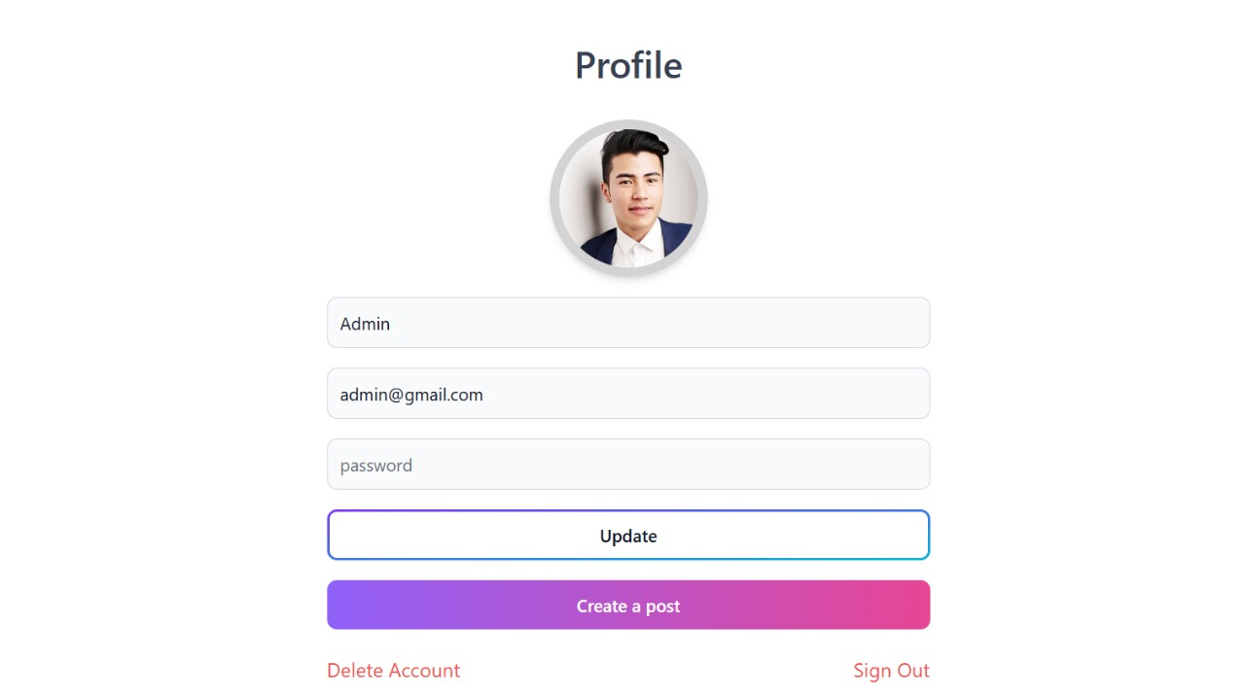
Blogs or Posts

Profile Page

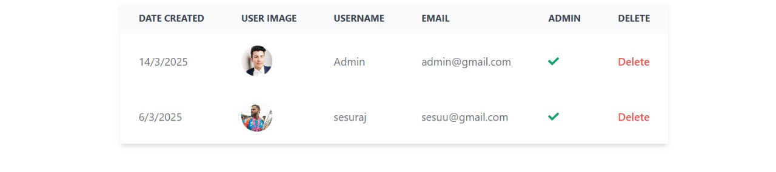
Admin Management Table
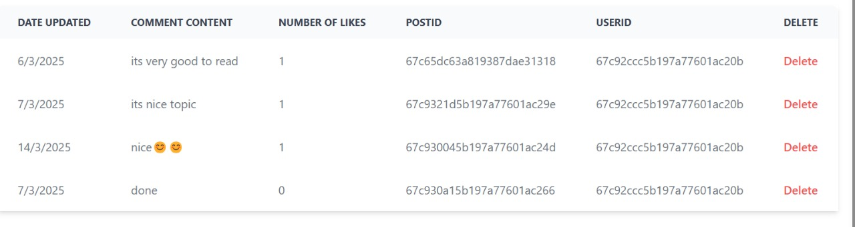
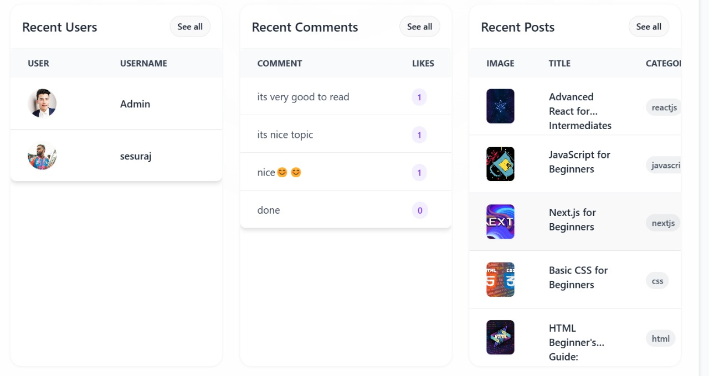
Comment Management Table
Admin Dashboard

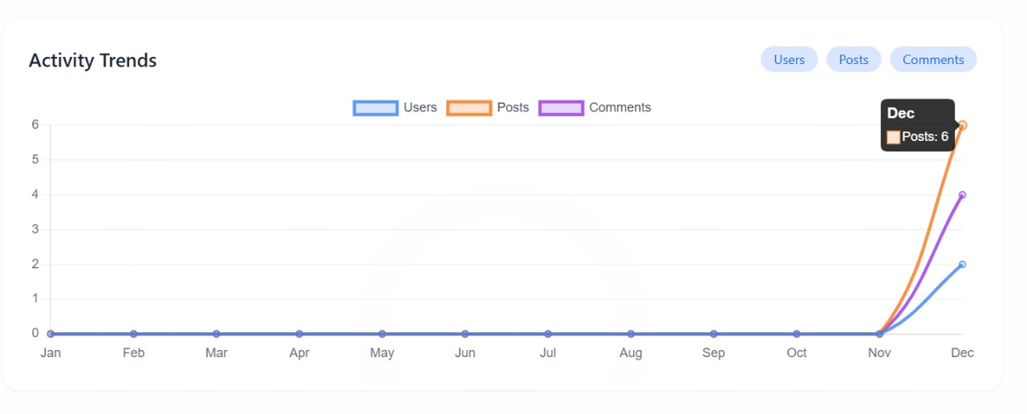
Plot For Users, Posts and Comments

ANNEXURE-B- Source Code
App.js
import { BrowserRouter, Routes, Route } from 'react-router-dom';
import Home from './pages/Home';
import About from './pages/About';
import SignIn from './pages/SignIn';
import Dashboard from './pages/Dashboard';
import Projects from './pages/Projects';
import SignUp from './pages/SignUp';
import Header from './components/Header';
import Footer from './components/Footer';
import PrivateRoute from './components/PrivateRoute';
import OnlyAdminPrivateRoute from './components/OnlyAdminPrivateRoute';
import CreatePost from './pages/CreatePost';
import UpdatePost from './pages/UpdatePost';
import PostPage from './pages/PostPage';
import ScrollToTop from './components/ScrollToTop';
import Search from './pages/Search';
export default function App() {
return (
<BrowserRouter>
<ScrollToTop />
<Header />
<Routes>
<Route path='/' element={<Home />} />
<Route path='/about' element={<About />} />
<Route path='/sign-in' element={<SignIn />} />
<Route path='/sign-up' element={<SignUp />} />
<Route path='/search' element={<Search />} />
<Route element={<PrivateRoute />}>
<Route path='/dashboard' element={<Dashboard />} />
</Route>
<Route element={<OnlyAdminPrivateRoute />}>
<Route path='/create-post' element={<CreatePost />} />
<Route path='/update-post/:postId' element={<UpdatePost />} />
</Route>
<Route path='/projects' element={<Projects />} />
<Route path='/post/:postSlug' element={<PostPage />} />
</Routes>
<Footer />
</BrowserRouter>
);
}
Signin.jsx
import { Alert, Button, Label, Spinner, TextInput } from 'flowbite-react';
import { useState } from 'react';
import { Link, useNavigate } from 'react-router-dom';
import { useDispatch, useSelector } from 'react-redux';
import { signInStart, signInSuccess, signInFailure } from '../redux/user/userSlice';
import OAuth from '../components/OAuth';
import loginImage from '../assets/hi2.png';
export default function SignIn() {
const [formData, setFormData] = useState({});
const { loading, error: errorMessage } = useSelector((state) => state.user);
const dispatch = useDispatch();
const navigate = useNavigate();
const handleChange = (e) => {
setFormData({ ...formData, [e.target.id]: e.target.value.trim() });
};
const handleSubmit = async (e) => {
e.preventDefault();
if (!formData.email || !formData.password) {
return dispatch(signInFailure('Please fill all the fields'));
}
try {
dispatch(signInStart());
const res = await fetch('/api/auth/signin', {
method: 'POST',
headers: { 'Content-Type': 'application/json' },
body: JSON.stringify(formData),
});
const data = await res.json();
if (data.success === false) {
dispatch(signInFailure(data.message));
}
if (res.ok) {
dispatch(signInSuccess(data));
navigate('/');
}
} catch (error) {
dispatch(signInFailure(error.message));
}
};
return (
<div className='min-h-screen flex items-center justify-center bg-gray-100 p-5'>
<div className='bg-white rounded-lg shadow-lg max-w-4xl w-full grid grid-cols-1 md:grid-cols-2'>
{/* Left Section */}
<div className='p-8 flex flex-col justify-center '>
<h2 className='text-2xl font-bold text-gray-900 '>Sign In</h2>
<p className='text-sm text-gray-600 mt-2'>Join the world’s largest network of designers and digital creatives.</p>
<div className='mt-5 items-center' >
<OAuth />
</div>
<div className='mt-3 flex items-center justify-center text-gray-500'>
<span className='w-full border-b ite'></span>
<span className='px-3 text-sm'>OR</span>
<span className='w-full border-b'></span>
</div>
<form className='flex flex-col gap-4 mt-5' onSubmit={handleSubmit}>
<div>
<Label value='Your email' />
<TextInput type='email' placeholder='name@company.com' id='email' onChange={handleChange} />
</div>
<div>
<Label value='Your password' />
<TextInput type='password' placeholder='' id='password' onChange={handleChange} />
</div>
<Button gradientDuoTone='purpleToPink' type='submit' disabled={loading}>
{loading ? <><Spinner size='sm' /><span className='pl-3'>Loading...</span></> : 'Sign In'}
</Button>
</form>
<div className='text-sm mt-5 flex justify-center '>
<span>Don’t have an account?</span>
<Link to='/sign-up' className='text-blue-500 pl-1'>Sign Up</Link>
</div>
{errorMessage && <Alert className='mt-5' color='failure'>{errorMessage}</Alert>}
</div>

{/* Right Section - Image */}
<div className='hidden md:block'>
<img src={loginImage} alt='Sign In' className='w-full h-full object-cover rounded-r-lg' />
</div>
</div>
</div>
);
}
OAuth.jsx
import { Button } from 'flowbite-react';
import { AiFillGoogleCircle } from 'react-icons/ai';
import { GoogleAuthProvider, signInWithPopup, getAuth } from 'firebase/auth';
import { app } from '../firebase';
import { useDispatch } from 'react-redux';
import { signInSuccess } from '../redux/user/userSlice';
import { useNavigate } from 'react-router-dom';
export default function OAuth() {
const auth = getAuth(app)
const dispatch = useDispatch()
const navigate = useNavigate()
const handleGoogleClick = async () =>{
const provider = new GoogleAuthProvider()
provider.setCustomParameters({ prompt: 'select_account' })
try {
const resultsFromGoogle = await signInWithPopup(auth, provider)
const res = await fetch('/api/auth/google', {
method: 'POST',
headers: { 'Content-Type': 'application/json' },
body: JSON.stringify({
name: resultsFromGoogle.user.displayName,
email: resultsFromGoogle.user.email,
googlePhotoUrl: resultsFromGoogle.user.photoURL,}),
})
const data = await res.json()
if (res.ok){
dispatch(signInSuccess(data))
navigate('/')
}
} catch (error) {
console.log(error);}}
return (
<Button type='button' gradientDuoTone='pinkToOrange' outline onClick={handleGoogleClick}>
<AiFillGoogleCircle className='w-6 h-6 mr-2'/>
Continue with Google
</Button>
)
}

Server.js
import express from 'express';
import mongoose from 'mongoose';
import dotenv from 'dotenv';
import userRoutes from './routes/user.route.js';
import authRoutes from './routes/auth.route.js';
import postRoutes from './routes/post.route.js';
import commentRoutes from './routes/comment.route.js';
import cookieParser from 'cookie-parser';
import path from 'path';
dotenv.config();
const PORT = process.env.PORT || 3000;
const DB_URL = process.env.MONGO;
mongoose
.connect(DB_URL)
.then(() => {
console.log('MongoDb is connected');})
.catch((err) => {
console.log(err);});
const __dirname = path.resolve();
const app = express();
app.use(express.json());
app.use(cookieParser());

app.listen(PORT, () => {
console.log(Server is running on port ${PORT});});
app.use('/api/user', userRoutes);
app.use('/api/auth', authRoutes);
app.use('/api/post', postRoutes);
app.use('/api/comment', commentRoutes);
app.use(express.static(path.join(__dirname, '/client/dist')));
app.get('*', (req, res) => {
res.sendFile(path.join(__dirname, 'client', 'dist', 'index.html'));
});
app.use((err, req, res, next) => {
const statusCode = err.statusCode || 500;
const message = err.message || 'Internal Server Error';
res.status(statusCode).json({
success: false,
statusCode,
message,
});
});

