**Exercise 1**

**A university DB contains information about professors (identified by SIN) and**

**courses (identified by course ID). Professors teach courses; each of the following**

**situations concerns the Teaches relationship set.**

**List all candidate keys of the Teaches relationship set.**

**a.Professors can teach the same course in several semesters, and each offering must be recorded.**

**b. Professors can teach the same course in several semesters, but only the most recent such**

**offering needs to be records. Assume the above Situation (b) applies in all subsequent situations.**

**List all the keys possible in each of the following situations.**

**a. Every professor teaches a course, and every course is taught by some professor.**

**b. Every professor teaches exactly one course, and every course is taught by exactly one professor.**

**Answer**

create table Professor(sin int primary key, p_name varchar(25),p_age int,p_speciality varchar(25));

create table course(cid int primary key, c_name varchar(25),c_fees int,c_duration varchar(25),cin int,constraint prof_fk foreign key (cin)references professor(cin));

create table semester(sid int primary key, s_number varchar(25),sin int,constraint profe_fk foreign key (sin)references professor(sin), cid int ,constraint course_fk foreign key (cid)references course(cid));

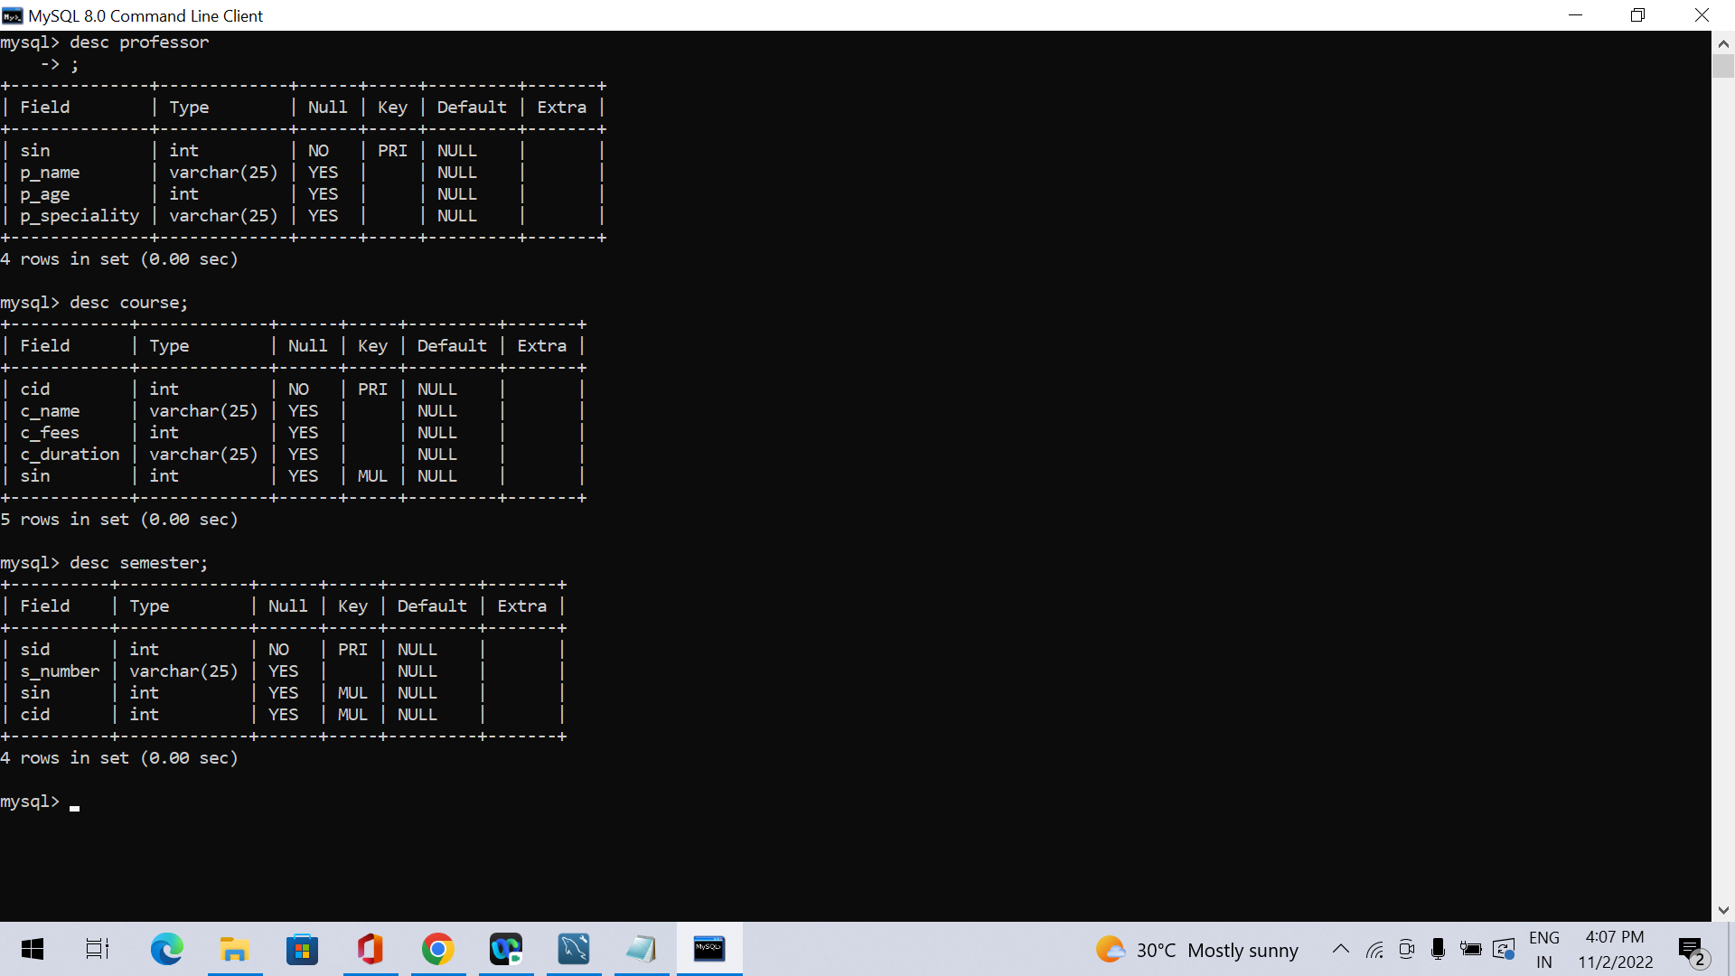

**a.Professors can teach the same course in several semesters, and each offering must be recorded.**

There is a single candidate key of the teaches relationship:

candidate keys..{sin,cid,sid}

**b.Professors can teach the same course in several semesters, but only the most recent such offering needs to be records**

Semester is attribute of teaches .The key of teaches is {SIN, CID}

**a. Every professor teaches a course, and every course is taught by some professor.**

it is m-to-m relationship, the candidate key remains {SIN, CID}.

**b. Every professor teaches exactly one course, and every course is taught by exactly one professor**

This time the relationship is 1-to-1. There are now two candidate keys: either {SIN} or {CID}.