Applied AI Strategies for Learning
Exercise 2.A Improving Weak Prompts

Weak prompts:
A) Explain regression
B) Help me understand SQL
C) Create a datasheet

Improved Prompts
- Explain regression in simple terms for a complete beginner. Start with a basic definition, then give a real-world example
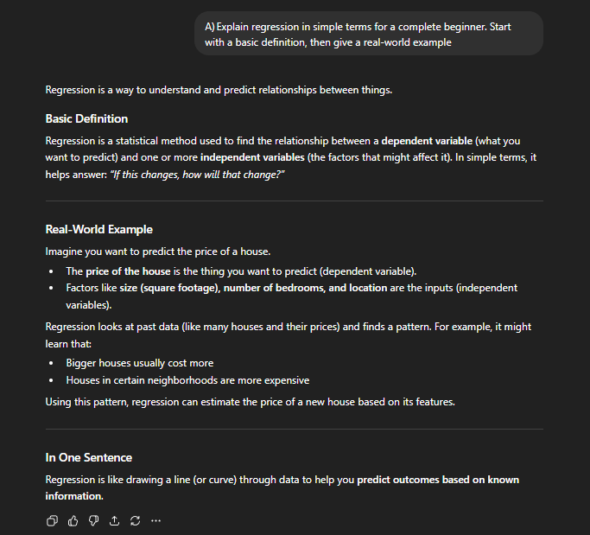
- This prompt is better because it allows for better understanding, and gives real world examples
- Teach me the basics of SQL as if I have no prior experience. Explain what SQL is used for, introduce key concepts (tables, rows, columns), and show simple examples of common commands like SELECT, INSERT, and WHERE. Include short explanations for each example
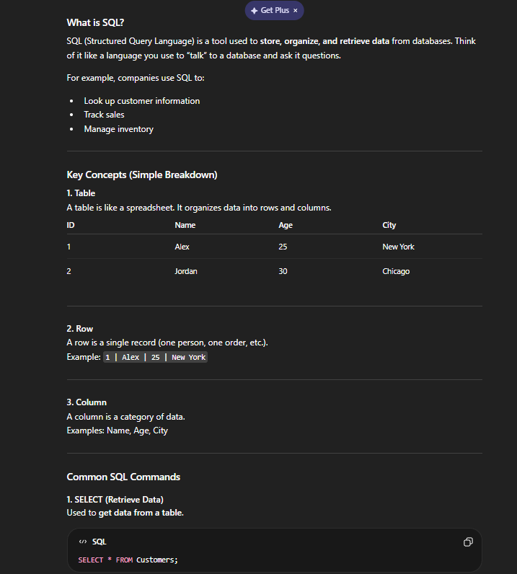
- This prompt is better because it is clear and asks for specific data and the format in which it is presented.
- Create a simple, beginner-friendly dataset in table format with 10–12 rows. Include clear column names and realistic sample data. Then briefly explain what each column represents and how the dataset could be used.
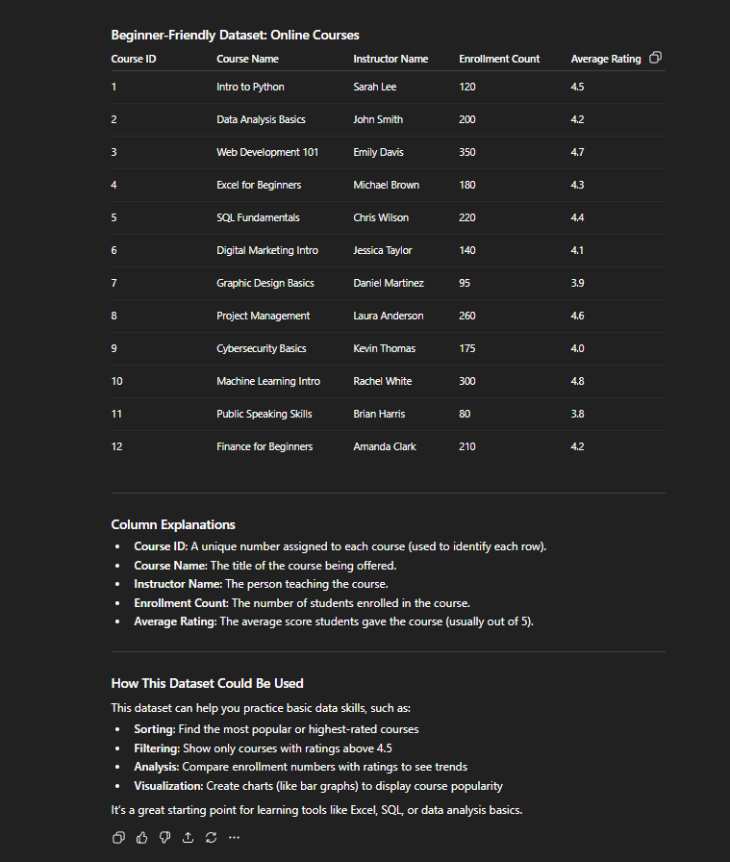
- This prompt is better because it had clear instructions and asked for a specific format in which the data is explained based on the level of the reader.

