MechaCarChallenge

## Deliverable 1

## Warning: package 'dplyr' was built under R version 4.1.1

##   
## Attaching package: 'dplyr'

## The following objects are masked from 'package:stats':  
##   
## filter, lag

## The following objects are masked from 'package:base':  
##   
## intersect, setdiff, setequal, union

#Multiple regression

##   
## Call:  
## lm(formula = mpg ~ vehicle_length + vehicle_weight + spoiler_angle +   
## ground_clearance + AWD, data = mecha_table)  
##   
## Coefficients:  
## (Intercept) vehicle_length vehicle_weight spoiler_angle   
## -1.040e+02 6.267e+00 1.245e-03 6.877e-02   
## ground_clearance AWD   
## 3.546e+00 -3.411e+00

##   
## Call:  
## lm(formula = mpg ~ vehicle_length + vehicle_weight + spoiler_angle +   
## ground_clearance + AWD, data = mecha_table)  
##   
## Residuals:  
## Min 1Q Median 3Q Max   
## -19.4701 -4.4994 -0.0692 5.4433 18.5849   
##   
## Coefficients:  
## Estimate Std. Error t value Pr(>|t|)   
## (Intercept) -1.040e+02 1.585e+01 -6.559 5.08e-08 ***  
## vehicle_length 6.267e+00 6.553e-01 9.563 2.60e-12 ***  
## vehicle_weight 1.245e-03 6.890e-04 1.807 0.0776 .   
## spoiler_angle 6.877e-02 6.653e-02 1.034 0.3069   
## ground_clearance 3.546e+00 5.412e-01 6.551 5.21e-08 ***  
## AWD -3.411e+00 2.535e+00 -1.346 0.1852   
## ---  
## Signif. codes: 0 '***' 0.001 '**' 0.01 '*' 0.05 '.' 0.1 ' ' 1  
##   
## Residual standard error: 8.774 on 44 degrees of freedom  
## Multiple R-squared: 0.7149, Adjusted R-squared: 0.6825   
## F-statistic: 22.07 on 5 and 44 DF, p-value: 5.35e-11

#Tests for normality and look at correlations for significant variables

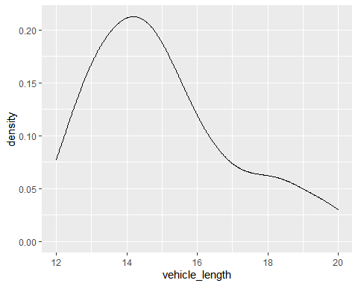

##   
## Shapiro-Wilk normality test  
##   
## data: mecha_table$vehicle_length  
## W = 0.93421, p-value = 0.008003

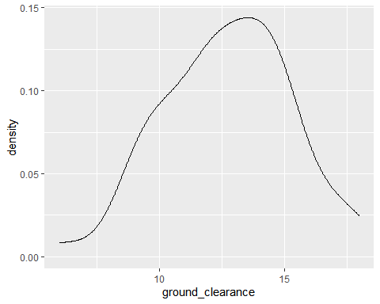

##   
## Shapiro-Wilk normality test  
##   
## data: mecha_table$ground_clearance  
## W = 0.98678, p-value = 0.8446

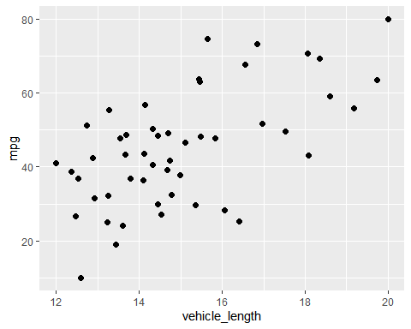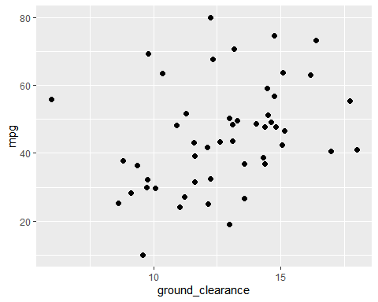 # Deliverable 2

## Mean Median Variance SD  
## 1 1498.78 1500 62.29356 7.892627

## # A tibble: 3 x 5  
## Manufacturing_Lot Mean Median Variance SD  
## <chr> <dbl> <dbl> <dbl> <dbl>  
## 1 Lot1 1500 1500 0.980 0.990  
## 2 Lot2 1500. 1500 7.47 2.73   
## 3 Lot3 1496. 1498. 170. 13.0

# Deliverable 3

##   
## One Sample t-test  
##   
## data: coil_table$PSI  
## t = -1.8931, df = 149, p-value = 0.06028  
## alternative hypothesis: true mean is not equal to 1500  
## 95 percent confidence interval:  
## 1497.507 1500.053  
## sample estimates:  
## mean of x   
## 1498.78

##   
## One Sample t-test  
##   
## data: lot1$PSI  
## t = 0, df = 49, p-value = 1  
## alternative hypothesis: true mean is not equal to 1500  
## 95 percent confidence interval:  
## 1499.719 1500.281  
## sample estimates:  
## mean of x   
## 1500

##   
## One Sample t-test  
##   
## data: lot2$PSI  
## t = 0.51745, df = 49, p-value = 0.6072  
## alternative hypothesis: true mean is not equal to 1500  
## 95 percent confidence interval:  
## 1499.423 1500.977  
## sample estimates:  
## mean of x   
## 1500.2

##   
## One Sample t-test  
##   
## data: lot3$PSI  
## t = -2.0916, df = 49, p-value = 0.04168  
## alternative hypothesis: true mean is not equal to 1500  
## 95 percent confidence interval:  
## 1492.431 1499.849  
## sample estimates:  
## mean of x   
## 1496.14