**MongoDB Sharding Setup on Windows (Real-Time Example)**

IN CMD:

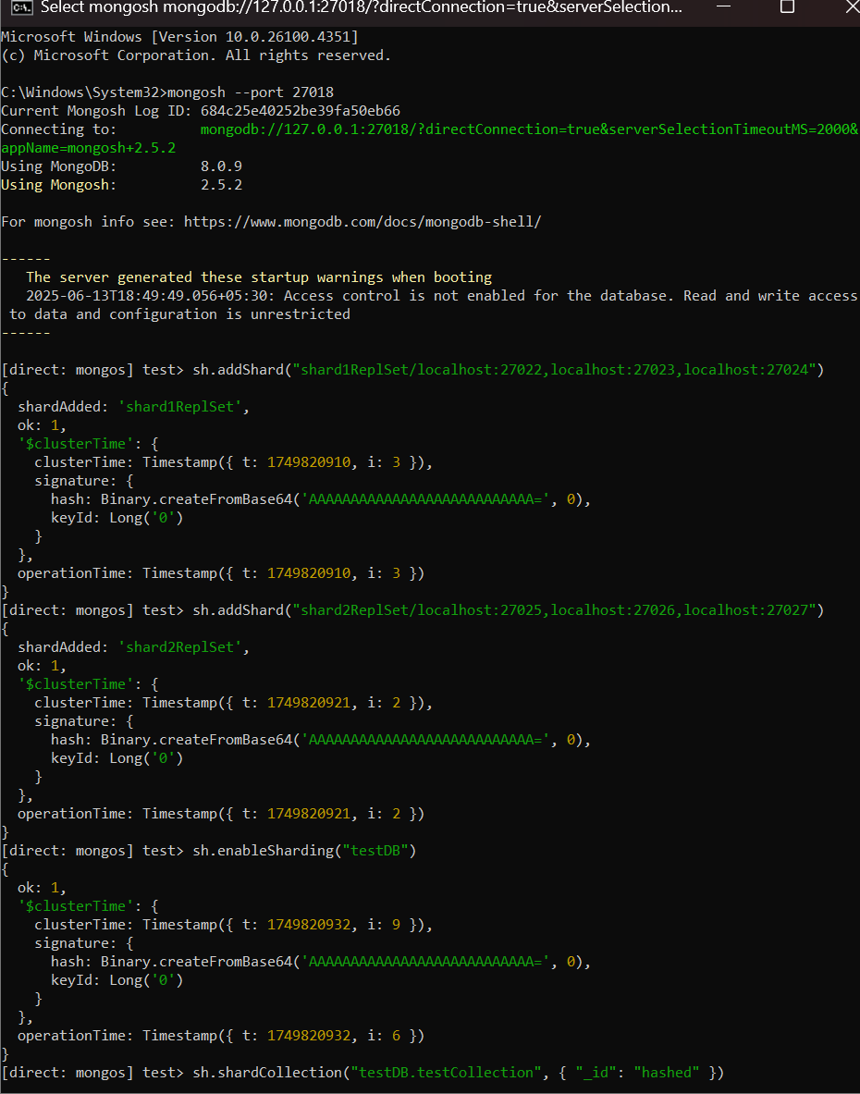

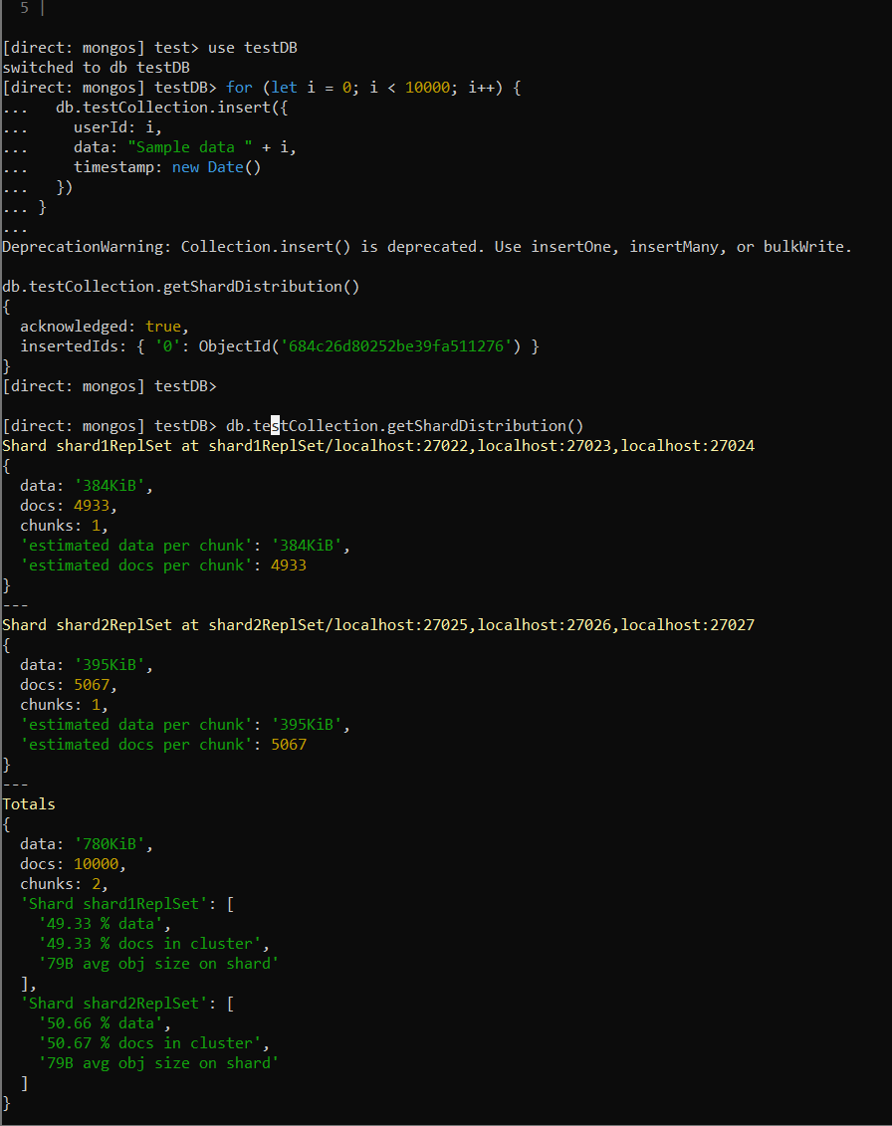

DATA IS SHARING PROPERLY BETWEEN TWO SHARDS:

THIS IS IN MONGODB:

