GIT REPO:

<https://github.com/PGoyal-SmartHelio/Microservices-Task>

## Deployment steps

Below are the steps to be followed to deploy complete application with microservices

1. Create an .env file in the root directory (same as in docker-compose config), referring to .env.sample for available variables.

2. Run below command to validate if the docker config is correct:

`docker-compose config`

3. Run below command to start containerization & running process:

`docker-compose up -d --env-file .env`

SCREENSHOTS:

Initial setup for deployment, with all file changes:

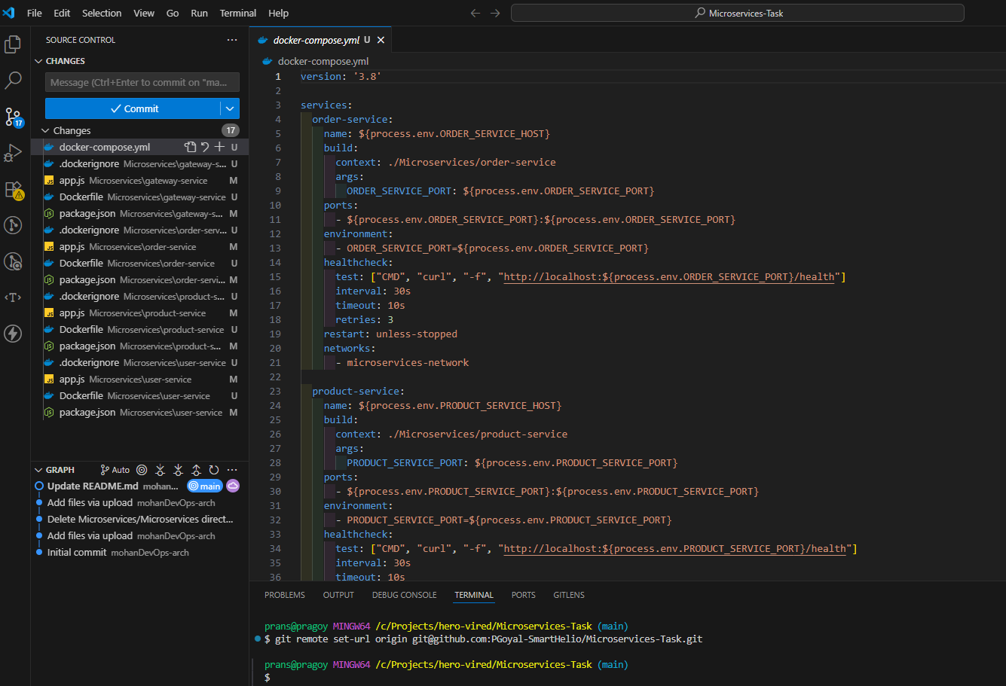

Errors encountered during run

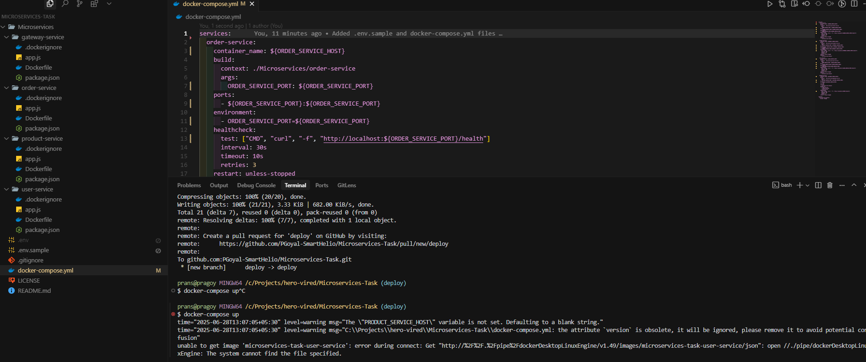

Validating docker-compose pipeline after encountering & fixing all issues:

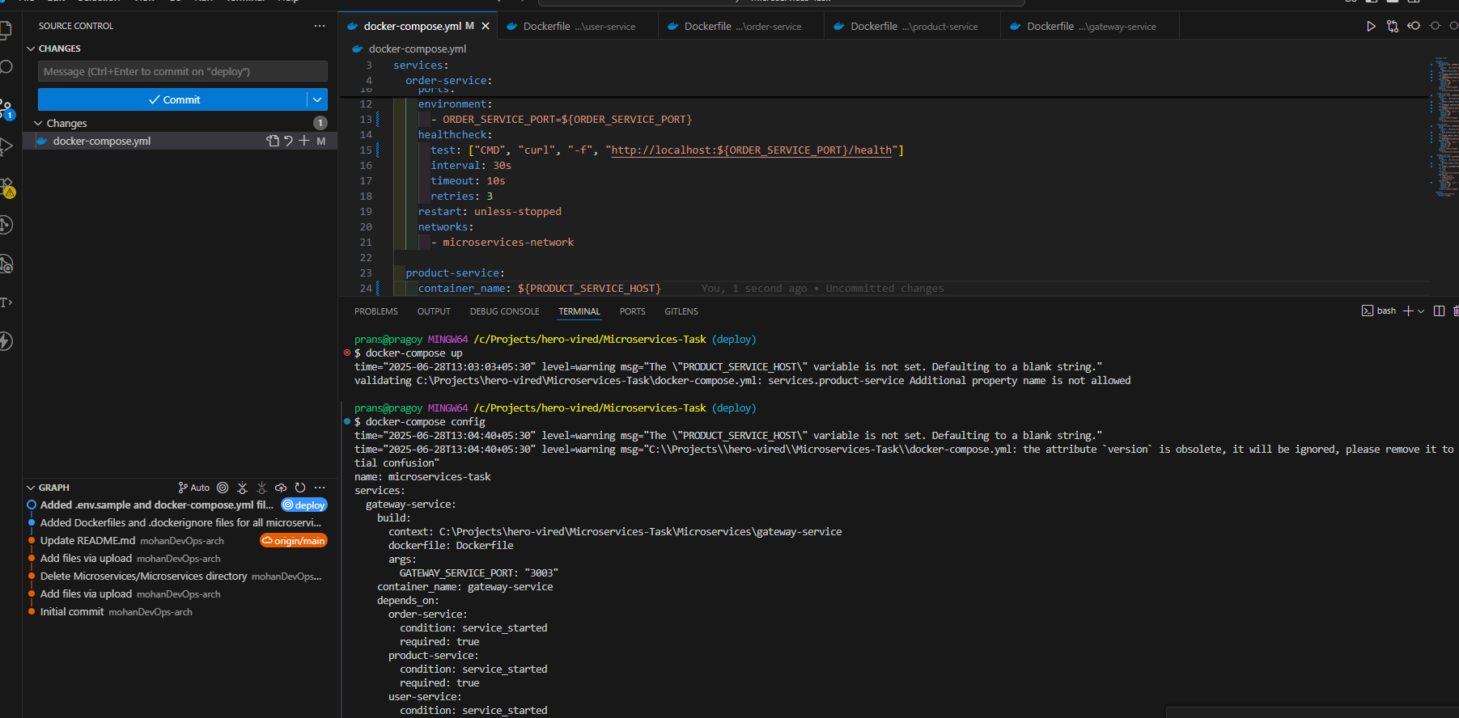

Successful process initiation

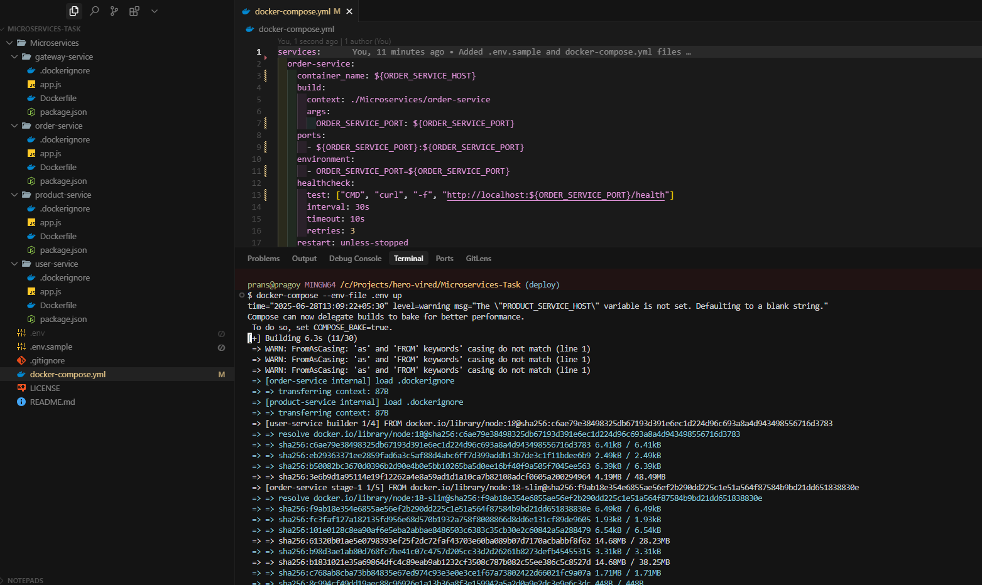

Running Containers:

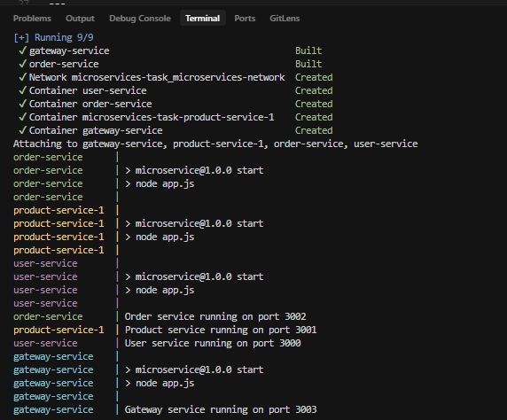

Running Containers In docker desktop with open ports:

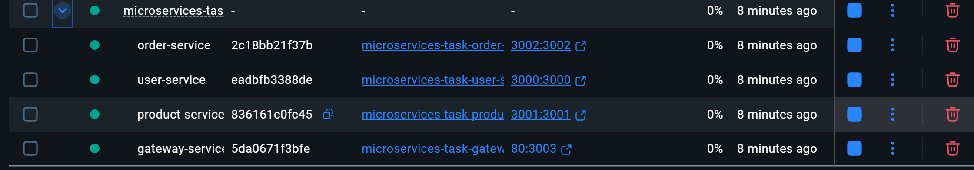

RUNNING SERVICES:

User service:

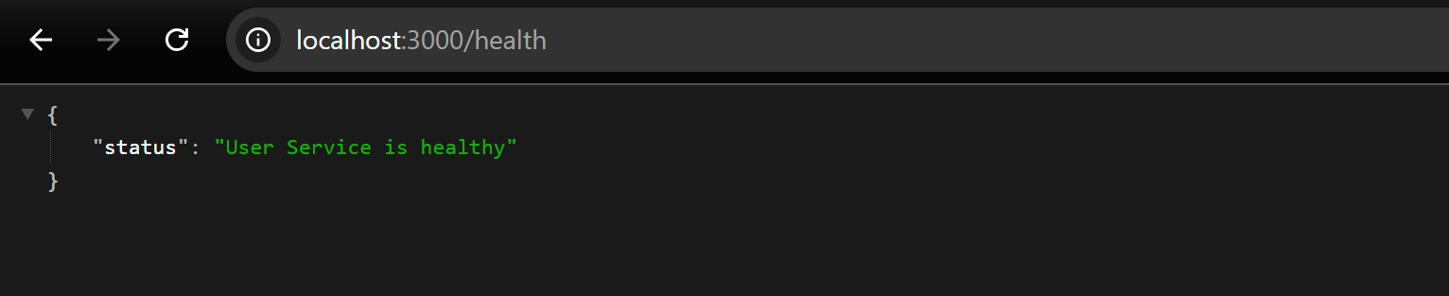

Product service:

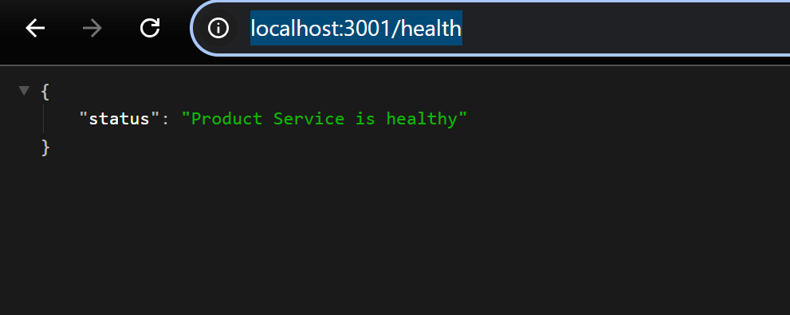

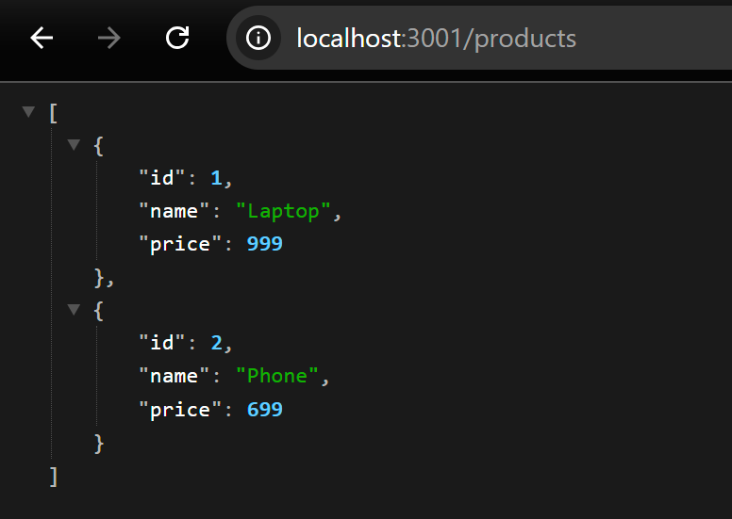

Order service:

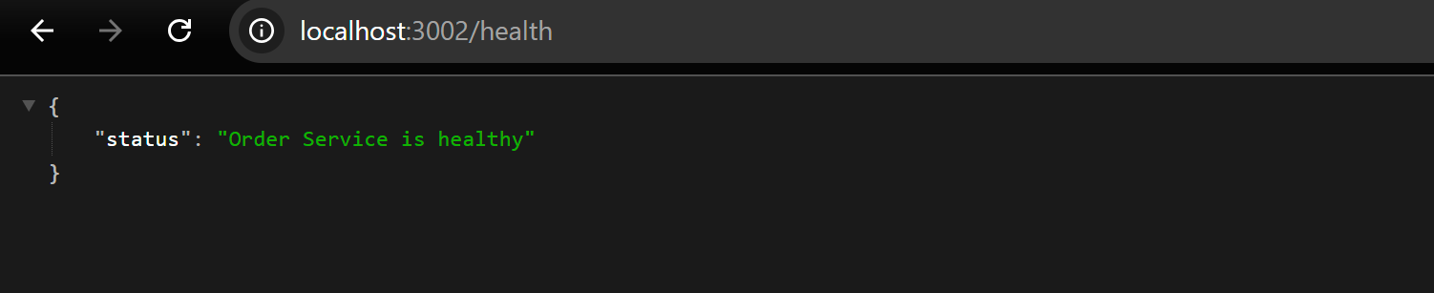

Gateway service:

