A Pragmatic, Parallel-Arm, Randomised Trial on the Effects of Two Repeated Sprint Training Protocols on Fitness Outcomes in Semi-Professional Male Soccer Players: Preliminary Report.

Palash Gupta¹, Anthony P. Turner¹, Shaun M. Phillips¹, Matthew Weston^{1,2}*
¹Institute for Sport, Physical Education and Health Sciences, University of Edinburgh, Edinburgh, Scotland
²Institute of Sport, Manchester Metropolitan University, Manchester, UK

* Corresponding Author
E-mail: Matthew.Weston@ed.ac.uk

ORCiD:
PG: https://orcid.org/0009-0000-0172-4009
AT: https://orcid.org/0000-0003-1202-6649
SP: https://orcid.org/0000-0002-7947-3403
MW: https://orcid.org/0000-0002-9531-3004

Abstract

Repeated sprint training is an effective training strategy, yet the impact of manipulating rest intervals is equivocal. We explored the effects of two six week, twice-weekly, time and volume matched repeated-sprint protocols with varying within- and between-set rest intervals on fitness outcomes in male soccer players. Twenty-three semi-professional soccer players were randomly allocated to Group 1 (10 sec within-set, 80 sec between-set rest; n = 12) or Group 2 (20 sec within-set, 40-54 sec between-set rest; n = 11). Both groups continued regular soccer training, gym-based training and matches with all sessions monitored using differential ratings of perceived exertion (dRPE). Fitness outcomes were: 10 m, 20 m, 40 m sprint times, maximum velocity (VMax), countermovement jump (CMJ), and maximal aerobic speed (MAS). A linear model examined the fixed effects of group, session type, dRPE mode, and session number on dRPE. Analysis of covariance compared between-group changes in fitness measures. Fixed effects of group and training mode on dRPE were significant with effects ranging -4.9 to 4.8 AU. Between-group changes in all fitness measures non-significant at 0.00 (95% Confidence Interval -0.03, 0.04), 0.03 (-0.03, 0.10), and 0.05 (-0.02, 0.12) seconds for 10-40 m sprint times, 0.09 (-0.30, 0.10) m.s⁻¹ for VMax, 0.9 (-2.3, 0.5) cm for CMJ, and 0.05 (-0.05, 0.16) m.s⁻¹ for MAS. These findings suggest little impact of manipulations in within- and between-set rest on between-group fitness changes following a 6-week repeated-sprint intervention. Given the limited sample size, our results must be interpreted as preliminary, requiring further confirmation.

Keywords: Football, Fitness, RPE, Sprinting, Jumping, Interval Training,

1.0 Introduction
1.1 Background
Semi-professional soccer players cover ~10 km per match, with high-speed running and sprinting constituting ~5% and ~3% of the total distance, respectively (Castillo-Rodríguez et al., 2020). Semi-professional players also perform repeated high-intensity accelerations (1.78 ± 0.38 per minute, at > (2 m.s⁻²)) and decelerations (1.80 ± 0.40 per minute, at < (- 2 m.s⁻²)) per match (Ortigosa-Melero et al., 2022). While the frequency of high-intensity actions in soccer is relatively low, importance is seen via 83% of goals being preceded by short sprints or jumps (Faude et al., 2012).
Along with match demands, players often need to manage congested match schedules, with the majority of training time dedicated to technical and tactical training; therefore, prescribing multiple training modalities can be challenging for practitioners due to the limited time available for fitness sessions. Considering these programming constraints, repeated sprint training is a time-efficient strategy for improving multiple fitness components. Meta-analyses (Taylor et al., 2015; Thurlow et al., 2024) show the multi-component benefits of short-term repeated sprint training with training-induced improvements in sprint speed, explosive leg power, and high-intensity intermittent running performance - all of which are integral to soccer. These findings suggest repeated sprint training could replace isolated training modalities (e.g., distinct speed, endurance, and power sessions) and coaches can, therefore, leverage repeated sprint training to develop fitness qualities in a single, streamlined protocol, especially when dedicated fitness training time is limited.
The most common repeated-sprint protocol is 6 × 30 m straight-line sprints with 20 s of within-set rest (Thurlow et al., 2023). The prescription of shorter (≤ 20 sec) and longer (≥ 30 seconds) within-set rest periods is effective, but rest manipulation elicits specific acute responses (Thurlow et al., 2023) that may prioritise the development of certain fitness qualities over others (Thurlow et al., 2025). For example, longer rest durations could reduce metabolic demand and limit aerobic adaptation, whereas shorter rest duration could induce fatigue, that limits neuromuscular adaptations (Thurlow et al., 2023). Studies investigating the effects of varying within-set rest have chosen broad work:rest ratios (1:1 vs 1:6) or (1:3 vs 1:6) but with no standardised prescription for between-set rest, or sprint time and volume matching (Iaia et al., 2017; Saraslanidis et al., 2011). Consequently, there is currently little consensus regarding the impact of this programming manipulation. Indeed, the most comprehensive examination yet on the effectiveness of repeated-sprint training did not include within- and between-set rest times in the moderator analysis (Thurlow et al., 2024).
Reducing within-set rest from 20 to 10 seconds is noteworthy, equating to a 3% sprint decrement via greater fatigue and slower sprint times (Thurlow et al., 2025). Despite offering coaches programming flexibility and notwithstanding the multi-component promise of repeated-sprint training (Taylor et al., 2016) such a decrement has potential to cause disparity between the prescribed training dose and the training response which could result players failing to meet the aims of their repeated-sprint training sessions. The potential impact of manipulating repeated sprint within- and between-set rest intervals therefore warrants further examination.
1.3 Aim
Our study aimed to examine the effects of two time and volume-matched repeated-sprint protocols with differing within- and between-set rest intervals on the fitness male semi-professional players.
2.0 Methods
2.1 Protocol Registration
While our protocol was not publicly registered, we have provided the journal with verifiable documentation, including the ethics committee application and internal academic correspondence, confirming that the current protocol is consistent with the version established prior to the commencement of data collection. The only deviation to the original protocol or planned analysis was the inclusion of a 10 m sprint test which was an extension of the originally planned 20 m and 40 m, measured as a split time on the 40 m sprint.
2.2 Trial Design and Setting
A parallel-arm, randomised group trial was used to examine the effects of two six-week repeated sprint training protocols with different within- and between-set rest intervals on fitness outcomes relevant to soccer. The study was conducted during the soccer pre-season, and all fitness tests were scheduled at the same time of day (5:00 – 9:00 PM) under similar environmental conditions (18.2 °C WBGT, 7.3 km.h⁻¹ Wind Speed, 55.2% Relative Humidity) (Kestrel 5400 (WBGT, HST, and WM), Kestrel Instruments) on the same artificial turf soccer pitch that the players habitually trained on. During the study, the first author of the study, a certified strength and conditioning specialist with the National Strength and Conditioning Association (NSCA), provided both groups with a standardised gym-based training programme, and both groups maintained their regular soccer-specific training. The design, conduct and reporting of this trial adheres to the SPIRIT checklist (Chan et al., 2025) with the exercise interventions adhering to the CERT (Slade et al., 2016)
2.3 Participants, Eligibility Criteria and Ethics
A soccer team (n = 30 players) competing in the Scottish Lowland Semi-Professional League and the top league of British Universities and Colleges Sport was invited to participate in this study. Eligibility criteria required participants to be injury-free, have a soccer training history of three years and have trained consistently for at least six months before study entry. Upon initial assessment, twenty-six participants satisfied the inclusion criteria (n = 26, Age: 22.8 ± 4.2 years, Weight: 75.9 ± 7.5 kg, Height: 181.1 ± 7.2 cm) (mean ± SD); however, those unavailable at the intervention start date (n = 3) were excluded. Players are classified as Tier 2 on the McKay classification framework (McKay et al., 2022), and Figure 2 shows the participant study flow. Participants were informed of the study procedures using participant information sheets and signed an electronic informed consent form before commencing the study. The University of Edinburgh Institutional Review Board approved the study protocol.
2.4 Intervention
Participants performed soccer training as a squad twice a week (~15 min of technical drills, ~15 min of physical conditioning, ~30 min of tactical/ possession drills, and ~30 min of various-sided games - intensive themed session on Monday and extensive themed session on Thursday), gym-based training (~60 min per session) also twice weekly but on self-selected days and played matches on weekends. During the 6-week intervention period, the regular physical conditioning performed on Mondays and Thursdays before the soccer training (i.e., tactical drills and sided games) was replaced by the repeated-sprint training protocols, ensuring 72 hours recovery between sessions. The rest of the weekly schedule routine was kept the same as before the study so that overall training exposure was consistent across the two experimental groups apart from the prescribed repeated sprint training intervention. When a participant was unable to attend a session, that session was rescheduled with the objective of completing it within the same week. Overall, 10 individual sessions, including four repeated-sprint sessions, were rearranged across the intervention.
The two repeated-sprint training protocols (Table 1) were time and volume matched to ensure ~4-min total recovery. Participants were supervised through a 10-minute dynamic warm-up using the “Raise, Activate, Mobilise, Potentiate” protocol (Haff & Triplett, 2015), which included ~3 min of continuous running (13 Shuttles, 50 meters, ~13 km.h⁻¹) (Shushan et al., 2024) and 5 min of lower-limb dynamic exercises (e.g., overhead walk on toes, walking hamstring stretches, walking linear and lateral lunges, walking hip openers, high knees, etc.). Players completed the warm-up with performed two progressive sprints of 35 m at 70% and 90% of their perceived maximal effort. Participants were encouraged by the first author of this study to exert maximum effort for each repetition across the intervention. All testing and training sessions occurred on the same artificial turf and were supervised by the first author and across the intervention the players completed 12 repeated-sprint training sessions, six matches, 12 gym-based sessions, and 12 soccer training sessions. Participants were instructed to maintain a standard diet throughout the intervention period and avoid alcohol and caffeine in the 12 hours preceding testing.
Table 1. Repeated-Sprint Training Protocols

Week | Sets x Reps | Sprint Distance | Group 1 |  | Group 2 |  | Time* | Volume*
 |  |  | Within-Repetition Rest | Between-Repetition Rest | Within-Repetition Rest | Between-Repetition Rest
1 | 4 x 3 | 35 m | 10 sec | 80 sec | 20 sec | 54 sec | 640 sec | 840 m
2 | 4 x 3 | 35 m | 10 sec | 80 sec | 20 sec | 54 sec | 640 sec | 840 m
3 | 4 x 3 | 35 m | 10 sec | 80 sec | 20 sec | 54 sec | 640 sec | 840 m
4 | 4 x 4 | 35 m | 10 sec | 80 sec | 20 sec | 40 sec | 720 sec | 1120 m
5 | 4 x 4 | 35 m | 10 sec | 80 sec | 20 sec | 40 sec | 720 sec | 1120 m
6 | 4 x 4 | 35 m | 10 sec | 80 sec | 20 sec | 40 sec | 720 sec | 1120 m
* Total values represent the weekly accumulation

2.5 Outcomes
All fitness tests were conducted within 10 days pre- and post-intervention and administered by the first author of this study who was not blinded to group allocation. On the first day of testing, body mass, stature, counter-movement jump height (CMJ), maximum velocity (VMax), and linear sprint time tests were performed with the maximal aerobic speed (MAS) measured on the second day when the investigator also explained the CR100 scale (centiMax® scale (CR100)) (Borg et al., 2010). Height and body mass were measured using a portable stadiometer (Seca Alpha model 213, Hamburg, Germany) and weighing scale (Seca 877 scales, Hamburg, Germany). Sprint times were measured using Electronic Timing Gates (Microgate srl, Bolzano, Italy) at 10 m splits. Participants were instructed to start with their dominant foot in a 2-point crouching staggered position on a point 0.5 m behind the timing gates before each effort, with a voluntary start of the sprint (Weakley et al., 2023). Timing gates were placed 0.75 m above the ground to ensure they captured trunk movement and avoided false signals through limb motion, between-trial recovery time was a passive three minutes, and the fastest sprint was retained for analysis. Maximum velocity was assessed using 10-Hz Global Positioning System (Polar Team Pro, Polar Electro, Kempele, Finland) (Roe et al., 2017). Assessing short sprint performance using timing gates and 10 Hz has consistently shown good reliability (Coefficient of Variation (CV) = 1 to 3%) (Weakley et al., 2023). Jump height was assessed by a CMJ, with hands placed on the hips, and measured via a dual force plate system (ForceDecks V2, Vald Performance, Brisbane, QLD, Australia). The impulse-momentum approach was used to calculate jump height while keeping time-to-take-off and counter-movement depth similar over multiple attempts. The best of three trials was recorded. Assessing jump height via force plates has consistently shown good reliability (CV = 3.1 to 3.5%) (Collings et al., 2024). Maximal aerobic speed was assessed via a 1600 m distance trial, with the speed assessed as per Bellenger et al. (2015). Set distance trials (1600 m to 2200 m) are reliable (CV = 1 – 3%) for calculating maximal aerobic speed (Bellenger et al., 2015). Players were already familiar with the fitness tests through their regular physical preparation program, so further test familiarisation was unnecessary.
2.6 Sample Size
2.6.1 Optimal Sample Size to Detect our Smallest Effect Size of Interest (SESOI)
Single studies are unlikely a good representation of population effect sizes, with effect sizes from a published meta-analysis a better approach at defining and justifying a SESOI (Abt et al., 2025). Given the typical between-study heterogeneity often observed in studies, meta-analysis estimates are not always accurate though and care should be taken when using such estimates in a power analysis (Lakens, 2022). A recent meta-analysis examining the effects of repeated-sprint training on physical fitness and physiological adaptation in athletes (Thurlow et al., 2024) was comparable in design, measures, and population (Lakens, 2022) with our study but the moderating effect of inter-repetition and inter-set rest duration was not reported. As such, we elected to use opinion seeking to define our SESOI (i.e., target difference) (Cook et al., 2018). Here, expert practitioner (n=30) opinion on the practically relevant changes in physical performance measures informed our target difference with 0.09 s (95% CI 0.04, 0.13), 0.21 s (95% CI 0.11, 0.32), 2.8 cm (95%CI 2.1, 3.4), and 164 m (95%CI 123, 206 m) for 5 m, 30 m, CMJ, and Yo-Yo Intermittent Recovery Test Level 1 (YYIR1) perceived as meaningful changes in fitness (Datson et al., 2021). While the physical domain of these four tests is consistent with the present study (i.e., sprint, jump, and aerobic performance), the only measure used in both studies was the CMJ. However, given the strong linear relationship for 10 m split times up to 40 m in soccer players (see Haugen et al. 2014), we derived target change times of 0.11 sec (10 m) 0.16 sec (20 m), and 0.26 sec (40 m) from linear regression modelling of the Datson et al. (2022) data. Five percent has been reported to be the typical training-induced change in maximal sprinting speed (Haugen and Buchheit, 2016) which represents 0.46 m.s⁻¹ when calculated from the maximal sprinting speed of male soccer players (9.27 m.s⁻¹, n=302) (Haugen et al., 2020). For maximal aerobic speed, given the accumulated distances between test stages, a change of 164 m on the YYIR1 is likely to progress a player to the next stage which equates to a change of 0.5 km.h⁻¹ (0.13 m.s⁻¹) in speed.
We acknowledge perceived change scores are context dependent and that intervention duration was not specified in the Datson et al. (2022) survey; however, the data were drawn from practitioners working with elite female soccer players and therefore of relevance to our study. Further, the use of expert opinion can maximise the practical context of findings (Cook et al., 2018) and provide a critical counterpoint to interpretation solely on statistical grounds (Datson et al., 2022). Conversely, while standardisation is often used to determine a target change, this approach should be considered a last resort (Cook et al., 2018) as it systematically underestimates target change values when compared to other approaches (Datson et al., 2022). For example, the standardised smallest worthwhile change values for sprint performance recommended for male soccer players (0.01 to 0.03 s, Taylor et al. 2022) are likely to be difficult to detect and too small to practically matter as a 30 to 50 cm difference (~0.04 to 0.06 s over 20 m) is thought to be sufficiently decisive in 1-on-1 duels by having body or shoulder in front of the opposing player (Haugen et al., 2014). Our target differences in fitness measures are therefore considered to be values necessary to alter practice (Cook et al., 2018) with practically interesting being obtained from domain knowledge (Lakens, 2022).
For the optimal sample size calculations, repeated-sprint pre-test pooled standard deviations for 10 m (0.11 s), 20 m (0.15 s), and counter-movement jump (6.4 cm – using only jumps measured by the same technology [Optojump, n=9]) were taken from Thurlow et al. (2014). We acknowledge heterogeneity in the author’s primary programming variables (i.e., duration, frequency, volume, mode, sets, repetitions [number and distance]); however, the moderating effects of these programming variables was trivial or inconclusive (see Figure 11 from Thurlow et al., 2024). Forty meter sprint performance (0.17 s), maximal sprinting speed (0.4 m.s⁻¹), and maximal aerobic speed (0.26 m.s⁻¹) standard deviations were derived from large scale cross-sectional data on the anaerobic and aerobic performance in soccer players (Tønnessen et al., 2013; Haugen et al. 2020). Correlations between covariate (pre-test) and the dependent variable (change score) show how much variation is explained by the covariate and are needed to calculate ANCOVA sample size. These correlations were calculated from the 10 m (r = 0.23), 20 m (r = -0.01), CMJ (-0.31), and field-based high-intensity intermittent running performance (r = 0.01) data of Thurlow et al. (2024). The 20 m correlation was used for 40 m and VMax. Given the multicomponent nature of repeated-sprint training we have not defined a primary outcome variable; multiple fitness were performed and each of these tests requires a dedicated sample size (Lakens, 2022). Correcting for a participant dropout of 20% (Collins et al., 2022), the optimal sample size for a frequentist one-way, two-sided ANCOVA test with an alpha of 0.05, beta of 0.80, pre-test score as the covariate and calculated using the Superpower package (Lakens and Caldwell, 2021), needed to detect our SESOI was: 43 (10 m), 40 (20 m), 23 (40 m), 35 (VMax), 190 (CMJ), and 163 (MAS).
2.6.2 Actual Study Sample Size
Our sample size is justified by resource constraints (Lakens, 2022) as this research was conducted for the lead author’s Masters degree dissertation. Research ethics were approved in May 2024, and the dissertation deadline was August 2024, thus giving the researcher ~14 weeks to complete data collection and the write-up. The population we want to generalise our findings to are semi-professional soccer players who typically have two pitch-based training sessions and one match per week and while there are several other semi-professional teams in the geographical area of this study, the lead researcher already had access to this squad, so the decision was made to focus their resources on delivering and measuring the interventions across one squad. This included in-person delivery and monitoring of all interventions sessions. The maximum sample size was therefore 30, which represents the entire squad of a Scottish Lowland Semi-Professional League team that the researcher already had access to. Our eventual group sample size is consistent with mean ± SD of 11 ± 5 group size for the 40 repeated-sprint training studies meta-analysed by Thurlow et al. (2024).
2.6.3 Comparison of Optimal and Actual Sample Size
With the exception of 40 m sprint performance, our actual sample size was substantially lower than the optimal sample size; therefore, our analysis is underpowered. The minimal statistically detectable effect informs the smallest effect size that would be statistically significant given a specified alpha and sample size (Lakens, 2022) and helps to contextualise the difference between optimal and actual sample size. To determine this effect with our actual sample size for each fitness test, sensitivity power analyses were performed using the same ANCOVA parameters previously described – a recommendation when sample size justification is based on resource constraints (Lakens, 2022). The minimal statistically detectable effect for each test is represented by the vertical red lines in Figure 1, with 40 m sprint target change being the only instance of sufficient power to detect the SESOI.

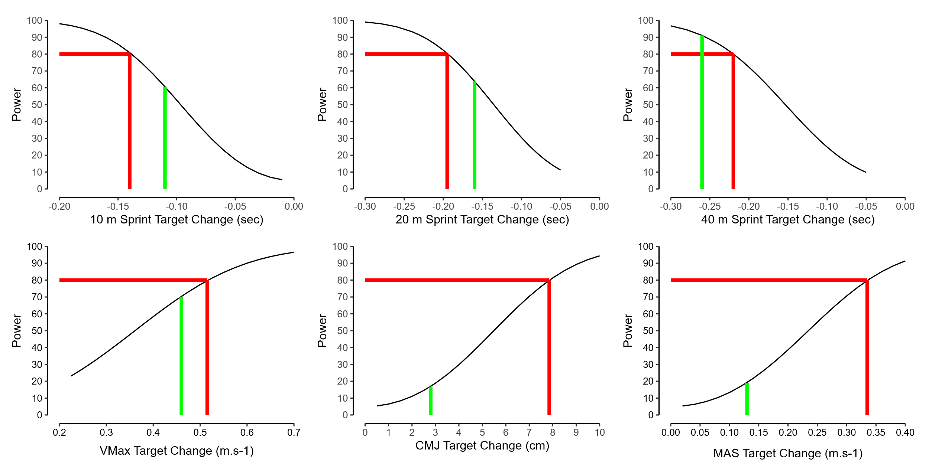Figure 1. Sensitivity power analyses for all six fitness outcomes showing the minimal statistically detectable effects this study could detect (vertical red line), statistical power across a realistic range of effect sizes, and SESOI (green line) for each fitness test.
2.7 Data Sharing
All raw data (training dRPE, pre and post fitness measures) and code (sample size calculations, dRPE analysis, fitness changes) are available to download at https://github.com/PGupta-Git/Gupta_et_al_RST_Paper_Submission with CC BY-NC-SA 4.0 License (A Pragmatic, Parallel-Arm, Randomised Trial on the Effects of Two Repeated Sprint Training Protocols on Fitness Outcomes in Semi-Professional Male Soccer Players: Preliminary Report © 2025 by Palash Gupta is licensed under Creative Commons Attribution-NonCommercial-ShareAlike 4.0 International. To view a copy of this license, visit https://creativecommons.org/licenses/by-nc-sa/4.0). Data users are kindly requested to notify the original authors if they intend to use the data for a new publication or significant analysis. In instances where the new analysis represent a substantial extension or re-analysis requiring the original authors' expertise or direct input, co-authorship should be considered, in accordance with International Committee of Medical Journal Editors guidelines.
2.8 Group Allocation
Following baseline testing, players were randomly allocated to Group 1 (10 sec within-set, 80 sec between-set rest, n=12]) or Group 2 (20 sec within-set, 40 to 54 sec between-set rest n = 11). Group allocation was performed using the minimisation approach and performed by one of the study authors who was not involved in baseline testing. Minimisation aims to achieve a balance between groups across several variables, even with small sample sizes (Altman & Bland, 2005) and variables chosen were: age, 10 m sprint time, VMax, CMJ and MAS (Table 1). Minimisation was performed using a custom-made spreadsheet (Hopkins, 2010).
Table 1. Participant Baseline Characteristics (Mean ± SD)
Characteristic | Group 1  n = 12 | Group 2  n = 11
Age (years) | 23.3 ± 4.4 | 22.3 ± 4.1
10m Sprint Time (sec) | 1.81 ± 0.08 | 1.80 ± 0.12
Maximal Velocity (m.s⁻¹) | 8.69 ± 0.48 | 8.78 ± 0.42
Counter-movement Jump Height (cm) | 39.5 ± 3.9 | 39.5 ± 3.9
Maximal Aerobic Speed (m.s⁻¹) | 4.10 ± 0.23 | 4.09 ± 0.20

2.9 Intervention Monitoring
All sessions (repeated-sprint, soccer training, match, and gym-based strength) were monitored by differential ratings of perceived exertion (dRPE) (breathlessness [dRPE-B], leg muscle exertion [dRPE-L]), measured using the CR100 scale (Borg et al., 2010), collected at the end of every training modality and recorded via custom-made online forms (McLaren et al., 2016).
2.10 Statistical Methods
Twenty-two of the 23 participants completed the intervention with 100% attendance. One participant withdrew due to a match contact injury during in the third week of the study (Figure 1). The missing post-test data were not imputed but removed from the analysis (along with their dRPE) as missing post-intervention data contribute no information of intervention effects (Taylor et al., 2015)
Missing data were explored using the nanair package (Tierney and Cook, 2023), with no missing intervention monitoring dRPE (n = 1914 observations) or outcomes measures (n = 660 observations). Training intensity (dRPE) was explored using the lme4 package (Bates et al., 2015) with model assumptions verified via the performance package (Lüdecke et al., 2022). We compared two models, 1) fixed effect of group, training mode (repeated-sprint training, matches, soccer training, gym-based training), dRPE measure (dRPE-L, dRPE-B), and session number (1 to 12, modelled as a continuous variable), and 2) the same fixed effects but with nested random effects (player/session). An ICC of only 0.016 and a between-player standard deviation of 0.6 (95%CI 0.0, 1.0) AU shows that player explained little heterogeneity in dRPE, so the mixed model was not required.
Pre and post-intervention fitness test data (individual data points, median, boxplot, and density plot) are visualised via raincloud plots (Allen et al., 2019), created using the ggdist package (Kay 2024). A complete-case approach (n=22, n=11 across both groups) was used for analysis of covariance (ANCOVA), via the lme4 package (Bates et al., 2015), comparing the between-group post-pre changes in fitness tests with pre-test as a covariate to control for any imbalances between the groups at baseline that can occur even after minimisation (Senn, 2006). Model-based outliers (method = “cook”) were examined using the performance package (Lüdecke et al., 2022), and where detected (20 m, 40 m models) values were visually inspected, deemed plausible and remained in the model. Model assumptions were checked using residual plots and formal tests of heteroscedasticity and normality, revealing some evidence of heteroscedasticity (20 m, 40 m, VMax, CMJ); therefore, robust standard errors (method = “Stata”) for these model estimates were derived via the estimatr package (Blair et al., 2025). Estimated model marginal means and pairwise comparisons were obtained using the modelbased package (Makowski et al., 2025). Intervention effects are presented as the ANCOVA adjusted mean between-group difference with uncertainty expressed as 95% confidence intervals, and plotted using the sjPlot package (Lüdecke et al., 2024). We used simple effect sizes over standardised effect sizes are in the original units which maximises practical context (Baguley, 2009). Effects are interpreted via traditional null hypothesis significance testing (i.e., p < 0.05) and all visualisations and analyses were performed in R (version 4.4.3, R Foundation for Statistical Computing).

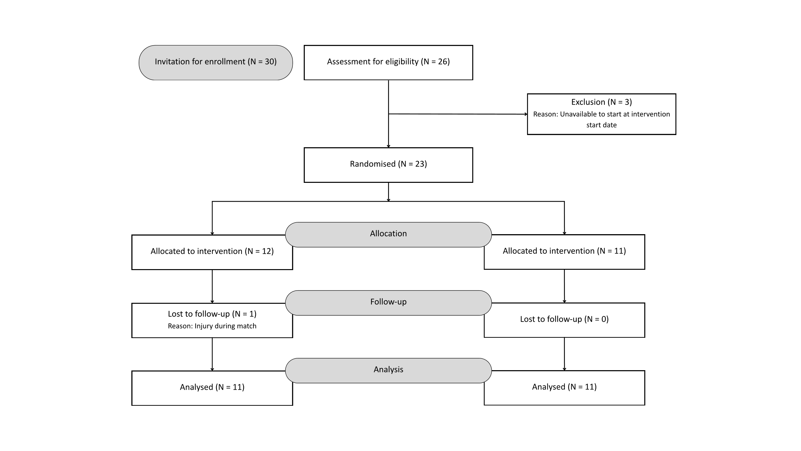
Figure 2. Participant flow chart
3.0 Results
Mean ± SD dRPE per session type were: 57.2 ± 6.9 AU for repeated-sprint training, 62.0 ± 6.6 AU for matches, 59.8 for soccer training, and 52.3 ± 5.1 AU for gym-based training (Figure 3) and with the exception of session, all between-group fixed effects were statistically significant (Figure 4). Pre- and post-test data for all fitness outcomes are shown in Figure 4 with the connecting lines showing a consistent direction of effects between groups. One-way ANCOVA’s on the between-group changes in fitness indicated no statistically significant differences across any of the six tests (Figure 5).
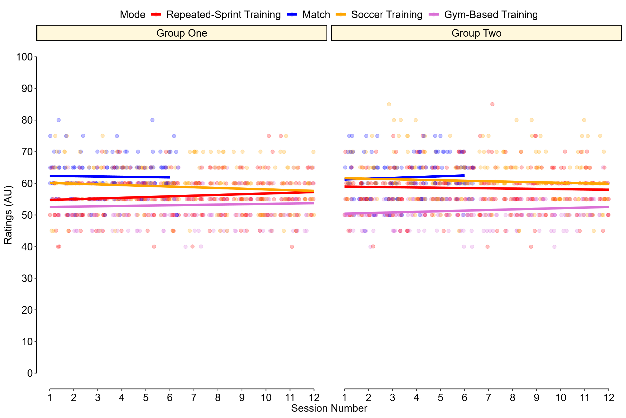Figure 3. Individual session dRPE, coloured by training mode across the study, with the relationship between session number and dRPE visualised via a linear trend line.
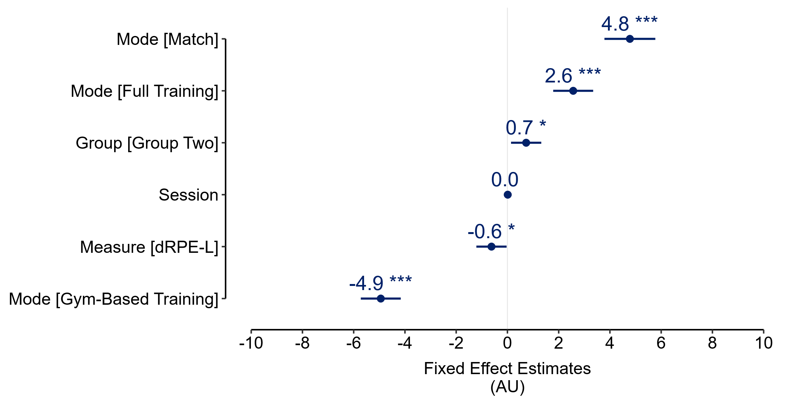
Figure 4. Fixed effect estimates (group, training mode, dRPE measure, and session number), along with 95% confidence intervals (* p < 0.05, ** p < 0.01, *** p < 0.001). Group one, repeated-sprint training, dRPE-B, and session one were the reference categories.

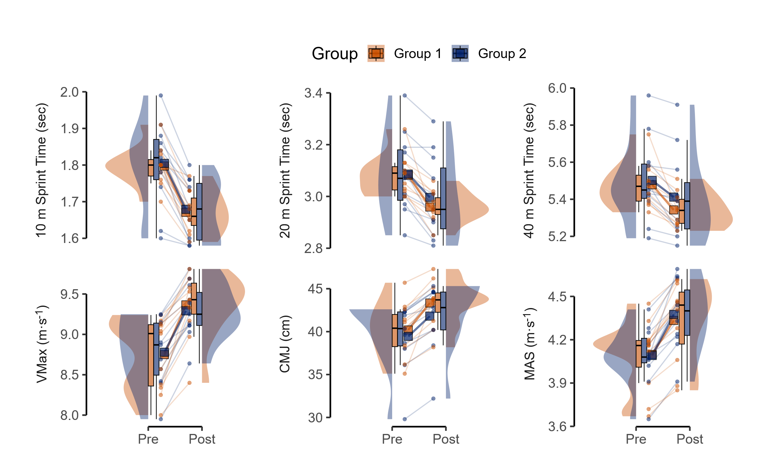Figure 5. Pre- and post-test scores for all outcome measures
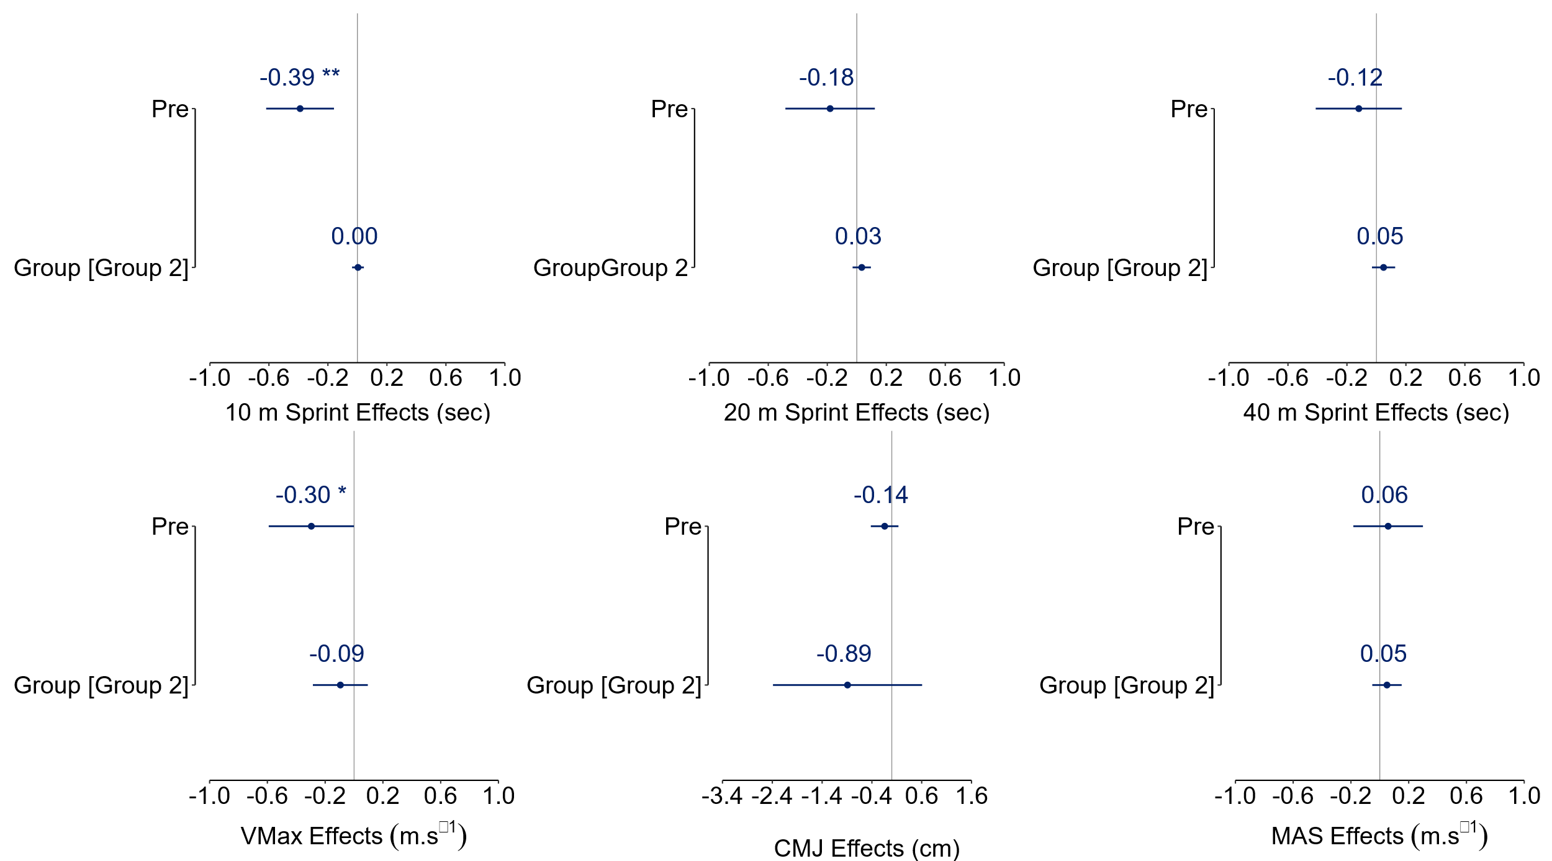Figure 6. ANCOVA estimates along with their 95% confidence intervals (* p < 0.05, ** p < 0.01) of the between-group effects and the influence of pre-test score.
4.0 Interpretation and Conclusions
The findings of a training study are of little to no use without detailed information of the training (Mujika, 2013) and the degree to which an intervention is delivered as intended and the quality of that delivery is termed fidelity (Pfledderer et al., 2024). Caution is needed when interpreting intervention effects when fidelity is not monitored or reported - recent work has shown a linear relationship between fidelity and treatment effects with higher degrees of fidelity associated with smaller yet more precise estimates (Páez et al., 2025). The consistent delivery and comprehensive monitoring of all training sessions across this training study shows our interventions were delivered and received as planned, so fidelity was high. Training session attendance and compliance data, represented via dRPE, show a consistent training stimulus for both groups across the study, most notably via the absence of between-session differences in training intensity for all four training modalities. Further, our repeated-sprint session intensity ranged from hard to very hard aligning with the meta-analysed acute effects of repeated-sprint training (6.5 AU on the deciMax scale) (Thurlow et al. 2023). This confirms both our protocols were conditioning methods perceived as “very hard”, fluctuating between “moderate” to “extremely hard” (Thurlow et al., 2025).
While there were statistically significant between-group differences in training intensity, a difference of -0.7 AU is too small to be meaningful as it is not detectable on the CR100 scale. Further, a magnitude of 8 AU represents the shift needed for ratings to be typically closer or equal to the next or preceding effort category on the nonlinear CR100 scale (Wright et al., 2020). This also applies to the significant effects of training mode on dRPE, although more variation here is expected here given the disparate training goals of each mode of training.
The volume and frequency of our two repeated-sprint protocols aligns with the reference protocol reported by Thurlow et al. (2024) that elicited improvements in 10 m, 20 m, CMJ height, and high-intensity intermittent running performance. Despite a substantial moderator analysis of repeated-sprint programming variables, all of which were trivial or unclear, Thurlow et al., (2024) were unable to extend this analysis to the effects of inter-repetition and inter-set rest duration due to insufficient data diversity. While rest manipulation is postulated to potentially impact adaptation (Thurlow et al., 2025), our ANCOVA findings show that the differing rest structures of the two repeated-sprint training protocols did not lead to a practically meaningful between-group differences in fitness changes. These findings suggest that for adaptations in sprint performance, vertical jumping ability and maximal aerobic speed coaches may have flexibility in adjusting within- and between-set rest periods to suit logistical needs, session objectives, or athlete feedback, provided the total sprint volume and overall recovery are maintained.
Ultimately, however, such interpretations are largely speculative as our study was insufficiently powered to detect practically meaningful changes in fitness, with the exception, to an extent, of 40 m sprint performance, so all between-group effects should be interpreted with caution. This study, therefore, represents only a small incremental advance in our understanding of the moderating impact of within- and between-set rest manipulations that are closer in duration to those previously reported (Saraslanidis et al.,2011; Iaia et al., 2017). However, we are hopeful our trial may encourage others to further explore the moderating impact of rest times, perhaps replicate our work, or even collaborate on large-scale clustered randomised trials. Our study will also help contribute to future meta-analyses examining the moderating influence of manipulating within- and between-set rest times – both of which provide practitioners with programming flexibility – as this has so far been beyond the reach of existing meta-analysis on the chronic effects of repeated-sprint training (Taylor et al., 2015; Thurlow et al., 2024).
Notwithstanding the implications of our underpowered study, other limitations should be considered when interpreting our findings. Firstly, the absence of an active control group continuing the regular physical conditioning during the soccer training sessions makes isolation of the repeated sprint training interventions challenging, especially during pre-season phase. Secondly, this study did not incorporate direct physiological or biomechanical measures; however, in the interest of research efficiency, it would make sense to determine the existence of effects before investing time and resources on measuring physiological and biomechanical responses that may subtend adaptations. Thirdly, while maximal effort was encouraged during the repeated sprints, collection of external training loads was not possible due to resource limitations. Precise sprint speeds or distances covered at maximal intensity during training were therefore not objectively verified beyond the ‘coaches eye’ and dRPE. Finally, although overall training exposure was intended to be identical bar intervention variations and dRPE differences were unlikely to be meaningful, variations in individual soccer-specific session durations or match minutes might have occurred due to team-specific logistics, representing an uncontrolled variable, albeit likely minimal in impact given the equivalent perceived load.
We recommend several areas for future research. Replication in females and soccer populations of varying competitive standards in needed as is establishing population-specific SESOI for fitness outcomes which will help the planning and interpretation of future trials. Expanding repeated sprint training interventions to more ecologically valid modalities (e.g. curvilinear sprinting) and examining integration with various-sided games are valuable directions. Finally, replicating similar interventions during the competitive in-season period would help clarify how repeated sprint training adaptations manifest amidst fixture congestion and how training variables might be periodised to manage fitness and fatigue. These future studies, addressing the current limitations, will deepen our understanding of repeated sprint training and its optimal application in soccer.
In conclusion, while our two repeated-sprint interventions had high fidelity, the subtle manipulation of within- and between-set rest periods was insufficient to result in any practically meaningful between-group differences in fitness changes. Given the limited sample size, however, these results must be interpreted as preliminary, requiring further confirmation.

References
- Castillo-Rodríguez, A., Cano-Cáceres, F. J., Figueiredo, A., & Fernández-García, J. C. (2020). Train Like You Compete? Physical and Physiological Responses on Semi-Professional Soccer Players. International Journal of Environmental Research and Public Health, 17(3), 756. https://doi.org/10.3390/ijerph17030756
- Ortigosa-Melero, A., Onetti, W., Figueiredo, A., & Castillo-Rodríguez, A. (2022). Effect of the contextual factors in competition on the performance of semi- professional soccer. Journal of Physical Education and Sport, 22, 2793–2799. https://doi.org/10.7752/jpes.2022.11354
- Faude, O., Koch, T., & Meyer, T. (2012). Straight sprinting is the most frequent action in goal situations in professional football. J Sports Sci, 30(7), 625–631. https://doi.org/10.1080/02640414.2012.665940
- Taylor, J., Macpherson, T., Spears, I., & Weston, M. (2015). The effects of repeated-sprint training on field-based fitness measures: A meta-analysis of controlled and non-controlled trials. Sports Med, 45(6), 881–891. https://doi.org/10.1007/s40279-015-0324-9
- Thurlow, F., Huynh, M., Townshend, A., McLaren, S. J., James, L. P., Taylor, J. M., Weston, M., & Weakley, J. (2024). The Effects of Repeated-Sprint Training on Physical Fitness and Physiological Adaptation in Athletes: A Systematic Review and Meta-Analysis. Sports Med. https://doi.org/10.1007/s40279-023-01959-1
- Thurlow, F., Weakley, J., Townshend, A. D., Timmins, R. G., Morrison, M., & McLaren, S. J. (2023). The Acute Demands of Repeated-Sprint Training on Physiological, Neuromuscular, Perceptual and Performance Outcomes in Team Sport Athletes: A Systematic Review and Meta-analysis. Sports Medicine, 53(8), 1609–1640. https://doi.org/10.1007/s40279-023-01853-w
- Thurlow, F., McLaren, S. J., Townshend, A., & Weakley, J. (2025). The Application of Repeated-Sprint Training. Strength and Conditioning Journal, 47(4), 398–413. https://doi.org/10.1519/ssc.0000000000000881
- Iaia, F. M., Fiorenza, M., Larghi, L., Alberti, G., Millet, G. P., & Girard, O. (2017). Short- or long-rest intervals during repeated-sprint training in soccer? PLoS One, 12(2), e0171462. https://doi.org/10.1371/journal.pone.0171462
- Saraslanidis, P., Petridou, A., Bogdanis, G. C., Galanis, N., Tsalis, G., Kellis, S., & Mougios, V. (2011). Muscle metabolism and performance improvement after two training programmes of sprint running differing in rest interval duration. J Sports Sci, 29(11), 1167–1174. https://doi.org/10.1080/02640414.2011.583672
- Taylor, J. M., Macpherson, T. W., Spears, I. R., & Weston, M. (2016). Repeated Sprints: An Independent Not Dependent Variable. International Journal of Sports Physiology and Performance, 11(5), 693–696. https://doi.org/10.1123/ijspp.2016-0081
- Chan, A.-W., Boutron, I., Hopewell, S., Moher, D., Schulz, K. F., Collins, G. S., Tunn, R., Aggarwal, R., Berkwits, M., Berlin, J. A., Bhandari, N., Butcher, N. J., Campbell, M. K., Chidebe, R. C. W., Elbourne, D. R., Farmer, A. J., Fergusson, D. A., Golub, R. M., Goodman, S. N., … Hróbjartsson, A. (2025). SPIRIT 2025 statement: updated guideline for protocols of randomised trials. The Lancet, 405(10491), e19–e27. https://doi.org/10.1016/s0140-6736(25)00770-6
- Slade, S. C., Dionne, C. E., Underwood, M., & Buchbinder, R. (2016). Consensus on Exercise Reporting Template (CERT): Explanation and Elaboration Statement. British Journal of Sports Medicine, 50(23), 1428–1437. https://doi.org/10.1136/bjsports-2016-096651
- McKay, A. K. A., Stellingwerff, T., Smith, E. S., Martin, D. T., Mujika, I., Goosey-Tolfrey, V. L., Sheppard, J., & Burke, L. M. (2022). Defining Training and Performance Caliber: A Participant Classification Framework. International Journal of Sports Physiology and Performance, 17(2), 317–331. https://doi.org/10.1123/ijspp.2021-0451
- Haff, G. G., & Triplett, N. T. (2015). Essentials of Strength Training and Conditioning 4th Edition. Human Kinetics.
- Shushan, T., Lovell, R., McLaren, S. J., Buchheit, M., Dello Iacono, A., Arguedas-Soley, A., & Norris, D. (2024). Assessing criterion and longitudinal validity of submaximal heart rate indices as measures of cardiorespiratory fitness: A preliminary study in football. J Sci Med Sport. https://doi.org/10.1016/j.jsams.2024.04.006
- Borg, E., Borg, G., Larsson, K., Letzter, M., & Sundblad, B.-M. (2010). An index for breathlessness and leg fatigue. Scandinavian Journal of Medicine & Science in Sports, 20(4), 644–650. https://doi.org/10.1111/j.1600-0838.2009.00985.x
- Weakley, J., McCosker, C., Chalkley, D., Johnston, R., Munteanu, G., & Morrison, M. (2023). Comparison of Sprint Timing Methods on Performance, and Displacement and Velocity at Timing Initiation. J Strength Cond Res, 37(1), 234–238. https://doi.org/10.1519/jsc.0000000000004223
- Collings, T. J., Lima, Y. L., Dutaillis, B., & Bourne, M. N. (2024). Concurrent validity and test–retest reliability of VALD ForceDecks’ strength, balance, and movement assessment tests. Journal of Science and Medicine in Sport. https://doi.org/10.1016/j.jsams.2024.04.014
- Bellenger, C. R., Fuller, J. T., Nelson, M. J., Hartland, M., Buckley, J. D., & Debenedictis, T. A. (2015). Predicting maximal aerobic speed through set distance time-trials. Eur J Appl Physiol, 115(12), 2593–2598. https://doi.org/10.1007/s00421-015-3233-6
- Abt, G., Boreham, C., Davison, G., Jackson, R., Jobson, S., Wallace, E., & Williams, M. (2025). Sample size estimation revisited. Journal of Sports Sciences, ahead-of-print(ahead-of-print), 1–6. https://doi.org/10.1080/02640414.2025.2499403
- Lakens, D. (2022). Sample Size Justification. Collabra: Psychology, 8(1). https://doi.org/10.1525/collabra.33267
- Cook, J. A., Julious, S. A., Sones, W., Hampson, L. V., Hewitt, C., Berlin, J. A., Ashby, D., Emsley, R., Fergusson, D. A., Walters, S. J., Wilson, E. C. F., MacLennan, G., Stallard, N., Rothwell, J. C., Bland, M., Brown, L., Ramsay, C. R., Cook, A., Armstrong, D., … Vale, L. D. (2018). DELTA 2guidance on choosing the target difference and undertaking and reporting the sample size calculation for a randomised controlled trial. BMJ, 363, k3750-7. https://doi.org/10.1136/bmj.k3750
- Datson, N., Lolli, L., Drust, B., Atkinson, G., Weston, M., & Gregson, W. (2022). Inter-methodological quantification of the target change for performance test outcomes relevant to elite female soccer players. Science and Medicine in Football, 6(2), 248–261. https://doi.org/10.1080/24733938.2021.1942538
- Haugen, T., Tønnessen, E., Hisdal, J., & Seiler, S. (2014). The role and development of sprinting speed in soccer. International Journal of Sports Physiology and Performance, 9(3), 432–441. https://doi.org/10.1123/ijspp.2013-0121
- Haugen, T., & Buchheit, M. (2016). Sprint Running Performance Monitoring: Methodological and Practical Considerations. Sports Medicine, 46(5), 641–656. https://doi.org/10.1007/s40279-015-0446-0
- Haugen, T. A., Breitschädel, F., & Seiler, S. (2020). Sprint mechanical properties in soccer players according to playing standard, position, age and sex. Journal of Sports Sciences, 38(9), 1070–1076. https://doi.org/10.1080/02640414.2020.1741955
- Taylor, J. M., Madden, J. L., Cunningham, L. P., & Wright, M. (2022). Fitness Testing in Soccer Revisited: Developing a Contemporary Testing Battery. Strength and Conditioning Journal, 44(5), 10–21. https://doi.org/10.1519/ssc.0000000000000702
- Lakens, D., & Caldwell, A. R. (2021). Simulation-Based Power Analysis for Factorial Analysis of Variance Designs. Advances in Methods and Practices in Psychological Science, 4(1), 2515245920951503. https://doi.org/10.1177/2515245920951503
- Collins, K. A., Huffman, K. M., Wolever, R. Q., Smith, P. J., Siegler, I. C., Ross, L. M., Hauser, E. R., Jiang, R., Jakicic, J. M., Costa, P. T., & Kraus, W. E. (2022). Determinants of Dropout from and Variation in Adherence to an Exercise Intervention: The STRRIDE Randomized Trials. Translational Journal of the ACSM, 7(1), e000190. https://doi.org/10.1249/tjx.0000000000000190
- Altman, D. G., & Bland, J. M. (2005). Treatment allocation by minimisation. BMJ, 330(7495), 843. https://doi.org/10.1136/bmj.330.7495.843
- Hopkins, W.G. (2010). Assinging Subjects to Groups in a Controlled Trial. Sportscience 14, 7-12, 2010 (sportsci.org/2010/wghminim.htm)
- McLaren, S. J., Graham, M., Spears, I. R., & Weston, M. (2016). The Sensitivity of Differential Ratings of Perceived Exertion as Measures of Internal Load. Int J Sports Physiol Perform, 11(3), 404–406. https://doi.org/10.1123/ijspp.2015-0223
- Tierney, N., & Cook, D. (2023). Expanding Tidy Data Principles to Facilitate Missing Data Exploration, Visualization and Assessment of Imputations. Journal of Statistical Software, 105(7), 1–31. https://doi.org/10.18637/jss.v105.i07
- Taylor, K. L., Weston, M., & Batterham, A. M. (2015). Evaluating Intervention Fidelity: An Example from a High-Intensity Interval Training Study. PLoS ONE, 10(4), e0125166-8. https://doi.org/10.1371/journal.pone.0125166
- Bates, D., Mächler, M., Bolker, B., & Walker, S. (2015). Fitting Linear Mixed-Effects Models Using lme4. Journal of Statistical Software, 67(1), 1–48. https://doi.org/10.18637/jss.v067.i01
- Lüdecke, D. (2024). sjPlot: Data Visualization for Statistics in Social Science.
- Lüdecke, D., Ben-Shachar, M. S., Patil, I., Wiernik, B. M., Bacher, E., Thériault, R., & Makowski, D. (2022). easystats: Framework for Easy Statistical Modeling, Visualization, and Reporting. CRAN.
- Allen, M., Poggiali, D., Whitaker, K., Marshall, T. R., Langen, J. van, & Kievit, R. A. (2019). Raincloud plots: a multi-platform tool for robust data visualization. Wellcome Open Research, 4, 63. https://doi.org/10.12688/wellcomeopenres.15191.1
- Kay M (2024). “ggdist: Visualizations of Distributions and Uncertainty in the Grammar of Graphics.” _IEEE Transactions on Visualization and Computer Graphics_, *30*(1), 414-424. doi:10.1109/TVCG.2023.3327195 https://doi.org/10.1109/TVCG.2023.3327195
- Senn, S. (2006). Change from baseline and analysis of covariance revisited. Statistics in Medicine, 25(24), 4334–4344. https://doi.org/10.1002/sim.2682
- Blair G, Cooper J, Coppock A, Humphreys M, Sonnet L (2025)._estimatr: Fast Estimators for Design-Based Inference_. R package version 1.0.6, <https://CRAN.R-project.org/package=estimatr>.
- Makowski, D., Ben-Shachar, M. S., Wiernik, B. M., Patil, I., Thériault, R., & Lüdecke, D. (2025). modelbased: An R package to make the most out of your statistical models through marginal means, marginal effects, and model predictions. Journal of Open Source Software, 10(109), 7969. https://doi.org/10.21105/joss.07969
- Baguley, T. (2009). Standardized or simple effect size: What should be reported? British Journal of Psychology (London, England: 1953), 100(Pt 3), 603–617. https://doi.org/10.1348/000712608X377117
- Mujika, I. (2013). The Alphabet of Sport Science Research Starts With Q. International Journal of Sports Physiology and Performance, 8(5), 465–466. https://doi.org/10.1123/ijspp.8.5.465
- Pfledderer, C. D., Klinggraeff, L. von, Burkart, S., Bandeira, A. da S., Lubans, D. R., Jago, R., Okely, A. D., Sluijs, E. M. F. van, Ioannidis, J. P. A., Thrasher, J. F., Li, X., & Beets, M. W. (2024). Consolidated guidance for behavioral intervention pilot and feasibility studies. Pilot and Feasibility Studies, 10(1), 57. https://doi.org/10.1186/s40814-024-01485-5
- Páez, A., Nunan, D., McCulloch, P., & Beard, D. (2025). The influence of intervention fidelity on treatment effect estimates in clinical trials of complex interventions: a metaepidemiological study. Journal of Clinical Epidemiology, 177, 111610. https://doi.org/10.1016/j.jclinepi.2024.111610
- Wright, M. D., Songane, F., Emmonds, S., Chesterton, P., Weston, M., & Mclaren, S. J. (2020). Differential Ratings of Perceived Match and Training Exertion in Girls’ Soccer. International Journal of Sports Physiology and Performance, 15(9), 1315–1323. https://doi.org/10.1123/ijspp.2019-0595

