Practical #5
Practical Title:
To understand the structure of a basic web application and its role in a DevOps pipeline
Theory:
1. What is a Web Application?
A web application is a software application that runs on a web server and is accessed through a web browser (like Chrome).
Examples: login forms, student portals, feedback systems.

2. Components of a Web Application
Frontend:
- User interface (UI)
- Built using HTML, CSS, JavaScript
- Runs in the browser
Backend
- Handles logic and processing
- Technologies: Node.js, Java, Python
- Communicates with database

Database
- Stores application data
- Examples: MySQL, MongoDB

3. What is DevOps Pipeline?
A DevOps pipeline is an automated process that allows developers to build, test, and deploy applications continuously.
It includes stages like:
- Code → Build → Test → Deploy → Monitor
Procedure:
Step 1: Create a Basic Web Page (HTML)
Step 2: Add Styling using CSS
Step 3: Add Simple JavaScript Functionality
Step 4: Run the Web Page in Browser
Step 5: (Optional) Upload the Web App to GitHub
Output Screenshots:
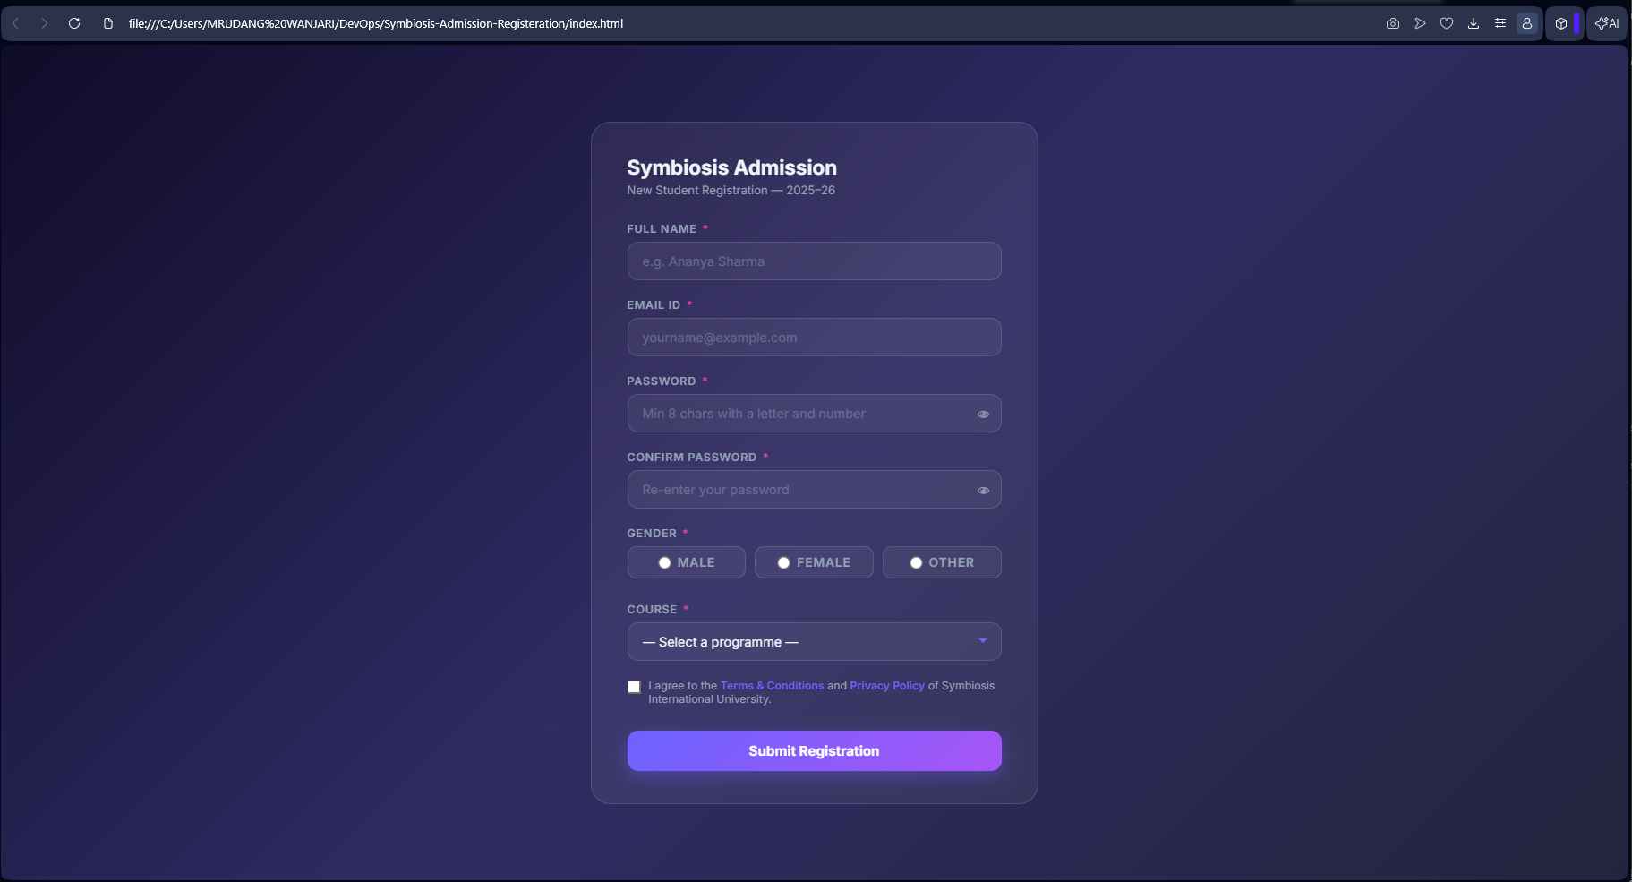
Activity / Task:
Task 1: Simple Web Application
Description:
A simple Student Admission Form where users enter their name and submit the form.
It uses HTML for structure, CSS for styling, and JavaScript for interaction.

Task 2: Use in DevOps Pipeline
- Code stored in GitHub
- Automatically built and tested
- Deployed to server using CI/CD
- Monitored for performance
Flow:
Developer → GitHub → CI/CD Tool → Deployment → Monitoring

Task 3: Steps to Deploy Application
- Create server (local/cloud)
- Install web server (Apache/Nginx)
- Upload files to server
- Configure server
- Access via browser (URL)

Advantages
- Easy to develop and deploy
- Platform independent
- Supports automation (DevOps)
- Scalable
- Accessible from anywhere

Challenges
- Security issues
- Browser compatibility
- Requires backend for complex logic

