Practical #6
Practical Title:
To deploy and manage a simple web application using version control and hosting techniques
Theory:
1. What is Web Hosting?
Web hosting is a service that allows you to store your website files on a server and make them accessible on the internet.
Example: When you open a website, files are loaded from a hosting server.

2. What is GitHub Hosting (GitHub Pages)?
GitHub Pages is a free hosting service provided by GitHub.
- Used to host static websites (HTML, CSS, JS)
- Provides a live URL for your project
- Automatically updates when you push code

3. Role of Version Control in Deployment
Version control (Git) helps in:
- Tracking changes in code
- Managing different versions
- Easy rollback if errors occur
- Smooth deployment using GitHub integration
Procedure:
Step 1: Create a simple web application (index.html)
Step 2: Initialize Git repository
Step 3: Add and Commit files
Step 4: Create GitHub repository
Step 5: Push code to GitHub
Step 6: Enable GitHub Pages
Step 7: Access deployed website using provided link
Output Screenshots:
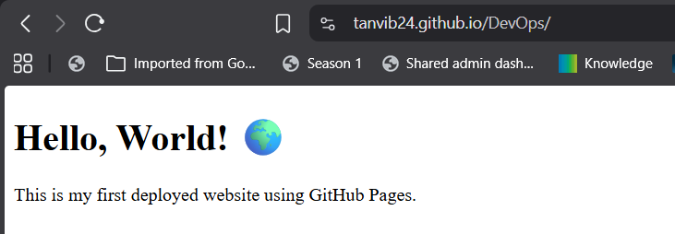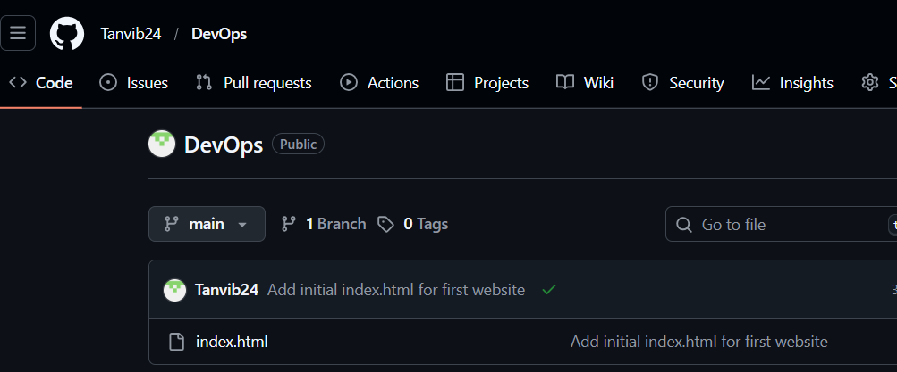
Activity / Task:
Task 1: Deploy Web Application
Repository Link: https://github.com/Tanvib24/DevOps
Live Website Link: https://tanvib24.github.io/DevOps/

Task 2: Update Website
Commands Used:
git add .
git commit -m "Updated website"
git push origin main
After pushing, GitHub Pages updates automatically.

Task 3: Benefits of Using GitHub for Deployment
- Free hosting
- Easy integration with Git
- Automatic updates
- Version control + deployment in one platform
- Good for beginners and small projects

Advantages
- Free hosting service
- Easy deployment process
- Automatic updates
- Integrated with Git
- Supports collaboration

Challenges
- Only static websites supported
- Limited customization
- Requires Git knowledge

