Practical #8
Practical Title:
To design and execute automated test scripts using Selenium for functional testing
Theory:
1. What is Functional Testing?
Functional testing is a type of testing where we verify that the application works according to the given requirements.
👉 It checks:
- Login functionality
- Form submission
- Buttons, links, and features

2. Advantages of Selenium for Testing
Using Selenium:
- Supports multiple browsers (Chrome, Firefox, Edge)
- Supports multiple programming languages
- Open-source and free
- Easy integration with CI/CD tools
- Automates repetitive testing tasks

Procedure:
Step 1: Setup Selenium environment
Step 2: Launch browser using WebDriver
Step 3: Navigate to a web application
Step 4: Locate elements using locators (id, name, xpath, etc.)
Step 5: Perform actions (click, send keys, submit)
Step 6: Validate output using assertions
Step 7: Close the browser
Output Screenshots:
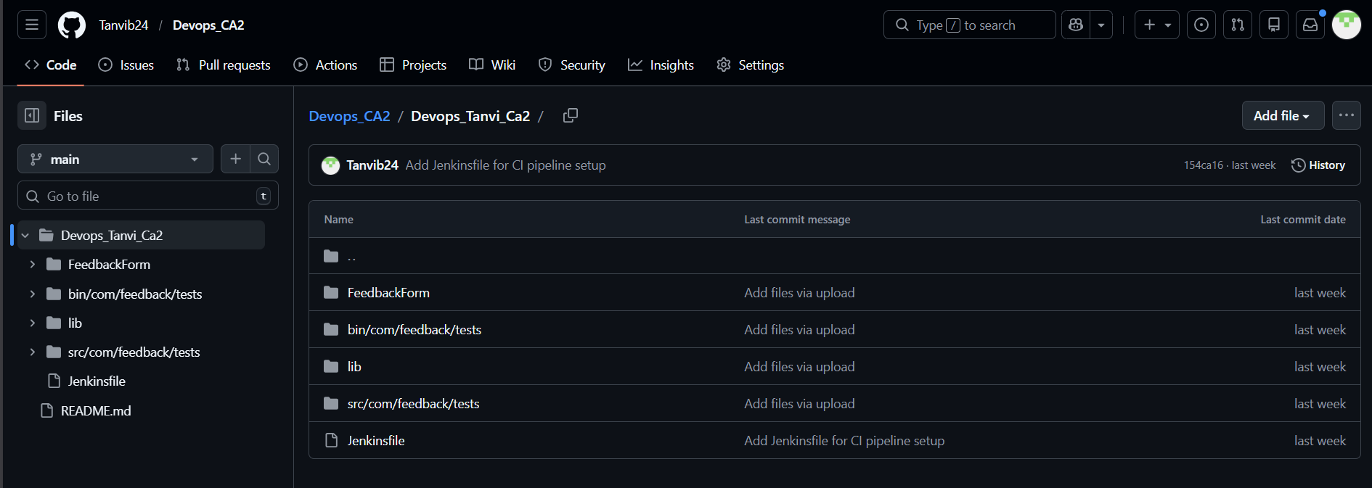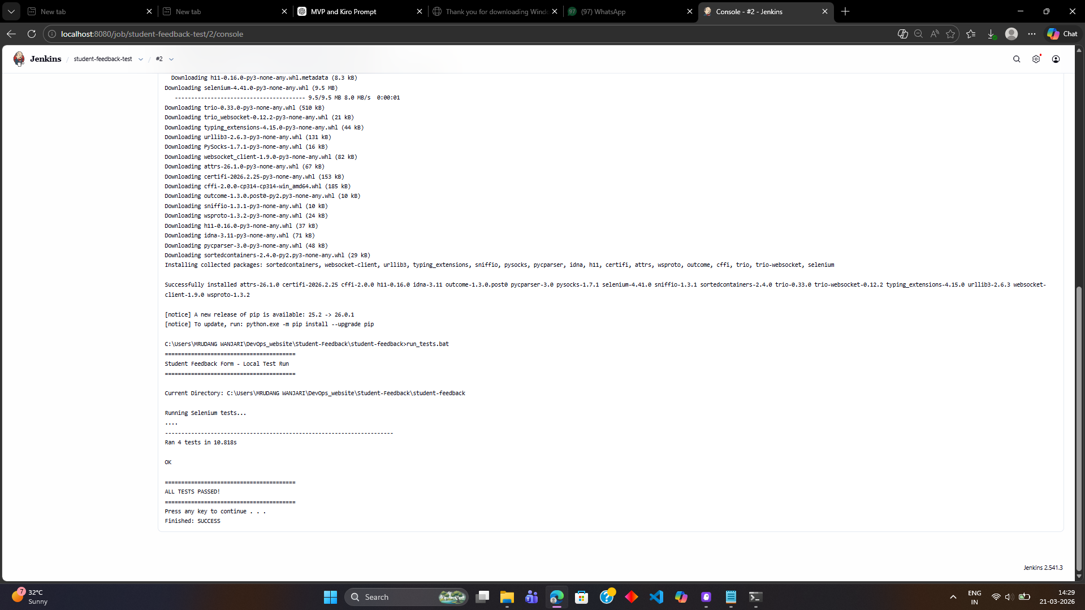
Activity / Task:
Task 1: Selenium Login Test Script
Code (Python Example):
package com.feedback.tests;
import org.openqa.selenium.*;
import org.openqa.selenium.chrome.ChromeDriver;
import org.openqa.selenium.support.ui.*;
import java.time.Duration;
import java.util.List;
public class FeedbackTest {
static WebDriver driver;
static WebDriverWait wait;
static int passed = 0;
static int failed = 0;
static String formPath = "file:///C:/Users/Tanvibandebuche/Downloads/devops_ca2/feedback_form.html";
public static void main(String[] args) throws Exception {
driver = new ChromeDriver();
wait = new WebDriverWait(driver, Duration.ofSeconds(10));
driver.manage().window().maximize();
test1_FormOpens();
test2_ValidSubmission();
test3_EmptyFields();
test4_InvalidEmail();
test5_InvalidMobile();
test6_Dropdown();
test7_Reset();
// FINAL SUMMARY
System.out.println("\n===== TEST SUMMARY =====");
System.out.println("Passed: " + passed);
System.out.println("Failed: " + failed);
System.out.println("Total: " + (passed + failed));
if (failed == 0) {
System.out.println("ALL TESTS PASSED ✅");
} else {
System.out.println("SOME TESTS FAILED ❌");
}
driver.quit();
}
static void markResult(String testName, boolean status) {
if (status) {
System.out.println(testName + " → PASSED");
passed++;
} else {
System.out.println(testName + " → FAILED");
failed++;
}
}

static void openForm() throws Exception {
driver.get(formPath);
wait.until(ExpectedConditions.visibilityOfElementLocated(By.id("studentName")));
Thread.sleep(500);
}

static void fillForm(String name, String email, String mobile,
String dept, String gender, String feedback) throws Exception {

driver.findElement(By.id("studentName")).clear();
driver.findElement(By.id("studentName")).sendKeys(name);

driver.findElement(By.id("email")).clear();
driver.findElement(By.id("email")).sendKeys(email);

driver.findElement(By.id("mobile")).clear();
driver.findElement(By.id("mobile")).sendKeys(mobile);

if (dept != null)
new Select(driver.findElement(By.id("department")))
.selectByValue(dept);

if (gender != null) {
List<WebElement> radios = driver.findElements(By.name("gender"));
for (WebElement r : radios) {
if (r.getAttribute("value").equals(gender))
r.click();
}
}

driver.findElement(By.id("feedback")).clear();
driver.findElement(By.id("feedback")).sendKeys(feedback);
}

static void submit() throws Exception {
driver.findElement(By.id("submitBtn")).click();
Thread.sleep(500);
}

// TEST CASES

static void test1_FormOpens() throws Exception {
openForm();
boolean status = driver.findElement(By.id("studentName")).isDisplayed();
markResult("Test1 Form Opens", status);
}

static void test2_ValidSubmission() throws Exception {
openForm();
fillForm("John", "john@test.com", "9876543210",
"cse", "male",
"This is a valid feedback with more than ten words");
submit();

boolean status = driver.getPageSource().toLowerCase().contains("success");
markResult("Test2 Valid Submission", status);
}

static void test3_EmptyFields() throws Exception {
openForm();
submit();

boolean status = driver.getPageSource().toLowerCase().contains("required");
markResult("Test3 Empty Fields", status);
}

static void test4_InvalidEmail() throws Exception {
openForm();
fillForm("Jane", "invalidemail", "9876543210",
"it", "female",
"This is valid feedback with enough words");
submit();

boolean status = driver.getPageSource().toLowerCase().contains("email");
markResult("Test4 Invalid Email", status);
}

static void test5_InvalidMobile() throws Exception {
openForm();
fillForm("Jane", "jane@test.com", "12345abc",
"it", "female",
"This is valid feedback with enough words");
submit();

boolean status = driver.getPageSource().toLowerCase().contains("mobile");
markResult("Test5 Invalid Mobile", status);
}

static void test6_Dropdown() throws Exception {
openForm();

Select dropdown = new Select(driver.findElement(By.id("department")));
List<WebElement> options = dropdown.getOptions();

boolean status = options.size() > 1;
markResult("Test6 Dropdown", status);
}

static void test7_Reset() throws Exception {
openForm();

fillForm("Test", "test@test.com", "9876543210",
"cse", "male", "Some feedback");

driver.findElement(By.id("resetBtn")).click();

String name = driver.findElement(By.id("studentName")).getAttribute("value");

boolean status = name.isEmpty();
markResult("Test7 Reset", status);
}
}

Task 2: Form Testing (Valid & Invalid Inputs)
Description:
- Valid Input Test:
  - Enter correct data (username, password)
  - Submit form
  - Verify success message
- Invalid Input Test:
  - Enter wrong data
  - Submit form
  - Verify error message
This ensures:
- Form validation works properly
- Error handling is correct

Advantages
- Faster execution than manual testing
- Supports automation of functional tests
- Reusable scripts
- Cross-browser testing
- Integration with DevOps pipelines

Challenges
- Requires coding knowledge
- Maintenance of scripts
- Handling dynamic elements can be difficult

