Project CO2410 - PhishPlay: Interactive Anti-Phishing Training Game

Introduction
This document describe the functional requirements for web-application include communication with users, main functions, constraints and quality criteria. The application is designed to manage tasks, share responsibilities, and monitor progress in team. The system works via a web browser and uses a standard tools: HTML, CSS, JavaScript, JSON, PHP.
The goal of the project is to develop a user-friendly and fast web game that in a short time (20 questions) will provide practical skills in recognizing phishing signals and provide measurable results (scores, leaderboard).

Project Overview
PhishPlay is an educational web-based game designed to help users identify phishing emails through an interactive and engaging experience. The primary purpose of the project is to provide a safe environment where players can practice distinguishing between legitimate and fraudulent emails, improving their cybersecurity awareness and reducing the risk of falling for phishing attacks.
The project is developed as part of the CO2410 Web Application module and aims to demonstrate understanding of client-side and server-side technologies, data management, and secure application design. PhishPlay uses a combination of HTML, CSS, JavaScript, PHP, and MySQL, with GitHub Pages hosting the frontend and a local server handling backend logic.

Key functions:
- Showing 20 email cases (in JSON format)
- Choosing the answer True / False
- Scoring, summary screen
- Saving the result to the database (PHP)
- Displaying the leaderboard (GET JSON)
- (Optional) timer for each question
- Stakeholders: student users, teachers, CO2410 team, administrator (for content management).

Problem definition
Phishing remains one of the most widespread and successful threats to information security. Many students and netizens are not sufficiently aware of the signs of phishing emails: fake links, social tricks, suspicious attachments, etc. Traditional lectures often do not provide practical recognition skills.

Effects:
- Loss of personal data
- Compromising accounts
- Financial and reputational losses
The game form increases engagement, gives an immediate feedback and promotes memorization of the rules in practice. The format of the short sessions (20 questions) allows you to use the app as a learning tool in pairs/seminars. The goal of solving this problem is to create an interactive, accessible and repeatable simulator that will improve students' ability to recognise phishing and reduce the risk of errors in real life.

Software Requirements Specification (SRS)

Purpose of the document
This SRS describes the functional and non-functional requirements for the PhishPlay web game. The document is intended for developers, testers, analysts and teachers. The purpose of this its to provide a comprehensive and formal description of the functional and non-functional requirements for the PhishPlay web application. This document provide a common understanding between all stakeholders in the project, including developers, system analysts, database administrators, testers, and course evaluators.
It describes the expected system behavior, constraints, data structures, and interaction patterns to ensure that the development process meets well-defined goals and measurable results.

Definitions and abbreviations
- Player – a player (user, student).
- Backend – PHP/MySQL
- Frontend – HTML/CSS/JS

Scope of application
PhishPlay is a browser-based educational game designed to improve user awareness of phishing techniques by simulating real-world email classification scenarios. The system allows players to review a set of email examples and determine whether each message is compose a phishing attempt. Based on the user’s decisions, the application dynamically calculates the score and provides feedback regarding overall performance.
The application is intended for students, teachers, and general users seeking to strengthen their cybersecurity literacy in an interactive and accessible format. The system supports up to twenty email cases per game session and operates entirely within a web environment. The backend handles scenario management, scoring logic, and strong storage of player results, while the frontend provides an intuitive interface for gameplay and interaction.

General description
The system is implemented as a client-server web application, where the browser-based frontend communicates with the backend through asynchronous fetch requests. The backend processes these requests, returns structured JSON responses, and manages all data stored in a MySQL database (Local university server Vesta). The product defines two primary user roles: the Player, who participates as a guest by entering a preferred username, and the Administrator, who is optionally responsible for creating and maintaining the email scenarios used in the game. The application is designed to operate exclusively within a web environment and imposes a functional constraint limiting each gameplay session to a maximum of twenty email cases.

Functional Requirements

Gameplay & Session Management
FR-1: The system should allow the player to enter a name before the session starts.
FR-2: At the start of the session, the system must load a set of 20 email scripts.
FR-3: The interface provides three modes of difficulty (Easy, Medium, Hard)
FR-4: Showing scripts one at a time, strictly consistently; returning to previous questions is prohibited.

Email Presentation
FR-5: Each script must display sender, subject, body, optionally attachment/preview.
FR-6: Scripts are uploaded via API /php/getEmails.php (JSON).

Answering & Feedback
FR-7: The interface provides two response options: True/ False.
FR-8: After sending the response, the system verifies the correctness by is_phishing and immediately displays feedback & explanation.
FR-9: The answers are taken into account when scoring points.

Scoring & Results
FR-10: The correct answer gives 1 point (configurable parameter).
FR-11: After completing 20 scenarios, a summary screen is displayed with the final score and statistics (correct/incorrect/time).
FR-12: After the session ends, the frontend sends a POST /php/saveScore.php with payload {name, score, total_questions, time_spent}.

Leaderboard
FR-13: The backend saves the results to the leaderboard table (name, score, total_questions, time_spent, created_at).
FR-14: The leaderboard is available via GET /php/leaderboard.php , returns JSON { "players": [...] }, sorted by descending score.

Non-functional requirements

Performance
NFR-1: API response time for local deployment < 1.5 s.
NFR-2: Full load of the main page for no more than 3 seconds under normal network conditions.

Scalability
NFR-3: Supports at least 20 simultaneous sessions.

Usability
NFR-4: The interface clearly display the number of lives and potential points based on the selected difficulty modes, so players understand the consequences of mistakes.

Maintainability
NFR-5: The structure of the scripts should be in JSON format or the emails table so that adding new cases does not require code changes.

Balance & Engagement
NFR-8: Difficulty levels must be balanced to provide:
- Easy: forgiving gameplay for beginners.
- Medium: moderate challenge for standard players.
- Hard: high-risk, high-reward gameplay for advanced players, encouraging skill improvement and repeated attempts.

UML-Diagram

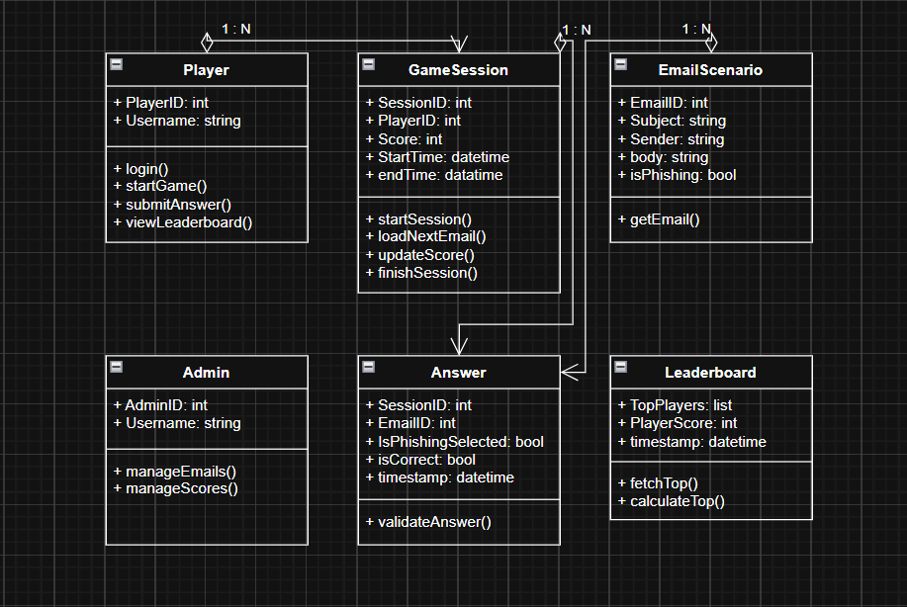
(UML Class Diagram)
Explanation: The diagram display the main entities: Player, GameSession, EmailScenario, Answer, Leaderboard and Admin. GameSession aggregates the answers (Answer) and a score is calculated based on them. EmailScenario is an email template with the is_phishing flag. The leaderboard aggregates the saved results. Admin can manage emails and scores if it is necessary.

