VIETNAM GENERAL CONFEDERATION OF LABOUR

**TON DUC THANG UNIVERSITY**

**FACULTY OF INFORMATION TECHNOLOGY**



**SOFTWARE TECHNOLOGY**

**APPLICATION TO SELL SOFTWARE**

*Instructing Lecturer:* **PhD. ĐẶNG MINH THẮNG**

*Student’s name:* **ĐINH GIA BẢO – 518H0326**

**PHẠM HÀ GIANG – 518H0170**

**LÊ ĐÌNH TRUNG TÍN – 518H0575**

Class: **: 18H50302 – 18H50204**

Course:  **: 22**

**HO CHI MINH CITY, YEAR 2020**

VIETNAM GENERAL CONFEDERATION OF LABOUR

**TON DUC THANG UNIVERSITY**

**FACULTY OF INFORMATION TECHNOLOGY**



**SOFTWARE TECHNOLOGY**

**APPLICATION TO SELL SOFTWARE**

*Instructing Lecturer:* **PhD. ĐẶNG MINH THẮNG**

*Student’s name:* **ĐINH GIA BẢO – 518H0326**

**PHẠM HÀ GIANG – 518H0170**

**LÊ ĐÌNH TRUNG TÍN – 518H0575**

Class: **: 18H50302 – 18H50204**

Course:  **: 22**

**HO CHI MINH CITY, YEAR 2020**

ACKNOWLEDGEMENT

I sincerely thank the teachers in the past who have taught wholeheartedly, provided me with a lot of knowledge and have done my best to help me complete this exercise in the best way. We wish you all good health and success in your teaching.

**THE PROJECT WAS COMPLETED AT TON DUC THANG UNVERSITY.**

I pledge that this is a product of our own project and is under the guidance of Mr. Pham Thai Ky Trung. The content of research, results in this subject is honest and not published in any form before. The data in the tables used for the analysis, comment, and evaluation were collected by the authors themselves from various sources indicated in the reference section. In addition, many comments and assessments as well as data from other authors and organizations have been used in the project, with references and annotations.

If any fraud is found, I am fully responsible for the content of my project. Ton Duc Thang University is not involved in any copyright infringement or copyright infringement in the course of implementation (if any).

*Ho Chi Minh city, December 5th 2020*

*Author*

*(sign and full name)*

*Đinh Gia Bảo*

*Lê Đình Trung Tín*

*Phạm Hà Giang*

**EVALUATION OF INSTRUCTING LECTURER.**

**Confirmation of the instructor.**

_______________________________________________________________________________________________________________________________________________________________________________________________________________________________________________________________________________________________________________________________________________________________________________________________________________

Ho Chi Minh city, *December 5th 2020*

*(sign and full name)*

**The assessment of the teacher marked**

_______________________________________________________________________________________________________________________________________________________________________________________________________________________________________________________________________________________________________________________________________________________________________________________________________________

Ho Chi Minh city, *December 5th 2020*

*(sign and full name)*

Contents

CHAPTER 1: SURVEY – EXECUTIVE SUMMARY – INTRODUCTION SOFTWARE. 5

1.1 Introduce Application: 5

1.2 Organization Chart – U&T: 5

1.3 The scope of the system: 6

1.4 Problem of Store Owner: 6

1.5 Introduction System of Store: 7

CHAPTER 2: SRS DOCUMENT 8

2.1 Actor: 8

2.2 Flow Chart: 8

*2.2.1 Customer:* 8

*2.2.2 Cashier / Accountant:* 9

*2.2.3 Staff:* 10

*2.2.4 Manager:* 10

*2.2.5 Store Owner:* 11

2.3 Question of Author and Customer Answer: 11

2.4 Functional Requirement: 15

2.5 Non Functional Requirement: 15

2.6 List of Use Case: 15

2.7 Use Case Diagram And Specification: 18

CHAPTER 3: DESIGN DOCUMENT 25

3.1 Class Diagram: 25

3.2 Activity and Sequence Diagram: 25

3.3 Entity Relationship Diagram: 31

CHAPTER 04: REALIZE SOFTWARE 32

4.1 Database: 32

*4.1.1 Entity relationship diagram:* 32

*4.1.2 Relation model diagram:* 32

*4.1.3 Details of the tables:* 33

CHAPTER 05: APPLICATION DEMO 36

5.1 Introduction: 36

5.2 Application detail: 36

*5.2.1 User account:* 36

*5.2.2 Shopping:* 39

*5.2.3 User information:* 43

*5.2.4 Admin:* 45

REFERENCES 52

Figure 1: Organization Chart of the department of Application management. 8

Figure 2: Flow Chart Of Customer 11

Figure 3: Flow Chart Of Cashier / Accountant 12

Figure 4: Flow Chart Of Staff 12

Figure 5: Flow Chart Of Manager 13

Figure 6: Flow Chart Of Store Owner (Admin) 13

Figure 7: Process Order Product 21

Figure 8: Schema use case diagram about customer with employee. 22

Figure 9: Schema use case diagram about system. 22

Figure 10: Use Case Specification Customer Login 23

Figure 11: Use Case Specification Store Owners manage product 24

Figure 12: Use Case Specification Customer create a new account 25

Figure 13: Use Case Specification Customer view the product 26

Figure 14: Activity Diagram about system management apparatus 27

Figure 15: Activity Diagram about login and order product. 28

Figure 16: Sequence Diagram for Customer Login with System 29

Figure 17: Sequence Diagram For Customer Forgot Password 30

Figure 18: Sequence Diagram For Store Owner Insert Product 31

Figure 19: Sequence Diagram For Customer Create New Account 32

Figure 20: Sequence Diagram For Customer View Home Page 33

Figure 21: Entity relationship diagram 34

Figure 22: Relation model diagram 35

Figure 23: Create acount 38

Figure 24: Error login 39

Figure 25: Success login 39

Figure 26: Wrong email 40

Figure 27: Wrong password 2 41

Figure 28: Right password 2 41

Figure 29: Home page 42

Figure 30: Add to cart button 43

Figure 31: See detail product 43

Figure 32: Product detail screen 44

Figure 33: Cart screen 44

Figure 34: Delete product 45

Figure 35: Apply code success 45

Figure 36: Payment 45

Figure 37: User page 46

Figure 38: List order 46

Figure 39: Detail order 47

Figure 40: Admin page 47

Figure 41: Pick a date 48

Figure 42: List confirmed orders 48

Figure 43: Cancel the order 49

Figure 44: List unconfirmed orders 49

Figure 45: Confirm the order 50

Figure 46: List products 51

Figure 47: Edit a product success 52

Figure 48: Delete a product 52

Figure 49: List code discounts 53

Figure 50: Add a code discount 53

Figure 51: Edit success 54

Figure 52: Delete a code discount 54

CHAPTER 1: SURVEY – EXECUTIVE SUMMARY – INTRODUCTION SOFTWARE.

* 1. Introduce Application:

The application of choice is intended to present and sell software such as anti-virus software and other popular software.

The app will provide the software name, selling price, details, and how it works and uses it for consumers.

Especially the software sold on the application has been carefully checked before being sold and will be warranted when there is any problem during use. Customers can be assured of product quality.

* 1. Organization Chart – U&T:

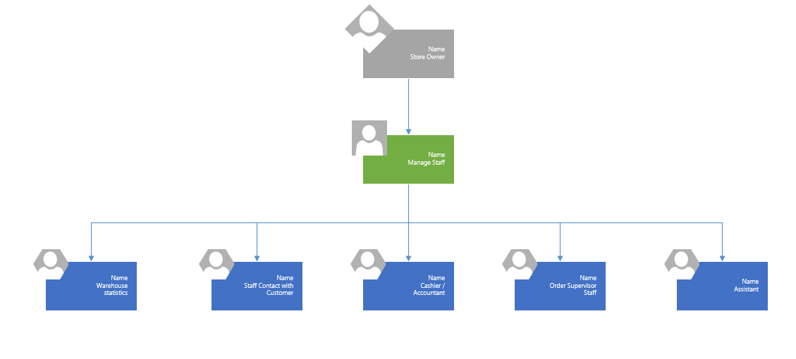

**Figure 1: Organization Chart of the department of Application management.**

* 1. The scope of the system:

Provide the software or solution for the owner with the following requirements:

- Customer Information Management.

- Manage orders.

- Revenue management.

- Introduce detailed information for the product.

- View order history.

- Consulting and customer support.

- Promote products widely to consumers.

* 1. Problem of Store Owner:

- Cannot promote the product to consumers.

- Poor customer information security.

- Staff only use paper to record customer information and orders.

- Difficulty in finding and editing customer and order information.

- It takes a lot of time to do sales statistics and order statistics.

- Bringing a lot of risks in the process of working and communicating with customers.

- The store management system still has many problems.

=> Store owners demanded an app that could be used by them to easily use, manage, save time, reduce risk, and operate the store more efficiently.

* 1. Introduction System of Store:

- The system of software to manage and support the sale of other softwares was born to replace the lack of the store's sales system.

- The aim of this project is to computerize all of the in-store processes.

- It is a mobile application that allows shop owners to view, retrieve information, and track the store's operation without having to visit the store regularly.

- The design of this app can be changed, upgraded and updated according to the shop owner's request.

- Staff information storage system. Employee details: ID, name, date of birth, address, phone number, email, password and work location.

- The system stores information about customers. Customer details: ID, name, phone, email, password, second-level password, address.

- System to store information of orders. Order details: ID, total order value, product ID, product name, quantity of products, price of each product, details of each product and image.

- System store promotions including promotion code and value.

CHAPTER 2: SRS DOCUMENT

2.1 Actor:

**Customer:** Interacting with the system to view products, find products, read product details and buy products. Customers can interact with employees to ask for advice, answer questions or need technical assistance.

**Employee:** Support customers in the process of purchasing products or product warranty support.

**Cashier / Accountant:** Check, receive payments, print invoices, save customer information, record revenue and check revenue.

**Manager:** Order management, employee management, revenue management, coupon management, write report.

**Store owner:** Responsible for managing the system, tracking all activities, viewing reports, viewing order history, sales, customer information, products and customer feedback.

**2.2 Flow Chart:**

***2.2.1 Customer:***

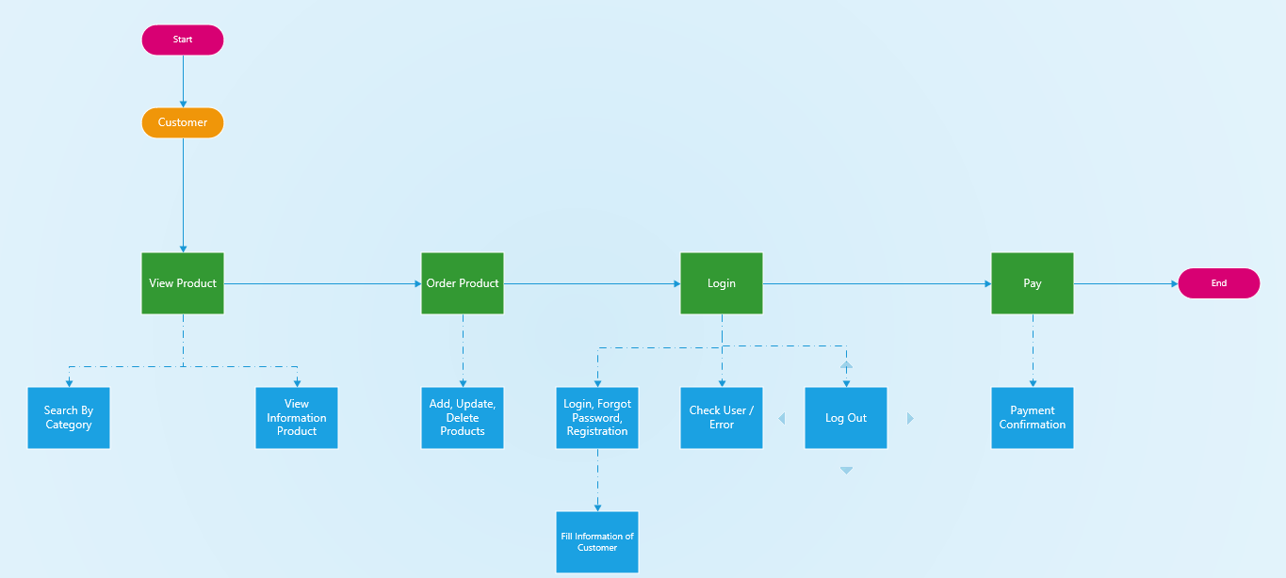

**Figure 2: Flow Chart Of Customer**

### *2.2.2 Cashier / Accountant:*

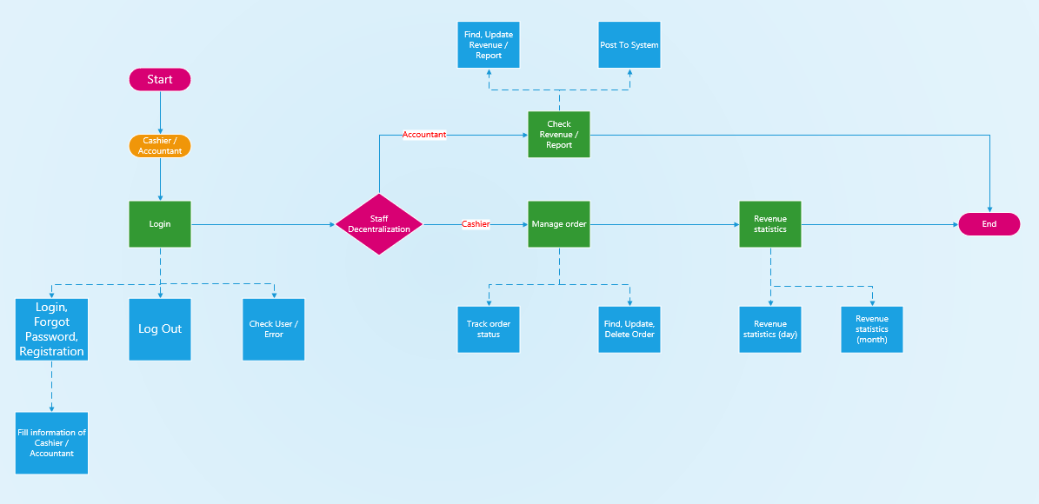

**Figure 3: Flow Chart Of Cashier / Accountant**

### *2.2.3 Staff:*

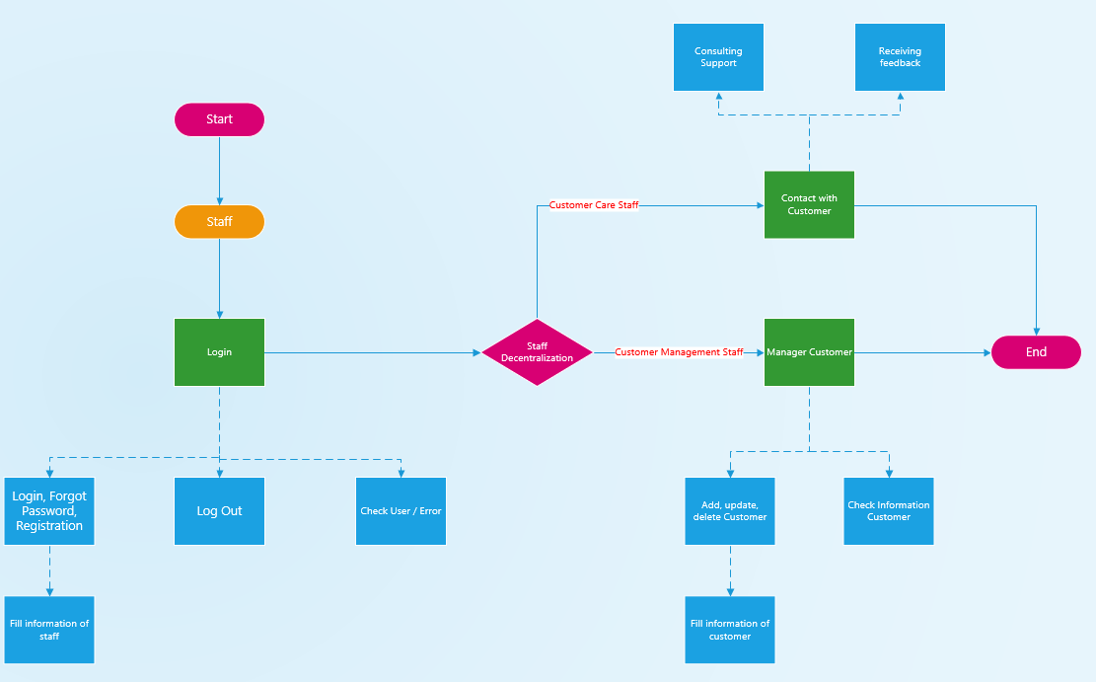

**Figure 4: Flow Chart Of Staff**

***2.2.4 Manager:***

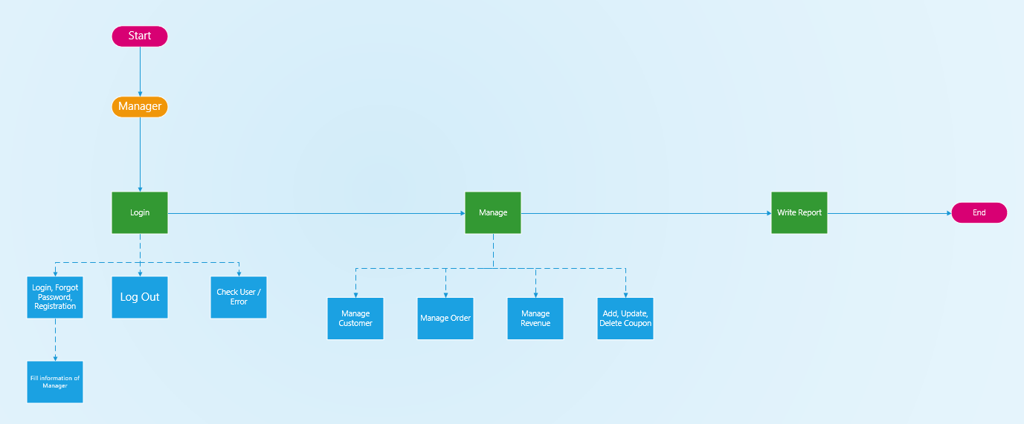

**Figure 5: Flow Chart Of Manager**

***2.2.5 Store Owner:***

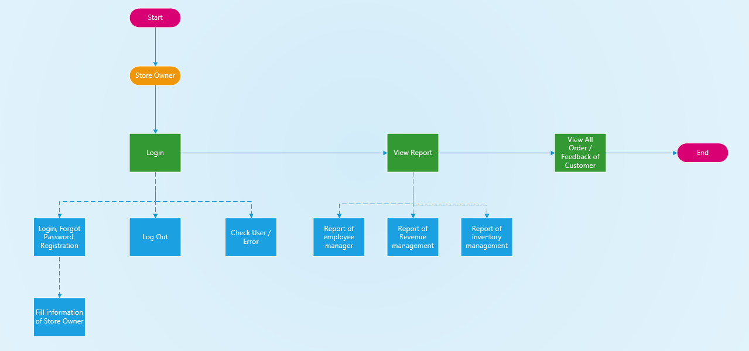

**Figure 6: Flow Chart Of Store Owner (Admin)**

2.3 Question of Author and Customer Answer:

|  |  |  |
| --- | --- | --- |
| Section / Screen | Comment / Question | Answer |
| Form Login | Question: Regarding the login entered the system, here I don't see mention of decentralization for user when logged in at all. Here covers. which positions and rights?  Offer: Here, there are 4 main. The positions are employees, shop owners (admin), managers, and customers.  Shop owner: is the person with the highest position in the system, can exercise all his powers.  Manager: is the person with the second highest position in the system, product management, employee management, order management, customer information management, revenue management.  Employees: is a person who directly interacts with customers through the system, supporting exchanging all problems with customers and orders.  Cashier / Accountant: who is obliged to collect money, print invoices, store customer information, orders, revenue statistics and reports.  Customer: have the right to view, search, order, respond to personal comments and review order history. | We totally agree |
| Product quality and warranty | Question: Products with quality assurance or not? Is there a warranty if an error or problem occurs during use?  Offer: Products have been carefully checked before selling and if there are any problems during use, they will be supported directly from the store. | We totally agree |
| Service | Question: If you have any questions or need advice, do you have to meet the staff in person or can you talk remotely?  Offer: If you have any questions or need advice, customers can go to the store to talk directly with staff or do not have time, you can still talk remotely, the staff will advise and answer all the questions, cost to customers in the fastest, most accurate and most dedicated way. | We totally agree |
| Coupon | Offer: Customers who order during the promotion or customers have a discount card or code, when customers make payment, they will be offered the corresponding value as provided in the voucher (the voucher must be still available. expiry date) | We totally agree |

2.4 Functional Requirement:

- The system supports adding, correcting and deleting customers.

- The system supports adding, fixing and deleting products.

- The system supports adding, correcting and deleting orders.

- The system supports adding, modifying and deleting staff.

- The system supports revenue statistics (day and month).

- The system supports interaction with customers through the application.

- Support system to introduce products to customers.

- Invoice printing and payment system.

2.5 Non Functional Requirement:

- The needs in terms of performance, logical database requirements, design

constraints, standards compliance, reliability, availability, security,

maintainability and portability.

- The load time for user interface screens shall take no logger than two seconds.

- The log in information shall be verified within five senconds.

- Queries shall return within five seconds.

2.6 List of Use Case:

* **Create Account**:
* Customers will be able to create their own account and password.
* The Store Owner will create a separate account to use for the admin page to manage his system.
* Each employee will be created by the shop owner with a default account to serve his work based on the employee's location.
* **Login**: Customers, employees and shop owners can use the login function to interact with the system in a better way.
* **Error password**: if the user write the wrong password, an error message will appear and show “login error” on screen, user must login again.
* **Change Password**: People can change their passwords to increase account security.
* **View Product**: People can view the full product information they need and all products in the store.
* **Search Product**: People can search for the products they want in the store.
* **Order Product**: Customers can buy products on the store system. The staff will then update the order and make an order confirmation.
* **Select the product number**: Customers can choose the number of products they want to buy.
* **Pay**: Pay the bill for the product you bought.
* **Support Customers**: People and staff can interact with each other through customer support function.
* **Create Order**: Staff will create orders upon request from customers.
* **Update Order**: Staff can update information of the order when requested from customers.
* **Delete Order**: In cases where the order has been paid or the customer cancels the order (where permitted), the order may be canceled.
* **Show Order On System**: Employees will display all orders on the system for everyone to see and rely on to conduct their work.
* **Check Information Order**: The cashier will check the order information before making payment and print an invoice.
* **Print receipts**: The cashier will print the invoice before or after the payment.
* **Save Information**: Cashier will record customer information when customers buy products at the store.
* **Account Management**: Store owners will manage all accounts.
* **Insert Account**: Store owners can add accounts when necessary.
* **Update Account:** Store owners can update accounts when necessary**.**
* **Delete Account**: Store owners can delete accounts when necessary.
* **Account Statistics**: Store owners has statistics of the number of accounts.
* **Search Account**: Store owners can search all accounts on the system.
* **Employee Manage**: Store owners can manage all employees through the system
* **Insert Employee**: Store owners can add employees when more employees work in the store.
* **Update Employee**: Store owners can update employees when necessary.
* **Delete Employee**: The owner of a store may delete an employee when he or she has quit a job in the store.
* **Employee Statistics**: The owner manage employees information and their status at the store.
* **Search Employee**: Store owners can search for all employee information at the store.
* **Product management**: this is where the owner manage products information. They can change product information if there is enough products, and update when new one is arrive at the store.
* **Insert Product**: When a new product is available, the store owner will be able to add products and information to the system.
* **Update Product**: When there is a problem to amend or add information to the product, the store owner can update the product information.
* **Delete Product**: When the store no longer sells the product or the product is no longer manufactured, the store owner can use this function to remove the product from the system.
* **Product Statistics**: We can count the number of products in stock or in stock and how many are left. Can make statistics on what products sell well and which products sell slowly.
* **Search Product**: When we want to see product or delete it, the search function will help you find it faster.
* **Revenue statistics:** report sales by day and by month.

2.7 Use Case Diagram And Specification:

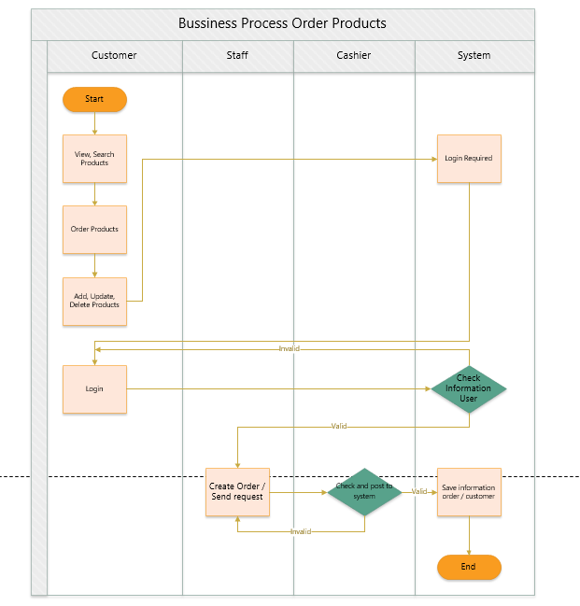

**Figure 7: Process Order Product**

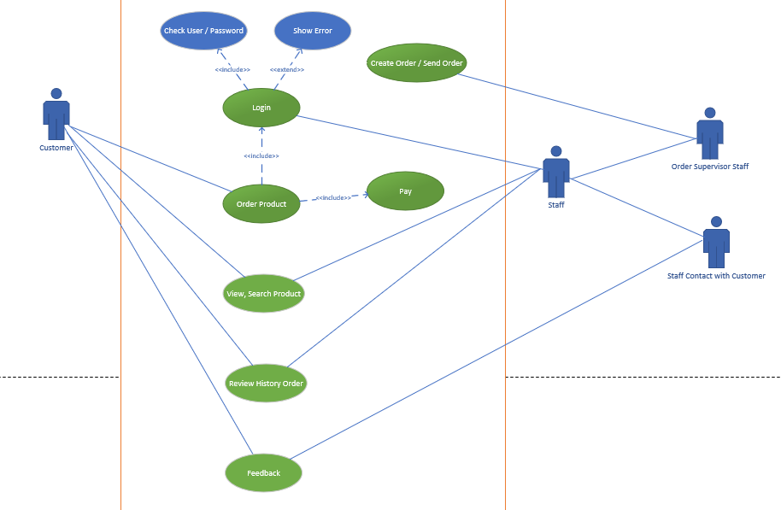

**Figure 8: Schema use case diagram about customer with employee.**

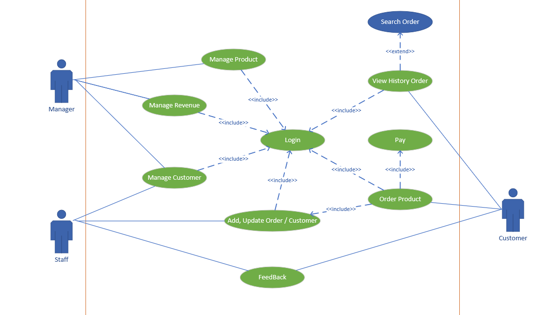

**Figure 9: Schema use case diagram about system.**

Use case specification:

* Use case Customer Login

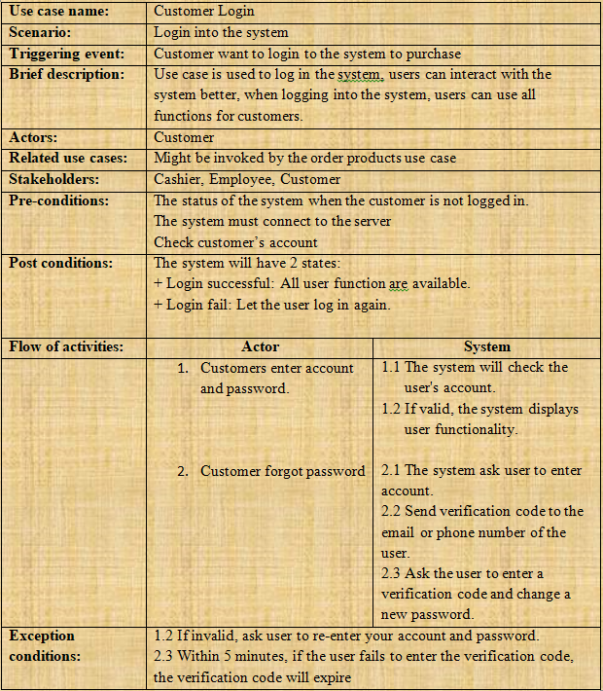

**Figure 10: Use Case Specification Customer Login**

* Use case Store Owners manage product

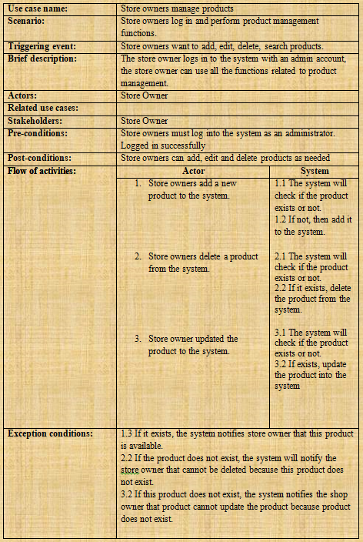

**Figure 11: Use Case Specification Store Owners manage product**

* Use case Customer create a new account:

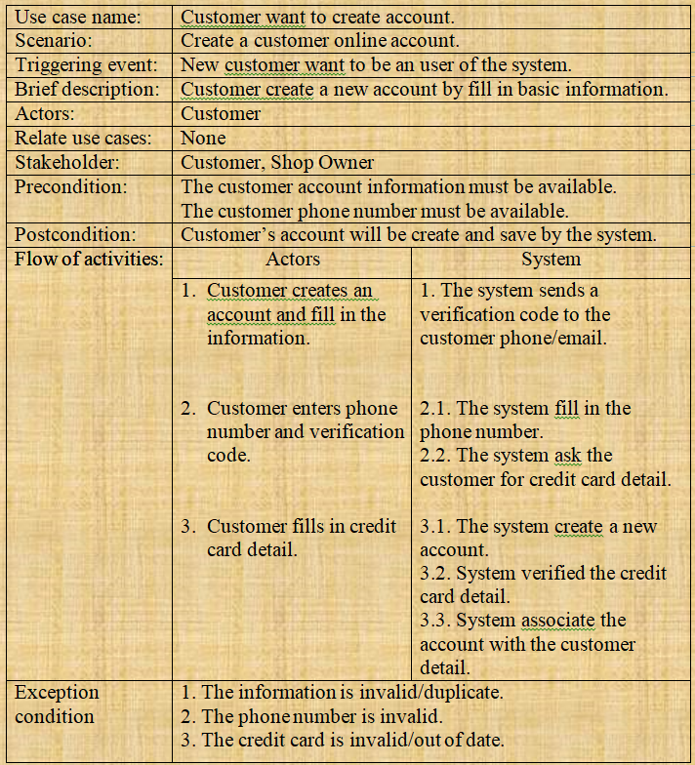

**Figure 12: Use Case Specification Customer create a new account**

* Use case Customer view the product:

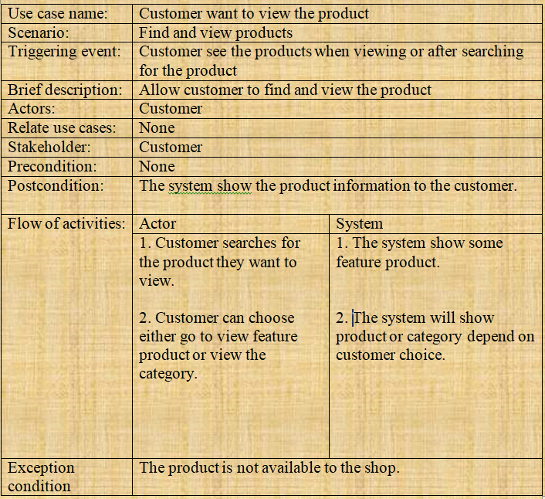

**Figure 13: Use Case Specification Customer view the product**

CHAPTER 3: DESIGN DOCUMENT

**3.1 Class Diagram:**

**3.2 Activity and Sequence Diagram:**

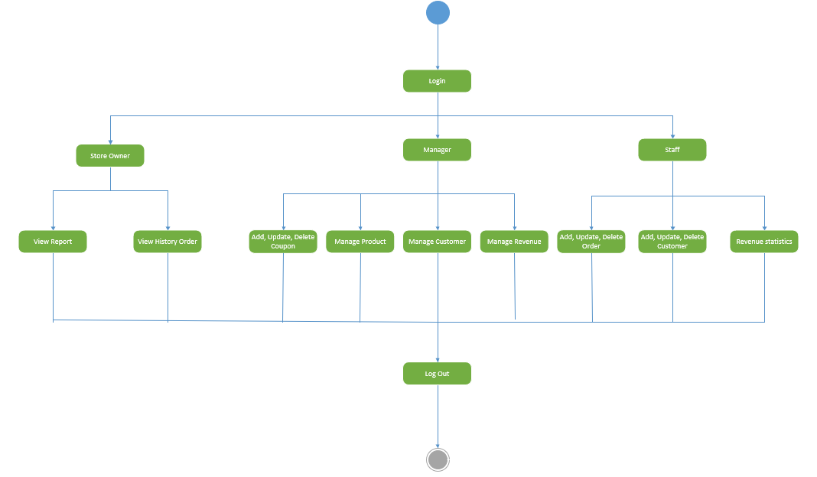

**Figure 14: Activity Diagram about system management apparatus**

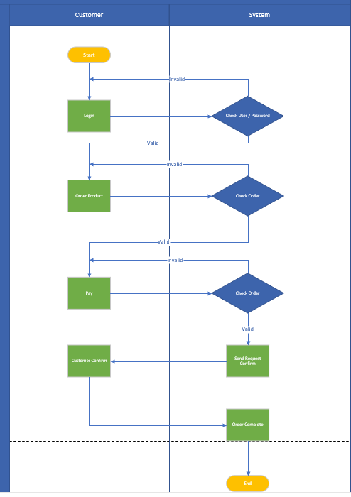

**Figure 15: Activity Diagram about login and order product.**

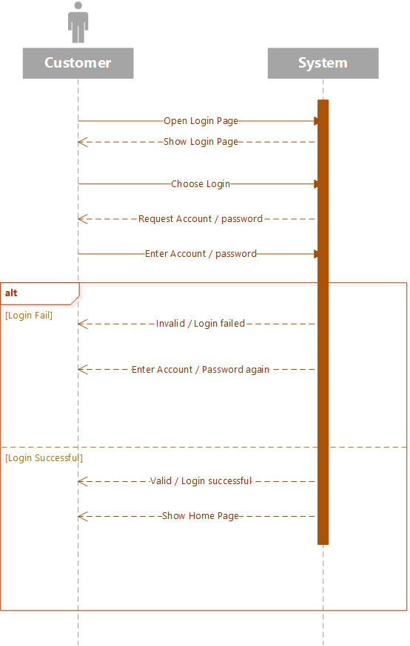

**Figure 16: Sequence Diagram for Customer Login with System**

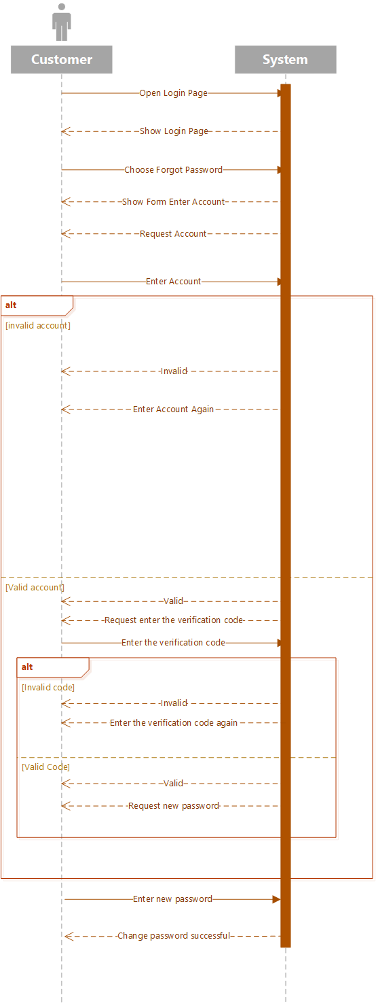

**Figure 17: Sequence Diagram For Customer Forgot Password**

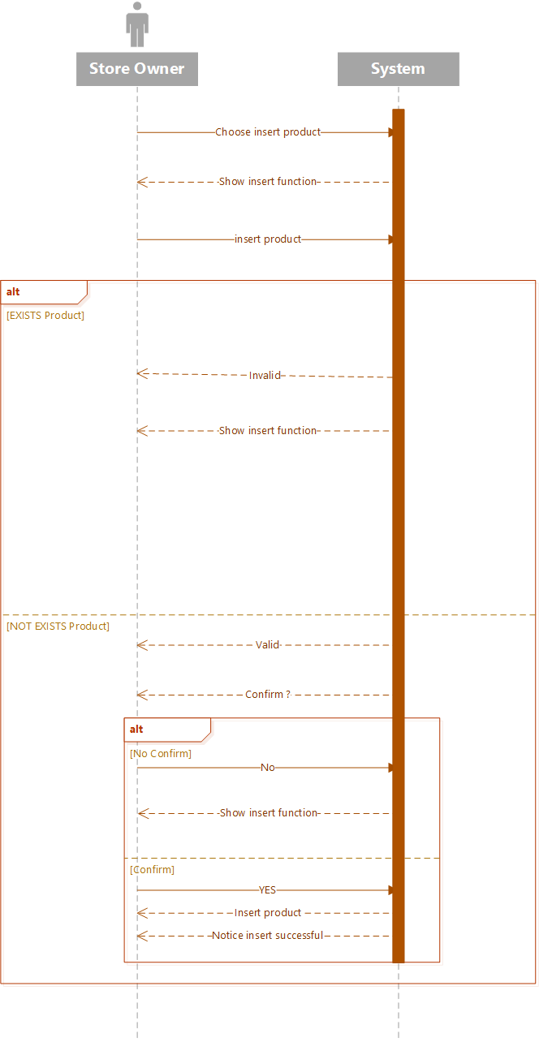

**Figure 18: Sequence Diagram For Store Owner Insert Product**



**Figure 19: Sequence Diagram For Customer Create New Account**



**Figure 20: Sequence Diagram For Customer View Home Page**

**3.3 Entity Relationship Diagram:**

**CHAPTER 04: REALIZE SOFTWARE**

**4.1 Database:**

***4.1.1 Entity relationship diagram:***

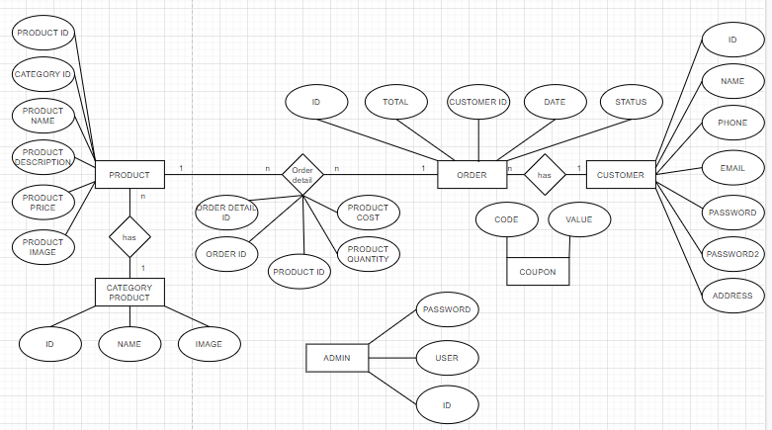

**Figure 21: Entity relationship diagram**

***4.1.2 Relation model diagram:***

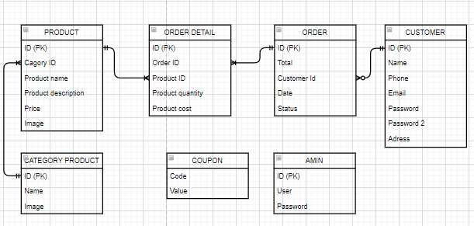

**Figure 22: Relation model diagram**

***4.1.3 Details of the tables:***

**- Admin table:**

|  |  |  |  |
| --- | --- | --- | --- |
| **Num** | **Variable Name** | **Data type and size** | **Binding** |
| 1 | Admin_id | int (11) | Primary key |
| 2 | Admin_user | varchar(50) | Not Null |
| 3 | Admin_password | varchar(50) | Not Null |

**- Category_Product table:**

|  |  |  |  |
| --- | --- | --- | --- |
| **Num** | **Variable Name** | **Data type and size** | **Binding** |
| 1 | Category_id | int (11) | Primary key |
| 2 | Category_name | varchar(100) | Not Null |
| 3 | Category_image | varchar(100) | Not Null |

**- Coupon table:**

|  |  |  |  |
| --- | --- | --- | --- |
| **Num** | **Variable Name** | **Data type and size** | **Binding** |
| 1 | Category_code | varchar (100) | Primary key |
| 2 | Category_value | int(11) | Not Null |

**- Customer table:**

|  |  |  |  |
| --- | --- | --- | --- |
| **Num** | **Variable Name** | **Data type and size** | **Binding** |
| 1 | Customer_id | int(11) | Primary key |
| 2 | Customer_name | varchar (100) | Not Null |
| 3 | Customer_phone | varchar(100) | Not Null |
| 4 | Customer_email | varchar(100) | Not Null |
| 5 | Customer_password | varchar(100) | Not Null |
| 6 | Customer_pass2 | text | Not Null |
| 7 | Customer_address | text | Not Null |

**- Order table:**

|  |  |  |  |
| --- | --- | --- | --- |
| **Num** | **Variable Name** | **Data type and size** | **Binding** |
| 1 | Order_id | int(11) | Primary key |
| 2 | Order_total | int(11) | Not Null |
| 3 | Customer_id | int(11) | Not Null |
| 4 | Order_date | datetime | Not Null |
| 5 | Order_status | int(11) | Not Null |

**- Order_Detail table:**

|  |  |  |  |
| --- | --- | --- | --- |
| **Num** | **Variable Name** | **Data type and size** | **Binding** |
| 1 | Order_detailID | int(11) | Primary key |
| 2 | Order_id | int(11) | Not Null |
| 3 | Product_id | int(11) | Not Null |
| 4 | Product_quantity | int(11) | Not Null |
| 5 | Product_cost | int(11) | Not Null |

**- Product table:**

|  |  |  |  |
| --- | --- | --- | --- |
| **Num** | **Variable Name** | **Data type and size** | **Binding** |
| 1 | Product_id | int(11) | Primary key |
| 2 | Category_id | int(11) | Not Null |
| 3 | Product_name | varchar(100) | Not Null |
| 4 | Product_description | varchar(100) | Not Null |
| 5 | Product_price | int(11) | Not Null |
| 6 | Product_image | varchar(255) | Not Null |

**CHAPTER 05: APPLICATION DEMO**

**5.1 Introduction:**

Mobile application that allows users to shop online. Users can view, select and make purchases.

The application can manage customer information including: Name, phone number, email, password and address. When making a purchase, the app stores order history and allows administrators to manage it.

In addition, administrators can edit or delete products, check sales by day and manage discount codes.

**5.2 Application detail:**

***5.2.1 User account:***

* Create account

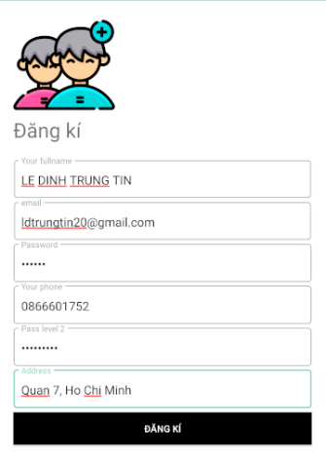

**Figure 23: Create acount**

* Login

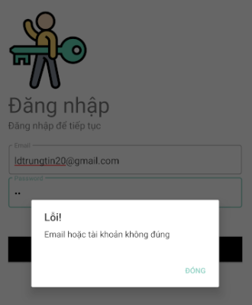

**Figure 24: Error login**

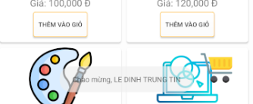

**Figure 25: Success login**

* Forget password

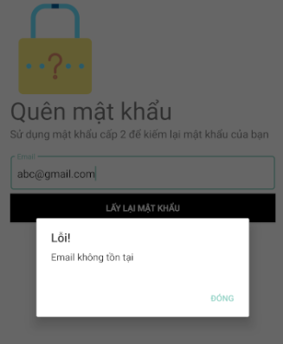

**Figure 26: Wrong email**

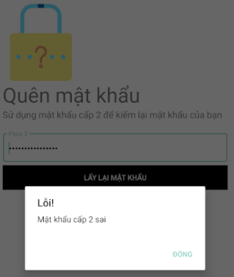

**Figure 27: Wrong password 2**

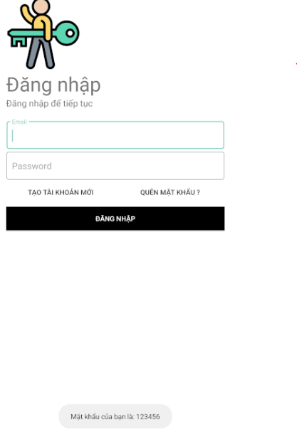

**Figure 28: Right password 2**

***5.2.2 Shopping:***

* Home page

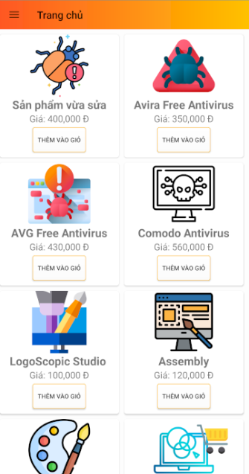

**Figure 29: Home page**

* You can click “Thêm vào giỏ” button to add to cart



**Figure 30: Add to cart button**

* You can click image of product to see detail



**Figure 31: See detail product**

* Product detail screen

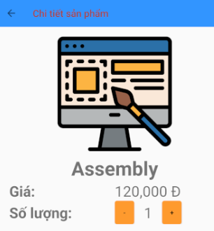

**Figure 32: Product detail screen**

* Cart screen

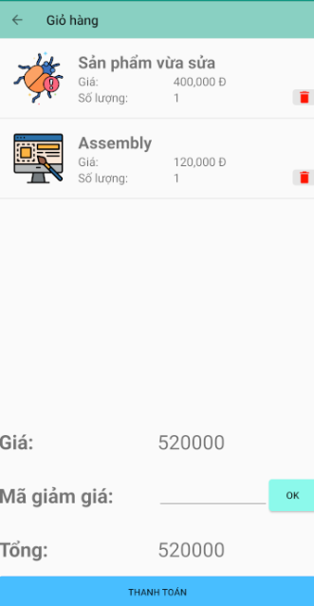

**Figure 33: Cart screen**

* Delete product

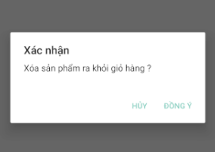

**Figure 34: Delete product**

* Apply discount

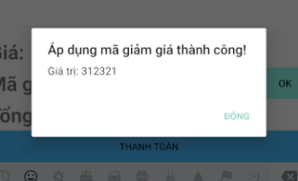

**Figure 35: Apply code success**

* Payment

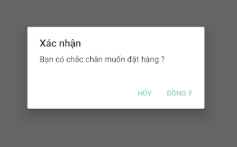

**Figure 36: Payment**

***5.2.3 User information:***

* User page

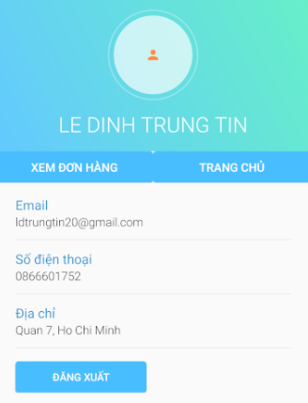

**Figure 37: User page**

* Check order
  + Click button “Xem đơn hàng”



* + List order

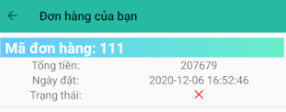

**Figure 38: List order**

* + Detail order

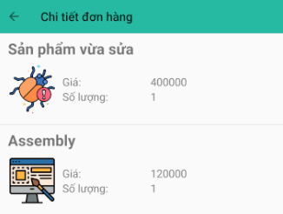

**Figure 39: Detail order**

***5.2.4 Admin:***

* Amin page

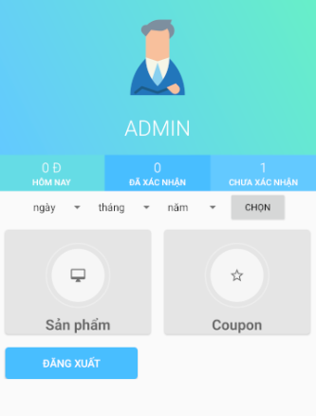

**Figure 40: Admin page**

* Main menu:

Revenue today, confirmed order and unconfirmed

You can choose the day, month, year to check the sales and the orders of the date to check

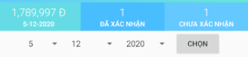

**Figure 41: Pick a date**

* Click button “Đã xác nhận” to see confirmed orders



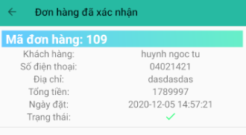

**Figure 42: List confirmed orders**



**Figure 43: Cancel the order**

* Click button “Chưa xác nhận” to see unconfirmed orders



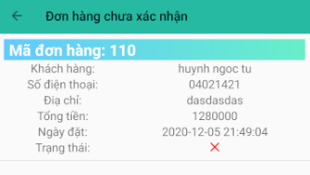

**Figure 44: List unconfirmed orders**

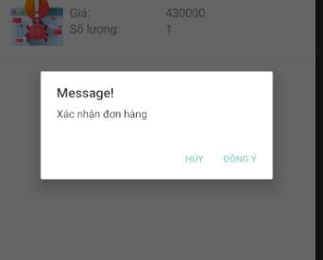

**Figure 45: Confirm the order**

* Product
  + Click button “Sản phẩm”

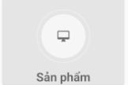

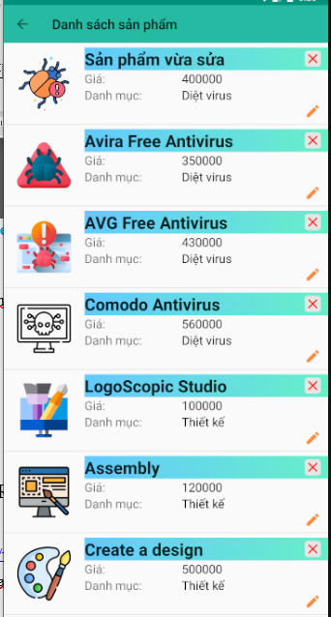

**Figure 46: List products**

* + Click edit button “” to enable edit

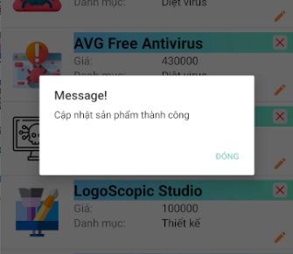

**Figure 47: Edit a product success**

* + Click delete button “ ” to delete button



**Figure 48: Delete a product**

* Coupon
  + Click button “Coupon”

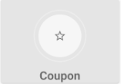

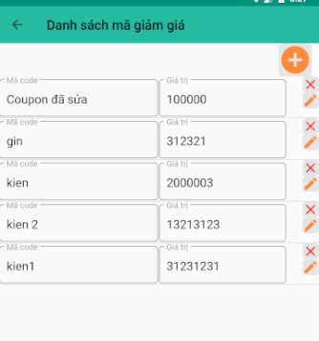

**Figure 49: List code discounts**

* + Add a code discount



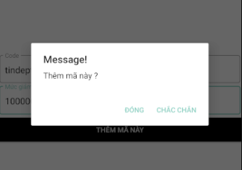

**Figure 50: Add a code discount**

* + Edit a code discount



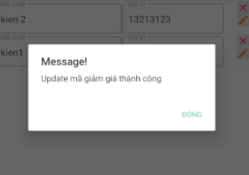

**Figure 51: Edit success**

* + Delete a code discount



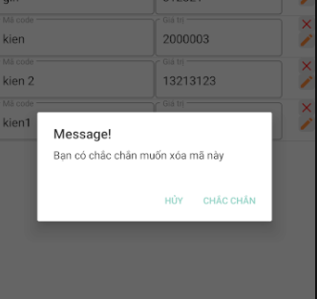

**Figure 52: Delete a code discount**

* **c**

**REFERENCES**

**VIETNAMESE:**

1. Tìm hiểu về use case, <https://viblo.asia/p/tim-hieu-ve-use-case-DbmvmLAXkAg>
2. Activity diagram: Bản vẽ hoạt động, <https://iviettech.vn/blog/1066-activity-diagram-ban-ve-hoat-dong.html>
3. Use case, <https://vi.wikipedia.org/wiki/Use_case>
4. Tổng quản về use case, <https://techmaster.vn/posts/7771/tong-quan-ve-use-case>

**ENGLISH:**

1. Class diagram, <https://en.wikipedia.org/wiki/Class_diagram#:~:text=The%20class%20diagram%20is%20the,be%20used%20for%20data%20modeling.>
2. Activity diagram, <https://www.tutorialspoint.com/uml/uml_activity_diagram.htm#:~:text=Activity%20diagram%20is%20another%20important,from%20one%20operation%20to%20another.>
3. What is activity diagram, <https://www.visual-paradigm.com/guide/uml-unified-modeling-language/what-is-activity-diagram/>
4. Sequence diagram, <https://en.wikipedia.org/wiki/Sequence_diagram#:~:text=A%20sequence%20diagram%20shows%20object,the%20functionality%20of%20the%20scenario.>
5. What is sequence diagram, <https://www.visual-paradigm.com/guide/uml-unified-modeling-language/what-is-sequence-diagram/>