Lab Work-3

Github Link:
Paste the Class Diagram here: (3pts)
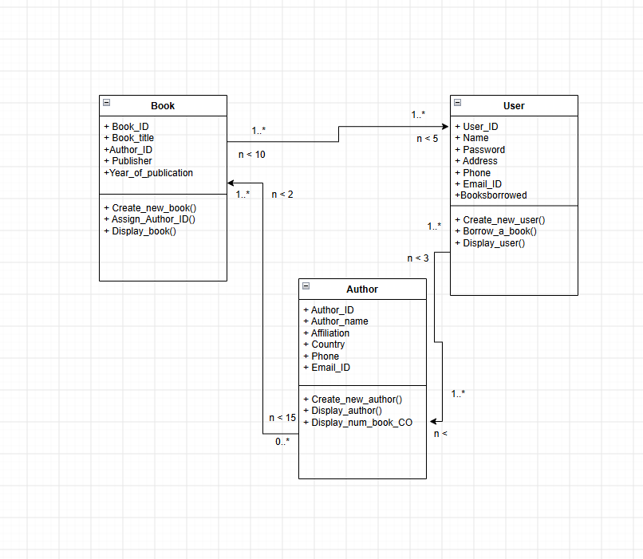
Paste your Python code here: (4pts)

Paste the screenshots of all possible [all the operation] outputs: (3pts)

