PORTFOLIO OF EVIDENCE: PART 2
Municipal Services Application
Read Me
Student Number: ST10540538
Sbahle Khuzwayo

GitHub Repository
The full source code for this project is hosted on GitHub:
https://github.com/PHAKATHWAYO0/MunicipalServicesApp

Project Overview
This submission continues the Municipal Services Application. Part 1 delivered the Report Issues module. Part 2 adds the Local Events and Announcements module, which lets residents see upcoming municipal events, search them by keyword, category and date, and receive recommendations based on what they search for.
On the Main Menu, Report Issues (Part 1) and Local Events and Announcements (Part 2) are enabled. Service Request Status stays disabled because it belongs to Task 3.

How to Compile and Run
- Install Visual Studio 2022 (Community edition is fine) with the ".NET desktop development" workload.
- Open MunicipalServicesApp.sln by double-clicking it, or use File > Open > Project/Solution.
- Build the solution with Build > Build Solution, or press Ctrl+Shift+B.
- Run the application with F5 or the green Start button.
- No NuGet packages or internet connection are needed. Only the built-in System.Windows.Forms libraries are used.

How to Use the Local Events Page
- On the Main Menu, click "Local Events and Announcements".
- The page opens with every upcoming event listed in date order.
- Type a word in Search to match event titles, descriptions or locations, then click Search.
- Pick a category from the Category dropdown to see only that type of event.
- Tick "Filter by date range", set the From and To dates, then click Search.
- Click "Clear" to remove all filters and show every event again.
- Click an event in the list to read its full details underneath. It is also added to the Recently Viewed list.
- Watch the sidebar: Next Upcoming, Recommended for You, Recently Viewed and Recent Searches update as you use the page.
- Click "Back to Main Menu" to return.

Data Structures Used
Each data structure was chosen for a specific job in the Local Events module, rather than using one list for everything.
Data structure | Where it is used | What it does for the user
SortedDictionary<DateTime, List<Event>> | EventRepository (main event store) | Keeps events organised by date automatically, so the list is always in date order and several events can share one day.
Dictionary<string, int> | EventRepository (category search counts) | Counts how often each category is searched. This is what the recommendation feature learns from.
HashSet<string> and HashSet<DateTime> | EventRepository (categories and dates) | Holds unique categories and dates, so the category dropdown never shows duplicates.
Stack<Event> | EventRepository (Recently Viewed) | Last-in, first-out history. The event you viewed most recently appears at the top.
Queue<string> | EventRepository (Recent Searches) | First-in, first-out list of search terms, limited to the last 8 searches.
Custom priority queue (min-heap) | EventPriorityQueue, used for Next Upcoming | Returns the soonest events first without re-sorting everything. Written by hand because .NET Framework 4.8 has no built-in PriorityQueue.

Recommendation Feature
Every time a user searches with a category selected, the app adds one to that category's count in a dictionary. The Recommended for You list then shows upcoming events from the category searched most often, soonest first.
If that category has fewer events than needed, the list is topped up with other upcoming events. If the user has not searched yet, the list falls back to the soonest upcoming events overall. Recommendations refresh after every search.

Source Code
The complete code is in the project folder and on GitHub.
Models/Event.cs: the event model
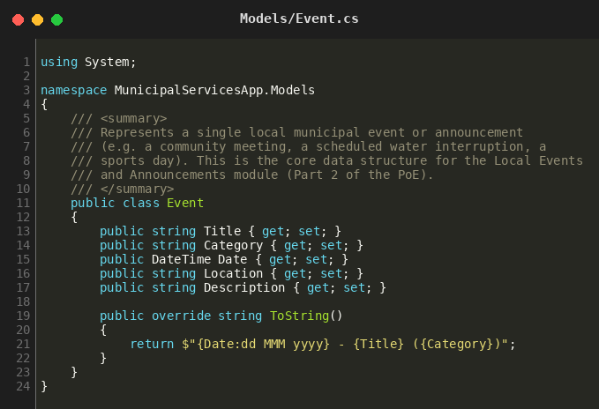
Data/EventPriorityQueue.cs: custom min-heap priority queue
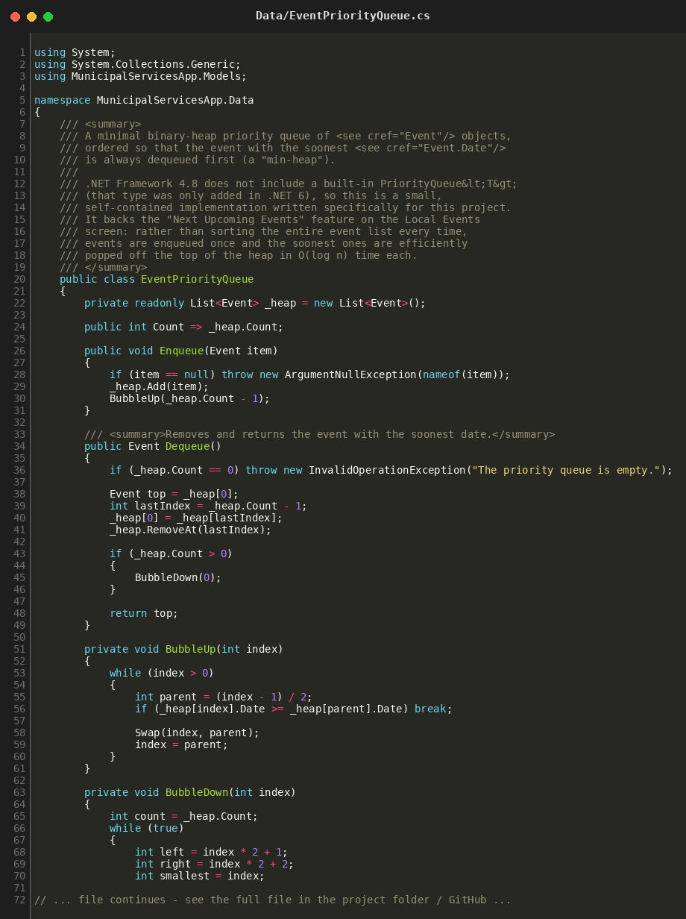
(Excerpt shown. The full file is in the project folder and on GitHub.)
Data/EventRepository.cs: SortedDictionary, HashSets, Stack, Queue, Dictionary, search and recommendations
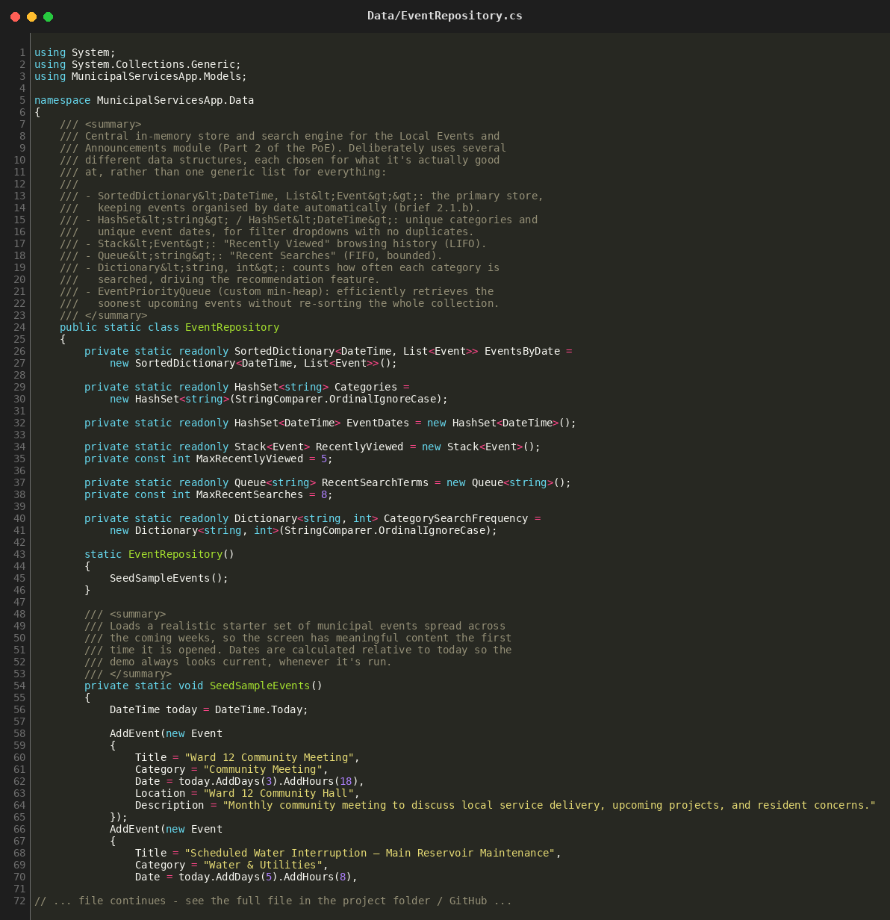
(Excerpt shown. The full file is in the project folder and on GitHub.)
Forms/LocalEventsForm.cs: the Local Events page logic
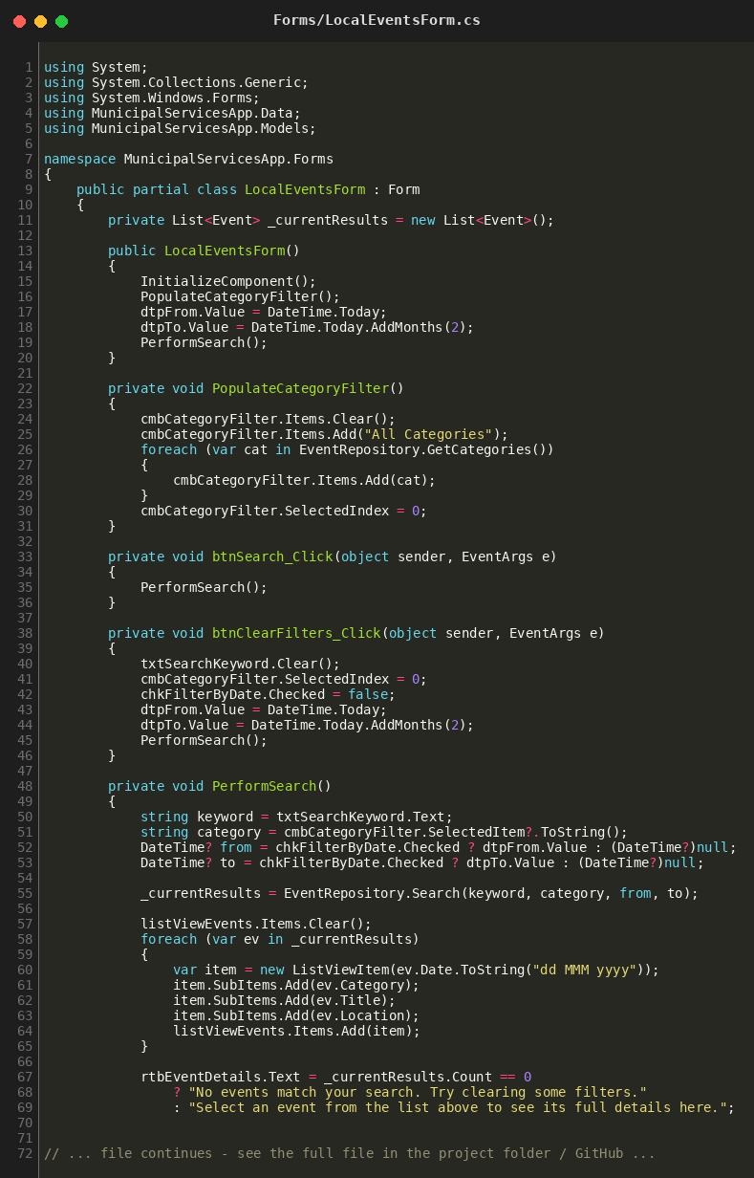
(Excerpt shown. The full file is in the project folder and on GitHub.)
Forms/MainMenuForm.cs: Main Menu with Local Events enabled
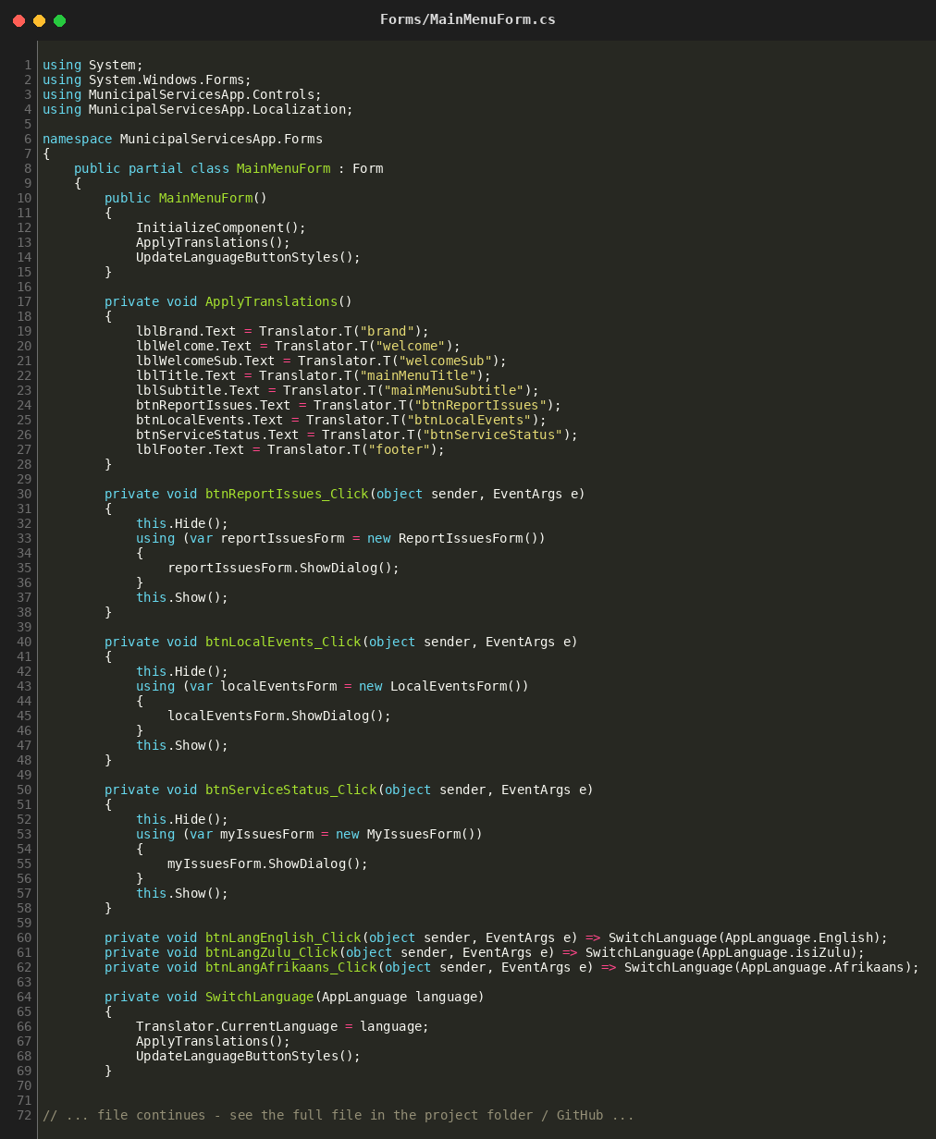
(Excerpt shown. The full file is in the project folder and on GitHub.)

Application Output: Screenshots

