同济大学计算机系

数字逻辑课程实验报告



学 号 2252707
姓 名 陈艺天
专 业 计算机科学与技术
授课老师 张冬冬

- 行为级ALU
- 实验内容
在本次实验中，我们将使用 Verilog HDL 语言实现行为级ALU 的设计和仿真。
- 模块建模
<ALU>模块建模

module alu(
input [31:0] a,
input [31:0] b,
input [3:0] aluc,
output reg [31:0] r,
output reg zero,
output reg carry,
output reg negative,
output reg overflow
);
reg [32:0] tmp;

always @(*) begin

casex(aluc)

4'b0000:/*Addu*/begin
{carry, r} = a + b;
negative = r[31];
zero = !r;
end

4'b0010:/*Add*/begin
r = a + b;
negative = r[31];
overflow =
(a[31]&b[31]&~r[31])|(~a[31]&~b[31]&r[31]);
zero = !r;
end
4'b0001:/*Subu*/begin
r = a - b;
negative = r[31];
tmp = 33'b1_00000000_00000000_00000000_00000000 + a - b;
carry = ~tmp[32];
zero = !r;
end
4'b0011:/*Sub*/begin
r = a - b;
negative = r[31];
overflow =
(~a[31]&b[31]&r[31])|(a[31]&~b[31]&~r[31]);
zero = !r;
end
4'b0100:/*And*/begin
r = a & b;
negative = r[31];
zero = !r;
end
4'b0101:/*Or*/begin
r = a | b;
negative = r[31];
zero = !r;
end
4'b0110:/*Xor*/begin
r = a ^ b;
negative = r[31];
zero = !r;
end
4'b0111:/*Nor*/begin
r = ~(a | b);
negative = r[31];
zero = !r;
end
4'b100x:/*Lui*/begin
r = {b[15:0],16'b0};
negative = r[31];
zero = !r;
end
4'b1011:/*Slt*/begin
if(a[31]==b[31])
r = (a < b) ? 1: 0;
else
r = a[31];
negative = r[0];
zero = (a==b)?1:0;
end
4'b1010:/*Sltu*/begin
r = (a < b) ? 1: 0;
negative = r[31];
carry = (a < b) ? 1: 0;
zero = (a==b)?1:0;
end
4'b1100:/*Sra*/begin
if(!b[31])
r=(b>>(a-1));
else
r=(b>>(a-1))|~(32'b11111111111111111111111111111111>>(a-1));
carry = r[0];
if(!b[31])
r = r>>1;
else begin
r = r>>1;
r = {1'b1,r[30:0]};
end
negative = r[31];
zero = !r;
end
4'b111x:/*Sll/sla*/begin
r = b << (a-1);
carry = r[31];
r = r << 1;
negative = r[31];
zero = !r;
end
4'b1101:/*srl*/begin
r = b >> (a-1);
carry = r[0];
r = r>>1;
negative = r[31];
zero = !r;
end
default:
;
endcase

end

endmodule
- 测试模块建模
<加法模块测试>
module alu_tb;

reg [31:0] a;
reg [31:0] b;
reg [3:0] aluc;
wire [31:0] r;
wire zero;
wire carry;
wire negative;
wire overflow;

alu inst(a,b,aluc,r,zero,carry,negative,overflow);

//test addu
initial begin
aluc = 4'b0000;
a = 32'b1000_0010_0000;
b = 32'b1000_0010_0000;

#40
aluc = 4'b0000;
a = 32'b0000_0000_0000;
b = 32'b0000_0000_0000;

#40
aluc = 4'b0000;
a = 32'b1000_0010_0000_0000_0000_0000_0000_0010;
b = 32'b1000_0010_0000_0001_0000_0000_0000_0000;

#40
aluc = 4'b0000;
a = 32'b0011_0110_0000_0000_0000_0000_0000_0010;
b = 32'b1000_0010_0000_0001_0000_0000_0000_0000;
end

endmodule

module alu_tb_add;

reg [31:0] a;
reg [31:0] b;
reg [3:0] aluc;
wire [31:0] r;
wire zero;
wire carry;
wire negative;
wire overflow;

alu inst(a,b,aluc,r,zero,carry,negative,overflow);

//test addu
initial begin
aluc = 4'b0010;
a = 32'b1000_0010_0000;
b = 32'b1000_0010_0000;

#40
aluc = 4'b0010;
a = 32'b0000_0000_0000;
b = 32'b0000_0000_0000;

#40
aluc = 4'b0010;
a = 32'b1000_0010_0000_0000_0000_0000_0000_0010;
b = 32'b1000_0010_0000_0001_0000_0000_0000_0000;

#40
aluc = 4'b0010;
a = 32'b0011_0110_0000_0000_0000_0000_0000_0010;
b = 32'b1000_0010_0000_0001_0000_0000_0000_0000;
end

endmodule

<减法模块测试>
module alu_tb_sub;

reg [31:0] a;
reg [31:0] b;
reg [3:0] aluc;
wire [31:0] r;
wire zero;
wire carry;
wire negative;
wire overflow;

alu inst(a,b,aluc,r,zero,carry,negative,overflow);

//test addu
initial begin
aluc = 4'b0011;
a = 32'b1000_0010_0000;
b = 32'b1000_0010_0000;

#40
aluc = 4'b0011;
a = 32'b0000_0000_0000;
b = 32'b1000_0000_0000;

#40
aluc = 4'b0011;
a = 32'b1000_0010_1111_0000_1111_0000_0000_0010;
b = 32'b1000_0010_0000_0001_0000_0000_0000_0000;

#40
aluc = 4'b0011;
a = 32'b0011_0110_0000_0000_0000_0000_0000_0010;
b = 32'b1000_0010_0000_0001_0000_0000_0000_0000;

#40
aluc = 4'b0011;
a = 32'b1111_0110_0000_0000_0000_0000_0000_0010;
b = 32'b0000_0010_0000_0001_0000_0000_0000_0000;
end

endmodule

module alu_tb_subu;

reg [31:0] a;
reg [31:0] b;
reg [3:0] aluc;
wire [31:0] r;
wire zero;
wire carry;
wire negative;
wire overflow;

alu inst(a,b,aluc,r,zero,carry,negative,overflow);

//test addu
initial begin

aluc = 4'b0011;
a = 32'b1000_0010_0000;
b = 32'b1000_0010_0000;

#40
aluc = 4'b0011;
a = 32'b0000_0000_0000;
b = 32'b1000_0000_0000;

#40
aluc = 4'b0011;
a = 32'b1000_0010_1111_0000_1111_0000_0000_0010;
b = 32'b1000_0010_0000_0001_0000_0000_0000_0000;

#40
aluc = 4'b0011;
a = 32'b0011_0110_0000_0000_0000_0000_0000_0010;
b = 32'b1000_0010_0000_0001_0000_0000_0000_0000;
end

endmodule

<位运算模块测试>
module alu_tb_shift;

reg [31:0] a;
reg [31:0] b;
reg [3:0] aluc;
wire [31:0] r;
wire zero;
wire carry;
wire negative;
wire overflow;

alu inst(a,b,aluc,r,zero,carry,negative,overflow);

//test addu
initial begin
aluc = 4'b1011;
a = 32'b1000_0010_0000;
b = 32'b1000_0010_0000;

#40
aluc = 4'b1010;
a = 32'b0000_0000_0000;
b = 32'b1000_0000_0000;

#40
aluc = 4'b1100;
b = 32'b1011_0110_0000_0000_0000_0000_0000_0010;
a = 32'b0000_0000_0000_0000_0000_0000_0000_1000;

#40
aluc = 4'b1111;
b = 32'b1011_0110_0000_0000_0000_0000_0000_0010;
a = 32'b0000_0000_0000_0000_0000_0000_0000_1000;

#40
aluc = 4'b1101;
a = 32'b1111_0110_0000_0000_0000_0000_0000_0010;
b = 32'b0000_0010_0000_0001_1111_1111_0000_0000;
end

endmodule

- 实验结果
Modelsim 仿真图

<1>加法模块
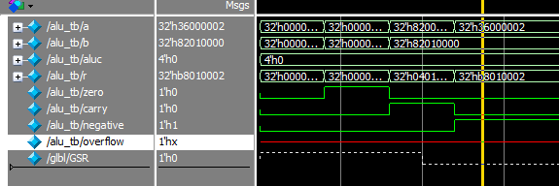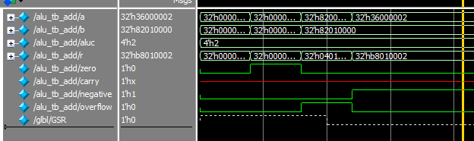

<2>减法模块
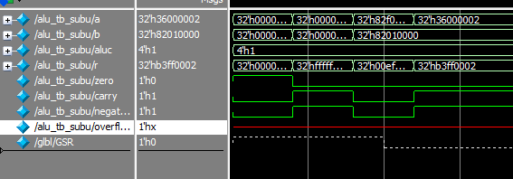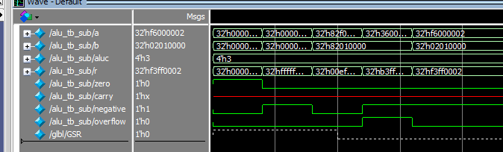
<位运算模块>
