**PHASE I**

**PROJECT NAME : Project 9: Machine Learning Model Deployment with IBM Cloud Watson Studio Edit Set Access Page Actions**

**Deploying and managing machine learning assets**

Use Watson Machine Learning to deploy models and solutions so that you can put them into productive use, then monitor the deployed assets for fairness and explainability. You can also automate the AI lifecycle to keep your machine learning assets current.

**Completing the AI lifecycle**

After you prepare your data and build then train models or solutions, you complete the AI lifecycle by deploying and monitoring your assets.

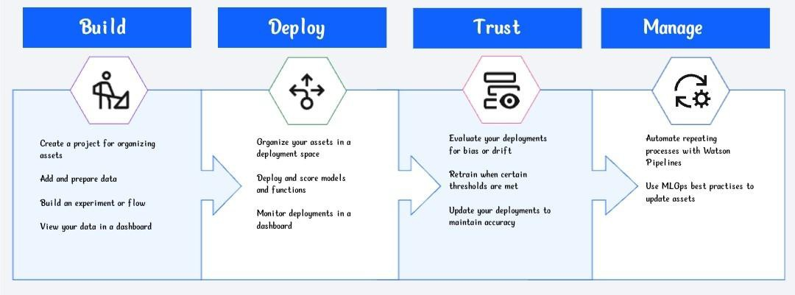

Deployment is the final stage of the lifecycle of a model or script, where you run your models and code. Watson Machine Learning provides the tools that you need to deploy an asset, such as a machine learning model or function, or a Decision Optimization solution.

Following deployment, you can use model management tools to evaluate your models. IBM Watson OpenScale tracks and measures outcomes from your AI models, and helps ensure they remain fair, explainable, and compliant. Watson

OpenScale also detects and helps correct the drift in accuracy when an AI model is in production.

Finally, you can use IBM Watson Pipelines to manage your ModelOps processes. Create a pipeline that automates parts of the AI lifecycle, such as training and deploying a machine learning model.

**Use cases and tutorials**

Watson Machine Learning is part of IBM's data fabric collection of tools and capabilities for managing and automating your data and AI lifecycle. These resources demonstrate how to plan for managing machine learning assets and how to build key pieces of your Data Fabric and machine learning solutions.

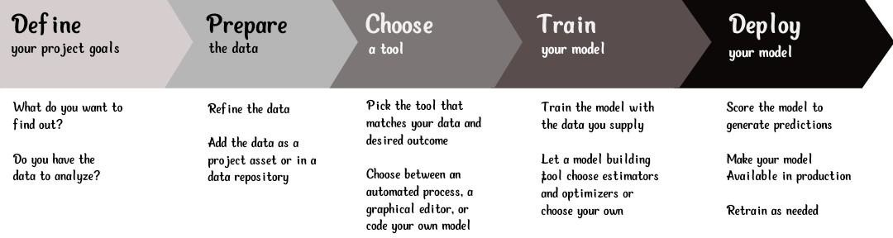

**IBM Watson Machine Learning architecture and services**

Watson Machine Learning is a service on IBM Cloud with features for training and deploying machine learning models and neural networks. Built on a scalable, open source platform based on Kubernetes and Docker components, Watson Machine Learning enables you to build, train, deploy, and manage machine learning and deep learning models.

Using IBM Watson Machine Learning, you can deploy models, scripts, functions, and web apps, manage your deployments, and prepare your assets to be put into production and to generate predictions and insights.

Service The Watson Machine Learning service is not available by default. An administrator must install this service on the IBM Cloud Pak for Data platform.

To determine whether the service is installed, open the Services catalog and check whether the Watson Machine Learning service is enabled.

This graphic illustrates a typical process for a machine learning model.

**Building a machine learning model**

Depending on what is installed and configured for your deployment, you can:

Build, train, and deploy models from notebooks by using the Watson Machine Learning Python client library or the Watson Machine Learning API.

Create AutoAI experiments. AutoAI automatically preprocesses your structured data, selects the best estimator for the data, and then generates model candidate pipelines for you to review and compare. Deploy the best performing pipeline as a machine learning model.

Run experiments to train complex models in Experiment builder.

Deploy your models so that you can score the models and generate predictions.

Running Watson Machine Learning without IBM Watson Studio

If Watson Studio is not installed, you will not be able to access any of the model-building tools and you will have to save your machine learning models to a deployment space programmatically. Additionally, you will be unable to create a batch deployment through the Analytic deployment space interface. Batch deployment requires that you upload a data asset from a project to a space to use as input for the deployment. Projects are not available without Watson Studio.

**Related data fabric use cases**

Review use cases with real-world example of how to put data fabric solutions into practice.

* **Data science and MLOps** use case describes how to manage data, operationalize model building and deployment, and evaluate model fairness and performance.
* **AI governance** use case provides context for how ModelOps can mesh with AI Governance to provide a comprehensive plan for tracking machine learning assets in your organization.

**Deploy Machine Learning (scikit-learn) Models in IBM Cloud — Watson Studio**

IBM Watson Studio provides tools for data scientists, application developers and subject matter experts to collaboratively and easily work with data to build and train models at scale. It gives you the flexibility to build models where your data resides and deploy anywhere in a hybrid environment so you can operationalize data science faster.

IBM Watson Studio provides various tools for designing, training, and managing machine learning models:

Model builder guides you, step by step, through building a model that uses Spark ML algorithms.

Flow editor presents a graphical view of your model while you build it by combining nodes representing objects or actions (including SPSS Modeler nodes, Spark ML algorithm nodes, and neural network nodes.)

Experiment builder automates running hundreds of training runs while tracking and storing results.

Notebooks provide an interactive programming environment for working with data, testing models, and rapid prototyping.

Machine learning command line interface lets you build and work with models in your local environment.

Now we’ll use the capability of Watson Studio notebook instance and deploy Machine learning model in IBM Watson Machine Learning service.

**Let’s deploy a scikit-learn Decision Tree model**

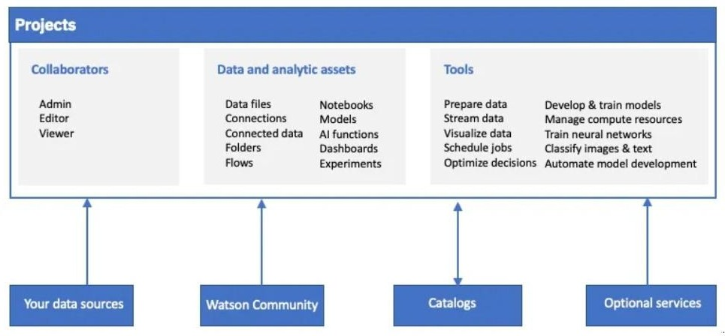

**Let’s deploy a scikit-learn Decision Tree model . You can find the entire code here.**

* Step-1: Login to IBM Cloud here.
* Step -2: Go to catalog and create a Watson Studio service in AI category.
* Step-3: Click on Get started to launch Watson Studio Dashboard
* Step-4: Create a project in IBM Watson Studio Dashboard and assign a Cloud object Storage service to manage datasets

**Note**: Cloud Object Storage is a storage service in IBM Cloud. We use this service to manage our datasets for training the ML Model and store required files. For more info check out the documentation