A small retail fashion store for online shopping which aims to supply the community with street fashion products. Due to long standing customer base and increasing affluence to the area, the store has decided to investigate the possibility of providing an online delivery service to the customer. The grocery store start has decided you! The java web developer to create a website that will enable their customers to shop online. They have also decided that you create an administration console alongside the website! Which will allow staff members to keep track of orders. The security and safety on system and customers information should be highly prioritised.

Every customer must be register on our online grocery store before they purchase any product and display some terms and conditions about our grocery store. Customer with explicit consent of terms of service solely can purchase and costumer needs to pay online.

**USER INTERFACE**

* 1. Pages
     1. Home Page
        1. Header will contain logo, menu, about, contact, profile (if logged in) , and login/logout options.

1. 1.1.1.2User will see THANK YOU message after successful login
2. 1.1.2 about Us
3. 1.1.2.1 This page contains information about the website.

1.1.2.2 Couple of sentences about your website

1.1.3 Contact Us

1.1.3.1 User can contact through E-mail

1.1.3.2 Through cell

1.1.3.3 Through Social Media

1.2 Item Selection:

1.2.1) Item Brand

1.2.2) Item Size

1.2.3) Item Price

1.2.4) Item Verities

1.3 Delivery

1.3.1 Customers Name

1.3.2 Customers Complete Address

1.3.3 Customer Cell

1.4 An online representation of the products that are sold in the physical store. There are many categories (e.g. dairy! meats! bakery! fruit etc. ), and every product for each category! which online shoppers can browse. Details are provided for each product (i.e.! name! image! description! and price)

1.5 Shopping cart functionality! Which includes the ability to:

1.5.1 Add items to a virtual shopping cart.

1.5.2Remove items from the shopping cart

1.5.3 Update item quantities in the shopping cart.

1.5.6 View a summary of all items and quantities in the shopping cart.

1.5.5 Place an order and make payment through a secure checkout process.

1.6 An administration console (enabling staff to view customer orders).

2. SCOPE OF THE PROJECT

The objective of this project proposal is to define the project scope of E-commerce Website and to provide the estimation. The advantage would be simple user interface that is easy to understand by all type of users.

2.1 SCOPE

The scope document is defined after discussing with

**The client**

2.1.1 Design goals

The application consists of following main things:

**Visitor Features**

View Home Banners or Slide Show gallery

Browse Products

View Product details

View FAQs

Become a Member through registration process

View Static Pages

**Registered Member Panel**

Login to site

Manage account

My Profile

My Orders

Buy Product (checkout)

Logout

**Admin panel**

Login

Dashboard

Administrator User Management

Site Member (customer) Management

Blind type Management

Product Attribute Management

Product Management

Price chart Management

Banner Manager

Order Manager

Shipping Management

High level Requirements

**System Block**

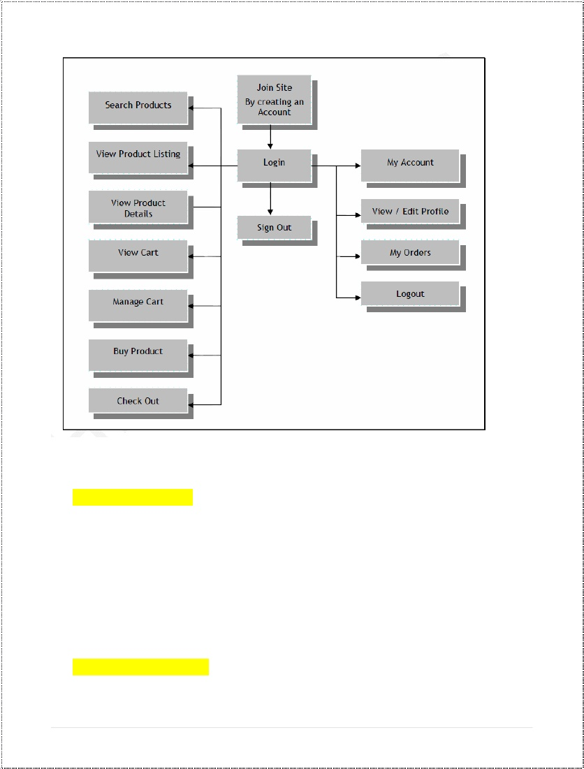

1. **User Registration**
   * 1. User will register before purchasing any product.
     2. Registration form will contain email, user name, password and home address.
     3. Security, in the form of protecting sensitive customer data while it is transferred over the internet, and preventing unauthorized access to the administration console.
     4. After enter user details then display terms and conditions for user in which user need to confirm and read our conditions.
     5. Display a welcome message to user after successful registrations.
2. **Terms and Conditions**
   1. **Privacy Policy**. Our privacy policy, which sets out how we will use your information, can be found at [Privacy Policy Link]. By using this website, you consent to the processing described therein and warrant that all data provided by you is accurate
   2. **Prohibitions**. You must not misuse this website. You will not: commit or encourage a criminal offense; transmit or distribute a virus, Trojan, worm, logic bomb or any other material which is malicious, technologically harmful , Breaching this provision would constitute a criminal offense.
   3. **Intellectual property, Software and content**. The intellectual property right in all software and content (including photographic images) made available to you or through this website remains the property of Fashworld.
   4. **Terms of Sale**. By placing an order you are offering to purchase a product on and subject to the following terms and conditions. All orders are subject to availability of and confirmation of the order price.
      1. **Our contract** – when you place an order, you will receive an acknowledgment w-mail confirming receipt of your order.
      2. **Pricing and availability** – whilst we try and ensure that all details, description, and prices appear on this website, are accurate, and error may occur.
      3. **Payment** – Upon receiving your order we carry out a standard authorization check on your payment Card to ensure there are sufficient funds to fulfil the transaction
   5. **Complaints-** Weoperate a complaints handling procedure which we will use to try to resolve disputes when they first arise, please let us know if you have any complaints or comments.
   6. **Entire Agreement.** The above Terms of service constitute the entire agreement of the parties and supersede any and all preceding and contemporaneous agreement between you and Fashworld. Any waiver of any provision of Terms of service will be effective only if in writing and signed by a Director of Fashworld.com.
3. **Shipping policy and Delivery**5.1 **Shipping policy should easily accessible** - Don’t require visitors to login or create accounts, before they can view our shipping policy. Visitors to our website will need to know the shipping terms before they place an order. An unpleasant surprise at the checkout will almost certainly lead to a lost sale.
   1. **Shipping policy must be accessible from all pages** - Placing a link within website as header or sidebar will usually do the trick.
   2. **Provide all shipping details at the checkout** - tell customers how much each shipping option will cost and how long it will take. Provide full details on international shipping, if applicable.

5.4 **No overcharge for shipping**. it should be clear that shipping is absolutely free.

* 1. **Provide detailed delivery time-frames.** List delivery time-frames for each shipping option by delivery region.
  2. **Provide tracking information** - e-mail the shipments tracking number to customer as soon as it is available. Being able to track his order, customer will know at any given time exactly what the status of the shipment is.
  3. **Responsibility for lost shipments -** Whenever a shipment is lost, take responsibility and re-ship it. It may not be our fault, and it probably won’t be, but customer has placed an order with our business and will rightly hold us responsible for it.

1. **USER INTERFACE**
   1. **Pages**
      1. Home Page
      2. Header (logo, menu --> about, contact, [profile < if logged in] , and [login/logout] options.
      3. Display THANK YOU ( message after successful login successfully
      4. Simple hero shot and marketing message
      5. About Us

* is a platform that aims to give start-up lstreetwearl fashion brands an opportunity to make their business profitable by offering services that will improve their internet presence
  + 1. Contact Us
       1. Through Email
       2. Through Cell
       3. Through Social media
  1. **Item Selection:**
     + - 1. Item Brand
         2. Item Size
         3. Item Price
  2. **Delivery**
     + - 1. Customers Name
         2. Customer Name
         3. Customers Complete Address
         4. Customer Cell
  3. An online representation of the products that are sold in the physical store. There are many categories (e.g. dairy! meats! bakery! fruit etc.), and every product for each category! Which online shoppers can browse? Details are provided for each product name ,image description and price.
  4. Shopping cart functionality! which includes the ability to:
     1. Add items to a virtual shopping cart.
     2. Remove items from the shopping cart
     3. Update item quantities in the shopping cart.
     4. View a summary of all items and quantities in the shopping cart
     5. Place an order and make payment through secure checkout process
  5. An administration console, enabling staff to view customer orders.

1. **User Registration Requirements** 
   1. **Build value around registration**.

Before users create an account you need to explain the reasons for creating account.

* 1. Eliminate as many fields as possible

Only get data from user which are most important and remove or make all other fields as optional which are not necessary about user.

2.3 **Group fields logically** - Some sites gather a lot of information in registration form like shipping address! Billing address etc! So many users want to deliver their personal information in certain order. And we need an order for user registration.

2.4 **Break up long registration professes into steps.**

And finally bread down all the processes into a well steps.

2.**5 Make your security and privacy policies clear as day**.

Make sure that the user who is creating an account on our website is secure. And include a clear link of our privacy policy.

2.**6 Make password recovery easy.**

If a user forgets his password or loses their password in some cases so we want a password recovery link in our both registration and login form.

**2.7 Give the option to refresh captcha.**

In order to secure website from robots usage. So we want a captcha code for users to enter it while creating an account

2.8 **Give a PayPal method**.

Before users enter into their accounts while in registration they need to confirm their account on PayPal or any other bank account.

2.9 **User Login System:**

It is necessary for every user to login into their accounts before they move to purchase any product from our website. We want a user email and password in login form for the users.

2.10 **Admin Panel:**

We want an admin panel in which we can control all the information/data about our website like we can insert a new data from admin panel and delete that data about product which are not available in our shop/market. And our admin panel must be secure in which only two admin can access to our admin area and edit / delete the data. And we have user information in our admin area So that we can easily check the user’s detail.

1. **Terms and Conditions** 
   1. **Privacy policy** : The privacy policy, which will set out how to use End user information, place at[Privacy Policy Link]
   2. **Prohibitions**: Display to user “You must not misuse this Website. You will not, commit or encourage a criminal offence; transmit or distribute a virus, Trojan, worm, logic bomb or any other material which is malicious, technologically harmful, breaching this provision would constitute a criminal offence.”
   3. **Intellectual property, software and Content**: The intellectual property rights in all s/w and content (including all graphics) made available to user on or through this system remains the property of Fashworld.
   4. **Terms of sale**: By placing an order, offering to purchase a product on and subject to the following terms and conditions. All orders will subject to availability and confirmation of the order price.
      * **Contract:** When user places an order, send an acknowledgement through email concerning receipt of order to user.
      * **Pricing and availability:** Whilst try and ensure that all details, descriptions and prices which appear on the system, errors may occur.
      * **Payment:** Receiving users order carry out a standard authorization check on user payment card to ensure that there are sufficient funds to fulfil the transaction.
   5. **Complaints**: Operating a complaints handling procedure, which will try and resolve disputes when they first arise, lets users lay complaints or any comments about the system.
   6. **Entire Agreement**: The above Terms of Service constitute the entire agreement of the parties and supersede any and all preceding and contemporaneous between the user and Fashworld. Any waiver of any provision of the Terms of Service will be effective only if in writing and signed by the director of Fashworld.
2. **Shipping policy and Delivery**

* **Shipping policy will be easily accessible**: It does not require visitors to login or create accounts, before they can view our shipping policy. Visitors to site will need to know the shipping terms before they place an order. An unpleasant surprise at the checkout will almost certainly lead to a lost sale.
* **Accessibility of shipping policy from all pages:** Place a link within the websites header or sidebar to do the trick.
* **Provide all shipping details at the checkout:** Tell customers how much each shipping option will cost and how long it will take. Provide full details on international shipping, if applicable.
* **No overcharge for shipping**: It should be clear that shipping is absolutely free
* **Provide tracking information:** Email the shipments tracking number to customer as soon as it is available. Being able to track his order, customer will know at any given time exactly what the status of the shipment is and we take responsibility of lost shipment.

