Kausalanalyse Resistenz

11.03.2022

# Bibliotheken laden, Hilfsfunktion

library(stringr) # String-verarbeitung  
library(ggplot2) # moderne plots  
library(gridExtra)  
  
debug <- T # debug printout  
debug <- F # kein debug printout  
Log <- function(string) {  
 if(debug){print(string)}   
}

# Resistenzen.Rmd erzeugte Resistenzen.csv, dieses einlesen

Und evtl. ansehen

Resistenzen <- read.csv("Resistenzen.csv")  
  
# csv schreiben fügt vorne Index-Spalte an; diese entfernen :  
Resistenzen[,1] <- NULL   
  
View(Resistenzen)

## Verteilungen

ResistenzenWM1 <- Resistenzen[Resistenzen["WM.group"] == "1",] # waste milk Group  
ResistenzenWM2 <- Resistenzen[Resistenzen["WM.group" ] == "2",] # no waste milk Group  
#View(ResistenzenWM2)  
  
ResistenzenOLS0 <- Resistenzen[Resistenzen["OLS.group"] == "0",] # other livestock Group  
ResistenzenOLS1 <- Resistenzen[Resistenzen["OLS.group"] == "1",] # no other livestock Group  
#View(ResistenzenOLS0);View(ResistenzenOLS1)  
  
ResistenzenIAC0 <- Resistenzen[Resistenzen["IAC.group"] == "0",] # ill animals in calving box Group  
ResistenzenIAC1 <- Resistenzen[Resistenzen["IAC.group"] == "1",] # no ill animals in calving box Group  
#View(ResistenzenIAC0);View(ResistenzenIAC1)  
  
ResistenzenHSC0 <- Resistenzen[Resistenzen["HSC.group"] == "0",] # stable w\o outlet  
ResistenzenHSC1 <- Resistenzen[Resistenzen["HSC.group"] == "1",] # stable with outlet  
ResistenzenHSC2 <- Resistenzen[Resistenzen["HSC.group"] == "2",] # outdoors  
ResistenzenHSC3 <- Resistenzen[Resistenzen["HSC.group"] == "3",] # 0+1  
ResistenzenHSC4 <- Resistenzen[Resistenzen["HSC.group"] == "4",] # 1+2  
ResistenzenHSC5 <- Resistenzen[Resistenzen["HSC.group"] == "5",] # 0+2  
#View(ResistenzenHSC0);View(ResistenzenHSC1);View(ResistenzenHSC2);View(ResistenzenHSC3);View(ResistenzenHSC4);View(ResistenzenHSC5)

Graphiken und Deskriptive Analyse: Für diesen Fall analysieren wir die (meist links und/oder rechts abgeschnittenen) Verteilungen

graphisch <- function(indep, antib, anfang,ende, schrittBin,schrittLab) {   
  
 if (ende < 0) { # kleiner Trick um zusätzliches Funktionsargument zu vermeiden  
 Ende=F  
 ende = -ende  
 } else{  
 Ende=T  
 }  
 Log(paste("Ende, ende =",Ende,ende))  
   
 if(indep == "WM.group" ){  
 listdfs <- list(Resistenzen , ResistenzenWM1 , ResistenzenWM2 ) # Vektor klappt hier nicht!  
 Titel <- c( "WM oder nicht", "WM ", "keine WM ")  
 }  
 if(indep == "OLS.group" ){  
 listdfs <- list(Resistenzen , ResistenzenOLS1 , ResistenzenOLS0 )   
 Titel <- c( "OLS oder nicht", "OLS ", "kein OLS ")  
 }  
 if(indep == "IAC.group" ){  
 listdfs <- list(Resistenzen , ResistenzenIAC1 , ResistenzenIAC0 )   
 Titel <- c( "IAC oder nicht", "IAC ", "kein IAC ")  
 }  
 if(indep == "HSC.group"){  
 listdfs <- list(Resistenzen , ResistenzenHSC0, ResistenzenHSC1,   
 ResistenzenHSC2, ResistenzenHSC3, ResistenzenHSC4, ResistenzenHSC5)   
 Titel <- c( "HSC beliebig ",   
 "0: stable w\\o outlet", "1: stable with outlet", "2: outdoors ","0+1 ","1+2 ","0+2 ")  
 }  
   
 for (i in 2:length(Titel)){ # nicht 1. plot "XY oder nicht"  
   
 DF <- listdfs[[i]]  
 numstrings <- str_replace(DF[[antib]], paste0("<=",anfang), as.character(anfang))   
 # z.B. "1" als numerischer Platzhalter für "<=1"   
   
 numstrings <- str_replace(numstrings , paste0(">",ende) , as.character(ende)) #+1))   
 # z.B. "33" als numerischer Platzhalter für ">32"  
   
 numbers <- as.numeric(numstrings ) # jetzt alles als Zahlen   
 DF$numbers <- numbers  
 Log("i, numbers=");Log(i);Log(numbers)  
  
 # https://stackoverflow.com/questions/23944355/r-hist-right-left-clump-binning war hier eine Inspiration,  
 # fieseln für die tick labels weil R sonst aus Platzproblemen das wichtige letzte tick label unterdrückt:  
 if(Ende) {  
 seqAt <- seq(schrittBin ,ende+schrittBin,by=schrittLab) # kleineres ende+... klappt nicht  
 seqAt[length(seqAt)] <- seqAt[length(seqAt)]-schrittBin # also zurückkorrigieren  
 #seqAt <- seq(schrittBin ,ende+0.001,by=schrittLab)   
 } else {  
 seqAt <- seq(schrittBin,ende ,by=schrittLab) # 1 Bin weniger  
 }  
 Log("seqAt:"); Log(seqAt)  
 seqLab <- seq(schrittBin+schrittLab,ende ,by=schrittLab)   
 seqLab <- seq(schrittBin ,ende+schrittBin,by=schrittLab)   
   
 Log("seqLab:");Log(seqLab)  
   
 seqLab_cutR <- seqLab[1:length(seqLab)-1]   
 Log("seqLab_cutR:");Log(seqLab_cutR)  
   
 seqLab_cutLR <- seqLab_cutR[2:length(seqLab_cutR)] # ... [2:...] klappt nicht  
 Log("seqLab_cutLR:");Log(seqLab_cutLR)  
   
 Labels <- c(paste0("<=",anfang),seqLab_cutLR)  
 Log("Labels, 1:");Log(Labels)  
   
 if(Ende) { Labels <- c(Labels,paste0(">",ende)) }  
 Log("Labels, 2:");Log(Labels)  
  
 Log("breaks="); Log(seqAt)  
 Log("labels ="); Log(Labels)  
   
 plot <- ggplot(DF, aes(x=numbers)) +   
 scale_x_continuous(trans = "log10", breaks=seqAt, labels=Labels, limits=c(anfang*.8,ende*1.2)) +   
 # limits=anfang...ende aber bisschen mehr um dort zu plotten   
 # -0.01 o. *0.9; +1 o. *1.1 genügt nicht  
 geom_histogram() +   
 theme(axis.text.x = element_text(size=12)) +  
 theme(axis.text.y = element_text(size=12)) +  
 xlab("Resistenz") + ylab("Frequenz") +  
 ggtitle(paste(antib,Titel[i]))   
   
 #if(i==1) { # 1. plot "XY oder nicht"  
 # pg <- ggplot_build(plot)  
 # ymax <- max(pg$data[[1]]$y) # these are the histogram heights for each bar  
 # print(paste("ymax=",ymax))  
 #}  
   
 # Vektor plots[i] klappt nicht gut, also programmiere ich doppelt  
 if( i == 2){   
 pg <- ggplot_build(plot)  
 ymax2 <- max(pg$data[[1]]$y) # these are the histogram heights for each bar  
 print(paste("ymax2=",ymax2))  
   
 plot2 <- plot  
# print(plot2+ylim(0,ymax2))   
 }   
 if( i == 3){  
 pg <- ggplot_build(plot)  
 ymax3 <- max(pg$data[[1]]$y) # these are the histogram heights for each bar  
 print(paste("ymax3=",ymax3))  
   
 plot3 <- plot  
 # print(plot3+ylim(0,ymax3))   
 }  
   
 numbers <- na.omit(numbers)  
   
 # Median könnte im "<=" Bereich liegen oder im ">=", entsprechend reagieren:  
 median <- median(numbers, n.rm=T) # (n.rm=T fürs Lesen aus file, vorher war das "NA")  
 rel <- "=" # Relations-Symbol  
 Log(paste( "median, anfang =",median, anfang ))  
 if(median == anfang){  
 rel <- "<="   
 }   
 if(Ende && median == ende){  
 rel <- ">"  
 }   
   
 print(paste(antib,"- Resistenz,", Titel[i], ":"))  
 print(paste(" Median ", rel, median))  
   
 if(Ende && (max(numbers) > ende)){ # gibt overflow bin, ist nicht leer: Verteilung nicht nach oben beschränkt  
   
 # kleinste Werte kleinstmöglich und grösste Werte kleinstmöglich ergibt Mindestwert des Mittelwertes  
 mean <- mean(replace(numbers, numbers==anfang, 0))   
   
 print(paste(" Mittelwert >= ", mean ))  
 print("")  
 } else { # Verteilung nach oben beschränkt  
 if (anfang %in% numbers) { # Verteilung nach oben beschränkt, nicht nach unten   
 # (underflow bin gibt's FAST immer)  
 mean1 <- mean(numbers) # kleinste Werte grösstmöglich gibt Höchstwert des Mittelwertes  
   
 numbers0 <- replace(numbers, numbers==anfang, 0) # kleinste Werte kleinstmöglich   
 mean0 <- mean(numbers0) # ergibt Mindestwert des Mittelwertes  
 print(paste(" Mittelwert in ", sprintf("%.3f",mean0), "...", sprintf("%.3f",mean1) ))  
 print("")  
 } else { # Verteilung nach oben und unten beschränkt : einfachster Fall  
 print(paste(" Mittelwert = ", sprintf("%.3f",mean(numbers)) ) )  
 print("")  
 }  
 }  
 }  
 ymax <- max(ymax2,ymax3)  
 #print(plot2+ylim(0,ymax))   
 #print(plot3+ylim(0,ymax))   
 grid.arrange(plot2+ylim(0,ymax), #+ coord_fixed(ratio=3),  
 plot3+ylim(0,ymax), #+ coord_fixed(ratio=3),   
 ncol=1) #+ coord_fixed(ratio=2)  
  
}

## Ill Animals in Calving Box - Gruppen

Mit “IAC” abgekürzt.

graphisch("IAC.group", "AMP", 1,32, 1,8)

## [1] "ymax2= 41"  
## [1] "AMP - Resistenz, IAC :"  
## [1] " Median = 4"  
## [1] " Mittelwert = 13.148"  
## [1] ""  
## [1] "ymax3= 21"  
## [1] "AMP - Resistenz, kein IAC :"  
## [1] " Median = 4"  
## [1] " Mittelwert = 13.875"  
## [1] ""

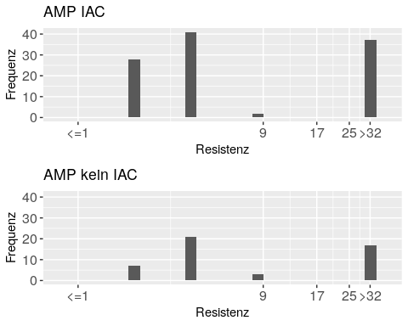

graphisch("IAC.group", "MERO", 0.03,-0.06, 0.015,0.015 )

## [1] "ymax2= 107"  
## [1] "MERO - Resistenz, IAC :"  
## [1] " Median <= 0.03"  
## [1] " Mittelwert in 0.001 ... 0.030"  
## [1] ""  
## [1] "ymax3= 48"  
## [1] "MERO - Resistenz, kein IAC :"  
## [1] " Median <= 0.03"  
## [1] " Mittelwert in 0.000 ... 0.030"  
## [1] ""

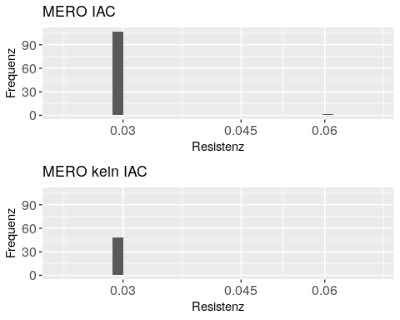

graphisch("IAC.group", "CIP" , 0.015, 8 , 0.015, 4 )

## [1] "ymax2= 91"  
## [1] "CIP - Resistenz, IAC :"  
## [1] " Median <= 0.015"  
## [1] " Mittelwert in 0.159 ... 0.171"  
## [1] ""  
## [1] "ymax3= 44"  
## [1] "CIP - Resistenz, kein IAC :"  
## [1] " Median <= 0.015"  
## [1] " Mittelwert in 0.667 ... 0.680"  
## [1] ""

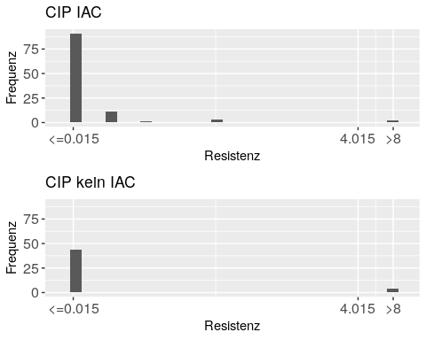

graphisch("IAC.group", "AZI" , 2 , 64 , 1 , 8 )

## [1] "ymax2= 70"  
## [1] "AZI - Resistenz, IAC :"  
## [1] " Median = 8"  
## [1] " Mittelwert in 6.556 ... 6.630"  
## [1] ""  
## [1] "ymax3= 34"  
## [1] "AZI - Resistenz, kein IAC :"  
## [1] " Median = 8"  
## [1] " Mittelwert in 7.167 ... 7.250"  
## [1] ""

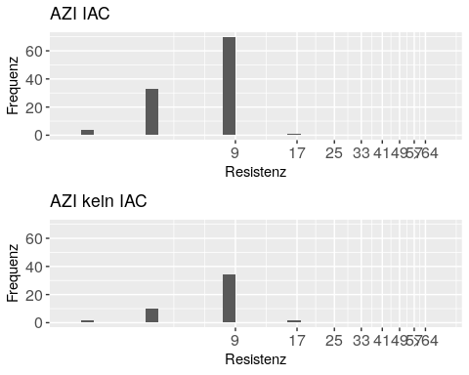

graphisch("IAC.group", "GEN" , 0.5 , 16 , 0.5 , 4 )

## [1] "ymax2= 83"  
## [1] "GEN - Resistenz, IAC :"  
## [1] " Median <= 0.5"  
## [1] " Mittelwert in 1.602 ... 1.986"  
## [1] ""  
## [1] "ymax3= 41"  
## [1] "GEN - Resistenz, kein IAC :"  
## [1] " Median <= 0.5"  
## [1] " Mittelwert in 1.083 ... 1.510"  
## [1] ""

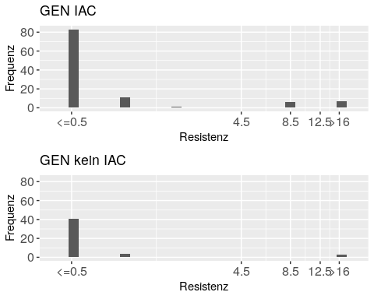

graphisch("IAC.group", "TGC" , 0.25 , -0.5 , 0.25 , 0.25 )

## [1] "ymax2= 100"  
## [1] "TGC - Resistenz, IAC :"  
## [1] " Median <= 0.25"  
## [1] " Mittelwert in 0.037 ... 0.269"  
## [1] ""  
## [1] "ymax3= 40"  
## [1] "TGC - Resistenz, kein IAC :"  
## [1] " Median <= 0.25"  
## [1] " Mittelwert in 0.083 ... 0.292"  
## [1] ""

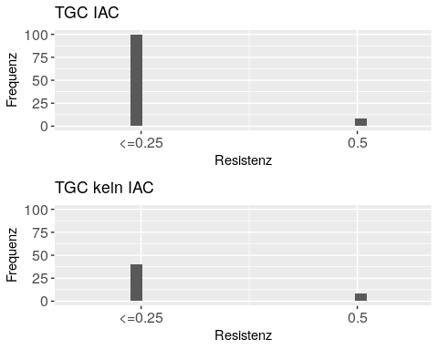

graphisch("IAC.group", "TAZ" , 0.25,-1, 0.25,0.25 )

## [1] "ymax2= 107"  
## [1] "TAZ - Resistenz, IAC :"  
## [1] " Median <= 0.25"  
## [1] " Mittelwert in 0.005 ... 0.252"  
## [1] ""  
## [1] "ymax3= 43"  
## [1] "TAZ - Resistenz, kein IAC :"  
## [1] " Median <= 0.25"  
## [1] " Mittelwert in 0.083 ... 0.307"  
## [1] ""

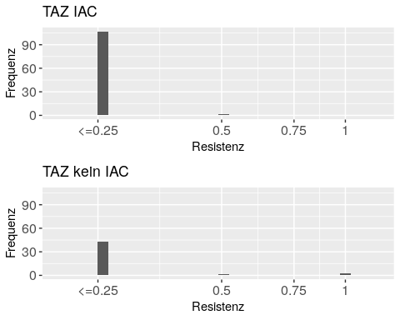

graphisch("IAC.group", "FOT" , 0.25,4 , 0.25,1 )

## [1] "ymax2= 107"  
## [1] "FOT - Resistenz, IAC :"  
## [1] " Median <= 0.25"  
## [1] " Mittelwert in 0.005 ... 0.252"  
## [1] ""  
## [1] "ymax3= 45"  
## [1] "FOT - Resistenz, kein IAC :"  
## [1] " Median <= 0.25"  
## [1] " Mittelwert in 0.250 ... 0.484"  
## [1] ""

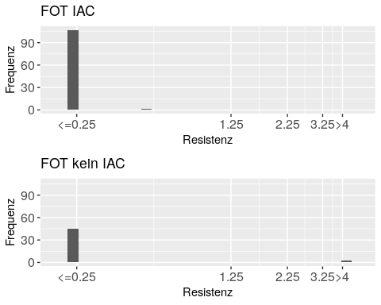

graphisch("IAC.group", "CHL" , 8 , 64 , 8,16 )

## [1] "ymax2= 81"  
## [1] "CHL - Resistenz, IAC :"  
## [1] " Median <= 8"  
## [1] " Mittelwert in 14.222 ... 20.222"  
## [1] ""  
## [1] "ymax3= 39"  
## [1] "CHL - Resistenz, kein IAC :"  
## [1] " Median <= 8"  
## [1] " Mittelwert in 9.000 ... 15.500"  
## [1] ""

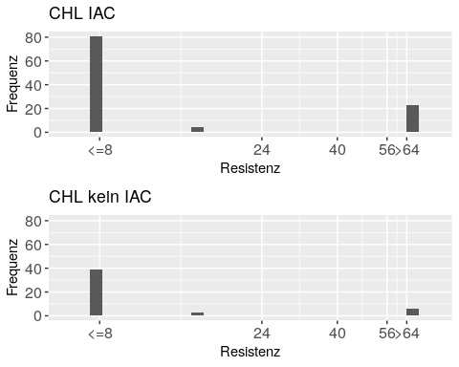

graphisch("IAC.group", "NAL" , 4,64, 4,16 )

## [1] "ymax2= 98"  
## [1] "NAL - Resistenz, IAC :"  
## [1] " Median <= 4"  
## [1] " Mittelwert in 2.815 ... 6.444"  
## [1] ""  
## [1] "ymax3= 44"  
## [1] "NAL - Resistenz, kein IAC :"  
## [1] " Median <= 4"  
## [1] " Mittelwert in 5.333 ... 9.000"  
## [1] ""

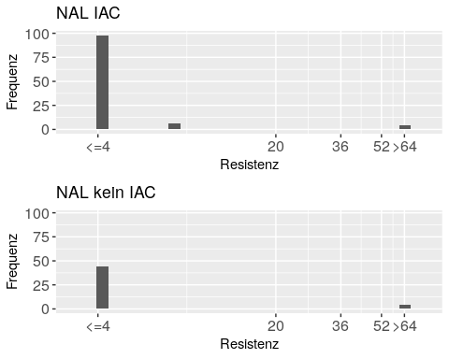

graphisch("IAC.group", "TET" , 2,32, 2,8 )

## [1] "ymax2= 49"  
## [1] "TET - Resistenz, IAC :"  
## [1] " Median = 4"  
## [1] " Mittelwert in 12.593 ... 13.500"  
## [1] ""  
## [1] "ymax3= 30"  
## [1] "TET - Resistenz, kein IAC :"  
## [1] " Median <= 2"  
## [1] " Mittelwert in 10.833 ... 12.083"  
## [1] ""

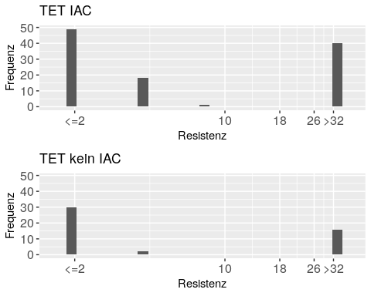

graphisch("IAC.group", "TMP" , 0.25 , 16 , 0.25,8 )

## [1] "ymax2= 60"  
## [1] "TMP - Resistenz, IAC :"  
## [1] " Median = 0.5"  
## [1] " Mittelwert in 3.741 ... 3.787"  
## [1] ""  
## [1] "ymax3= 22"  
## [1] "TMP - Resistenz, kein IAC :"  
## [1] " Median = 0.5"  
## [1] " Mittelwert in 5.250 ... 5.302"  
## [1] ""

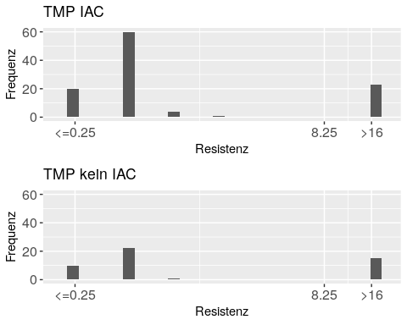

graphisch("IAC.group", "SMX" , 8 , 512 , 8,256 )

## [1] "ymax2= 42"  
## [1] "SMX - Resistenz, IAC :"  
## [1] " Median = 16"  
## [1] " Mittelwert in 205.926 ... 207.852"  
## [1] ""  
## [1] "ymax3= 20"  
## [1] "SMX - Resistenz, kein IAC :"  
## [1] " Median = 24"  
## [1] " Mittelwert in 220.333 ... 222.167"  
## [1] ""

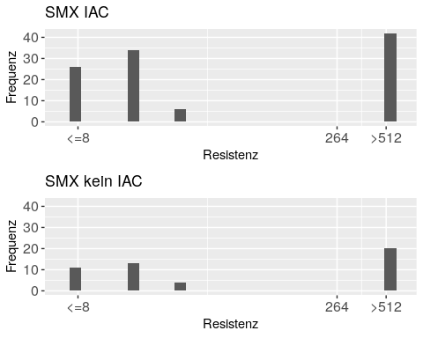

#stop the script - by error

Die Mittelwerte der Resistenz sind für 5 Antibiotika vergleichbar (AMP, MERO, TGC, TAZ, CHL), für GEN tendenziell grösser im Fall *Ill Animals in Calving box*, für 3 Antibiotika tendenziell kleiner in diesem Fall (ZIP, AZI, NAL), für TET definitv grösser in diesem Fall und für 3 Antibiotika definitiv kleiner in diesem Fall (FOT, TMP, SMX). Diese Relationen sind im wesentlichen gleich gerichtet wie in WM - keine WM.

Der Vergleich des Medians der 2 Gruppen zeigt Unterschiede nur für TET und SMX, in der gleichen Richtung wie der Mittelwert. Deshalb diskutiere ich den Median nicht weiter.

## Other Live Stock - Gruppen

Mit “OLS” abgekürzt.

graphisch("OLS.group", "AMP", 1,32, 1,8)

## [1] "ymax2= 51"  
## [1] "AMP - Resistenz, OLS :"  
## [1] " Median = 4"  
## [1] " Mittelwert in 13.188 ... 13.195"  
## [1] ""  
## [1] "ymax3= 61"  
## [1] "AMP - Resistenz, kein OLS :"  
## [1] " Median = 4"  
## [1] " Mittelwert = 9.685"  
## [1] ""

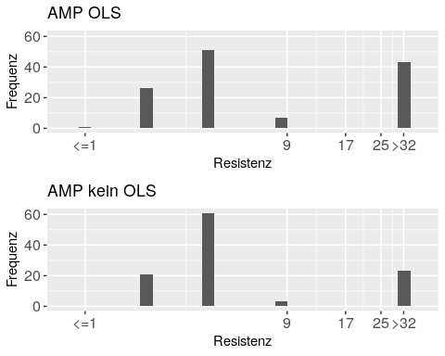

graphisch("OLS.group", "MERO", 0.03 , -0.06, 0.015, 0.015 )

## [1] "ymax2= 127"  
## [1] "MERO - Resistenz, OLS :"  
## [1] " Median <= 0.03"  
## [1] " Mittelwert in 0.000 ... 0.030"  
## [1] ""  
## [1] "ymax3= 108"  
## [1] "MERO - Resistenz, kein OLS :"  
## [1] " Median <= 0.03"  
## [1] " Mittelwert in 0.000 ... 0.030"  
## [1] ""

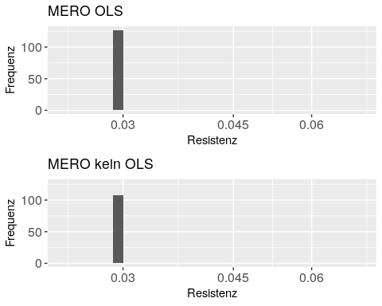

graphisch("OLS.group", "CIP" , 0.015, 8 , 0.015, 4 )

## [1] "ymax2= 116"  
## [1] "CIP - Resistenz, OLS :"  
## [1] " Median <= 0.015"  
## [1] " Mittelwert in 0.257 ... 0.271"  
## [1] ""  
## [1] "ymax3= 94"  
## [1] "CIP - Resistenz, kein OLS :"  
## [1] " Median <= 0.015"  
## [1] " Mittelwert in 0.154 ... 0.167"  
## [1] ""

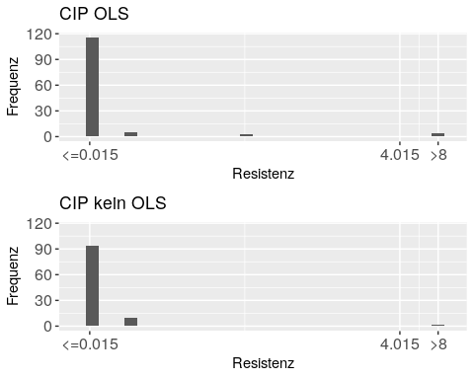

graphisch("OLS.group", "AZI" , 2 , 64 , 1 , 8 )

## [1] "ymax2= 88"  
## [1] "AZI - Resistenz, OLS :"  
## [1] " Median = 8"  
## [1] " Mittelwert in 7.281 ... 7.344"  
## [1] ""  
## [1] "ymax3= 76"  
## [1] "AZI - Resistenz, kein OLS :"  
## [1] " Median = 8"  
## [1] " Mittelwert in 6.852 ... 6.889"  
## [1] ""

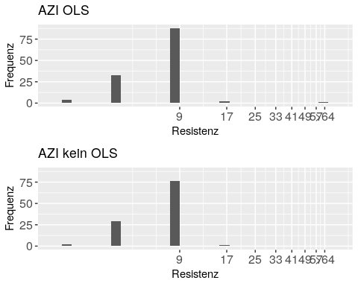

graphisch("OLS.group", "GEN" , 0.5 , 16 , 0.5 , 4 )

## [1] "ymax2= 105"  
## [1] "GEN - Resistenz, OLS :"  
## [1] " Median <= 0.5"  
## [1] " Mittelwert in 1.055 ... 1.465"  
## [1] ""  
## [1] "ymax3= 91"  
## [1] "GEN - Resistenz, kein OLS :"  
## [1] " Median <= 0.5"  
## [1] " Mittelwert in 0.917 ... 1.338"  
## [1] ""

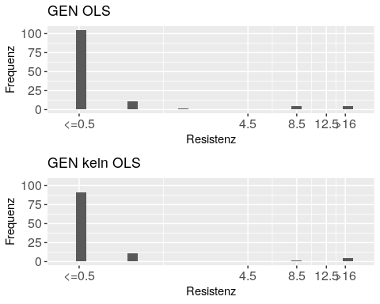

graphisch("OLS.group", "TGC" , 0.25 , -0.5 , 0.25 , 0.25 )

## [1] "ymax2= 120"  
## [1] "TGC - Resistenz, OLS :"  
## [1] " Median <= 0.25"  
## [1] " Mittelwert in 0.031 ... 0.266"  
## [1] ""  
## [1] "ymax3= 93"  
## [1] "TGC - Resistenz, kein OLS :"  
## [1] " Median <= 0.25"  
## [1] " Mittelwert in 0.069 ... 0.285"  
## [1] ""

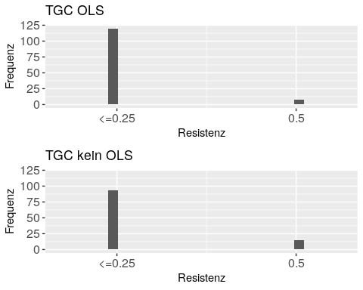

graphisch("OLS.group", "TAZ" , 0.25,-1 , 0.25,0.25 )

## [1] "ymax2= 121"  
## [1] "TAZ - Resistenz, OLS :"  
## [1] " Median <= 0.25"  
## [1] " Mittelwert in 0.039 ... 0.275"  
## [1] ""  
## [1] "ymax3= 108"  
## [1] "TAZ - Resistenz, kein OLS :"  
## [1] " Median <= 0.25"  
## [1] " Mittelwert in 0.000 ... 0.250"  
## [1] ""

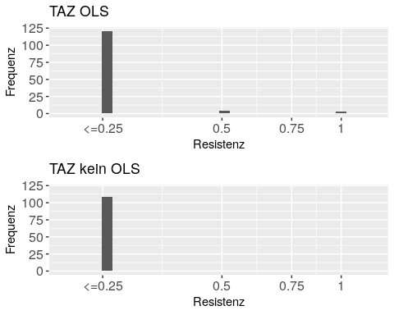

graphisch("OLS.group", "FOT" , 0.25 , 4 , 0.25 , 1 )

## [1] "ymax2= 124"  
## [1] "FOT - Resistenz, OLS :"  
## [1] " Median <= 0.25"  
## [1] " Mittelwert in 0.098 ... 0.340"  
## [1] ""  
## [1] "ymax3= 108"  
## [1] "FOT - Resistenz, kein OLS :"  
## [1] " Median <= 0.25"  
## [1] " Mittelwert in 0.000 ... 0.250"  
## [1] ""

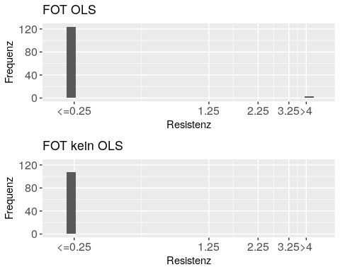

graphisch("OLS.group", "CHL" , 8 , 64 , 8,16 )

## [1] "ymax2= 93"  
## [1] "CHL - Resistenz, OLS :"  
## [1] " Median <= 8"  
## [1] " Mittelwert in 14.500 ... 20.312"  
## [1] ""  
## [1] "ymax3= 90"  
## [1] "CHL - Resistenz, kein OLS :"  
## [1] " Median <= 8"  
## [1] " Mittelwert in 9.333 ... 16.000"  
## [1] ""

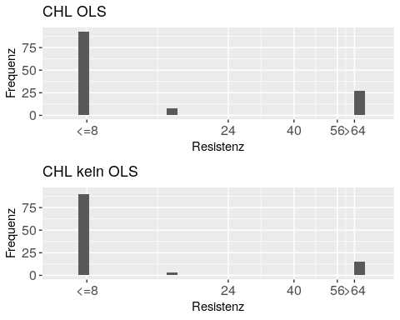

graphisch("OLS.group", "NAL" , 4 , 64 , 4,16 )

## [1] "ymax2= 119"  
## [1] "NAL - Resistenz, OLS :"  
## [1] " Median <= 4"  
## [1] " Mittelwert in 3.188 ... 6.906"  
## [1] ""  
## [1] "ymax3= 101"  
## [1] "NAL - Resistenz, kein OLS :"  
## [1] " Median <= 4"  
## [1] " Mittelwert in 2.074 ... 5.815"  
## [1] ""

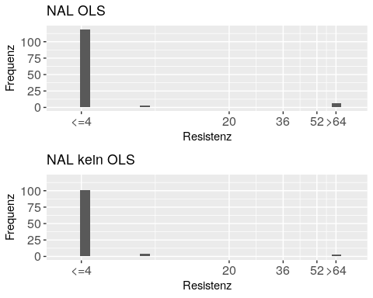

graphisch("OLS.group", "TET" , 2 , 32 , 2,8 )

## [1] "ymax2= 60"  
## [1] "TET - Resistenz, OLS :"  
## [1] " Median = 4"  
## [1] " Mittelwert in 13.500 ... 14.438"  
## [1] ""  
## [1] "ymax3= 70"  
## [1] "TET - Resistenz, kein OLS :"  
## [1] " Median <= 2"  
## [1] " Mittelwert in 8.963 ... 10.259"  
## [1] ""

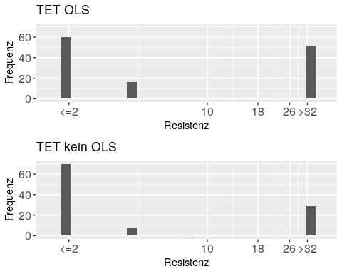

graphisch("OLS.group", "TMP" , 0.25 , 16 , 0.25,8 )

## [1] "ymax2= 58"  
## [1] "TMP - Resistenz, OLS :"  
## [1] " Median = 0.5"  
## [1] " Mittelwert in 4.625 ... 4.689"  
## [1] ""  
## [1] "ymax3= 70"  
## [1] "TMP - Resistenz, kein OLS :"  
## [1] " Median = 0.5"  
## [1] " Mittelwert in 2.324 ... 2.363"  
## [1] ""

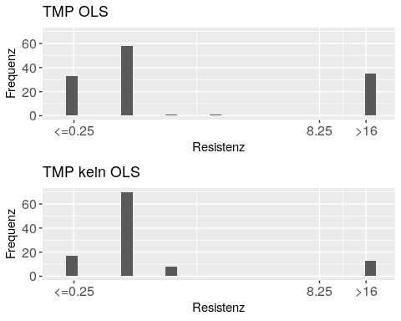

graphisch("OLS.group", "SMX" , 8 , 512 , 8,256 )

## [1] "ymax2= 60"  
## [1] "SMX - Resistenz, OLS :"  
## [1] " Median = 16"  
## [1] " Mittelwert in 244.625 ... 246.625"  
## [1] ""  
## [1] "ymax3= 37"  
## [1] "SMX - Resistenz, kein OLS :"  
## [1] " Median = 16"  
## [1] " Mittelwert in 151.556 ... 153.704"  
## [1] ""

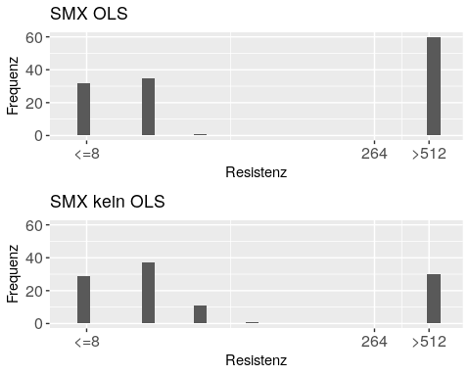

#stop the script

Die Mittelwerte der Resistenz sind für MERO, GEN und TAZ vergleichbar, für 5 Antibiotika tendenziell grösser im Fall *Other Livestock* (CIP, FOT, CHL, NAL, SMX), für TGC tendenziell kleiner in diesem Fall und für 4 Antibiotika definitiv kleiner in diesem Fall (AMP, AZI, TET, TMP). Diese Relationen sind im wesentlichen entgegengesetzt zu WM - keine WM!

# Waste Milk - Gruppen

graphisch("WM.group", "AMP", 1,32, 1,8)

## [1] "ymax2= 65"  
## [1] "AMP - Resistenz, WM :"  
## [1] " Median = 4"  
## [1] " Mittelwert in 9.517 ... 9.526"  
## [1] ""  
## [1] "ymax3= 47"  
## [1] "AMP - Resistenz, keine WM :"  
## [1] " Median = 4"  
## [1] " Mittelwert = 13.583"  
## [1] ""

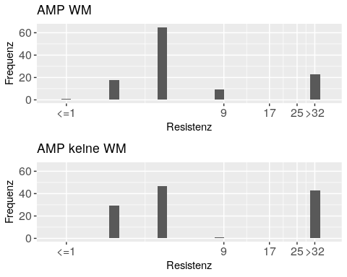 Der Mittelwert ist höher ohne WM.

graphisch("WM.group", "MERO", .03,-0.06, .015,.015)

## [1] "ymax2= 116"  
## [1] "MERO - Resistenz, WM :"  
## [1] " Median <= 0.03"  
## [1] " Mittelwert in 0.000 ... 0.030"  
## [1] ""  
## [1] "ymax3= 119"  
## [1] "MERO - Resistenz, keine WM :"  
## [1] " Median <= 0.03"  
## [1] " Mittelwert in 0.001 ... 0.030"  
## [1] ""

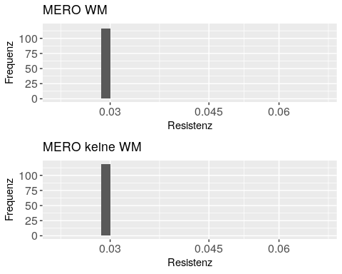 Der Mittelwert ist vergleichbar ohne WM (tatsächlich tendenziell minimal höher - das ist leicht zu kontrollieren: MERO ist immer <=3 - ausser einmal 0.06 für Betrieb 4 und der ist WM group 2).

graphisch("WM.group", "CIP", 0.015,8, .015,4)

## [1] "ymax2= 105"  
## [1] "CIP - Resistenz, WM :"  
## [1] " Median <= 0.015"  
## [1] " Mittelwert in 0.077 ... 0.091"  
## [1] ""  
## [1] "ymax3= 105"  
## [1] "CIP - Resistenz, keine WM :"  
## [1] " Median <= 0.015"  
## [1] " Mittelwert in 0.338 ... 0.351"  
## [1] ""

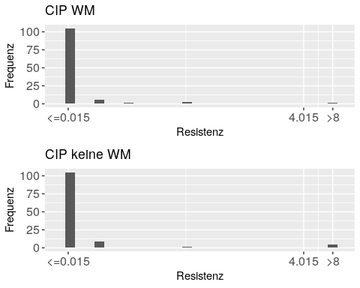 Der Mittelwert ist tendenziell höher ohne WM.

graphisch("WM.group", "AZI", 2,64, 1,16)

## [1] "ymax2= 84"  
## [1] "AZI - Resistenz, WM :"  
## [1] " Median = 8"  
## [1] " Mittelwert in 6.828 ... 6.862"  
## [1] ""  
## [1] "ymax3= 80"  
## [1] "AZI - Resistenz, keine WM :"  
## [1] " Median = 8"  
## [1] " Mittelwert in 7.333 ... 7.400"  
## [1] ""

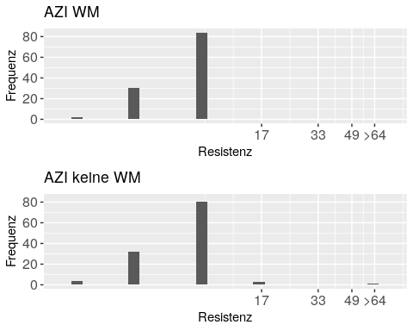 Der Mittelwert ist höher ohne WM.

graphisch("WM.group", "GEN", 0.5,16, 0.5,4)

## [1] "ymax2= 98"  
## [1] "GEN - Resistenz, WM :"  
## [1] " Median <= 0.5"  
## [1] " Mittelwert in 0.983 ... 1.405"  
## [1] ""  
## [1] "ymax3= 98"  
## [1] "GEN - Resistenz, keine WM :"  
## [1] " Median <= 0.5"  
## [1] " Mittelwert in 1.000 ... 1.408"  
## [1] ""

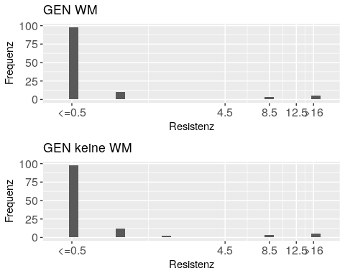 Der Mittelwert ist vergleichbar ohne WM.

graphisch("WM.group", "TGC", 0.25,-0.5, 0.25,0.25)

## [1] "ymax2= 103"  
## [1] "TGC - Resistenz, WM :"  
## [1] " Median <= 0.25"  
## [1] " Mittelwert in 0.056 ... 0.278"  
## [1] ""  
## [1] "ymax3= 110"  
## [1] "TGC - Resistenz, keine WM :"  
## [1] " Median <= 0.25"  
## [1] " Mittelwert in 0.042 ... 0.271"  
## [1] ""

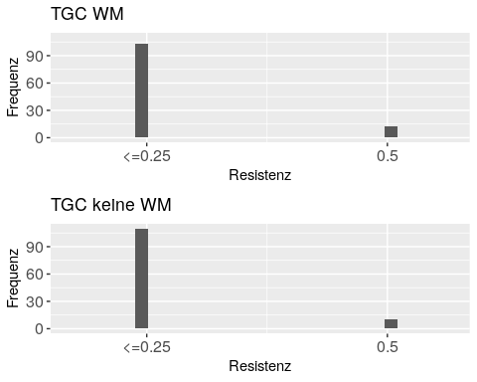 Der Mittelwert ist vergleichbar ohne WM.

graphisch("WM.group", "TAZ", 0.25, -1, .25,.25)

## [1] "ymax2= 114"  
## [1] "TAZ - Resistenz, WM :"  
## [1] " Median <= 0.25"  
## [1] " Mittelwert in 0.009 ... 0.254"  
## [1] ""  
## [1] "ymax3= 115"  
## [1] "TAZ - Resistenz, keine WM :"  
## [1] " Median <= 0.25"  
## [1] " Mittelwert in 0.033 ... 0.273"  
## [1] ""

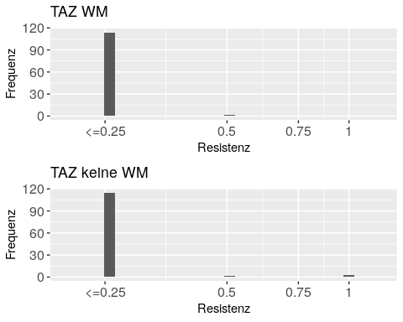 Der Mittelwert ist vergleichbar ohne WM. Genauer: tendenziell höher - das kann man auch noch per Hand kontrollieren: TAZ ist immer <= 0.25 ausser für:

* Waste Milk: 0.5 für Betriebe 11 und 15
* Keine Waste Milk: 0.5 für Betriebe 12, 59 und 3*1 für Betrieb 52

(Betrieb 30 wurde ganz am Anfang schon gelöscht)

Die Werte 0.5 balanzieren sich also aus für Waste Milk oder nicht, und der Unterschied kommt von den 3 Werten 1: Ohne WM ist resistenter.

graphisch("WM.group", "FOT", 0.25, 4, .25, 1)

## [1] "ymax2= 115"  
## [1] "FOT - Resistenz, WM :"  
## [1] " Median <= 0.25"  
## [1] " Mittelwert in 0.004 ... 0.252"  
## [1] ""  
## [1] "ymax3= 117"  
## [1] "FOT - Resistenz, keine WM :"  
## [1] " Median <= 0.25"  
## [1] " Mittelwert in 0.100 ... 0.344"  
## [1] ""

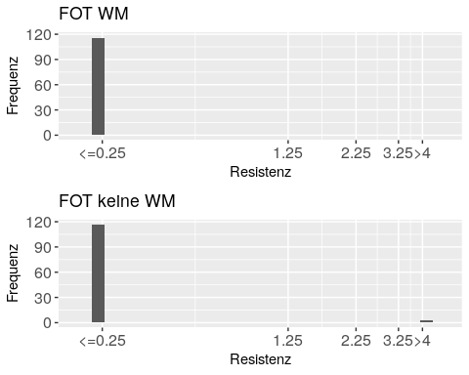 Der Mittelwert ist tendenziell höher ohne WM.

graphisch("WM.group", "CHL", 8,64, 8,16)

## [1] "ymax2= 98"  
## [1] "CHL - Resistenz, WM :"  
## [1] " Median <= 8"  
## [1] " Mittelwert in 7.862 ... 14.621"  
## [1] ""  
## [1] "ymax3= 85"  
## [1] "CHL - Resistenz, keine WM :"  
## [1] " Median <= 8"  
## [1] " Mittelwert in 16.267 ... 21.933"  
## [1] ""

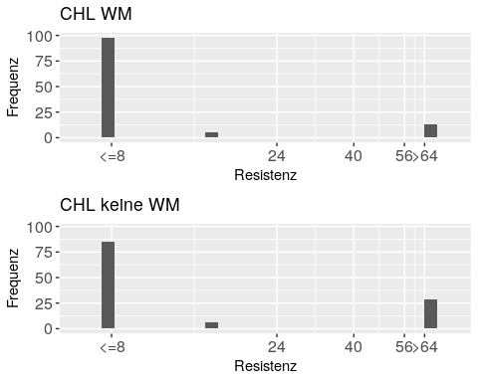 Der Mittelwert ist tendenziell höher ohne WM.

graphisch("WM.group", "NAL", 4,64, 4,16)

## [1] "ymax2= 111"  
## [1] "NAL - Resistenz, WM :"  
## [1] " Median <= 4"  
## [1] " Mittelwert in 2.276 ... 6.103"  
## [1] ""  
## [1] "ymax3= 109"  
## [1] "NAL - Resistenz, keine WM :"  
## [1] " Median <= 4"  
## [1] " Mittelwert in 3.067 ... 6.700"  
## [1] ""

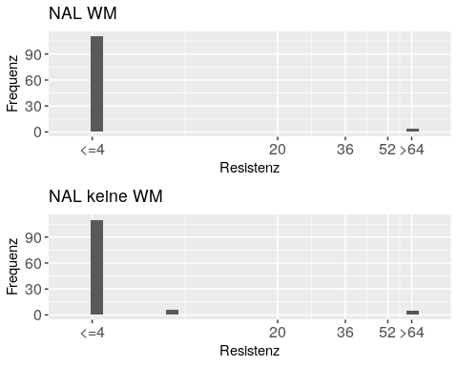 Der Mittelwert ist tendenziell höher ohne WM.

graphisch("WM.group", "TET", 2,32, 2,8)

## [1] "ymax2= 68"  
## [1] "TET - Resistenz, WM :"  
## [1] " Median <= 2"  
## [1] " Mittelwert in 9.862 ... 11.034"  
## [1] ""  
## [1] "ymax3= 62"  
## [1] "TET - Resistenz, keine WM :"  
## [1] " Median <= 2"  
## [1] " Mittelwert in 12.933 ... 13.967"  
## [1] ""

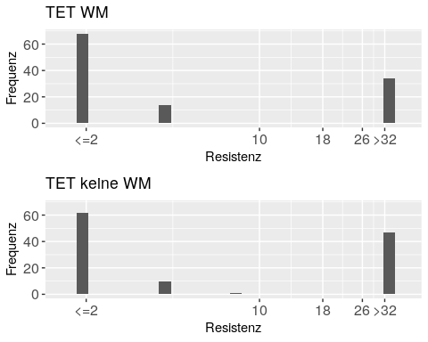 Der Mittelwert ist tendenziell höher ohne WM.

graphisch("WM.group", "TMP", 0.25,16, .25,8)

## [1] "ymax2= 73"  
## [1] "TMP - Resistenz, WM :"  
## [1] " Median = 0.5"  
## [1] " Mittelwert in 2.297 ... 2.347"  
## [1] ""  
## [1] "ymax3= 55"  
## [1] "TMP - Resistenz, keine WM :"  
## [1] " Median = 0.5"  
## [1] " Mittelwert in 4.804 ... 4.860"  
## [1] ""

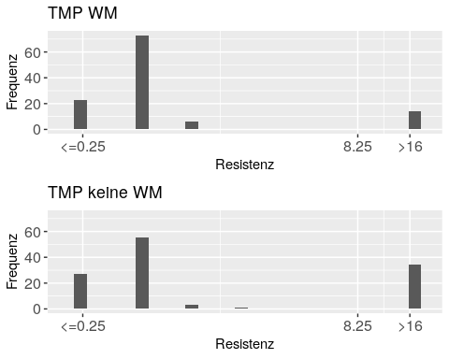 Der Mittelwert ist höher ohne WM.

graphisch("WM.group", "SMX", 8,512, 8,256)

## [1] "ymax2= 46"  
## [1] "SMX - Resistenz, WM :"  
## [1] " Median = 16"  
## [1] " Mittelwert in 172.138 ... 173.862"  
## [1] ""  
## [1] "ymax3= 53"  
## [1] "SMX - Resistenz, keine WM :"  
## [1] " Median = 16"  
## [1] " Mittelwert in 230.933 ... 233.333"  
## [1] ""

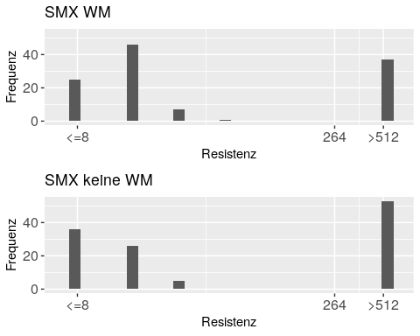 Der Mittelwert ist vergleichbar ohne WM.

Die Mittelwerte der Resistenz sind für 5 Antibiotika vergleichbar (MERO, GEN, TGC, TAZ, SMX), für 3 Antibiotika tendenziell grösser im Fall *WM* (CIP, FOT, NAL) und für 5 Antibiotika definitiv grösser in diesem Fall (AMP, AZI, HCL, TET, TMP).

# Husbandry System Calves - Gruppen

Mit “HSC” abgekürzt.

graphisch("HSC.group", "AMP", 1,32, 1,8)

## [1] "ymax2= 48"  
## [1] "AMP - Resistenz, 0: stable w\\o outlet :"  
## [1] " Median = 4"  
## [1] " Mittelwert = 10.795"  
## [1] ""  
## [1] "ymax3= 27"  
## [1] "AMP - Resistenz, 1: stable with outlet :"  
## [1] " Median = 4"  
## [1] " Mittelwert = 13.192"  
## [1] ""  
## [1] "AMP - Resistenz, 2: outdoors :"  
## [1] " Median = 4"  
## [1] " Mittelwert = 10.450"  
## [1] ""  
## [1] "AMP - Resistenz, 0+1 :"  
## [1] " Median = 4"  
## [1] " Mittelwert = 7.625"  
## [1] ""  
## [1] "AMP - Resistenz, 1+2 :"  
## [1] " Median = 4"  
## [1] " Mittelwert = 13.400"  
## [1] ""  
## [1] "AMP - Resistenz, 0+2 :"  
## [1] " Median = 4"  
## [1] " Mittelwert in 14.500 ... 14.550"  
## [1] ""

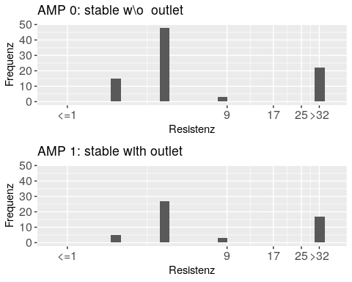

graphisch("HSC.group", "MERO", 0.03 , -0.06, 0.015,0.015)

## [1] "ymax2= 88"  
## [1] "MERO - Resistenz, 0: stable w\\o outlet :"  
## [1] " Median <= 0.03"  
## [1] " Mittelwert in 0.000 ... 0.030"  
## [1] ""  
## [1] "ymax3= 52"  
## [1] "MERO - Resistenz, 1: stable with outlet :"  
## [1] " Median <= 0.03"  
## [1] " Mittelwert in 0.000 ... 0.030"  
## [1] ""  
## [1] "MERO - Resistenz, 2: outdoors :"  
## [1] " Median <= 0.03"  
## [1] " Mittelwert in 0.000 ... 0.030"  
## [1] ""  
## [1] "MERO - Resistenz, 0+1 :"  
## [1] " Median <= 0.03"  
## [1] " Mittelwert in 0.000 ... 0.030"  
## [1] ""  
## [1] "MERO - Resistenz, 1+2 :"  
## [1] " Median <= 0.03"  
## [1] " Mittelwert in 0.000 ... 0.030"  
## [1] ""  
## [1] "MERO - Resistenz, 0+2 :"  
## [1] " Median <= 0.03"  
## [1] " Mittelwert in 0.003 ... 0.032"  
## [1] ""

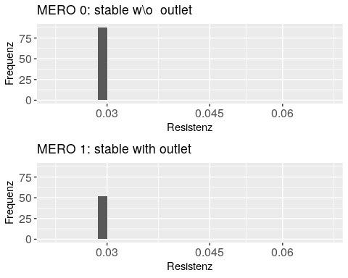

graphisch("HSC.group", "CIP" , 0.015, 8 , 0.015, 4 )

## [1] "ymax2= 79"  
## [1] "CIP - Resistenz, 0: stable w\\o outlet :"  
## [1] " Median <= 0.015"  
## [1] " Mittelwert in 0.278 ... 0.291"  
## [1] ""  
## [1] "ymax3= 48"  
## [1] "CIP - Resistenz, 1: stable with outlet :"  
## [1] " Median <= 0.015"  
## [1] " Mittelwert in 0.011 ... 0.025"  
## [1] ""  
## [1] "CIP - Resistenz, 2: outdoors :"  
## [1] " Median <= 0.015"  
## [1] " Mittelwert in 0.405 ... 0.416"  
## [1] ""  
## [1] "CIP - Resistenz, 0+1 :"  
## [1] " Median <= 0.015"  
## [1] " Mittelwert in 0.002 ... 0.016"  
## [1] ""  
## [1] "CIP - Resistenz, 1+2 :"  
## [1] " Median <= 0.015"  
## [1] " Mittelwert in 0.400 ... 0.414"  
## [1] ""  
## [1] "CIP - Resistenz, 0+2 :"  
## [1] " Median <= 0.015"  
## [1] " Mittelwert in 0.015 ... 0.028"  
## [1] ""

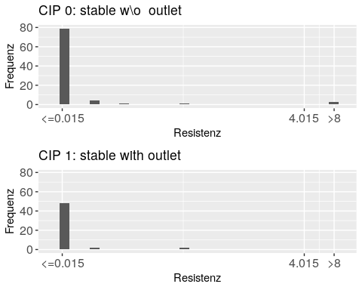

graphisch("HSC.group", "AZI" , 2 , 64 , 1 , 8 )

## [1] "ymax2= 63"  
## [1] "AZI - Resistenz, 0: stable w\\o outlet :"  
## [1] " Median = 8"  
## [1] " Mittelwert in 7.636 ... 7.659"  
## [1] ""  
## [1] "ymax3= 34"  
## [1] "AZI - Resistenz, 1: stable with outlet :"  
## [1] " Median = 8"  
## [1] " Mittelwert in 6.462 ... 6.538"  
## [1] ""  
## [1] "AZI - Resistenz, 2: outdoors :"  
## [1] " Median = 8"  
## [1] " Mittelwert in 6.600 ... 6.700"  
## [1] ""  
## [1] "AZI - Resistenz, 0+1 :"  
## [1] " Median = 8"  
## [1] " Mittelwert = 6.500"  
## [1] ""  
## [1] "AZI - Resistenz, 1+2 :"  
## [1] " Median = 8"  
## [1] " Mittelwert in 8.200 ... 8.300"  
## [1] ""  
## [1] "AZI - Resistenz, 0+2 :"  
## [1] " Median = 8"  
## [1] " Mittelwert = 6.600"  
## [1] ""

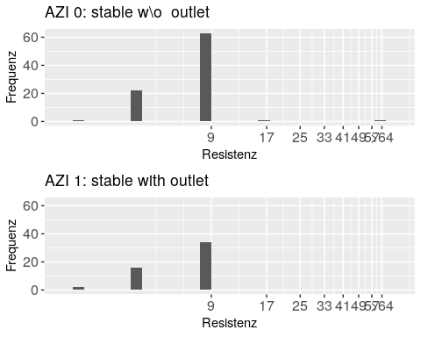

graphisch("HSC.group", "GEN" , 0.5 , 16 , 0.5 , 4 )

## [1] "ymax2= 76"  
## [1] "GEN - Resistenz, 0: stable w\\o outlet :"  
## [1] " Median <= 0.5"  
## [1] " Mittelwert in 0.557 ... 0.989"  
## [1] ""  
## [1] "ymax3= 41"  
## [1] "GEN - Resistenz, 1: stable with outlet :"  
## [1] " Median <= 0.5"  
## [1] " Mittelwert in 1.481 ... 1.875"  
## [1] ""  
## [1] "GEN - Resistenz, 2: outdoors :"  
## [1] " Median <= 0.5"  
## [1] " Mittelwert in 2.575 ... 2.925"  
## [1] ""  
## [1] "GEN - Resistenz, 0+1 :"  
## [1] " Median <= 0.5"  
## [1] " Mittelwert in 0.062 ... 0.531"  
## [1] ""  
## [1] "GEN - Resistenz, 1+2 :"  
## [1] " Median <= 0.5"  
## [1] " Mittelwert in 0.050 ... 0.525"  
## [1] ""  
## [1] "GEN - Resistenz, 0+2 :"  
## [1] " Median <= 0.5"  
## [1] " Mittelwert in 0.150 ... 0.575"  
## [1] ""

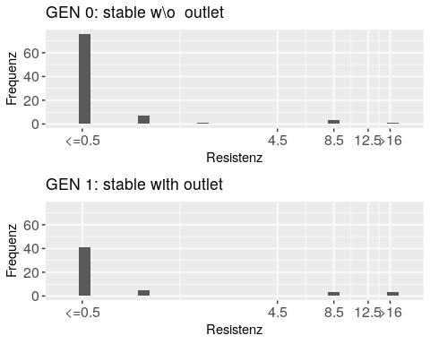

graphisch("HSC.group", "TGC" , 0.25 , -0.5 , 0.25 , 0.25 )

## [1] "ymax2= 81"  
## [1] "TGC - Resistenz, 0: stable w\\o outlet :"  
## [1] " Median <= 0.25"  
## [1] " Mittelwert in 0.040 ... 0.270"  
## [1] ""  
## [1] "ymax3= 42"  
## [1] "TGC - Resistenz, 1: stable with outlet :"  
## [1] " Median <= 0.25"  
## [1] " Mittelwert in 0.096 ... 0.298"  
## [1] ""  
## [1] "TGC - Resistenz, 2: outdoors :"  
## [1] " Median <= 0.25"  
## [1] " Mittelwert in 0.013 ... 0.256"  
## [1] ""  
## [1] "TGC - Resistenz, 0+1 :"  
## [1] " Median <= 0.25"  
## [1] " Mittelwert in 0.062 ... 0.281"  
## [1] ""  
## [1] "TGC - Resistenz, 1+2 :"  
## [1] " Median <= 0.25"  
## [1] " Mittelwert in 0.075 ... 0.287"  
## [1] ""  
## [1] "TGC - Resistenz, 0+2 :"  
## [1] " Median <= 0.25"  
## [1] " Mittelwert in 0.000 ... 0.250"  
## [1] ""

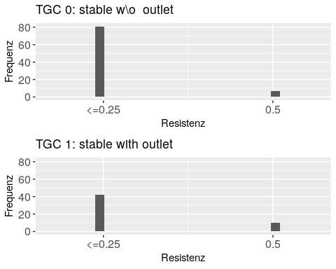

graphisch("HSC.group", "TAZ" , 0.25 , -1 , 0.25 , 0.25 )

## [1] "ymax2= 85"  
## [1] "TAZ - Resistenz, 0: stable w\\o outlet :"  
## [1] " Median <= 0.25"  
## [1] " Mittelwert in 0.034 ... 0.276"  
## [1] ""  
## [1] "ymax3= 52"  
## [1] "TAZ - Resistenz, 1: stable with outlet :"  
## [1] " Median <= 0.25"  
## [1] " Mittelwert in 0.000 ... 0.250"  
## [1] ""  
## [1] "TAZ - Resistenz, 2: outdoors :"  
## [1] " Median <= 0.25"  
## [1] " Mittelwert in 0.025 ... 0.263"  
## [1] ""  
## [1] "TAZ - Resistenz, 0+1 :"  
## [1] " Median <= 0.25"  
## [1] " Mittelwert in 0.031 ... 0.266"  
## [1] ""  
## [1] "TAZ - Resistenz, 1+2 :"  
## [1] " Median <= 0.25"  
## [1] " Mittelwert in 0.025 ... 0.263"  
## [1] ""  
## [1] "TAZ - Resistenz, 0+2 :"  
## [1] " Median <= 0.25"  
## [1] " Mittelwert in 0.000 ... 0.250"  
## [1] ""

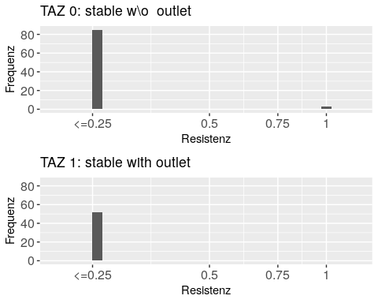

graphisch("HSC.group", "FOT" , 0.25 , 4 , 0.25 , 1 )

## [1] "ymax2= 85"  
## [1] "FOT - Resistenz, 0: stable w\\o outlet :"  
## [1] " Median <= 0.25"  
## [1] " Mittelwert in 0.136 ... 0.378"  
## [1] ""  
## [1] "ymax3= 51"  
## [1] "FOT - Resistenz, 1: stable with outlet :"  
## [1] " Median <= 0.25"  
## [1] " Mittelwert in 0.010 ... 0.255"  
## [1] ""  
## [1] "FOT - Resistenz, 2: outdoors :"  
## [1] " Median <= 0.25"  
## [1] " Mittelwert in 0.000 ... 0.250"  
## [1] ""  
## [1] "FOT - Resistenz, 0+1 :"  
## [1] " Median <= 0.25"  
## [1] " Mittelwert in 0.000 ... 0.250"  
## [1] ""  
## [1] "FOT - Resistenz, 1+2 :"  
## [1] " Median <= 0.25"  
## [1] " Mittelwert in 0.000 ... 0.250"  
## [1] ""  
## [1] "FOT - Resistenz, 0+2 :"  
## [1] " Median <= 0.25"  
## [1] " Mittelwert in 0.000 ... 0.250"  
## [1] ""

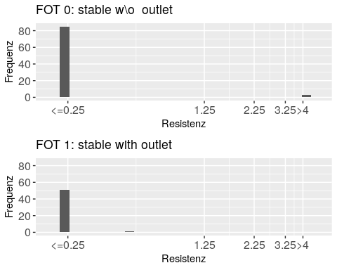

graphisch("HSC.group", "CHL" , 8 , 64 , 8,16 )

## [1] "ymax2= 68"  
## [1] "CHL - Resistenz, 0: stable w\\o outlet :"  
## [1] " Median <= 8"  
## [1] " Mittelwert in 13.455 ... 19.636"  
## [1] ""  
## [1] "ymax3= 36"  
## [1] "CHL - Resistenz, 1: stable with outlet :"  
## [1] " Median <= 8"  
## [1] " Mittelwert in 16.000 ... 21.538"  
## [1] ""  
## [1] "CHL - Resistenz, 2: outdoors :"  
## [1] " Median <= 8"  
## [1] " Mittelwert in 8.800 ... 15.400"  
## [1] ""  
## [1] "CHL - Resistenz, 0+1 :"  
## [1] " Median <= 8"  
## [1] " Mittelwert in 2.000 ... 9.000"  
## [1] ""  
## [1] "CHL - Resistenz, 1+2 :"  
## [1] " Median <= 8"  
## [1] " Mittelwert in 6.400 ... 13.600"  
## [1] ""  
## [1] "CHL - Resistenz, 0+2 :"  
## [1] " Median <= 8"  
## [1] " Mittelwert in 16.800 ... 22.400"  
## [1] ""

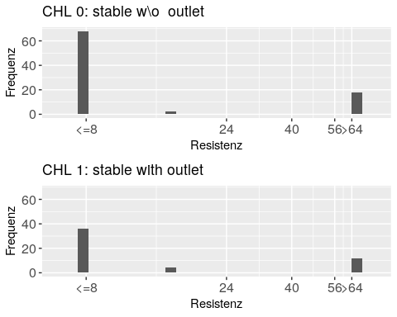

graphisch("HSC.group", "NAL" , 4 , 64 , 4,16 )

## [1] "ymax2= 83"  
## [1] "NAL - Resistenz, 0: stable w\\o outlet :"  
## [1] " Median <= 4"  
## [1] " Mittelwert in 2.364 ... 6.136"  
## [1] ""  
## [1] "ymax3= 50"  
## [1] "NAL - Resistenz, 1: stable with outlet :"  
## [1] " Median <= 4"  
## [1] " Mittelwert in 2.462 ... 6.308"  
## [1] ""  
## [1] "NAL - Resistenz, 2: outdoors :"  
## [1] " Median <= 4"  
## [1] " Mittelwert in 3.800 ... 7.300"  
## [1] ""  
## [1] "NAL - Resistenz, 0+1 :"  
## [1] " Median <= 4"  
## [1] " Mittelwert in 0.000 ... 4.000"  
## [1] ""  
## [1] "NAL - Resistenz, 1+2 :"  
## [1] " Median <= 4"  
## [1] " Mittelwert in 3.200 ... 7.000"  
## [1] ""  
## [1] "NAL - Resistenz, 0+2 :"  
## [1] " Median <= 4"  
## [1] " Mittelwert in 4.000 ... 7.400"  
## [1] ""

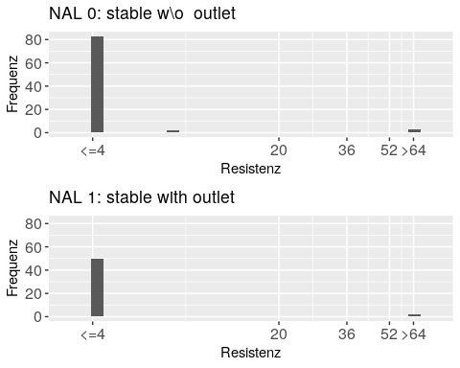

graphisch("HSC.group", "TET" , 2 , 32 , 2,8 )

## [1] "ymax2= 54"  
## [1] "TET - Resistenz, 0: stable w\\o outlet :"  
## [1] " Median <= 2"  
## [1] " Mittelwert in 10.136 ... 11.364"  
## [1] ""  
## [1] "ymax3= 22"  
## [1] "TET - Resistenz, 1: stable with outlet :"  
## [1] " Median = 4"  
## [1] " Mittelwert in 12.538 ... 13.385"  
## [1] ""  
## [1] "TET - Resistenz, 2: outdoors :"  
## [1] " Median <= 2"  
## [1] " Mittelwert in 10.100 ... 11.300"  
## [1] ""  
## [1] "TET - Resistenz, 0+1 :"  
## [1] " Median <= 2"  
## [1] " Mittelwert in 12.000 ... 13.250"  
## [1] ""  
## [1] "TET - Resistenz, 1+2 :"  
## [1] " Median <= 2"  
## [1] " Mittelwert in 10.000 ... 11.200"  
## [1] ""  
## [1] "TET - Resistenz, 0+2 :"  
## [1] " Median > 32"  
## [1] " Mittelwert in 17.800 ... 18.600"  
## [1] ""

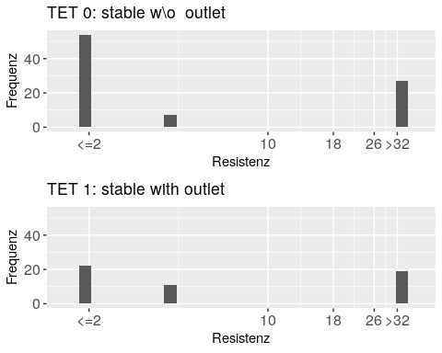

graphisch("HSC.group", "TMP" , 0.25 , 16 , 0.25,8 )

## [1] "ymax2= 51"  
## [1] "TMP - Resistenz, 0: stable w\\o outlet :"  
## [1] " Median = 0.5"  
## [1] " Mittelwert in 2.915 ... 2.963"  
## [1] ""  
## [1] "ymax3= 27"  
## [1] "TMP - Resistenz, 1: stable with outlet :"  
## [1] " Median = 0.5"  
## [1] " Mittelwert in 4.279 ... 4.332"  
## [1] ""  
## [1] "TMP - Resistenz, 2: outdoors :"  
## [1] " Median = 0.5"  
## [1] " Mittelwert in 3.875 ... 3.931"  
## [1] ""  
## [1] "TMP - Resistenz, 0+1 :"  
## [1] " Median = 0.5"  
## [1] " Mittelwert in 1.438 ... 1.469"  
## [1] ""  
## [1] "TMP - Resistenz, 1+2 :"  
## [1] " Median = 0.5"  
## [1] " Mittelwert in 5.900 ... 5.938"  
## [1] ""  
## [1] "TMP - Resistenz, 0+2 :"  
## [1] " Median = 0.5"  
## [1] " Mittelwert in 3.400 ... 3.500"  
## [1] ""

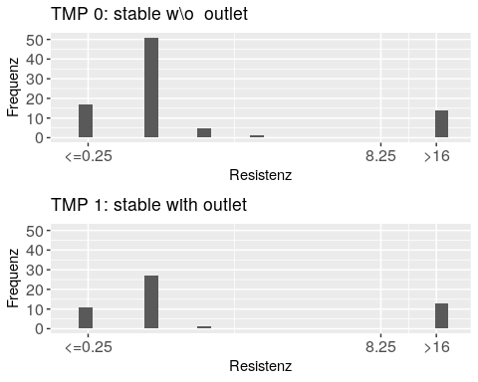

graphisch("HSC.group", "SMX" , 8 , 512 , 8,256 )

## [1] "ymax2= 33"  
## [1] "SMX - Resistenz, 0: stable w\\o outlet :"  
## [1] " Median = 16"  
## [1] " Mittelwert in 199.455 ... 201.455"  
## [1] ""  
## [1] "ymax3= 21"  
## [1] "SMX - Resistenz, 1: stable with outlet :"  
## [1] " Median = 16"  
## [1] " Mittelwert in 212.615 ... 214.769"  
## [1] ""  
## [1] "SMX - Resistenz, 2: outdoors :"  
## [1] " Median = 16"  
## [1] " Mittelwert in 160.400 ... 163.000"  
## [1] ""  
## [1] "SMX - Resistenz, 0+1 :"  
## [1] " Median = 16"  
## [1] " Mittelwert in 199.000 ... 200.500"  
## [1] ""  
## [1] "SMX - Resistenz, 1+2 :"  
## [1] " Median = 32"  
## [1] " Mittelwert in 214.400 ... 215.600"  
## [1] ""  
## [1] "SMX - Resistenz, 0+2 :"  
## [1] " Median = 264"  
## [1] " Mittelwert in 259.200 ... 261.600"  
## [1] ""

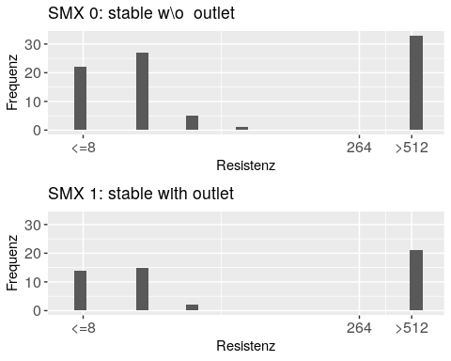

Es ist kein sehr ausgeprägtes Muster für grösste/kleinste Resistenzen zu erkennen. Tendenziell ergeben 1 und 1+2 die grössten Resistenzen, 2 und vor allem 0+1 die kleinsten.

# Vollständigkeit

Jetzt sind alle Verteilungen geplotted und deskriptiv analysiert, ausser:

* AMI: alle Proben sensitiv <=4
* COL: alle Proben sensitiv <=1

# Weitere Schritte

## Technischer Natur

* je 2 plots kombinieren übereinander in einem Quadrat

## Fundamentaler Natur

* Kausalitäten studieren mittels Regressionen