***Software Engineering for Geoinformatics, 2020***

|  |  |  |
| --- | --- | --- |
| **Requirement Analysis**  **GROUP MEMBERS** | | |
| **Name** | **Student ID** | **E-mail** |
| Felix Enyimah Toffah | 10647752 | felixenyimah.toffah@mail.polimi.it |
| Sahar Gholami Bourani | 10718755 | sahar.gholami@mail.polimi.it |
| Phesto Osano | 10714566 | phesto.osano@mail.polimi.it |
| Arli Ardiandy Nurseramika | 10693181 | arliardiandy.nurseramika@mail.polimi.it |

**Lecturer**

**Professor Di Nitto Elisabetta**

Delivery date: April 19, 2020

# Section 1 - Project scope and goals

The usage of the road is an indisputable mode of transportation for vehicle users, individuals, bicycle users, etc. As a result of the increase in human activities in the urban areas, the safety of pedestrians in the usage and crossing of streets becomes an issue of concern to road designers, managers and local Government authorities. The Pedestrian Level of Service (PLOS) is an index that incorporates the size of the road for vehicular and human traffic flow, terrestrial features such as the buffer of the road, spaces for different modes of travel, traffic volume and speed and the availability of street lights. It is aimed at enhancing safety of pedestrians on the road and to ease traffic flow at all times of the day. Oftentimes, concerns of pedestrians are left out after the design of the road. However, regular interaction of road managers and local government authorities with pedestrians would provide valuable information that can facilitate planning, enhance maintenance and make the streets more useful for the people at all times. Thus, the participation of the road users in decision making would be very vital.

SpaVia is an intended web application aimed at offering a participative geographic information system environment for the people in an area to offer their views as an input for decision making by the relevant authorities. It is intended to be managed by the local authorities and road managers. It provides a spatial interface for an individual to visualize the level of service of a segment of a street using the PLOS index computed for that street section. A segment is an integrated section of a street with respect to the parameters measured.

The application involves road designers and managers taking the necessary measurement data involving geographic coordinates, a series of quantitative and qualitative attributes, and digital media information using the Epicollect5 platform to compute the PLOS index. The data are then retrieved, processed and displayed on the Spavia application for visualization.

## Goal:

Using pre-existing data the web app is able to encode the PLOS for each segment and store it in the back end. It provides the user with multiple visualization of the data collected and PLOS calculated whether through segment id or through the location.

# Section 2- Domain analysis

## Intended audience

The intended users for the proposed web application include, but not limited to;

* Citizens, city managers.
* Researchers, both universities and Local Government authorities
* Professionals e.g. civil engineers, urban planners, transportation engineers,
* Interested Programmers for upscaling the web app

## Pre-existing platforms

The developing web app is retrieving data from two platforms. Which are now called pre-existing references.

First is the base map which enables the user to navigate through the study area easily. In order to do that the web app employs basemap from OSM platform.

The other part of data is retrieved from Epicollect5 platform. It is a geo-localized mobile data-gathering platform. The data is collected (including GPS and media) in order to evaluate the quality of sidewalks in Stazione Milano Lancetti. The quantities collected are explained below.

## Vm is the count of vehicles traveling along the segment in an hour. This is specified separately for each direction of travel along the segment.

1. Nth is the number of thorough lanes in the subject direction of travel. This count is specified separately for each direction of travel.
2. SR is the motorized vehicle running speed expressed in km/h to be converted to mph.
3. Wv is the sum of the width of the outside lane, bike lane and shoulder expressed in metres and converted to feet.
4. W1 is the sum of the width of the bike lane and the shoulder also expressed in metres and converted to feet. The bike lane width is assigned a value of zero(0) if it is not provided.
5. ppk is the proportion of parallel on-street parking occupied in the analyzed period. If parking is not allowed, a zero value is assigned. If parking is allowed along the full length of the segment, but only one half is occupied during the analyzed period, a value of 0.50 and if it is allowed and fully occupied, a value of 1 is assigned.
6. Wbuf is the width of a buffer (containing greenery, bollards, trees) between roadway and sidewalk, expressed in meters and converted to feet. fb is the buffer continuity coefficient assigned a value of 5.37 is the buffer is continuous, and 1 if the buffer is discontinuous.
7. WaA is the sidewalk width, measured in meters and converted to feet.
8. fsw is the coefficient of the sidewalk width that is assigned a value of 3 if sidewalk width is greater than 10 feet. If the sidewalk width is less than 10 feet, then

fsw = (6 – 0.3*actual width of sidewalk).

These parameters, after collection, are used in the formula below to compute the index for the PLOS.

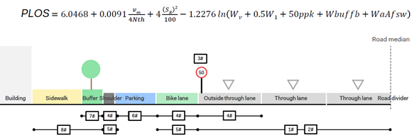

## 

## 

## 

## 

# Section 3 - Relevant phenomena

Regarding the procedure to analyze the street quality the phenomena is defined.

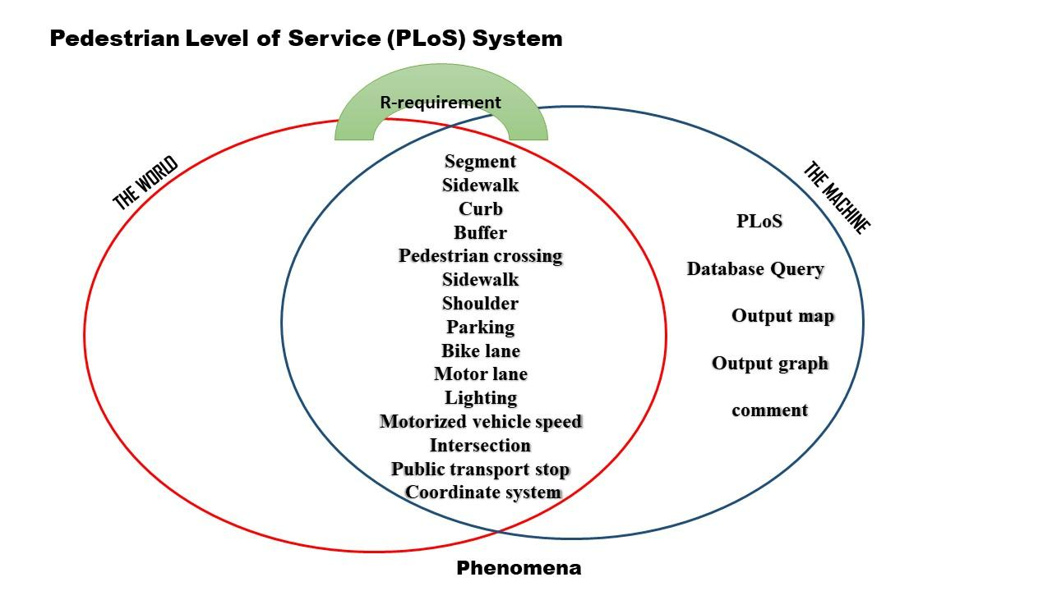

As it is clear in the figure all parameters measured in the world have specific values in the machine so they are shared phenomena between the world and the machine. But the PLOS calculation and analyzing maps and graphs along with queries are just available in the machine. The requirements, which function as a bridge between these two will be explained for every specific Use Cases.

# Section 4 - Use cases

* **UC1: User signs up**
* **UC2: User logs in**
* **UC3: User scroll**
* **UC4: User query based on location**
* **UC5: User query based on attribute**
* **UC6: User request to visualize a graph**
* **UC7: User send comment**
* **UC8: User request to visualize the PLOS map**

## Participating actors:

* User (Sarah in Use Cases)
* Machine (Spavia in Use Cases)
* Pre-existing reference (OSM as the basemap reference and Epicollect as the dataframe platform)

## UC1: User Signs up

## UC2: User Logs in

### Flow of events:

* Sarah requests an HTTP protocol.
* Spavia responds to the request by sending the home page to Sarah.

(The home page interface includes a basemap retrieved from an external reference, overlapped by a map implemented from a dataframe which is extracted from an external data platform, a search box and a bar consisting of a list of maps).

### Entry Condition

True (the user always requests an HTTP protocol)

### Exit condition:

* Sarah stops using the HTTP protocol
* Sarah requests among map bar

### Requirements:

* Spavia must allow Sara to visualize the home page
* Spavia must guarantee connection with references websites (OSM and Epicollect5)
* The PLOS must be calculated in the dataframe.

## UC3: The user scroll

### Follow of events:

* Sarah moves scroll of the basemap
* Spavia updates the map on the screen corresponding the direction of the scroll.

### Entry Condition

* Moving the scroll

### Exit condition:

* Sarah stops using the HTTP protocol
* Sarah requests among map bar

### Requirements:

* Spavia must allow Sara to use scroll
* Spavia must guarantee that each direction movement corresponds to a map frame.

## UC4: User query based on location

### Follow of events

* Sarah selects a segment by clicking on it on the map frame.
* Spavia retrieves data of the requested segment from dataframe.
* Spavia responds to the request by a pop up which presents the values of all parameters and PLOS values available in the dataframe.

### Entry Condition

* Sarah should click on a specific segment.

### Exit condition:

* Sarah stops using the HTTP protocol
* Sarah closes the pop up

### Exception:

* Sarah clicks somewhere else than on the segments.

### Requirements:

* Spavia must allow Sara to select a segment in each click.
* Spavia must guarantee that each segment selected corresponds to an index in the dataframe which consists of parameter values and PLOS.
* Spavia must guarantee the pop up execution once a segment is selected.
* Spavia must not respond in case of clicking on wherever else than the segments.

## UC5: User query based on attribute

### Follow of events:

* Sarah requests the attributes of a specific segment.
* Spavia retrieves data of the requested segment from dataframe.
* Spavia responds to the request by a pop up which presents the values of all parameters and PLOS values available in the dataframe.

### Entry Condition:

* Sarah should input an integer corresponding to a segment number.

### Exit condition:

* Sarah stops using the HTTP protocol
* Sarah closes the pop up

### Exception:

* Sarah input non integer or integer greater than available segments.

### Requirements:

* Spavia must allow Sara to write in the search box.
* Spavia must guarantee that every single number entered in the search box corresponds to a unique index in the dataframe which consists of the parameter values and PLOS.
* Spavia must ensure that the pop up is executed once Sarah enters a correct number.
* Spavia must return an error in case Sarah enters an unknown segment number.

## UC6: User request to visualize a graph

### Follow of events

* Sarah requests the attributes of a specific segment (by location or by attribute)
* Spavia retrieves data of the requested segment from dataframe.
* Spavia responds to the request by a pop up which presents the values of all parameters and PLOS values available in the dataframe and contains a graph request.
* Sarah requests to visualize the graph of the segment
* Spavia makes the graph visualization for the segment

### Entry Condition

* Sarah clicks on the graph button.

### Exit condition:

* Sarah stops using the HTTP protocol
* Sarah closes the pop up.

### Requirements:

* Spavia must allow Sara to write in the search box or click on a segment.
* Spavia must guarantee that every single number or each segment selected corresponds to a unique index in the dataframe which consists of the parameter values and PLOS.
* Spavia must ensure that the pop up is executed once Sarah enters a correct number or selects a segment on the map.
* Spavia must return an error in case Sarah enters an unknown segment number.
* Spavia must ensure a graph visualization for each single segment.
* Spavia must offer the graph within the pop up.

## UC7: User send comment

### Follow of events

* Sarah requests the attributes of a specific segment (by location or by attribute).
* Spavia retrieves data of the requested segment from dataframe.
* Spavia responds to the request by executing a pop up which presents the values of all parameters and PLOS values available in the dataframe and contains a comment box.
* Sarah input and sends a comment.
* The comment series of the back end data frame is updated by a new comment.

### Entry Condition

* Sarah should write in the comment box and press the send button.

### Exit condition:

* Sarah stops using the HTTP protocol
* Sarah closes the pop up

### Exception:

* Sarah writes nothing and presses the send button.
* Sarah writes longer than allowed character.

### Requirements:

* Spavia must allow Sara to write in the search box or click on a segment.
* Spavia must guarantee that every single number or each segment selected corresponds to an index in the dataframe which consists of the parameter values and PLOS.
* Spavia must ensure that the pop up is executed once Sarah enters a correct number or selects a segment on the map.
* Spavia must return an error in case Sarah enters an unknown segment number.
* Spavia must ensure a graph for each single segment.
* Spavia must offer the graph within the pop up.
* Spavia must offer a comment box in the pop up.
* Spavia must define the length of comment in the comment box.
* Spavia must ensure that every comment inserted will be stored in the backend.
* Spavia must allow multiple users to comment on each segment.
* Spavia must return an error in case of empty or long comments.

## UC8: User request to visualize the PLOS map

### Follow of events

* Sarah requests for the PLOS map of the study area.
* Spavia implements the requested map and displays it on the screen.

### Entry Condition

* Sarah should click on the links to a map.

### Exit condition:

* Sarah stops using the HTTP protocol
* Sarah closes the map page.

### Requirements:

* Spavia must allow Sara to visualize a new map page.

# Section 5: Requirements and Domain assumption

## Requirements:

Apart from requirements explained for each Use Case, there are system requirements. Followings are all requirement needed:

* Spavia must retrieve data from the Eppicollect5 platform as a dataframe.
* Spavia must implement the PLOS function in order to calculate the PLOS value using values of the dataframe as the arrays of the matrix.
* Spavia must allow Sara to visualize the home page
* Spavia must allow Sara to use scroll
* Spavia must guarantee that each direction movement corresponds to a map frame.
* Spavia must allow Sara to select a segment in each click.
* Spavia must guarantee that each segment selected corresponds to a unique index in the
* dataframe which consists of parameter values and PLOS.
* Spavia must guarantee the pop up execution once a segment is selected.
* Spavia must not respond in case of clicking on wherever else than the segments.
* Spavia must allow Sara to write in the search box.
* Spavia must guarantee that every single number entered in the search box corresponds
* to a unique index in the dataframe which consists of the parameter values and
* PLOS.
* Spavia must ensure that the pop up is executed once Sarah enters a correct number.
* Spavia must return an error in case Sarah enters an unknown segment number.
* Spavia must ensure a graph visualization for each single segment.
* Spavia must offer the graph within the pop up.
* Spavia must offer a comment box in the pop up.
* Spavia must define the length of comment in the comment box.
* Spavia must ensure that every comment inserted will be stored in the backend.
* Spavia must allow multiple users to comment on each segment.
* Spavia must return an error in case of empty or long comments.
* Spavia must allow Sara to visualize a new map page.

## Domain assumption

* The data are precisely collected for every single segment
* In case a parameter value is not available it is assumed to be zero.
* The PLOS function is applied to each single segment. So all segments have a PLOS value.
* The coordinate system of the points containing the values has 10 meter accuracy with respect to the segments’ location.