5 foods you should never cook straight from frozen – and 5 you can
Knowing when to defrost is essential for safe and tasty meals. Find out which foods you can, and can't, cook from frozen, with expert advice on how to thaw food safely

Hannah DalyConsumer writer
Hannah has dedicated her career to understanding what matters to consumers, and writes practical, trustworthy advice to help people spend wisely and make everyday life easier.
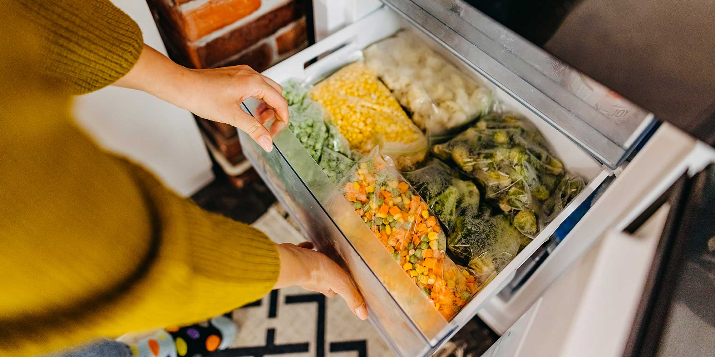
Save articleSet as preferred source
Freezing food is a simple and convenient way to reduce waste, maintain nutritional value and save money. But not all food can be cooked straight from frozen.
From poultry to dairy, it can be confusing to know when you should – and shouldn't – skip the defrosting process.
Our expert tips, along with trusted advice from the Food Standards Agency (FSA), will help you navigate the myths and save time in the kitchen.
Read on to learn which foods you should always defrost before cooking, plus the foods you can safely cook straight from the freezer.
At a glance: tips for storing and defrosting your food safely
- Freeze food before its use-by date Doing so ensures it will be safe to eat after defrosting. Remember to label what the food is, as well as the date you froze it, so you can easily identify it and prevent its quality from deteriorating over time.
- Store food in its packaging or clean, sealed containers The original packaging is designed with food freshness in mind, but reusable containers can also help you to save space in your freezer and avoid cross-contamination.
- Place raw meat, poultry and fish on the bottom shelf of the fridge The bottom shelf is the coldest section of a fridge. Storing poultry products here prevents them from touching or dripping on to other food. Find expert tips on how to organise your fridge.
- Thaw food in the fridge Avoid defrosting food at room temperature, as this encourages the growth of bacteria. When defrosting in the fridge, place the food in a container or on a plate to catch drips and spills.
- Never wash meat, poultry or fish before cooking This can spread bacteria to surrounding food and kitchen surfaces, increasing your risk of food poisoning.

5 foods you should never cook straight from frozen

1. Chicken
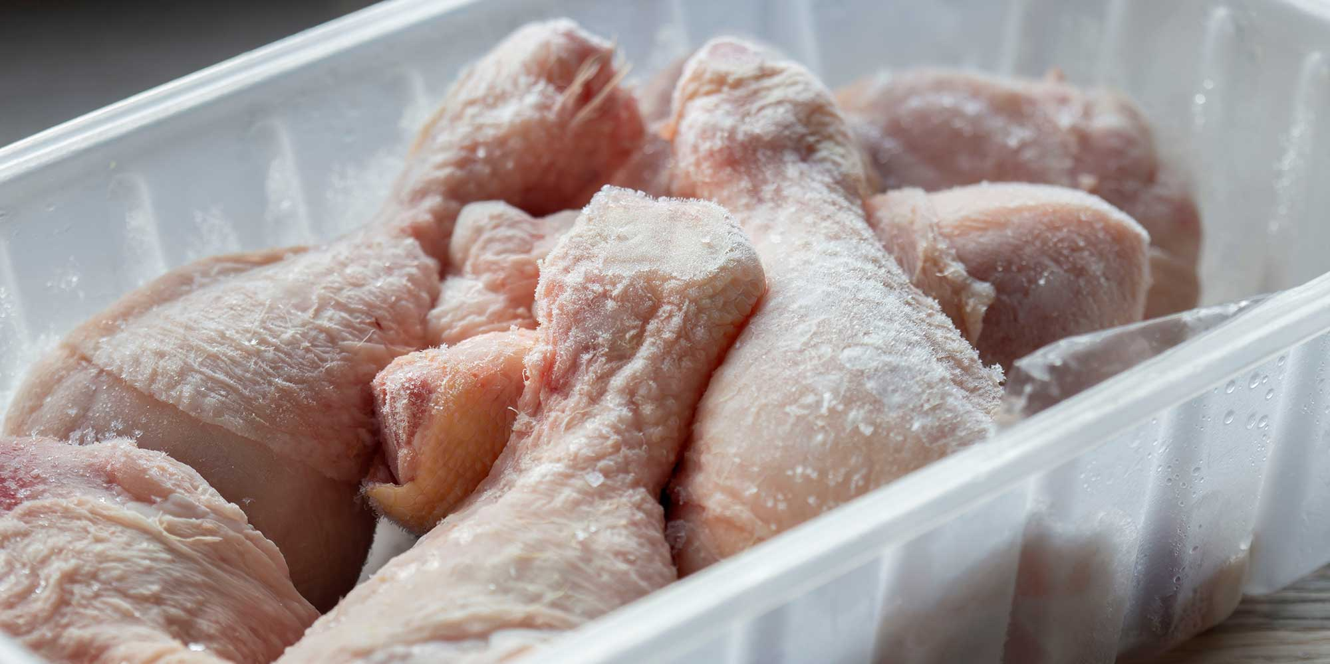
The FSA strongly advises against cooking raw chicken from frozen as it can lead to uneven cooking and bacteria growth.
While the outside of the chicken may heat up and appear done, the inside may remain undercooked and take longer to reach a safe temperature, creating ideal conditions for bacteria, such as campylobacter and salmonella.
This does not apply to many processed chicken products, like nuggets or burgers, which are designed to be cooked from frozen – always check the pack instructions.

How to defrost chicken safely
- Never defrost chicken at room temperature.
- The FSA and NHS recommend defrosting chicken in the fridge at 5°C or lower. In the fridge, this can take 24 hours or longer to defrost, so make sure to plan your meals ahead.
- If you are planning to cook chicken straight away, use your microwave's defrost setting. To check if your chicken is thoroughly defrosted, cut a small slit in the thickest part of the meat – the flesh should be soft and no ice crystals should remain.
- Washing chicken increases the risk of food poisoning as the water droplets can splash on to surfaces, contaminating them with bacteria.
- When you cook chicken, always ensure it is piping hot – not just warmed through. A meat thermometer can help you check that it reaches an internal temperature of 75°C (or 165°F) throughout.

Live well and stay healthy
free newsletter
Sign up for our Healthy Living newsletter, it's free.
窗体顶端
First name (required)
Last name (required)
Email address (required)
Postcode (optional)
Get the newsletter
窗体底端
Our Healthy Living newsletter delivers free health and wellbeing-related content, along with other information about Which? Group products and services. We won't keep sending you the newsletter if you don't want it – unsubscribe whenever you want. Your data will be processed in accordance with our privacy notice.

2. Sausages
Buying a big pack of sausages and freezing them helps you save money and get more meals from one shop.
To make life easier, separate sausages into portions before freezing. This way they won’t all stick together and you can defrost only what you need.
Just remember: home-frozen sausages need to be fully defrosted before cooking to avoid uneven results and food safety risks, so check the centres are fully thawed before you start cooking.
By contrast, some sausages are sold frozen and are safe to cook straight from the freezer – always check the label for guidance.

How to defrost sausages safely
- Defrost sausages in the microwave, using the defrost setting, if you are going to cook them straight away.
- Thaw sausages in the fridge, if you want to defrost and cook them later. Store them in the fridge and use within two days of defrosting.
- Make sure to cook sausages until they are steaming hot all the way through.
Freezing food saves time and money, but all that good work will go to waste if you're not freezing it properly. Avoid these 7 mistakes you might be making when freezing food.

3. Mince

Whether you're preparing a chilli con carne or spaghetti bolognese, the FSA advises defrosting mince thoroughly before cooking.
Blocks of mince are dense, which can result in an unevenly cooked meal if they're not defrosted first. Like chicken and sausages, some mince may remain undercooked, increasing your risk of food poisoning.
To defrost mince safely, follow the same steps for sausages, outlined above.
Looking to buy a new fridge freezer? See our top-scoring models in our guide to the best fridge freezers.

4. Prawns or shellfish
In most cases, prawns and other types of seafood should be defrosted thoroughly before cooking.
Cooking prawns straight from frozen, without following the tested instructions, can lead to the outsides becoming tough and overcooked, while the centres remain cold. This can increase the risk of harmful bacteria surviving.
There are some packs of frozen prawns specifically prepared to be cooked straight from the freezer. This will be clearly stated on the packaging, along with cooking instructions designed to ensure they heat all the way through.

How to defrost prawns safely
- Thaw prawns in the fridge overnight, keeping them covered and below 5°C.
- To defrost more quickly, use your microwave's defrost setting and cook immediately.
- Prawns are done when they're firm, opaque and piping hot throughout.
- Do not wash raw prawns before cooking – this can spread bacteria around your kitchen.
Prevent waste with our food storage tips to keep your groceries fresher for longer.

5. Homemade frozen meals
Batch cooking and freezing meals, such as lasagne or cottage pie, is quick, easy and saves both time and money. But there is a risk that large, dense portions of homemade meals, especially layered dishes containing dairy products or minced meat, can cook unevenly from frozen.
Always defrost your homemade meals thoroughly before cooking and serving.
The FSA says: 'With homemade meals, it's important to check food is fully cooked and steaming hot the whole way through.'
Is it safe to reheat takeaways? Find out how to get the most out of leftovers.


Health? or Hype?
Make the right choice with recommendations you can trust, backed by expert testing.
Explore health recommendations

5 foods you can cook straight from frozen

1. Sliced bread or rolls
Frozen bread can be put straight in the toaster, oven or grill. While you may need to toast the bread for slightly longer to ensure it fully defrosts and heats through, the FSA says it is safe to eat this way.
To help reduce waste, bread can be stored in the freezer for up to three months. Make sure to slice your bread before freezing so you can pop it straight in the toaster.
If you're looking to make your own delicious loaves at home, see our pick of the best bread makers from our expert tests.

2. Most vegetables and herbs
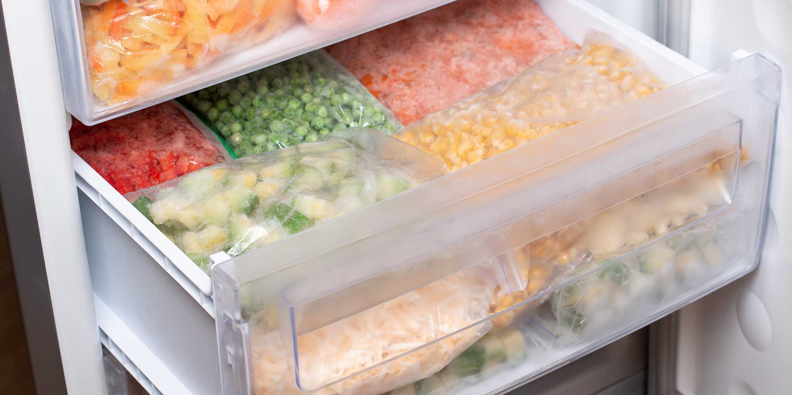
Frozen vegetables such as peas, carrots and stir-fry mixes are designed for direct cooking, so there's no need to defrost them first. Simply toss your frozen vegetables into boiling water, stir-fries or steamers straight from the bag.
If you’re freezing fresh vegetables at home, results can vary. Peas and beans usually freeze well. Carrots and parsnips can also be cooked from frozen, but blanching them first helps preserve their texture. Vegetables with a high water content, such as lettuce and cucumber, don’t freeze well as they tend to go mushy once thawed.
Herbs such as basil, coriander, chives and oregano can also be preserved in the freezer and later added to sauces, curries and stews straight from frozen. Once frozen, however, herbs are only suitable for cooking rather than eating fresh or garnishing.
Some herbs freeze better than others. Delicate dill fronds, for example, can lose their texture after being frozen.
How to grow herbs: fresh herbs are much tastier than dried ones – see which varieties can be grown indoors on your windowsill, and how to grow your favourite herbs outdoors

3. Cream
You can freeze tubs of fresh single and double cream. Both are best used only for cooking after freezing, as defrosting can make them separate and become lumpy.
Adding cream directly to a very hot sauce can also cause it to curdle or split, so make sure to remove the pan from direct heat before adding and reheat gently.
Need a new freezer? Head to our round-up of the best freezers to buy now.

4. Prepackaged food

Provided the packaging says you can cook from frozen, you can put prepackaged food, including ready meals, pies, curries and frozen fish fillets, straight in the oven.
The FSA advises following the cooking instructions exactly – these products have been tested to ensure they're safe to eat once cooked.
However, items that you've frozen yourself, such as cod, haddock or salmon fillets, should be thoroughly defrosted in the fridge before cooking.
Unlike prepackaged food, home-frozen items can vary in portion size, making cooking times harder to judge and increasing the risk that harmful bacteria survive if undercooked.
From coffee to extra virgin olive oil, we round up the best supermarket food and drink from our independent taste tests.

5. Fruit
Soft fruits, such as berries, cherries and mango, can go straight from freezer to pan for sauces, crumbles, pies or compotes.
No defrosting is required if they're being cooked, but keep in mind they will soften more quickly than fresh fruit.
What temperature should a freezer be? We explain why your freezer temperature matters.
The top business accreditations to choose for your trade
Updated 01/25

By: Tommy Burgess

Blog>Trade>Starting a Business>The top business accreditations to choose for your trade

Table of contents

Which trade associations to join in the UK
Wondering what qualifications you might need to start working in a trade?
Why ISO certification is important
Become a Checkatrade-approved tradesperson
Quick roundup
FAQs
The easier way to book quality trades

Download app
Business accreditations are a great way to prove that your trade business has the skills, standards and work ethic to deliver an excellent service. To help you choose the right ones, we’ve put together a list of UK business accreditations for some of the most popular trades.

In the UK, we have a whole range of common business accreditations and trade associations that cover trades – from builders, electricians and plumbers to double glaziers, roofers and painters and decorators.

This guide covers the business accreditations the some of the most popular trades in the UK have gained.

Which trade associations to join in the UK
For many trades in the UK, there are multiple trade associations you can join that will offer accreditations and specialist services for their members – such as training, bespoke insurance, and trade-related advice.

If you’re considering joining a trade association, it’s worth checking out the options and deciding which one(s) might be the best option for your trade business.

Below we’ve put together a list of some of the most popular trade associations in the UK, but there may be others out there worth considering for your business.

Which accreditations to choose for a builder
For the building trade, you might want to look into the following:

Federation of Master Builders – It’s the largest construction trade association in the UK. The FMB is there to protect the interests of small and medium-sized building companies both locally and nationally.

Guild of Builders and Contractors – The GBC aims to bring together reputable and experienced construction tradespeople and businesses who are actively involved in the industry.

Guild of Master Craftsmen – As part of the GMC, you’ll be joining skilled tradespeople and artisans who display professional integrity and work hard to maintain standards in their chosen industries.

Stone Federation Great Britain – If you work with stone, the Stone Federation should be on your research list as it’s the official trade association for the natural stone industry in Great Britain.

Which accreditations to choose for a plumber
Here are some of the most popular plumbing trade associations:

The Association of Plumbing and Heating Contractors – APHC offer support and guidance for plumbing and heating businesses that are looking for professional success.

Building Engineering Services Competence Assessment Limited – BESCA acts as a certification body and aims to help businesses and individual tradespeople to meet industry standards, ensure compliance and promote best practice within the construction industry.

Chartered Institute of Plumbing and Heating Engineers – The CIPHE is a professional body for the UK plumbing and heating industry that currently has over 7,500 members.

Which accreditations to choose for an electrician
When considering accreditations as an electrician or electrical businesses, here are some of the accreditations and trade associations to consider:

Blue Flame Certification – BFC offers UKAS-accredited certification services for the energy industry, including gas, oil, electrical and renewable technologies.

NAPIT – With over 16,000 registered members, NAPIT is one of the leading Government-approved and UKAS-accredited membership scheme operators in the UK. They cover electrical, heating, plumbing, ventilation, and building fabric trades for

domestic, commercial and industrial markets.

NICEIC (formerly ELECSA) – NICEIC is the largest voluntary register of electrical businesses in the UK. They work to ensure that all electrical installations are carried out safely and offer inspection, assessment and certification services to contractors working across the building services sectors.

Which accreditations to choose for a roofer
As a roofer or roofing business, two of the biggest trade associations to consider for their business accreditations are:

National Federation of Roofing Contractors – The NFRC is the UK’s largest roofing trade association. They promote quality contractors and products within the roofing industry, and actively ensure that all their members offer high standards of workmanship and reliable business practice.

National Access & Scaffolding Confederation – If you’re in the scaffolding business, you’ll want to look into the NASC as it’s the go-to trade body for access and scaffolding businesses in the UK.

Which accreditations to choose for windows, doors and conservatories
As one of the most popular trades in the UK, there are a number of popular trade associations that offer accreditations for window, door and conservatory businesses. They include:

Assure Certification – If you’re offering a replacement service for windows, roof windows, roof lights and doors in England and Wales then Assure might be for you. It’s an official, UKAS-accredited Competent Persons Scheme that’s authorised by the Ministry of Housing, Communities and Local Government.

CERTASS – As part of CERTASS accreditation, you’ll be assessed to ensure that you’re meeting specific industry standards. They offer a Competent Persons Scheme, a CQ Assured Workmanship Scheme, and PAS 2030 Certification.

Exova BM TRADA Competent Persons Scheme – This scheme is designed to ensure that all window or door replacement work legally complies with the Building Regulations and is notified to Local Authority Building Control.

FENSA – FENSA is a government-authorised scheme that monitors building regulation compliance specifically for the replacement of windows and doors. Each FENSA Approved Installer is assessed regularly to ensure that they comply with current Building Regulations in England and Wales.

Glass and Glazing Federation – The GGF is the main representative organisation for companies involved in all aspects of the manufacture of glass and products and services for all types of glazing in the UK.

Which accreditations to choose for a central heating engineer
As a central heating engineer, you’ll need to consider the Gas Safe Register and you might also want to look into becoming HETAS-registered:

Gas Safe Register – It’s a legal requirement for all gas engineers in the UK to be on the Gas Safe Register. It’s the official list of registered gas businesses who are recognised to work safely and legally on boilers, cookers, fires and all other gas appliances.

HETAS – Being a HETAS-registered installer shows that your biomass and solid fuel heating installation work complies with the relevant Building Regulations in England and Wales.

Which accreditations to choose for a painter and decorator
For painters and decorators in the UK, there’s one leading trade association:

Painting and Decorating Association – The PDA offers tailored support to painters and decorators across both domestic and commercial markets in the UK.

Which accreditations to choose for renewable energy
With the rise in popularity in renewable energy and green homes, you might want to look into becoming accredited by a trade association that focuses on green trades:

MCS –The MCS is a standards organisation that creates and maintain standards that allows for the certification of low carbon products, installers and their installations. MCS membership shows quality, competency and compliance to recognised industry standards.

Oil Firing Technical Association Limited – OFTEC leads the way in the off-gas grid heating sector in the UK. They operate UKAS-accredited registration schemes for heating technicians who work in liquid fuels, heat pumps, solar thermal, biomass and solid fuel.

Solar Trade Association – The STA works to promote the benefits of solar energy and to make its adoption easy and profitable for domestic and commercial users.

Wondering what qualifications you might need to start working in a trade?
Here's a handy read for you:

Official trade qualifications in the UK
Now is a great time to be a tradesperson in the UK. Because becoming a qualified tradesperson has never been more accessible. Getting official trade qualifications sets you up with the right skills to do the job well. Plus, it shows potential customers that you’re dedicated to your trade. Types of

Learn more
Why ISO certification is important
ISO (International Organisation for Standardisation) is an independent body that develops standards for ensuring the quality, safety, and efficiency of the products or services provided by your businesses.

The benefits of ISO certification include:

It allows you to identify risks and opportunities through standardised quality management

It helps you avoid recurring problems by requiring you to maintain useful records

It gives you a marketing boost as you can promote your business as being ISO-certified

It improves your control over the business because you’re forced to monitor, measure, analyse and evaluate the quality of your product and service delivery

Become a Checkatrade-approved tradesperson
By joining Checkatrade and gaining our seal of approval, you’ll get the tick that…

Gives you the platform to build your online reputation

Increases your business’s trust with homeowners

Gives you our seal of approval

Helps you to win more business

Gives you exclusive access to trade deals

Not only that, but we trust our members enough to guarantee their work up to £1,000 (T&Cs apply). That’s right, as a Checkatrade member, you’ll know we’ve got your back.

Quick roundup
Whether you’re thinking about starting a new business or you’re already up and running and want to grow your business, accreditations are a brilliant way to show customers that you’re dedicated to professional standards in your industry.

Just remember to do your homework, research the trade associations we’ve listed above – or see which other recognised bodies offer accreditations for your trade business.

FAQs
Do I need UKAS accreditation?
It’s often a good idea to check that the accreditation schemes you’re looking at are UKAS-accredited. The United Kingdom Accreditation Service (UKAS) is the UK’s only national accreditation body and the UK government policy is that it only recognises accreditation schemes of UK-based bodies that have been accredited by UKAS.

What is the difference between ISO and UKAS?
The ISO is the international organisation that writes, reviews and updates standards for many different industry sectors - so it sits at the top of the standards tree. UKAS, as the UK’s national accreditation body, makes sure that any UK certification bodies are performing to the relevant standards.

If you're looking to be certified in an ISO standard, then we’d recommend choosing a UKAS-accredited certification body to ensure that you can be confident that you’re certified to the right standard.

Is accreditation important in the UK?
We believe that business accreditations are extremely important, if you want to show customers that your trade business is dedicated to upholding standards within your industry. For some businesses, such as gas engineers, they’re also a legal requirement to operate in the UK.

Having national standards and accreditations helps to ensure that both businesses and customers can be confident that the products and services they purchase meet certain regulatory requirements.

Share this article:

This content has been created for general information purposes and should not be taken as formal advice. Read our full disclaimer here.

Read our most popular content

View local tradespeople in your area
Copyright Checkatrade. Using this information in an article or blog? Please add a link back to https://www.checkatrade.com/blog/trade/start-business/trade-business-accreditations/

Homeowner
Trades
Trade sign up
Download app

COST GUIDES
New kitchen: Cost Breakdown 2026
Updated 03/26

Verified by our professional estimators
Estimators are CIOB & RICS members
By: Content Team

Reviewed: Alex Peters

Blog>Cost Guides>New kitchen: Cost Breakdown 2026

Table of contents

How much does a new kitchen cost in 2026?
What's the average cost of a new kitchen in the UK?
New kitchen cost: Job estimator tool
Factors affecting the cost of a new kitchen
Hidden costs to watch out for
Cost of a kitchen fitter vs fitting a new kitchen yourself
Should I hire a kitchen fitter for my new kitchen?
New kitchen cost: FAQs
The easier way to book quality trades

Download app
The kitchen is the heart of the home. So, it's no surprise that a new kitchen is one of the most popular home improvement jobs. Here, we’ll break down the typical new kitchen cost to help you budget.

THIS ARTICLE CAN HELP YOU UNDERSTAND
Average costs for new kitchens

Labour and refit costs for kitchen installation

Factors that affect total kitchen cost

Hidden or additional costs to watch out for

DIY vs professional fitting comparison

Tools and calculators for estimating your budget

How to find local kitchen companies

FAQs about new kitchen pricing

Before you start tearing out your current kitchen and ordering your new one, it’s essential to consider how much a new kitchen costs.

From budget kitchens, to fitted kitchens and entire kitchen refits, there's lots to consider when calculating the cost of a new kitchen.

Keep reading to find out the average cost of a new kitchen in the UK.

How much does a new kitchen cost in 2026?
The cost of a new kitchen can range from under £7,000 for a small budget kitchen, to up to £10,000 for a large, bespoke kitchen.

These prices include the labour cost of removing your old kitchen and installing your new one. They also include the cost of the new kitchen itself – such as new flooring, plumbing, decorating and a few key appliances such as a built-in cooker, hob and hood.

Our cost table below will give you ballpark averages for the individual components.

New kitchen items Low cost (small kitchen) High cost (large kitchen) Average cost
Units £1,500 £10,000 £3,000
Worktops £100 £5,000 £1,000
Appliances £450 £5,200 £2,000
Kitchen installation £2,200 £4,600 £3,000
Plumbing £200 £600 £300
Electrics £300 £1,000 £500
Flooring £500 £2,000 £750
Total cost £5,250 £28,400 £10,550
Last updated: March 2026
Our costs are ballpark averages - get a local tradesperson to quote now

Verified by our professional estimators
Estimators are CIOB & RICS members

What's the average cost of a new kitchen in the UK?
It’s estimated that the UK average someone pays for their new kitchen to be fitted is around £3,500 (not including the cost of the kitchen itself). But again, installation costs will vary hugely depending on the size of your kitchen, its spec and the scope of the project.

You’ll also have to factor in your location, as the price of labour tends to be higher in cities (especially London).

As a rough guide, you could expect to pay in the region of £2,200 to have a small kitchen installed, or £4,600 to have a large kitchen installed. Some kitchen companies will include installation when they provide you with a new kitchen. Other times, you’ll need to find a kitchen fitter yourself.

Don’t forget, as well as a kitchen fitter, you’ll need the expertise of other tradespeople to complete the job too. This usually includes a plumber, electrician, Gas Safe registered engineer, plasterer and painter and decorator.

TOP TIP
With planning and some creativity, you can design a kitchen that is both functional and stylish for you to enjoy time in – whether that’s cooking, cleaning, eating or entertaining.

16 new build kitchen ideas to add personality and style
Who said new build kitchens have to be boring? Here's how to inject both style and personality into your kitchen.

Learn more
New kitchen cost: Job estimator tool
To help work out the average price of a new kitchen, including labour costs, use our estimator tool below.

Job Estimate Calculator
Get Started

Step 0/3
This guide price is generated using AI based on past Checkatrade jobs. Actual costs may vary. Please contact a tradesperson for a confirmed quote.

Kitchen refit labour cost UK
The average kitchen fitter day rates in the UK are between £250–£350. However, your kitchen fitter price can vary depending on your fitter’s experience, and where you live in the UK.

Factors affecting the cost of a new kitchen
Cost of new kitchen cabinets
Your kitchen cabinet prices will depend on their material, as well as whether they arrive flat-pack or pre-assembled.

Standard base unit: between £20 - £70

Standard wall unit: between £20 - £50

Higher-quality base unit: between £70 - £130

Higher-quality wall unit: between £70 - £100

Kitchen cupboard installation: around £225

Although pre-assembled units are more expensive than flat-pack units, they tend to be sturdier as the joints have already been fixed together (this will also save your kitchen fitter time).

Similarly, joints that rely entirely on wooden dowels and glue won’t be as robust as joints that use screws or metal studs and cams. Ultimately, choosing quality units will save you money in the long run.

Cost of new kitchen worktops
Your kitchen worktop is another factor that can have a big influence on your overall kitchen cost.

For a 5m length of kitchen worktop, here’s roughly what you can expect to spend…

Laminate: between £200–£800

Wood: between £300–£900

Quartz: between £500–£1,100

Granite: between £550–£1,150

Read our kitchen worktop cost guide for more detailed breakdowns.

Cost of new kitchen appliances
Another thing that you’ll need to take into consideration when installing your new kitchen is whether or not you’re going to be installing completely new appliances.

Are you going to be opting for all-new kitchen appliances?

Do you want built-in or freestanding appliances?

Will you need to reroute plumbing and electrical wiring to meet the needs of your new layout?

Are you going for gas appliances? If so, have you got the contact details of a reputable Gas Safe registered engineer?

It’s essential to think about not only the type of appliance you require but also the costs and practicalities of having that appliance.

Your costs will vary based on what appliance you’re having fitted, whether it’s electric or gas, and the price for both the appliance itself and the labour to install it.

For a cooker, hob and hood from budget brands, you can expect to pay around £450.

In contrast, if you want a cooker, hob, hood, fridge/freezer, dishwasher and microwave, all from premium brands, you’re looking at closer to £5,200.

When you’re buying a new kitchen appliance, always read the reviews to make sure it’s a reputable item, and check that it comes with a decent warranty.

Find guaranteed kitchen experts near you
Enter your postcode
Search

Hidden costs to watch out for
Let’s be honest, if you’re looking to transform your kitchen, there’ll probably be a few other things you want to have done to perfect it. Here are some extra costs you might need to consider.

Kitchen refit complexity
More complex projects will typically take longer to complete and may also require more expertise – which can push up your overall costs. To begin with, there might be parts of the room that need to be repaired before you even start fitting your new kitchen.

A plasterer is likely to charge around £1,100 to plaster a small room, or £1,900 to plaster a large one.

A complete kitchen rewire will usually cause you to spend around £1,000 on electrics.

If you have a particularly awkward space, you may also find that forking out for a bespoke kitchen is the best way to maximise it.

This is because budget kitchen suppliers will usually only sell kitchen cabinets in set sizes. If you end up going for a bespoke kitchen, this will of course push up your overall price.

How easy is it to rip out a kitchen for a kitchen refit?
A kitchen refit can be an expensive project. Save money by using our step-by-step guide to rip out the kitchen yourself.

Learn more

Cost to remove old kitchen
The cost of removing your existing kitchen will usually be included in your quote. However, it’s always worth checking to make sure.

Even if the cost of removing your kitchen is included, the cost of removing the waste generated might not be.

A builder 6 - 8 yard skip costs on average £320 per week

A ‘man with a van’ service typically costs between £64 - £94

per hour depending on the number of workers required

You could need to pay for skip hire, or for a rubbish removal service to take your old kitchen away in a van.

New kitchen plumbing costs
Planning to replace your kitchen tap? Or your dishwasher? Don’t forget to factor in the cost of hiring a plumber.

The typical plumber will charge between £40 - £60 per hour, or between £325 and £375 per day.

Likewise, if you’re investing in gas appliances (or disconnecting old ones), you’ll need the help of a Gas Safe registered engineer.

How to tell if your gas engineer is working legally
Did you know that gas engineers are the only tradespeople where it is compulsory for them to be part of a registration body in order to carry out work legally? If not, you’re not alone…

Learn more
New kitchen flooring costs
You can reduce your kitchen refurbishment cost by keeping your existing kitchen flooring in place. But if you want a whole new look for the ‘heart of the home,’ you’ll likely want to upgrade your floors.

Vinyl flooring. Between £10 - £40 per m2, plus around £225 per day for installation

LVT flooring. Between £15 - £60 per m2, plus around £300 per day for installation

Laminate. Between £20 - £60 per m2, plus around £270 per day for installation

Wood flooring. Between £35 - £80+ per m2, plus around £250 per day for installation

Cork flooring. Between £40 - £70 per m2 for supply and installation

Polished concrete floor. Between £120–£150 per m2 for supply and installation (or just £50 per m2 if you have an existing concrete floor that you want polished)

Tile. Between £20 - £400+ per m2, plus around £300 per day for installation

Psst! Don’t forget that you can tile your kitchen walls too! Our kitchen wall tile ideas have got you covered.

TOP TIP
Many of your decisions throughout the kitchen design process will be influenced by your budget, so you’ll need to know how much you have to spend from the very beginning.

Price of new kitchen accessories and decor
Once your kitchen has been fitted, there are a few finishing touches that you won’t want to scrimp on. The average painter and decorator charges around £325 per day.

With that in mind, the average cost to paint a room is £450, while the average cost to wallpaper a room is also around £450.

Depending on your situation, you may also want to factor in new kitchen lighting, shelving, picture hanging and more.

Struggling to set a budget for a new kitchen? It's a good idea to make a list of everything you need before start. For accurate kitchen pricing, don't forget the small details!

Include these from the start so you can estimate total costs as accurately as possible.

New kitchen accessories to consider

Cupboard drawer handles

Extractor fan

Lighting

Fitted oven

Fitted dishwasher

Sink and draining board

Sufficient plugs and electrics

Cost of a kitchen fitter vs fitting a new kitchen yourself
If you have the skills, tools and experience, you may be able to install your kitchen on a DIY basis. This will save you on the cost of hiring a kitchen fitter – the UK average paid for professional kitchen fitting is £3,500.

However, you should only tackle the job yourself if you’re confident in your DIY skills. Otherwise, you could end up spending more on rectifying costly mistakes.

Should I hire a kitchen fitter for my new kitchen?
Hiring a kitchen fitter to install your new kitchen is the safest option if you’re looking for quality results. Here are some of the main benefits of hiring a kitchen fitter.

Reduced cost for tools and equipment

Saves time and energy compared to DIY

A job done right

Attempting to install a kitchen yourself could lead to issues that are costly to repair. Doing your homework can help you find a tradesperson committed to quality.

For extra peace of mind, use Checkatrade to find checked tradespeople with reviews from real people.

Find guaranteed kitchen experts near you
Enter your postcode
Search

New kitchen cost: FAQs

How long does fitting a new kitchen take?

How much is the labour cost to fit a kitchen?

Should you hire a professional kitchen fitter?

Does a new kitchen add value?

What costs the most in a kitchen?

How much is a good kitchen in the UK?

Do kitchen fitters remove the old kitchen?

Checkatrade
Follow us

Share this article:

Working with professional estimators, we collate cost estimates for the common home improvement and repair jobs in the UK.

All the costs are estimates only. For accurate costs for your particular requirements, you are encouraged to reach out to professional tradespeople to receive a quote for your job.

Our estimators are Chartered Members (MRICS) of the Royal Institution of Chartered Surveyors and Members of the Chartered Institute of Building (MCIOB). See full disclaimer.

More Kitchens Articles

How much does kitchen fitting cost in 2026?

Kitchen design cost guide

How much value does a new kitchen add to your home?
View all
See the tradespeople we've checked for your job

PostcodeSearch

Read our most popular content

View local tradespeople in your area

Popular Jobs

Find Tradespeople

Cost Guides

Helpful Info
Information Centre
Terms and Conditions
Privacy
Contact Us
Careers
Sitemap
FIND US ON SOCIALS

DOWNLOAD THE APP

© Checkatrade.com all rights reserved

Copyright Checkatrade. Using this information in an article or blog? Please add a link back to https://www.checkatrade.com/blog/cost-guides/new-kitchen-cost/

