**Document Of Understanding**

**For**

**Patient Photo, Tracking & Reminder App**

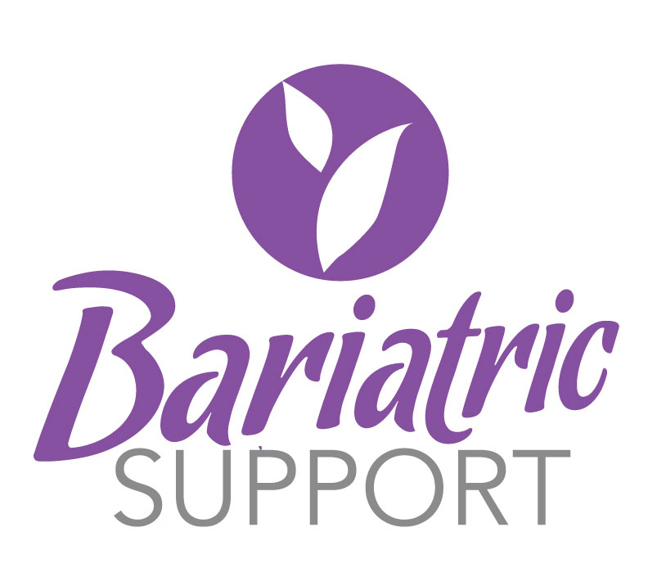

**by WLF Medical**

**Application Objective**

Application will be developed for WLF Medical patients to give them the tools they will need to be successful long-term and celebrate their successes.

Tools will include before and after photo generator, goal setter, timely reminders about the activities they need to do, tracking of completed activities, achieving goals, health milestones, as well as comment and like other user’s posted photos and milestones and share on social media (facebook, twitter and pinterest) if desired.

This application will help the patients in post-operative phase recover faster and increase overall weight loss.

MFP is too labour-intensive.  And no one wants to be constantly reminded if they ate crap or feel guilty for not logging the handful of chips they snuck.

**[melanie](https://wlfmedical.slack.com/team/melanie" \t "/team/melanie)***[10:21 AM]*MFP does too much.  
Ours - did you eat a protein? a veggie?  Good.  Did you eat crap? We don't log that.  
Did you get your protein drinks in?  Good.  
Did you get your water in? Great!  
Did you lose weight? Awesome! Let's celebrate and share your achievements with each other.

Application will have basically 10 parts involved:

1. Allow patients to set and record their goals and the activities required to meet goals:
   1. Weight Loss Goal Generator
   2. Daily weight
   3. # of hours of sleep
   4. Daily Activity
   5. Water Intake (coffee, tea, water, other)
   6. Vitamin & Medications Taken
   7. Protein Supplements Taken
   8. Food Tracking is based on Surgery Phases:
      * **Solid Food, Maintenance, Back on Track:**
      * Breakfast (Choose from lean protein, eggs, (protein shake – also added to their protein supplement goals)) *Remember not to eat and drink at the same time
      * Lunch (Choose from lean protein, veggies, salad, (protein shake – also added to their protein supplement goals))
      * Dinner (Choose from lean protein, veggies, salad, (protein shake – also added to their protein supplement goals))
      * Snack (Choose from lean protein, veggies, salad, (protein shake – also added to their protein supplement goals))
      * **Clear Foods:**
      * Breakfast, Lunch, Dinner, Snack: (Choose from jello, herbal tea, water, broth, other clear)
      * **Full Foods:**
      * Breakfast, Lunch, Dinner, Snack: (Choose from jello, soup, smoothie, yogurt, (protein shake – also added to their protein supplement goals))
      * **Soft Foods:**
      * Breakfast, Lunch, Dinner, Snack: (Choose from soft protein, soft eggs, soup, smoothie, yogurt, (protein shake – also added to their protein supplement goals))
      * 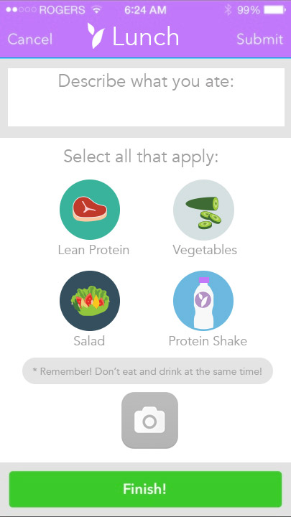
2. Allow patients to set reminders based on above activities and time from Date of Surgery and Surgery Phases: preoperative, postoperative: clears, fulls, soft foods, solids, maintenance, back on track:
   1. Preop Diet (select 12, 10, 8, 6, 4 or 2 week preop)
   2. Postop Diet (select 2, 3, 4 week clear fluid), (select week when protein is allowed 3,4,5), (Clear Phase is always followed by 2 weeks Full, 2 weeks Soft, Solids)
   3. Patient who are past the postop phases are on solids by default
3. Photo Maker for before and after photos, and to record food and drink and activities
4. Ability to post photos privately or publicly to other users and comment on other user’s photos
5. Users will be sent timely push notifications for the goals they have set. Users will be able to mark the goal as achieved and not achieved and take photos to post.
6. Guide section with instructions for the patients.
7. Assigned Success Coach will be displayed with contact via in app messaging that automatically bcc’s email to [push@mail.wlfmedical.ca](mailto:push@mail.wlfmedical.ca)
8. Weight loss visual graph to show weight loss over time, compared to their recorded activities for that time frame. ie. Hours of sleep and weight loss, or protein supplements and weight loss.
9. Reports will be generated to see how the users are following their defined schedule and help them improve.
10. Integrated Blogs from wlfmedical site

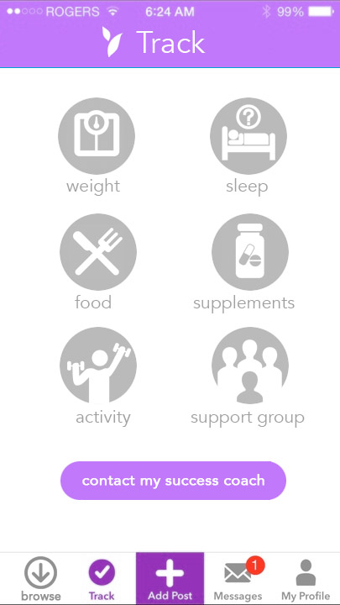 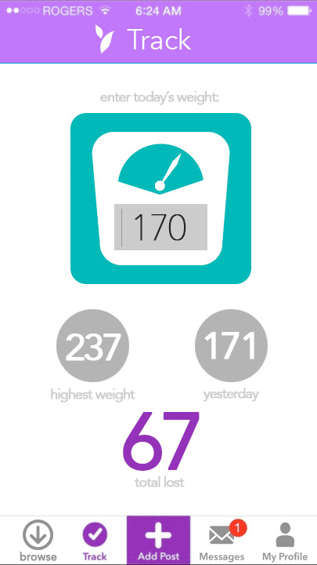 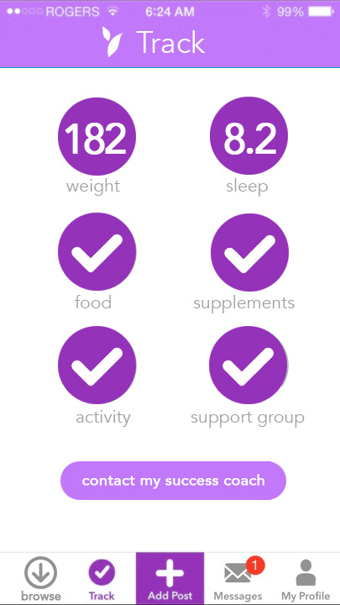

**Workflow of the Application:**

* WLF Medical patients will download the free application
* Once downloaded users will be shown a splash screen with BariatricSupport by WLF Medical logo
* Patient will enter their email address and password from the WLF Database, or be invited to create an account at amiacandidate.com
* Users will be prompted to select their weight loss goal based on following criteria:
  + - Highest Weight
    - Present weight
    - BMI will be automatically calculated
    - Weight loss required to reach goal BMI will be calculated
    - Patient selects weight loss goal:
    - They can choose by BMI: example, Current BMI = 42, Goal BMI = 29, weight loss required is calculated for them (Patient is shown what their Total Excess Weight is (Current weight minus weight at a BMI of 29)
    - Patient enters surgery date (can be prior date)
    - Patient will choose date for reaching goal
    - Patient selects before photo
    - Optional: Patients chooses from list of health problems they currently have (as their health problems are resolved, they can select resolved and share, or post a picture). Example: Type II Diabetes, 2 months after surgery is resolved.
    - Optional: Patient chooses Non Scale Victories (NSV’s as goals to achieve) as they achieve them they can select it and share. Example: Patient wants to wrap towel around them. 6 months after surgery, they reach this NSV Goal. They can share their achievement with a photo, image, and share on social media.
* Based on the above, users will be shown amount of protein required, water required, vitamins required etc:
  + - 3 protein shakes per day minimum
    - Vitamin B12, Multivitamin, Probiotic (starts only at week 5 after surgery)
* Postop water tracker:
  + Early postop: 4 oz every half hour with reminder
  + Long-term: 2 litres per day minimum (user can select higher water goal and reminders)
* User will then define various goals for himself like daily water intake, Protein, weight measurement, sleep taken, meals tracked etc.
* User will also be able to define the time for each activity. For example drink water at 12:00PM, 1:00PM, 3:00PM, Take vitamins at 9:00am, Record Weight, Record Hours Slept etc.
* Based on the user activity defined, push notifications will be triggered.
* Once the push notification is triggered user will mark the task as complete or not complete, and take a photo if applicable.
* Based on this data, user will be able to see the summary information of the tasks complete and not completed and also a graph is displayed, as well as points achieved.
* A section will be available on the device, which will allow the front end users to view the postoperative guidelines (pdf) for their phase (preoperative, clear fluids, full fluids, soft foods, solids).
* Application will be integrated with the existing blog feed to fetch results and display it.
* Patient will be able to text, email or message their assigned Success Coach within the app
* As patient’s health problems are resolved, they can deselect them and share them

**Other Issues**

1. We prefer cross platform system
2. I believe that this application will be used for both patient's/User's own reference, so integration with back is required so as to allow doctor/success coach’s to see the reports and also advise the patients.
3. We are assuming that self-reporting of the defined parameters will be based on “Yes/No”. No other parameter is considered.
4. Point system, rewards etc will be developed in next phase and are not part of this phase, but design should consider this.
5. Future version of app will have store or link to purchase protein supplements and vitamins.
6. Once app is fully tested with out own patients, app may become stand-alone and not tied to wlfmedical users.