**上机作业一**

1. 生成一个 $4×5$，且元素按行放置的矩阵，并分别行、列求和.

> Z <- matrix(1:20, nrow = 4, ncol = 5, byrow = T); Z

[,1] [,2] [,3] [,4] [,5]

[1,] 1 2 3 4 5

[2,] 6 7 8 9 10

[3,] 11 12 13 14 15

[4,] 16 17 18 19 20

> apply(Z, 1, sum)

[1] 15 40 65 90

> apply(Z, 2, sum)

[1] 34 38 42 46 50

1. 生成两个 $3×4$ 元素按列放置的矩阵，并将其分别按行合并，按列合并.

> A <- 1:12; dim(A) = c(3,4); A

[,1] [,2] [,3] [,4]

[1,] 1 4 7 10

[2,] 2 5 8 11

[3,] 3 6 9 12

> B <- 13:24; dim(B) = c(3,4); B

[,1] [,2] [,3] [,4]

[1,] 13 16 19 22

[2,] 14 17 20 23

[3,] 15 18 21 24

> X1 <- rbind(A, B); X1

[,1] [,2] [,3] [,4]

[1,] 1 4 7 10

[2,] 2 5 8 11

[3,] 3 6 9 12

[4,] 13 16 19 22

[5,] 14 17 20 23

[6,] 15 18 21 24

> X2 <- cbind(A, B); X2

[,1] [,2] [,3] [,4] [,5] [,6] [,7] [,8]

[1,] 1 4 7 10 13 16 19 22

[2,] 2 5 8 11 14 17 20 23

[3,] 3 6 9 12 15 18 21 24

1. 计算如下线性方程组系数矩阵的逆矩阵，并求解方程组

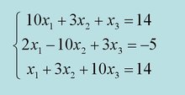

> A <- array(c(10,2,1,3,-10,3,1,3,10), dim = c(3,3)); A

[,1] [,2] [,3]

[1,] 10 3 1

[2,] 2 -10 3

[3,] 1 3 10

> b <- array(c(14,-5,14), dim = c(3,1)); b

[,1]

[1,] 14

[2,] -5

[3,] 14

> solve(A)

[,1] [,2] [,3]

[1,] 0.09688889 0.024 -0.01688889

[2,] 0.01511111 -0.088 0.02488889

[3,] -0.01422222 0.024 0.09422222

> solve(A, b)

[,1]

[1,] 1

[2,] 1

[3,] 1

1. 生成一个 $5×6$，且元素按行放置的矩阵，并将其转换为数据框.

> Z <- matrix(1:30, nrow = 5, ncol = 6, byrow = T); Z <- data.frame(Z); Z

X1 X2 X3 X4 X5 X6

1 1 2 3 4 5 6

2 7 8 9 10 11 12

3 13 14 15 16 17 18

4 19 20 21 22 23 24

5 25 26 27 28 29 30

1. 用write( )函数写一个数据文件.

> setwd("D:/杂物箱/计算机作业/R")

> write(A, file = "data")

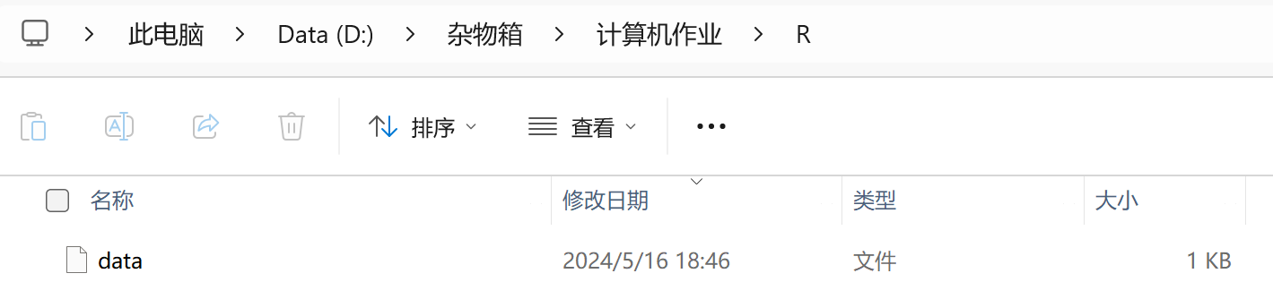

1. 用write.table( )函数写一个数据框数据文件.

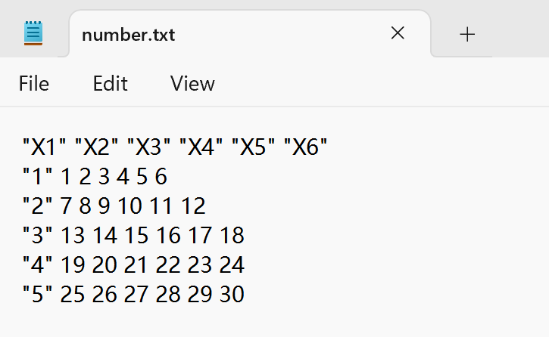> write.table(Z, file = "number.txt")

1. 将后缀为.xls的Excel表数据文件保存为相应格式，并分别用read.delim( )和read.csv( )读取.

> rd1 <- read.delim("temp1.txt") # Attention: Remember to change the code form to UTF-8 in Notepad

> rd2 <- read.csv("temp1.csv")

> head(rd1)

大学 排名

1 清华大学 1

2 西安电子科技大学 2

> head(rd2)

大学 排名

1 清华大学 1

2 西安电子科技大学 2