**上机作业四**

1. 完成轮船相遇（实验十）的理论分析，用R编程实现仿真模拟分析。

理论分析：

$$X,Y∼U\left(0,24\right),P\left\{\left(X≤Y\text{或}X≥Y+2\right)\text{且}\left(Y≤X\text{或}Y≥X+1\right)\right\}=0.879\text{（作图法）}$$

boat <- function(){

  x <- runif(1, min = 0, max = 24)

  y <- runif(1, min = 0, max = 24)

  if((x<=y | x>=y+2) & (y<=x | y>=x+1)) return(T)

  else return(F)

}

N <- 10000;

sum <- 0;

for(i in 1:N){

  if(boat()) sum = sum + 1;

}

p <- sum/N; p

[1] 0.8779

1. 完成最大游程问题（实验十一）的理论分析，用R编程实现仿真模拟分析。

理论分析：

$$p=\frac{1}{6}$$

$ξ∼g\left(p\right),E\left(ξ\right)=\frac{1}{p}$

1. 记 $A_{nk}$：在 $n$ 次试验中连续出现 $k$ 次点数为7， $B_{k}$：前 $k$ 次都为7， $C_{j}$：第一次非7为第 $j$ 次， $j=1,⋯,k$。则 $$P\left(A_{nk}\right)=\sum_{j=1}^{k}{P（A_{nk}∣C_{j}）P\left(C_{j}\right)}+P（A_{nk}∣B_{k}）P\left(B_{k}\right)$$ 其中 $P（A_{nk}∣B_{k}）=1$， $P（A_{nk}∣C_{j}）=P（A_{n-j,k}）$， $P\left(C_{j}\right)=p^{j-1}\left(1-p\right)$， $P\left(B_{k}\right)=p^{k}$，即 $$P\left(A_{nk}\right)=\sum_{j=1}^{k}{P（A_{n-j,k}）p^{j-1}\left(1-p\right)}+p^{k}$$

由 $P（A_{nk}）=0,n=1,⋯,k-1,P\left(A_{kk}\right)=p^{k}$，迭代可得 $P\left(A_{100,5}\right)=0.0103$

fun <- function(n, k = 5, p = 1/6, memo){

  if(is.null(memo)) memo <- c(rep(0, k-1), p^k, rep(NA, n-k))

  if(!is.na(memo[n])){

    list(value = memo[n], memory = memo)

  }

  else{

    rt <- p^k

    for(j in 1:k){

      temp <- fun(n = n-j, memo = memo)

      memo <- temp$memory

      rt <- rt + temp$value*p^(j-1)*(1-p)

    }

    memo[n] <- rt

    list(value = rt, memory = memo)

  }

}

p <- fun(n = 100, memo = NULL); p$value

[1] 0.01026239

dice1 <- function(){

  t <- 1

  repeat{

    x <- sample(1:6, 2, replace = T)

    if(sum(x) == 7) return(t)

    t <- t + 1

  }

}

N <- 10000;

sum <- 0;

for(i in 1:N){

  sum <- sum + dice1();

}

E <- sum/N; E

[1] 5.9889

dice2 <- function(n, k){

  con <- 0

  for(i in 1:n){

    x <- sample(1:6, 2, replace = T)

    if(sum(x) == 7) con <- con + 1

    else con <- 0

    if(con == k) return(T)

  }

  return(F)

}

N <- 20000;

sum <- 0;

for(i in 1:N){

  if(dice2(100, 5)) sum <- sum + 1;

}

p <- sum/N; p

[1] 0.01105

1. 完成野鸭射击问题（实验十二）的理论分析，用R编程实现仿真模拟分析。

理论分析：

设 $ξ_{i}=\left\{\begin{aligned}1,\text{存活} \\ 0,\text{被射中}\end{aligned}\right.$，则 $$P\{ξ_{i}=1\}=\sum_{n=0}^{10}{C_{10}^{n}{\left(\frac{1}{10}\right)}^{n}{\left(1-\frac{1}{10}\right)}^{10-n}⋅{\left(1-0.7\right)}^{n}}={0.93}^{10}$$

即 $E（ξ_{i}）={0.93}^{10}$。于是 $$E\left(η\right)=E\sum_{i=1}^{10}{ξ_{i}}=10⋅{0.93}^{10}=4.8398$$

shoot <- function(n, m, p){

  # n: hunter, m: duck

  x <- sample(1:m, n, replace = T)

  flag <- rbinom(n, 1, p) == 1 # must be logical values

  return(m - length(unique(x[flag])))

}

N <- 10000;

sum <- 0;

for(i in 1:N){

  sum <- sum + shoot(10, 10, 0.7);

}

E <- sum/N; E

[1] 4.8311

1. 查找三门问题的相关资料，进行理论分析和模拟分析。

理论分析：

正面考虑，显然不换门赢得汽车的概率是 $\frac{1}{3}$（主持人选择的一定是羊，拉开门前后无影响），从而换门赢得汽车的概率是 $\frac{2}{3}$。反面考虑，特别要注意主持人的选择不是随机的，而是根据第一次选择而定的，即记 $A$：换门赢得汽车， $B$：不换门赢得汽车，则 $P\left(A∣B\right)=0$， $P\left(A∣\overline{B}\right)=1$，于是 $$P\left(A\right)=P\left(A∣B\right)P\left(B\right)+P\left(A∣\overline{B}\right)P\left(\overline{B}\right)=\frac{2}{3}$$

door <- function(){

  car <- sample(1:3, 1)

  choose <- sample(1:3, 1)

  if(choose == car){

    remain <- T

    change <- F

  }

  else{

    remain <- F

    change <- T

  }

  c(remain, change)

}

N <- 1000;

sum1 <- 0;

sum2 <- 0;

for(i in 1:N){

  rt <- door();

  if(rt[1]) sum1 <- sum1 + 1;

  if(rt[2]) sum2 <- sum2 + 1;

}

p1 <- sum1/N; p1

p2 <- sum2/N; p2

[1] 0.332

[1] 0.668

1. 自主找一道概率统计问题，进行理论分析和模拟分析。

使用逆变换法模拟poisson分布：

$$P\left\{ξ=k\right\}=\frac{λ^{k}}{k!}e^{-λ}$$

则 $p_{k}=\frac{λ}{k}p_{k-1},p_{0}=e^{-λ}$。先产生一个随机数 $x∼U\left(0,1\right)$，根据其在poisson分布函数中对应的位置来确定其属于哪一个取值区间，即依次累计 $p_{i}$ 的值，直至找到 $k$ 满足 $$\sum_{i=0}^{k-1}{p_{i}}≤x<\sum_{i=0}^{k}{p_{i}}$$

getpoisson <- function(n, lambda){

  rt <- numeric(n)

  for(i in 1:n){

    p <- exp(-lambda)

    x <- runif(1)

    k <- 0

    repeat{

      if(x < p){

        rt[i] <- k

        break

      }

      else{

        k <- k + 1

        p <- p + lambda^k/factorial(k)*exp(-lambda)

      }

    }

  }

  rt

}

lambda <- 100;

n <- 1000;

x <- getpoisson(n,100)

hist(x)

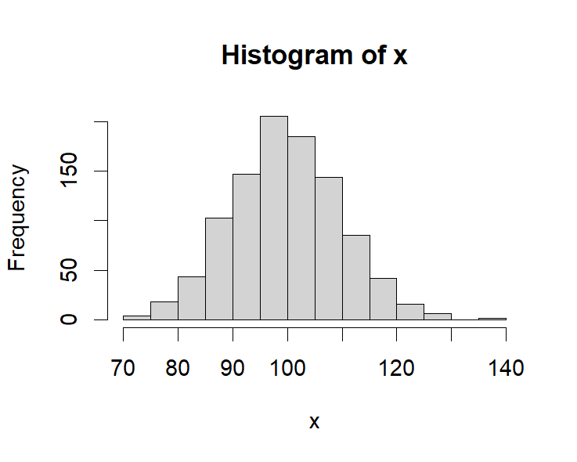

1. 分别用投点法和平均值法估计

(1) (2) 

stochastic <- function(f, a, b, m, M){

  # \int_a^b f(x)dx, m and M is a low/up bound of integrate field (not f(x) !)

  N = 100000

  x <- runif(N, min = a, max = b)

  y <- runif(N, min = m, max = M)

  (sum(f(x) >= 0 & y <= f(x) & y >= 0) - sum(f(x) < 0 & y >= f(x) & y <= 0))/N*(b-a)*(M-m)

}

meanmethod <- function(f, a, b){

  N = 1000

  x <- runif(N, min = a, max = b)

  sum(f(x)*(b-a))/N

}

> f1 <- function(x){

+ exp(-x)

+ }

> integrate(f1, 2, 4)

0.1170196 with absolute error < 1.3e-15

> stochastic(f1, 2, 4, 0, 1)

[1] 0.11752

> meanmethod(f1, 2, 4)

[1] 0.1167726

>

> f2 <- function(x){

+ sin(x)

+ }

> integrate(f2, 0, pi/3)

0.5 with absolute error < 5.6e-15

> stochastic(f2, 0, pi/3, 0, 1)

[1] 0.4982671

> meanmethod(f2, 0, pi/3)

[1] 0.5050794

7. 用Monte Carlo积分法估计

(1)  (2) 

(3)  (4) 

> f3 <- function(x) exp(exp(x))

> integrate(f3, 0, 1)

6.316564 with absolute error < 7e-14

> stochastic(f3, 0, 1, 0, exp(exp(1)))

[1] 6.324934

> meanmethod(f3, 0, 1)

[1] 6.130032

>

> f4 <- function(x) x*(1+x^2)^(-2)*(-1/(x+1)^2)

> integrate(f4, 1, 0)

0.1097061 with absolute error < 3e-15

> -stochastic(f4, 0, 1, -1, 0)

[1] 0.10915

> -meanmethod(f4, 0, 1)

[1] 0.1109257

>

> f5 <- function(x) x*sin(x)

> integrate(f5, 0, 1)

0.3011687 with absolute error < 3.3e-15

> stochastic(f5, 0, 1, 0, 1)

[1] 0.29967

> meanmethod(f5, 0, 1)

[1] 0.2954073

>

> f6 <- function(x) sin(exp(x))

> integrate(f6, 0, 1)

0.8749572 with absolute error < 9.7e-15

> stochastic(f6, 0, 1, -1, 1)

[1] 0.8702

> meanmethod(f6, 0, 1)

[1] 0.870826

8. 用投点法估计二重积分



stochastic2 <- function(f, a, b, c, d, m, M){

  N = 100000

  x <- runif(N, min = a, max = b)

  y <- runif(N, min = c, max = d)

  z <- runif(N, min = m, max = M)

  (sum(f(x,y) >= 0 & z <= f(x,y) & z >= 0) - sum(f(x,y) < 0 & z >= f(x,y) & z <= 0))/N*(b-a)*(d-c)*(M-m)

}

meanmethod2 <- function(f, a, b, c, d){

  N = 100000

  x <- runif(N, min = a, max = b)

  y <- runif(N, min = c, max = d)

  sum(f(x,y)*(b-a)*(d-c))/N

}

> f7 <- function(x,y) exp((x+y)^2)

> stochastic2(f7, 0, 1, 0, 1, 0, exp(4))

[1] 4.859781

> meanmethod2(f7, 0, 1, 0, 1)

[1] 4.930981