**CEBU CITY**

SIRAO GARDEN

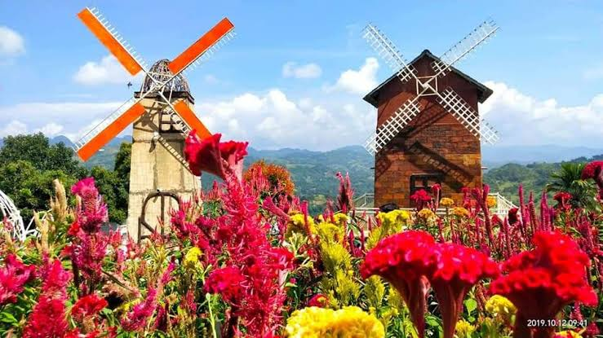

Sirao Garden, also known as the “Little Amsterdam of Cebu,” is a popular tourist destination located in the mountains of Cebu City, Philippines. This picturesque garden is renowned for its stunning display of colorful flowers, particularly celosia flowers, which bloom in vibrant shades of red, pink, orange, and yellow. The Sirao Flower Garden in Cebu City is an amazing location with an abundance of vivid flowers and verdant foliage. Envision strolling across an exquisite terrain, with vibrant flowers blooming in every direction. Surrounded by the splendor of nature, you could feel as though you've stepped into a realm straight out of a fairytale as you stroll through the garden. From sunflowers to roses, the garden's assortment of blooms creates a breathtaking tapestry of hues. You can stroll down the paths bordered with flowers at your leisure, pausing to observe and take pictures of the many floral displays. The breathtaking view that Sirao Flower Garden provides is one of its charms. It offers expansive views of the city below and the surrounding countryside from its hilltop location. The breathtaking scenery frequently enthralls visitors, making it the ideal place for contemplation and rest. In summary, a trip to Sirao Flower Garden offers more than just admiring stunning flowers it's also about losing yourself in a calming, enchanted environment that uplifts the spirit and calms the soul.(<https://iamtravelinglight.com/2020/02/11/sirao-flower-garden-a-color-burst-of-blooms-in-cebus-little-amsterdam-travel-guide-with-p300-budget-for-day-trip/>)

SHANGRI-LA 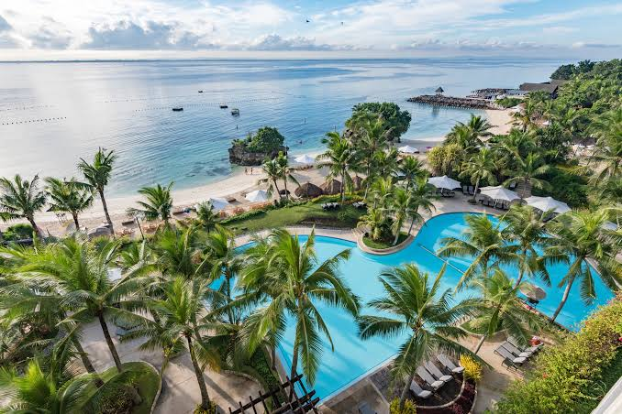

<https://theshutterwhale.com/blog/2017/1/8/hotel-review-shangri-las-mactan-resort-and-spa-cebu-ocean-wing-panorama-room>

Shangri-La's in Cebu is an opulent haven that provides a remarkable encounter with luxury, pleasure, and scenic splendor. Imagine yourself arriving at the resort and being welcomed with a cool welcome drink and friendly smiles, which would set the tone for an amazing vacation right away. The breathtaking seaside location is frequently the first thing that draws in guests. The resort is tucked away on Mactan Island's immaculate shoreline, encircled by shimmering palm trees and glistening waves. A comfortable ensured by the rooms' and villas' great size, beautiful design, and modern conveniences. The variety of experiences and activities available at Shangri-La's Mactan Resort & Spa is one of the best parts about visiting. During the day, you can enjoy spa services, water sports like jet skiing, kayaking, and snorkeling, or just relax by the pool.

LAPU-LAPU TRAVEL GUIDE



<https://www.facebook.com/DepartmentOfTourism/photos/a.422370504456494/1788346931192171/?type=3&locale=ko_KR>

Discovering Cebu's Lapu-Lapu City is an intriguing trip that explores the city's rich history, cultural legacy, and natural beauty Imagine beginning your journey at the well-known Lapu-Lapu Shrine, a memorial honoring the courage of the local chieftain Datu Lapu-Lapu for his resistance to Spanish colonization. One cannot help but be in awe of Lapu-Lapu's bravery and tenacity as they stand in front of the enormous statue of him. The shrine's position over the Mactan Channel, which provides expansive vistas that heighten the experience, adds to the site's significance. Next, your tour might take you to Magellan's Marker, a historical spot marking the place where Ferdinand Magellan, the Portuguese explorer, was killed in the Battle of Mactan led by Lapu-Lapu. This site serves as a reminder of the clash of cultures and the pivotal moment in Philippine history. After exploring these historical landmarks, you might visit a nearby market or souvenir shop to browse local handicrafts, artworks, and traditional delicacies. Overall, a Lapu-Lapu tour in Cebu is a blend of history, culture, nature, and culinary delights, offering a well-rounded and enriching experience for travelers seeking to immerse themselves in the vibrant tapestry of the Philippines.

10,000 ROSES CAFE

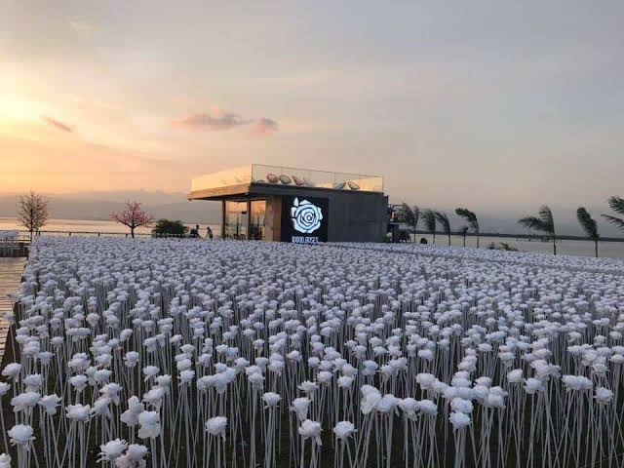

<https://sugbo.ph/2017/10000-roses-cafe-cebu/>

The 10,000 Roses Cafe in Cebu is a unique and visually stunning destination that offers a memorable experience for visitors. Picture yourself arriving at the cafe, greeted by a sea of artificial white roses illuminated by LED lights, creating a magical and romantic ambiance. As you step into the garden, you'll be surrounded by rows upon rows of these glowing roses, creating a mesmerizing sight, especially during sunset or in the evening when the lights are most vibrant. The contrast between the white roses and the darkening sky adds to the beauty of the scene, making it a perfect spot for photography. Many visitors enjoy exploring the garden pathways, The cafe itself offers outdoor seating areas where you can relax, enjoy refreshments, and soak in the enchanting surroundings. In addition to the roses, the cafe also provides views of the nearby coastline, adding to the overall charm of the location. Visitors often find themselves spending time admiring the beauty of the roses, taking walks, and simply enjoying the environment.

WHALE SHARK

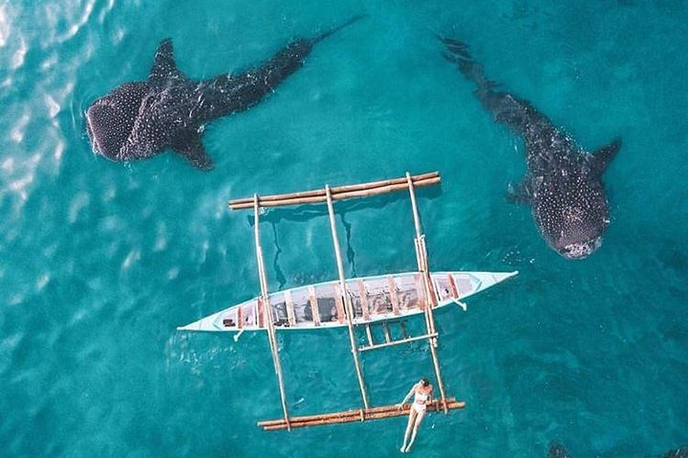

<https://www.googleadservices.com/pagead/aclk?sa=L&ai=DChcSEwjcrYPB5LyFAxXbL4MDHexuC3gYABAIGgJzZg&ae=2&gclid=CjwKCAjwt-OwBhBnEiwAgwzrUmV047TDjg2MyL4h_CetcaU6Kb22---_rg2Q7D1_7fV5ydffS4R5qhoCl7EQAvD_BwE&ohost=www.google.com&cid=CAESVeD2WcBgIfrTrPEe7nVIjBovxKWIOuQ_bVWs6986Y2aFLpkWxfa6R9WvpfTXVjlN8gGMuHYwbqL7jCogcJ2QTugkiylAmd5X9pB-FaeiBGei5CKuJUo&sig=AOD64_170x2eCElyfUfHGanOU1ETwBXYqw&adurl=&ved=2ahUKEwie3f3A5LyFAxUQTWwGHUCuDekQ4bEFegQIARA->

Upon arriving at the whale shark watching area, you'll board a boat accompanied by experienced guides who will provide safety instructions and insights about whale sharks. As the boat sets sail, the anticipation builds, and you eagerly scan the waters, hoping to catch a glimpse of these gentle giants.Once the guides spot a whale shark, the boat slows down, and you prepare to enter the water. Snorkeling gear in hand, you take a deep breath and plunge into the clear blue ocean, surrounded by the beauty of marine life.The moment you spot a whale shark gliding gracefully beneath you, it's a breathtaking sight. Underwater, you might also encounter colorful fish, coral reefs, and other marine species, adding to the richness of the experience. The guides ensure that the interaction is respectful and sustainable, emphasizing the importance of conservation and responsible tourism. After spending unforgettable moments in the water with the whale sharks, the boat journey back to shore is filled with excitement and conversations about the incredible encounter.

SARDINE

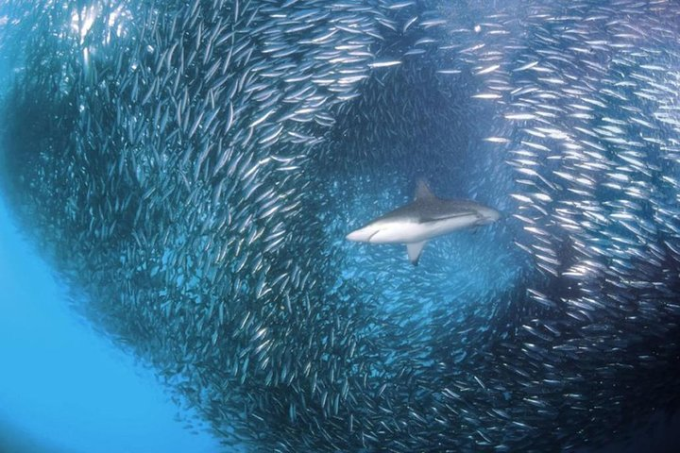

<https://www.googleadservices.com/pagead/aclk?sa=L&ai=DChcSEwjcrYPB5LyFAxXbL4MDHexuC3gYABAIGgJzZg&ae=2&gclid=CjwKCAjwt-OwBhBnEiwAgwzrUmV047TDjg2MyL4h_CetcaU6Kb22---_rg2Q7D1_7fV5ydffS4R5qhoCl7EQAvD_BwE&ohost=www.google.com&cid=CAESVeD2WcBgIfrTrPEe7nVIjBovxKWIOuQ_bVWs6986Y2aFLpkWxfa6R9WvpfTXVjlN8gGMuHYwbqL7jCogcJ2QTugkiylAmd5X9pB-FaeiBGei5CKuJUo&sig=AOD64_170x2eCElyfUfHGanOU1ETwBXYqw&adurl=&ved=2ahUKEwie3f3A5LyFAxUQTWwGHUCuDekQ4bEFegQIARA->

After a short boat ride, you arrive at the dive site near Pescador Island, where the sardine run occurs regularly. Equipped with snorkeling gear or scuba diving equipment, you enter the crystal-clear waters and descend into a world teeming with marine activity. As you continue to explore the underwater landscape around Pescador Island, you'll encounter vibrant coral reefs, sea fans, and an array of marine creatures that call this area home. The diversity of marine life adds depth to your experience, showcasing the beauty. After a thrilling and dive or snorkel session among the sardines, you resurface with a newfound appreciation for the ocean's wonders. The sardine run tour in Cebu not only offers an unforgettable adventure but also raises awareness about marine conservation and the need to protect our oceans for future generations to enjoy.