Project Development Phase
Workflow Automation Verification
Date | 16-10-2026
Team ID | Individual participant - 323103312152@gvpce.ac.in
Project Name | Car Rental Request Automation - ServiceNow
Maximum Marks | As specified by template

Automation Summary
The project uses rule-based ServiceNow configuration: a Flow Designer flow and a server-side Business Rule. No artificial-intelligence model, training pipeline or AI-generated decision is part of it. The verification target is therefore the behaviour of the catalog intake, the approval, the catalog task, the variable retrieval, the email and the exception rule.
Area | Expected behaviour | Verification evidence to capture
Catalog intake | The Car Rental Request item collects Requestor, Requested date, Pickup Location, Drop Location, Duration (hrs), Car Type and Reason1. | Catalog form (Fig 1) and item record (Fig 2).
Approval | Ask For Approval on the Requested Item; If Approve continues only when approved. | Approval action (Fig 5); flow overview (Fig 4); RITM approved (Fig 3).
Catalog Task | Create Catalog Task on sc_task assigned to the Transport Team. | Figs 6, 7 and the task record (Fig 11).
Variable retrieval | Get Catalog Variables reads all seven variables. | Fig 8.
Email notification | Send Email with subject Your car request is approved. | Send Email action (Fig 9) and email log (Fig 13).
Exception handling | Business Rule creates an incident with request number and requested date. | Business Rule record (Fig 12); incident record not yet evidenced.
End to end | All five flow steps complete. | Flow Execution Details (Fig 10).
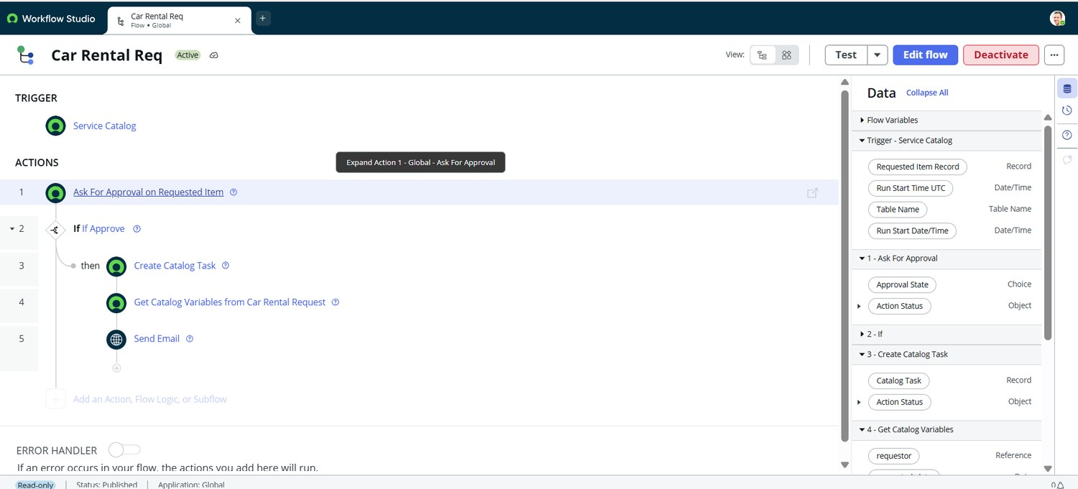
Figure 4. Car Rental Req flow in Workflow Studio: Service Catalog trigger and five actions.
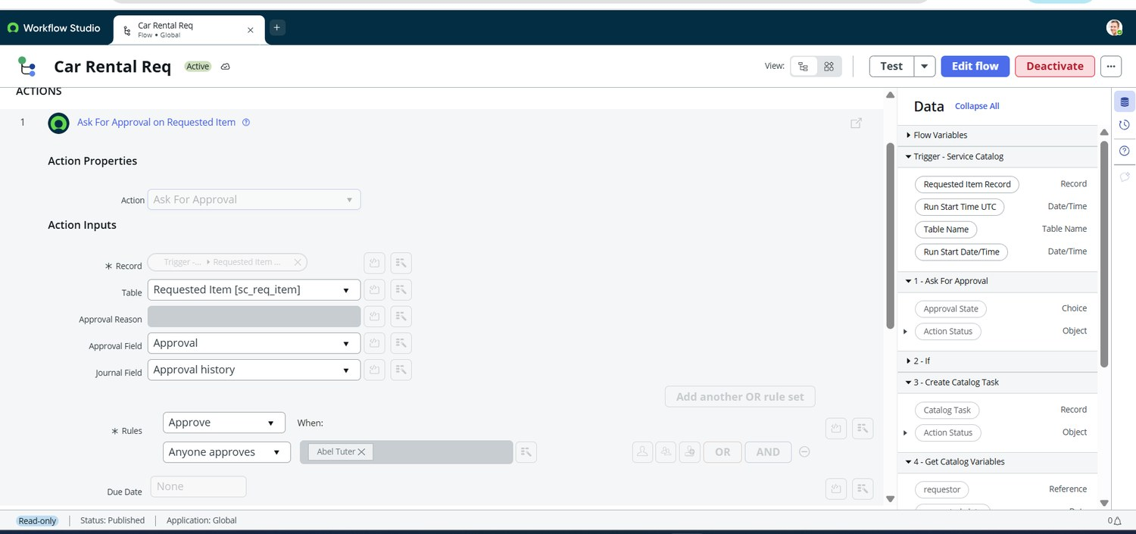
Figure 5. Ask For Approval on Requested Item: rule Approve, Anyone approves, approver Abel Tuter.
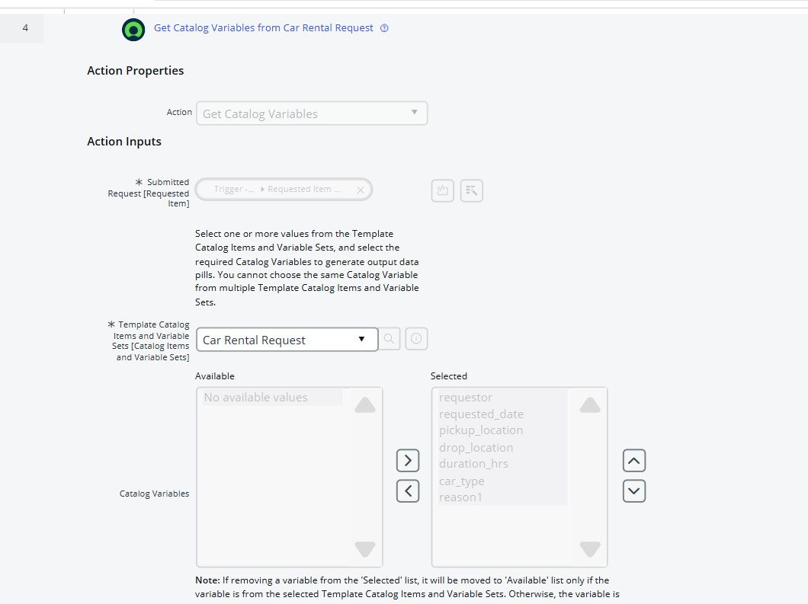
Figure 8. Get Catalog Variables from Car Rental Request: all seven variables selected.
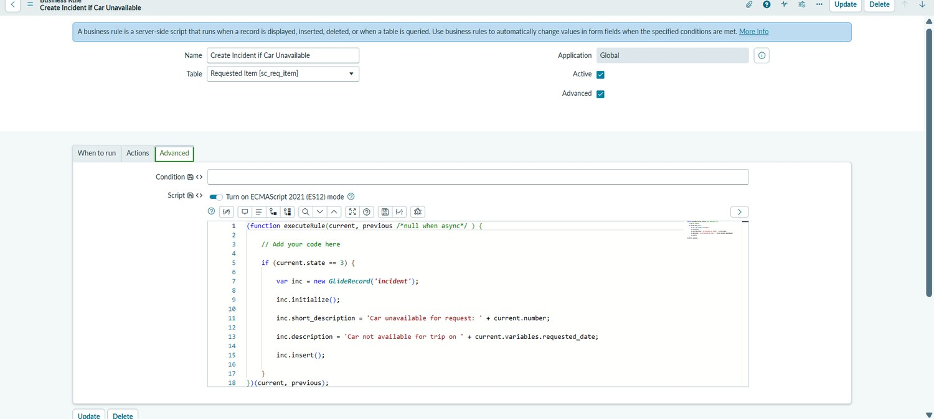
Figure 12. Business Rule "Create Incident if Car Unavailable" on Requested Item [sc_req_item] with its advanced script.

AI-specific fields from the source template
Template field | Project-specific value
Model summary | Not applicable - no AI model is part of this project.
Training / validation accuracy | Not applicable - there is no model training or labelled evaluation dataset.
Fine-tuning result | Not applicable - no fine-tuning is performed.
Evidence note
Figure numbers follow the project’s full set of output screenshots (Figs 1 to 14). The flow was inspected in read-only Workflow Studio; the email action input and business-rule When to run tab are not fully visible in the supplied evidence.

