Project Development Phase
Functional & Performance Testing
Date | 16-10-2026
Team ID | Individual participant - 323103312152@gvpce.ac.in
Project Name | Car Rental Request Automation - ServiceNow
Maximum Marks | As specified by template

Functional Test Scenarios
Tests were run in the project’s ServiceNow instance. Results below reflect the screenshots supplied and the project owner’s testing summary.
ID | Scenario | Steps | Expected result | Actual status
FT-01 | Catalog item and form | Open Service Catalog > Top Requests > Car Rental Request. | Item opens with seven variables under Transportation Services. | Passed (Figs 1, 2)
FT-02 | Request submission | Order the item. | Request and Requested Item are created. | Passed (Figs 3, 13)
FT-03 | Approval and validation | Flow asks for approval; approver approves. | Approval = Approved and If Approve evaluates True. | Passed (Figs 3, 5, 10)
FT-04 | Catalog task creation and routing | Approved request continues. | Catalog Task created and assigned to the Transport Team. | Passed (Figs 6, 7, 11)
FT-05 | Catalog variable retrieval | Get Catalog Variables runs. | Seven variables retrieved. | Passed (Figs 8, 10)
FT-06 | Email notification | Send Email runs; review email log. | Approval email action completes; created and approved emails are logged. | Passed (Figs 9, 10, 13)
FT-07 | End-to-end flow | Run Test on Car Rental Req. | All actions complete. | Passed (Fig 10)
FT-08 | Business rule configuration | Open Create Incident if Car Unavailable. | Active advanced rule on sc_req_item that inserts an incident. | Passed - configuration (Fig 12)
FT-09 | Update Set migration | Preview and Commit Car Rental Request Setup on the second instance. | Committed; 12 inserted; 0 collisions. | Passed (Fig 14)

Test evidence
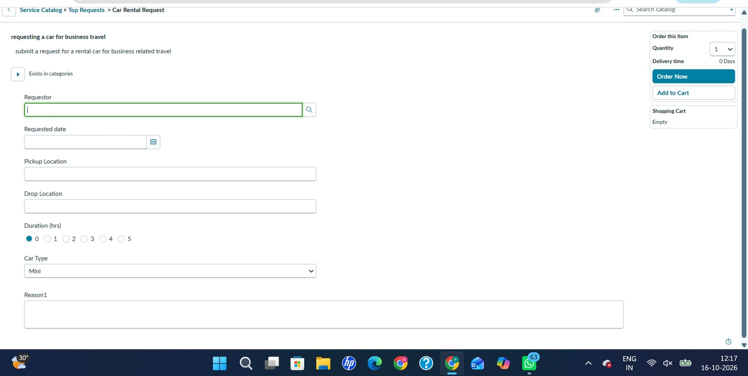
Figure 1. Car Rental Request catalog form: Requestor, Requested date, Pickup Location, Drop Location, Duration (hrs), Car Type and Reason1.
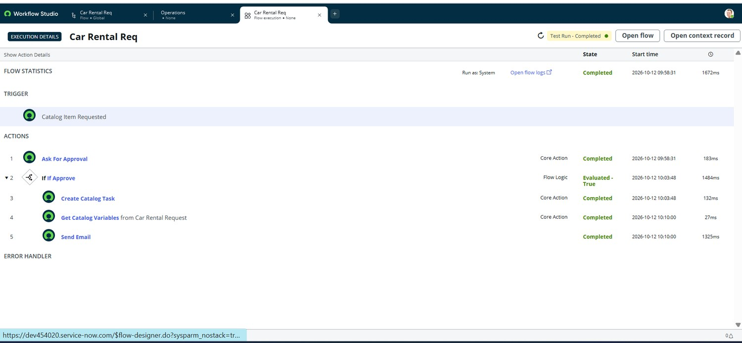
Figure 10. Flow Execution Details: Test Run - Completed on 2026-10-12 (1672 ms); all five steps completed.
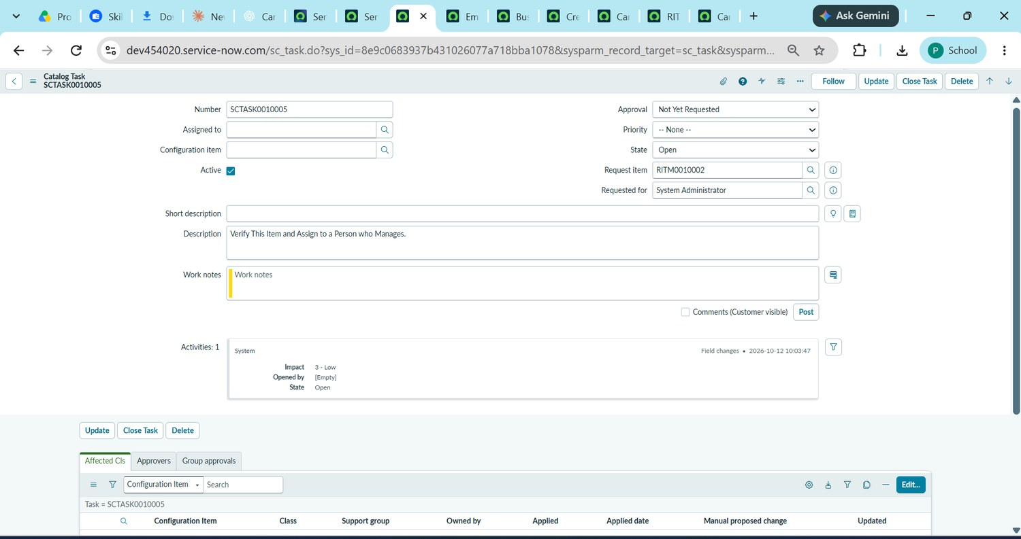
Figure 11. Catalog Task SCTASK0010005 linked to RITM0010002 (State: Open; Requested for: System Administrator).
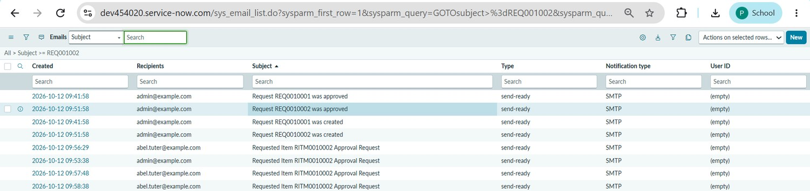
Figure 13. Email log (sys_email): request created, request approved and approval-request emails for REQ0010001, REQ0010002 and RITM0010002.

Performance Testing Plan
Test | Method | Metrics to record | Current evidence
Response time | Run the flow repeatedly in a non-production instance. | Flow and per-action durations. | One test run: 1672 ms total; Ask For Approval 183 ms, Create Catalog Task 132 ms, Get Catalog Variables 27 ms, Send Email 1325 ms.
Concurrent submissions | Submit several test requests. | Successful flows, errors, delays. | No load-test evidence supplied.
Approval turnaround | Compare request and approval times. | Elapsed time to approval. | One example: flow started 09:58:31 and If Approve evaluated True at 10:03:48 on 2026-10-12.
Notification reliability | Run many requests and check the email log. | Emails generated per request. | Created and approved emails logged for REQ0010001 and REQ0010002.
Note
The timings come from a single Flow Execution Details record and are not a performance benchmark. No numeric performance target is asserted.

