Project Development Phase
Workflow Validation Metrics
Date | 16-10-2026
Team ID | Individual participant - 323103312152@gvpce.ac.in
Project Name | Car Rental Request Automation - ServiceNow
Maximum Marks | As specified by template

Applicability
The source template asks for machine-learning metrics. This project has no ML model, so MAE, MSE, RMSE, R-squared, confusion matrices, classifier accuracy and hyperparameter tuning do not apply. The equivalent quality evidence is functional correctness of the flow and the integrity of the request records.
Validation dimension | Acceptance check | Evidence / measurement
Catalog definition | Item has seven variables in Transportation Services. | Fig 2.
Approval correctness | Flow continues only when approval is granted. | If Approve evaluated True after approval (Fig 10); RITM Approved (Fig 3).
Task routing | Catalog Task is created for the Transport Team. | Figs 6, 7 and SCTASK0010005 (Fig 11).
Data retrieval | All seven variables are retrieved. | Fig 8.
Notification | Email action completes and emails are logged. | Figs 9, 10, 13.
Exception rule | Business Rule exists and is active. | Fig 12; execution not yet evidenced.
Packaging | Update Set migrates without collisions. | Fig 14: 12 inserted, 0 collisions.

Metrics from executed tests
Counts come from the nine functional test cases FT-01 to FT-09 in the functional testing document and from the Flow Execution Details record.
Metric | Calculation | Result
Functional pass rate | Passed test cases / executed test cases x 100 | 9 / 9 = 100%
Evidence coverage | Test cases with a screenshot / executed test cases x 100 | 9 / 9 = 100%
Flow action completion | Completed or evaluated actions / flow actions x 100 | 5 / 5 = 100% (Fig 10)
Update Set migration | Records inserted / records in the set x 100 | 12 / 12 = 100%, 0 collisions (Fig 14)
Approval email logging | Requests with created and approved emails / requests tested | 2 / 2 (REQ0010001, REQ0010002)
Incident creation success | Incidents created / unavailable-car cases tested | Not yet measured
Reject-path correctness | Rejected requests handled correctly / rejected requests tested | Not yet measured
How to read these figures
A 100% pass rate over nine cases confirms the documented behaviour works for the cases tested. It is not evidence that the reject path, repeated requests or the car-unavailable incident work; those are listed as pending in the UAT documents.
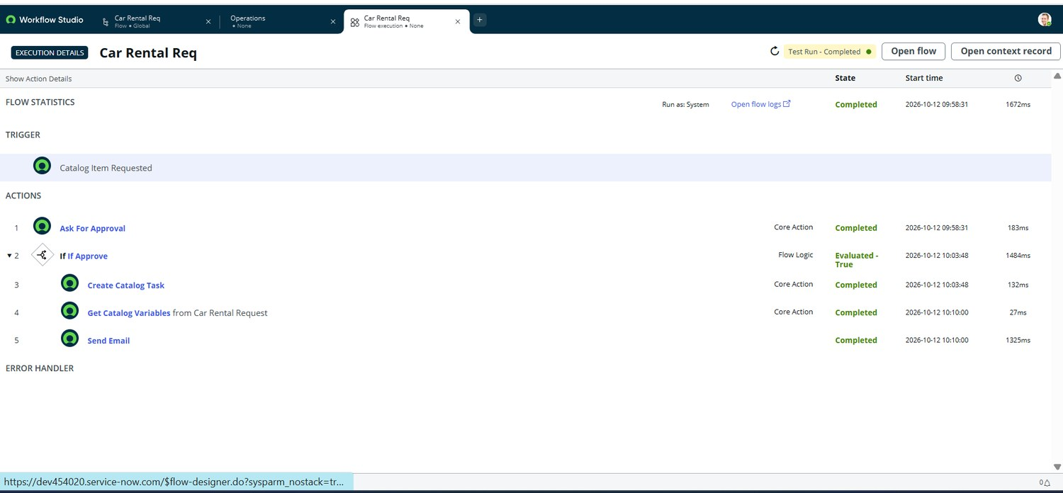
Figure 10. Flow Execution Details: Test Run - Completed on 2026-10-12 (1672 ms); all five steps completed.
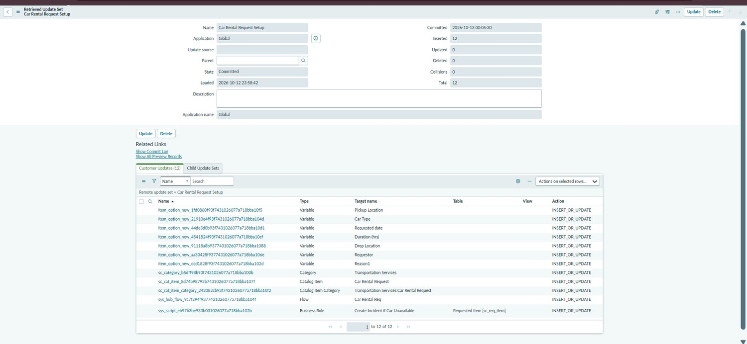
Figure 14. Retrieved Update Set "Car Rental Request Setup": State Committed, 12 records inserted, 0 collisions.

