Project Development Phase
Request Data & Reporting Review
Date | 16-10-2026
Team ID | Individual participant - 323103312152@gvpce.ac.in
Project Name | Car Rental Request Automation - ServiceNow
Maximum Marks | As specified by template

Reporting / Data Review
No Power BI report or dashboard is evidenced in the project materials. This document maps the original template’s data-rendering and reporting fields to the ServiceNow request, task and email records without claiming a separate BI implementation.
Template parameter | Project-specific assessment | Evidence
Data rendered | The Requested Item shows number, due date, approval and delivery plan; the catalog task shows request item, state and description; the email log lists subjects and recipients. | Figs 3, 11, 13.
Data preprocessing | No Power Query pipeline is documented. Trip data is captured by seven catalog variables and retrieved by Get Catalog Variables. | Figs 2, 8.
Filters | No BI slicers are documented. The email list is filtered by Subject (REQ001002 query) using list filters. | Fig 13.
DAX queries | Not applicable - no Power BI semantic model. | None supplied.
Dashboard design | No dashboard is evidenced. | Do not invent visuals.
Report design | Reporting is limited to platform list and form views. | Platform UI only.
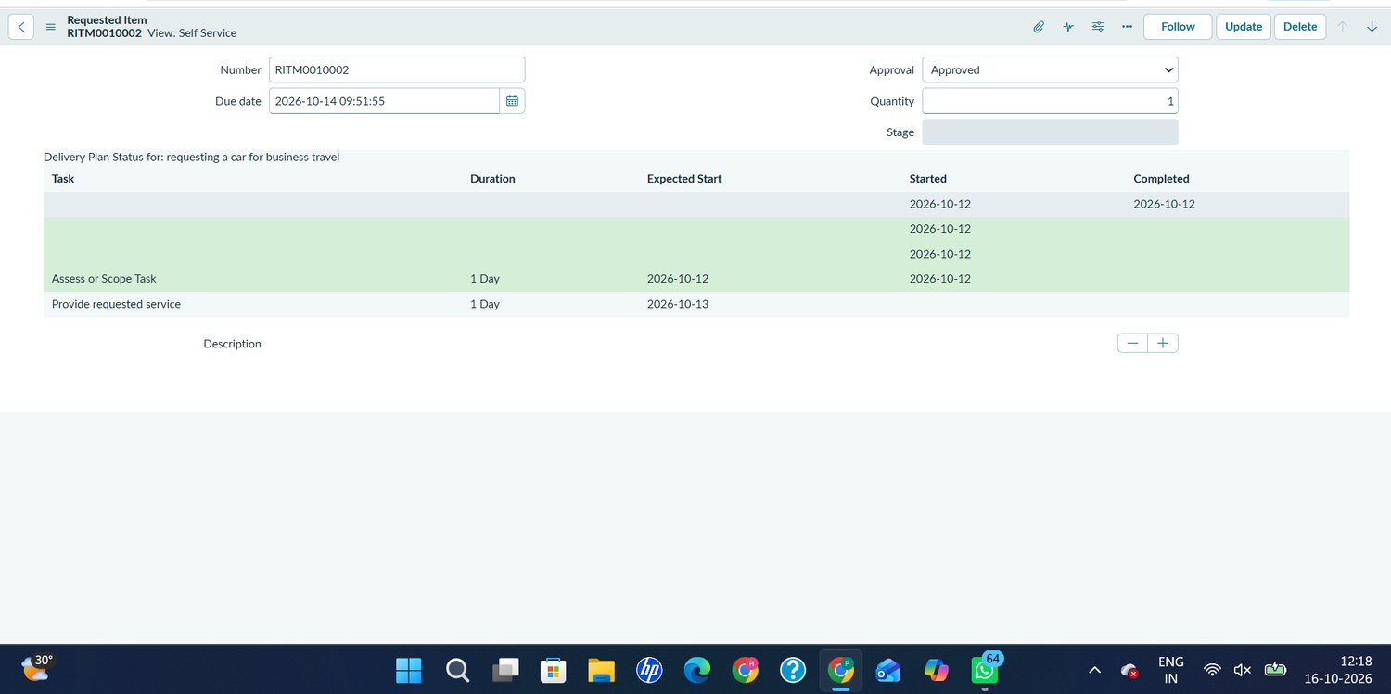
Figure 3. Requested Item RITM0010002: Approval = Approved, due date 2026-10-14 09:51:55 and its delivery plan.
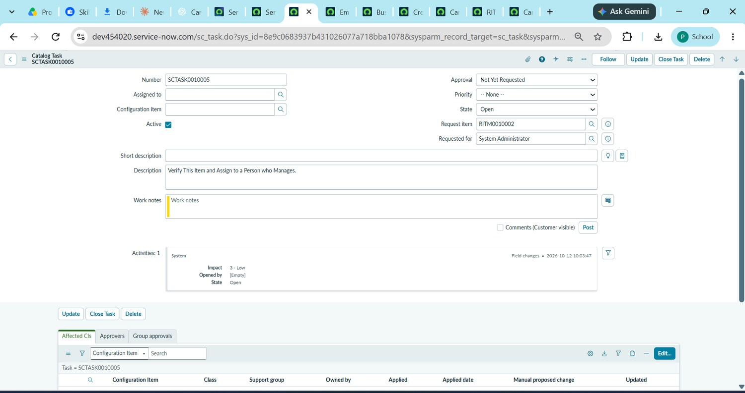
Figure 11. Catalog Task SCTASK0010005 linked to RITM0010002 (State: Open; Requested for: System Administrator).
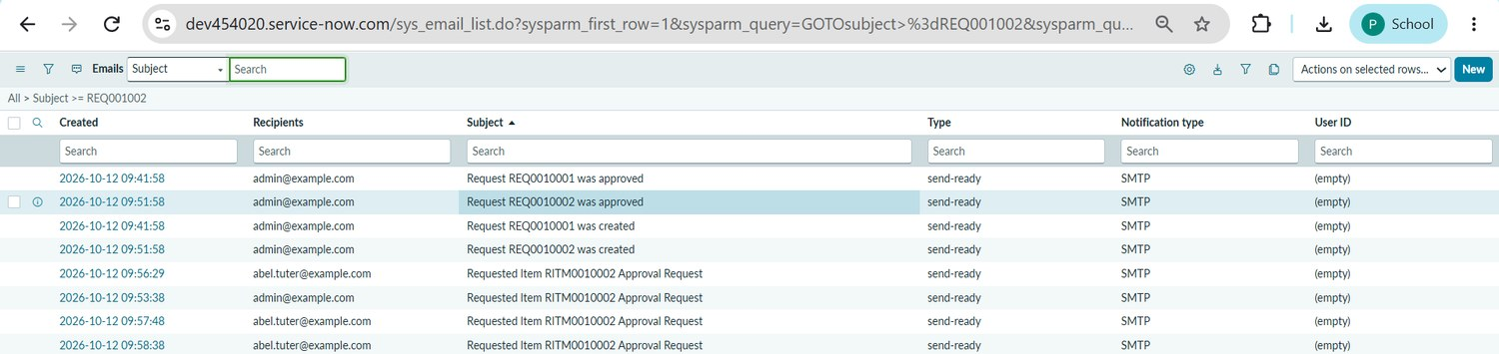
Figure 13. Email log (sys_email): request created, request approved and approval-request emails for REQ0010001, REQ0010002 and RITM0010002.
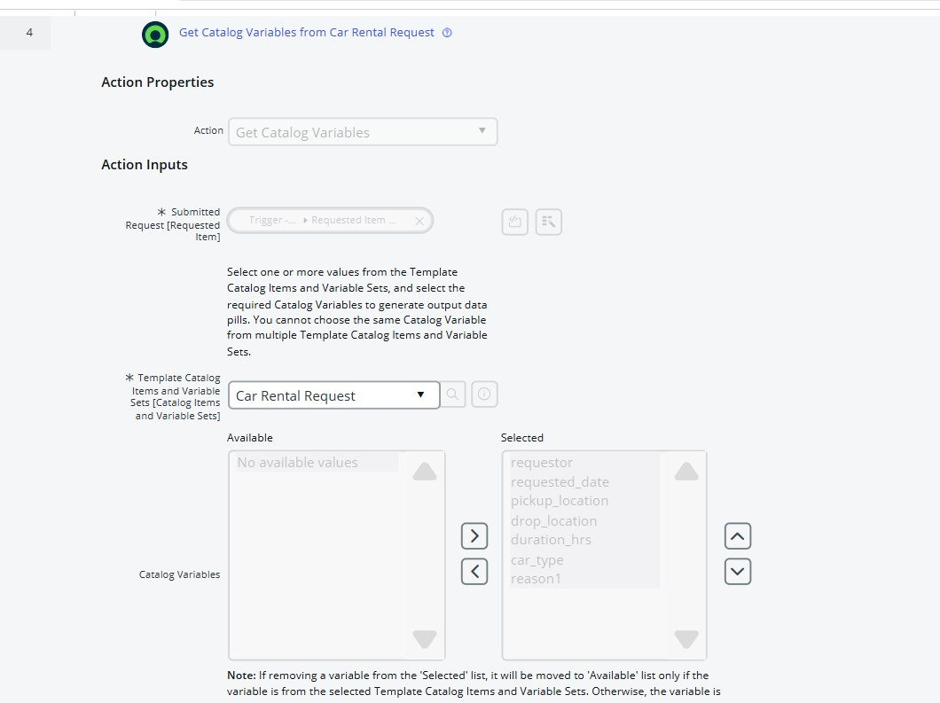
Figure 8. Get Catalog Variables from Car Rental Request: all seven variables selected.

Possible future reporting (not current scope)
If authorised reporting is added later, useful measures could include requests by car type, pickup and drop locations, average duration, approval turnaround, tasks per Transport Team member and incidents raised for unavailable cars. These are recommendations only and must not be presented as implemented dashboards.

