Project Development Phase
Platform Configuration & Integration Verification
Date | 16-10-2026
Team ID | Individual participant - 323103312152@gvpce.ac.in
Project Name | Car Rental Request Automation - ServiceNow
Maximum Marks | As specified by template

Platform Summary
The implementation platform is ServiceNow. Salesforce is not part of the project. The configuration points are the Service Catalog, Flow Designer, the approval, the catalog task, the email action, the Business Rule and the Update Set.
Verification area | Expected result | Evidence to retain
Catalog item | Car Rental Request in Service Catalog, category Transportation Services, owner System Administrator, active. | Fig 2.
Catalog variables | Seven variables: Requestor (80), Requested date (100), Pickup Location (200), Drop Location (300), Duration (hrs) (400), Car Type (500), Reason1 (600). | Fig 2.
Flow | Car Rental Req is Active, trigger Service Catalog, five actions. | Fig 4.
Approval | Ask For Approval on sc_req_item, Approve rule, Anyone approves: Abel Tuter. | Fig 5.
Catalog Task | sc_task assigned to the Transport Team. | Figs 6, 7.
Variables and email | Get Catalog Variables; Send Email to the requestor email. | Figs 8, 9.
Business Rule | Create Incident if Car Unavailable on sc_req_item; Active; Advanced. | Fig 12.
Email logs | Created and approved emails logged. | Fig 13.
Update Set | Car Rental Request Setup committed on the second instance with 12 records. | Fig 14.
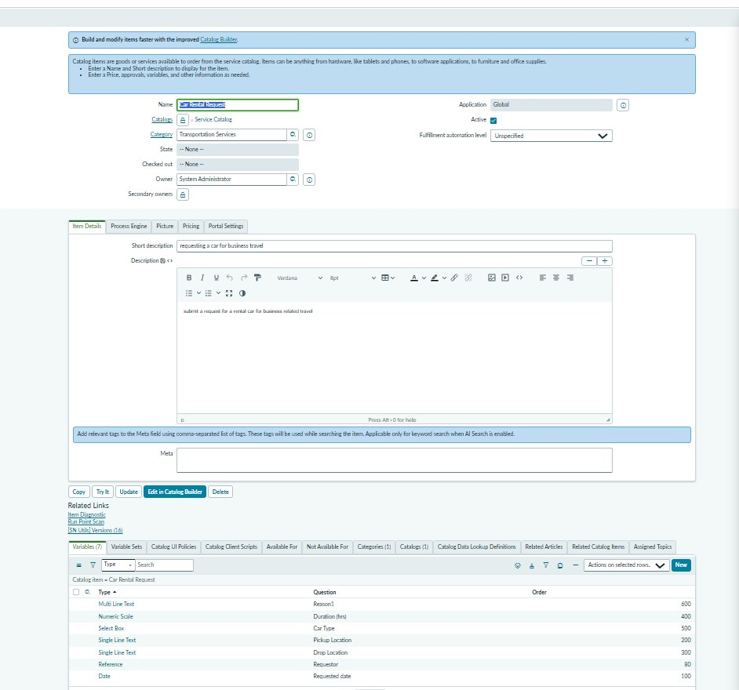
Figure 2. Car Rental Request catalog item record: category Transportation Services, short description and the seven catalog variables.
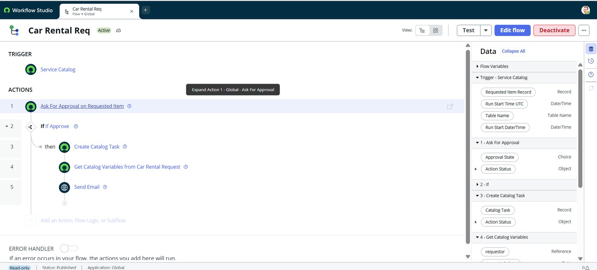
Figure 4. Car Rental Req flow in Workflow Studio: Service Catalog trigger and five actions.
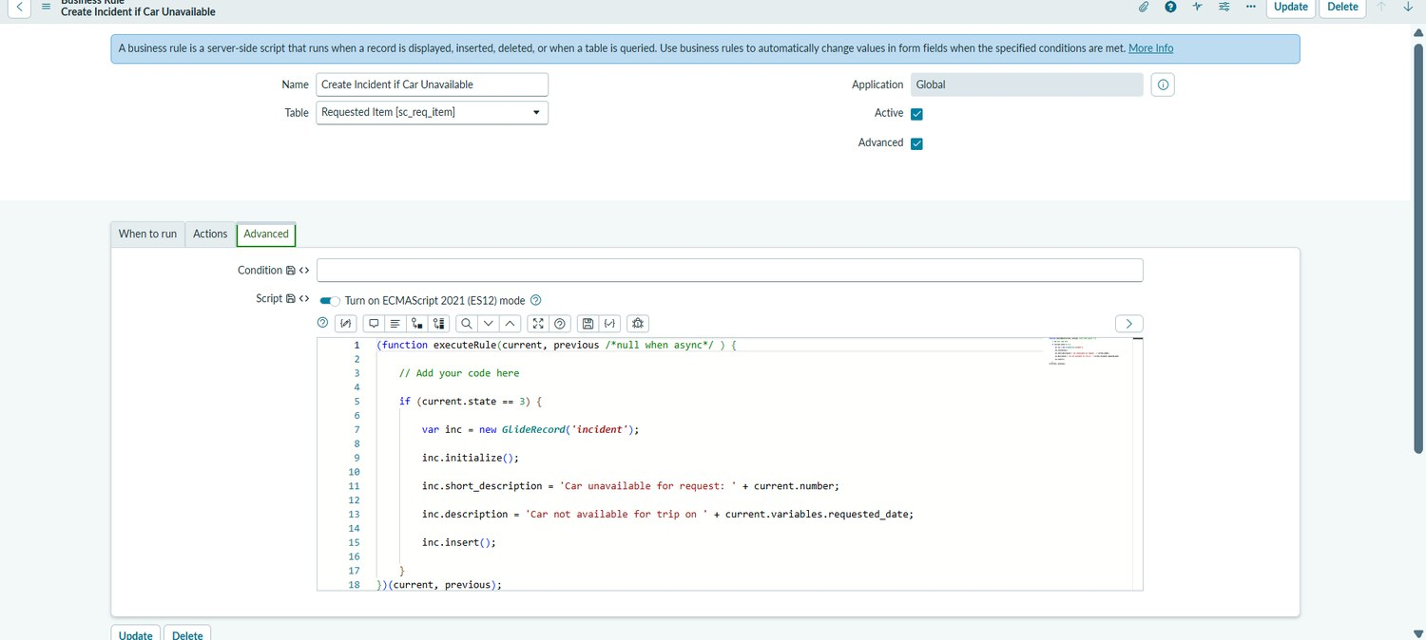
Figure 12. Business Rule "Create Incident if Car Unavailable" on Requested Item [sc_req_item] with its advanced script.
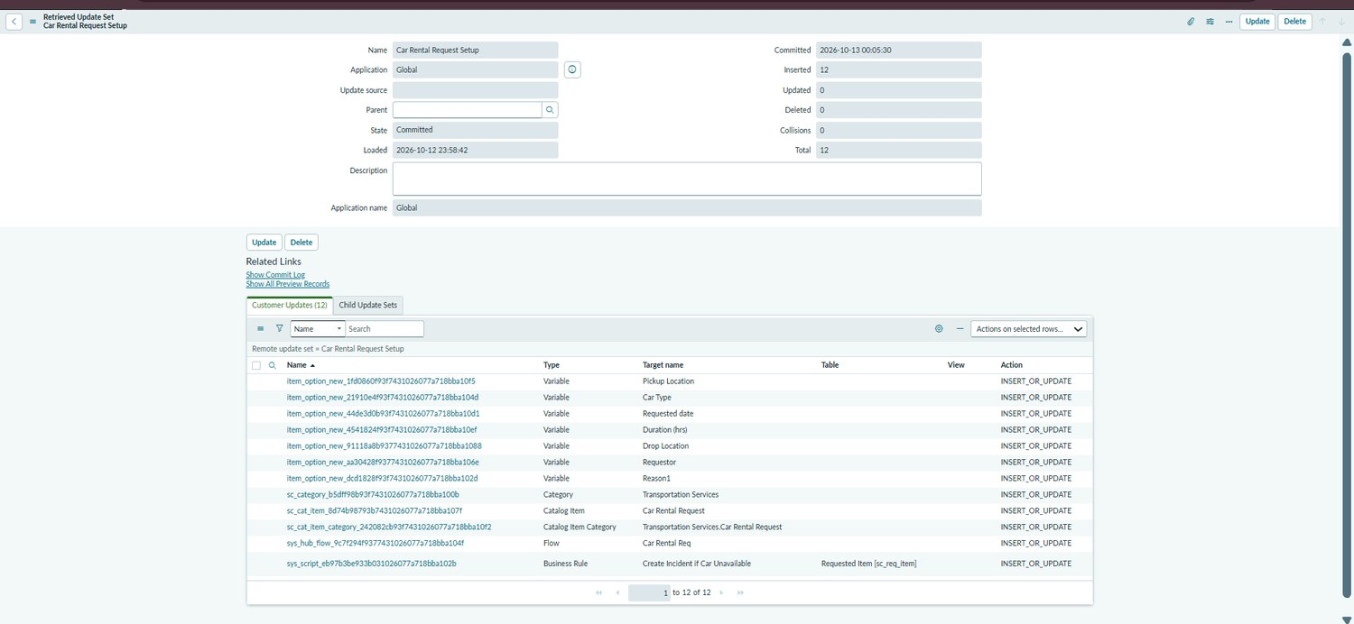
Figure 14. Retrieved Update Set "Car Rental Request Setup": State Committed, 12 records inserted, 0 collisions.

Accuracy / confidence fields from the source template
Training accuracy, validation accuracy and YOLO confidence scores are not applicable. Correctness should be reported from executed functional tests, not an invented model-accuracy percentage.

