Project Development Phase
Request Status & Usability Review
Date | 16-10-2026
Team ID | Individual participant - 323103312152@gvpce.ac.in
Project Name | Car Rental Request Automation - ServiceNow
Maximum Marks | As specified by template

UI / Status Review
No Tableau workbook, dashboard or story is identified in the project materials. The equivalent review covers the Car Rental Request form, the request and task status screens, the email log and the clarity of the steps.
Review area | Expected behaviour | Review evidence
Data displayed | The Requested Item shows number, approval, due date and delivery plan. | Fig 3.
Input preparation | Labelled fields with a Duration scale and a Car Type select box. | Fig 1.
Search / navigation | The item is reachable via Service Catalog > Top Requests and catalog search. | Fig 1.
Task status | The catalog task shows state, request item and description. | Fig 11.
Dashboard / story | Not applicable. | None.
Usability | The employee understands what to enter; user feedback to be collected. | Observations below.
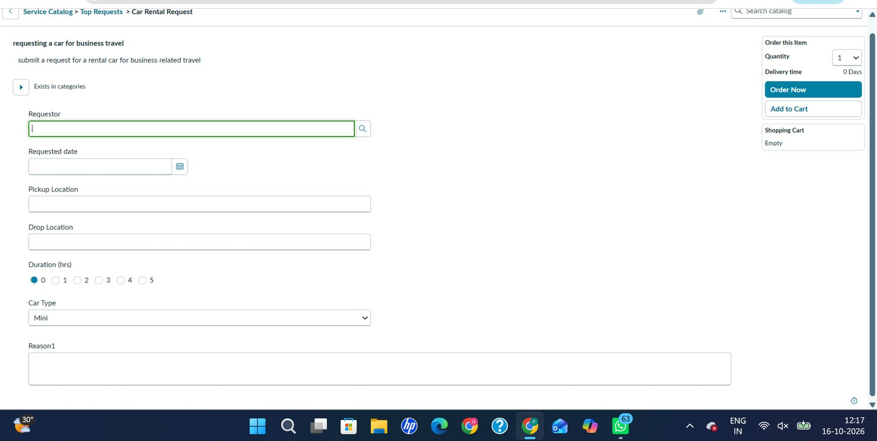
Figure 1. Car Rental Request catalog form: Requestor, Requested date, Pickup Location, Drop Location, Duration (hrs), Car Type and Reason1.
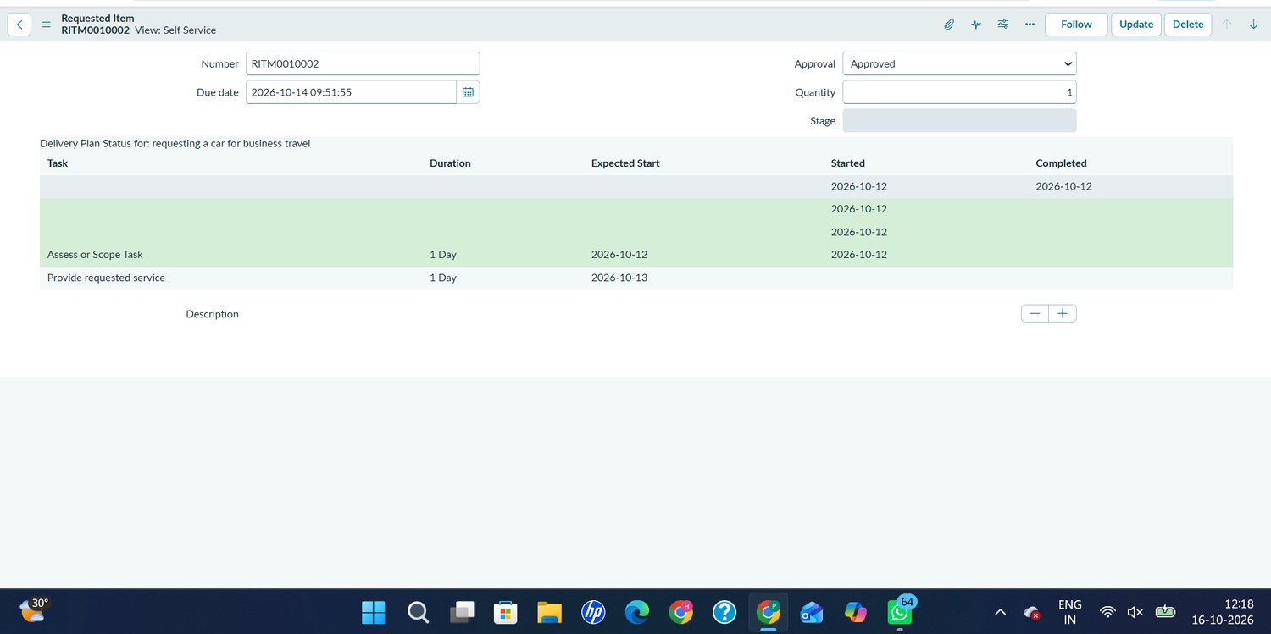
Figure 3. Requested Item RITM0010002: Approval = Approved, due date 2026-10-14 09:51:55 and its delivery plan.
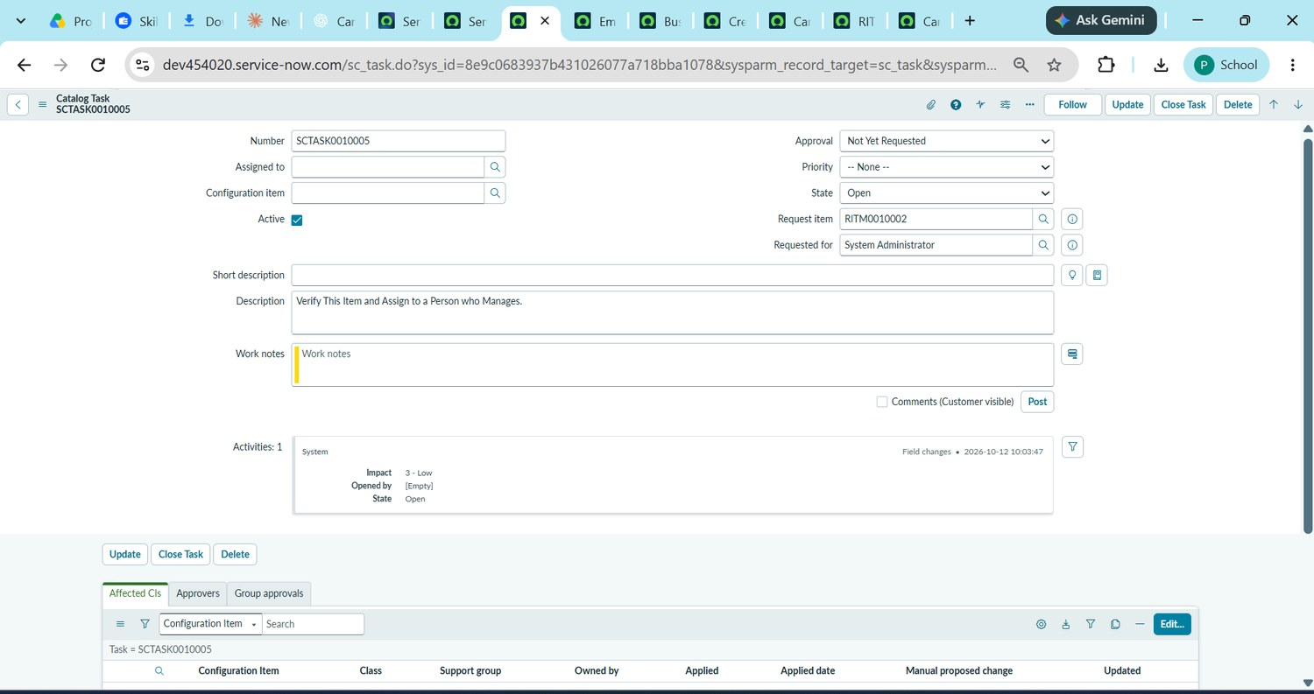
Figure 11. Catalog Task SCTASK0010005 linked to RITM0010002 (State: Open; Requested for: System Administrator).

Review checklist
- Labels are understandable and consistent (Reason1 needs renaming).
- Required fields are clear before submission (no markers shown).
- Approval state is visible on the Requested Item (Approved).
- The Transport Team task states what to do.
- The approval email is short and clear.

Observations from the review
ID | Observation | Suggested action
O-1 | No field on the Car Rental Request form shows a required marker, Duration defaults to 0 hours and one label reads Reason1 (Fig 1, Fig 2). | Mark the key variables as mandatory, remove or validate the 0 duration, and rename Reason1 to Reason.
O-2 | The Business Rule has an empty Condition field and tests current.state == 3 in its script (Fig 12). Confirm that this value means a car is unavailable, since 3 is normally Closed Complete on a Requested Item. | Confirm the intended state or add an explicit availability condition, and capture the When to run settings.
O-3 | The catalog task has an empty short description and no assignee (Fig 11) and the email greeting reads Dear, without the requestor name (Fig 9). | Add a short description, assign a person, and insert the requestor name in the email body.

