Project Development Phase
User Acceptance Testing - Test Specification
Date | 16-10-2026
Team ID | Individual participant - 323103312152@gvpce.ac.in
Project Name | Car Rental Request Automation - ServiceNow
Maximum Marks | As specified by template

Project Overview
Purpose: verify that an employee can submit a Car Rental Request, that the request is approved before fulfilment, that a catalog task is routed to the Transport Team, that the approval is notified, and that unavailable cars raise an incident.

Scope
- Catalog item access and form fields.
- Request submission and Requested Item creation.
- Approval request and approval check.
- Catalog task creation and routing to the Transport Team.
- Catalog variable retrieval and email notification.
- Incident creation when a car is unavailable.
- Update Set migration to a second instance.

UAT Test Cases
ID | Scenario | Steps | Expected result | Execution status
UAT-01 | Locate catalog item | Open Service Catalog > Top Requests. | Car Rental Request is visible and opens. | Executed - Passed
UAT-02 | Form fields | Open the form. | Seven variables are shown. | Executed - Passed
UAT-03 | Submit request | Select Order Now. | Request and RITM are created. | Executed - Passed
UAT-04 | Approval requested | Observe the flow and approval email. | Approval request goes to the approver. | Executed - Passed
UAT-05 | Approval validated | Approve the request. | RITM Approval = Approved; If Approve is True. | Executed - Passed
UAT-06 | Catalog task and routing | Observe the task. | Task created for the Transport Team. | Executed - Passed
UAT-07 | Variable retrieval | Check Get Catalog Variables. | Seven variables retrieved. | Executed - Passed
UAT-08 | Email notification | Check Send Email and email log. | Approval email action completes. | Executed - Passed
UAT-09 | Request emails | Filter the email log. | Created and approved emails exist. | Executed - Passed
UAT-10 | Update Set migration | Preview and Commit on the second instance. | Committed with no collisions. | Executed - Passed
UAT-11 | Car unavailable incident | Trigger the unavailable condition. | Incident created with request number and date. | Not yet executed
UAT-12 | Rejected approval | Reject the request. | No task is created; outcome is communicated. | Not yet executed
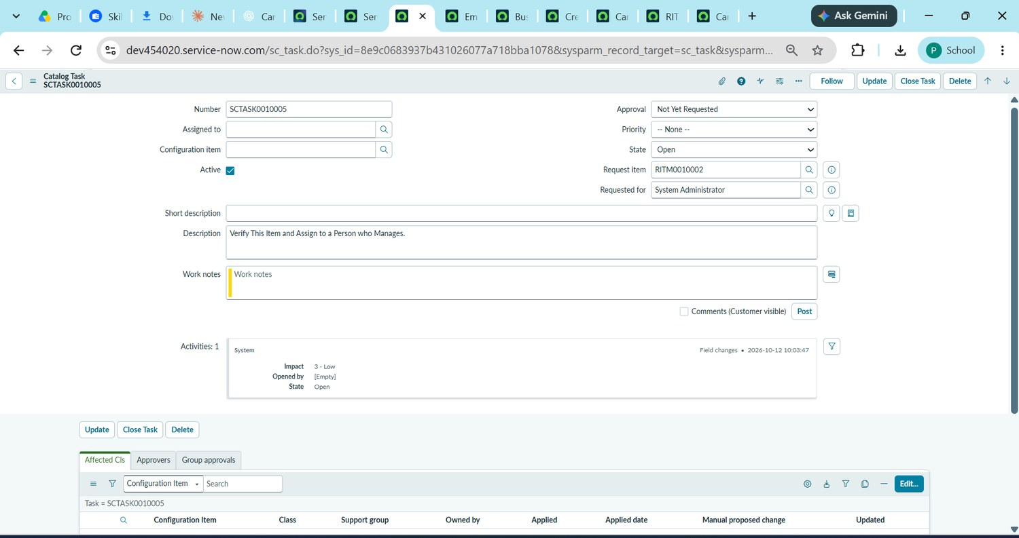
Figure 11. Evidence for UAT-06: catalog task SCTASK0010005.

Defect and Sign-off
Log only reproducible defects found during execution with defect ID, severity, steps, owner, status and resolution. Observations raised so far are listed in the UAT Execution Report. Complete the sign-off table after the remaining cases are executed.
Tester | Execution date | Result summary | Sign-off
________________ | ________________ | ________________________ | ________________

