Requirement Analysis
Customer Journey Map
Date | 16-10-2026
Team ID | Individual participant - 323103312152@gvpce.ac.in
Project Name | Car Rental Request Automation - ServiceNow
Maximum Marks | As per template / not specified

Scenario
An employee needs a rental car for business travel. They open the Service Catalog, submit a Car Rental Request, wait for approval, and are told by email when it is approved while the Transport Team receives a catalog task. If no car is available, an incident is raised. This journey map is a design synthesis based on the project build and screenshots; it is not based on new customer interviews.

Journey stages and key needs
Stage | User action | Touchpoint | User need | System response (intended)
Access | Open Service Catalog > Top Requests and choose Car Rental Request. | Service Catalog | Find the request item quickly. | Show the catalog item under Transportation Services.
Request | Fill Requestor, Requested date, Pickup, Drop, Duration, Car Type and Reason. | Catalog item form | Describe the trip once. | Capture seven catalog variables.
Submit | Select Order Now. | Order this Item panel | Send the request. | Create the request and Requested Item (RITM) and start the Car Rental Req flow.
Approval | Approver decides on the request. | Approval request | Get an authorised decision. | Ask For Approval on the Requested Item; If Approve continues the flow.
Fulfilment | Transport Team receives the task. | Catalog Task | Know which approved trips to act on. | Create Catalog Task assigned to the Transport Team.
Notify | Read the approval email. | Email | Know the outcome. | Get Catalog Variables, then Send Email: Your car request is approved.
Exception | Car is not available. | Incident | Have the gap recorded. | Business Rule creates an Incident with the request number and date.

Evidence for each stage
The screenshots below come from the project’s ServiceNow instance and match the stages above.
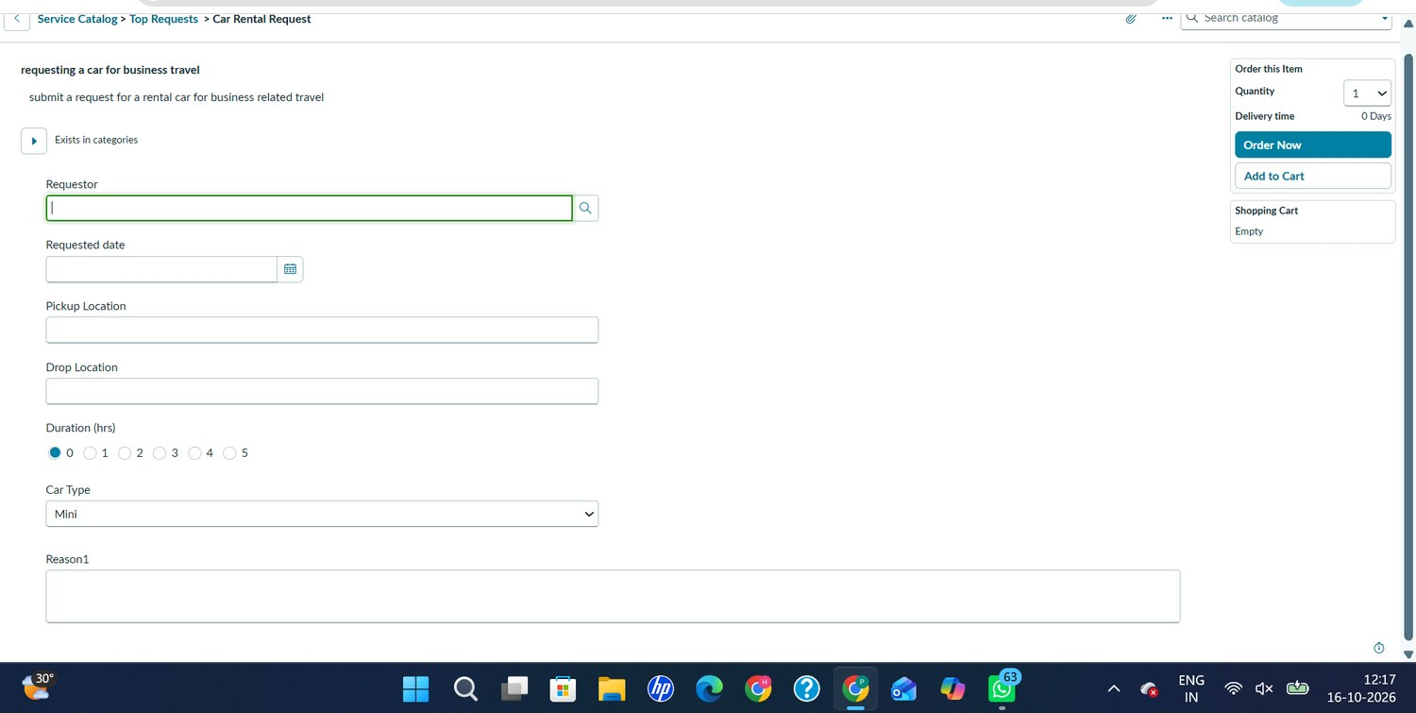  Fig 1. Access and request: catalog form | 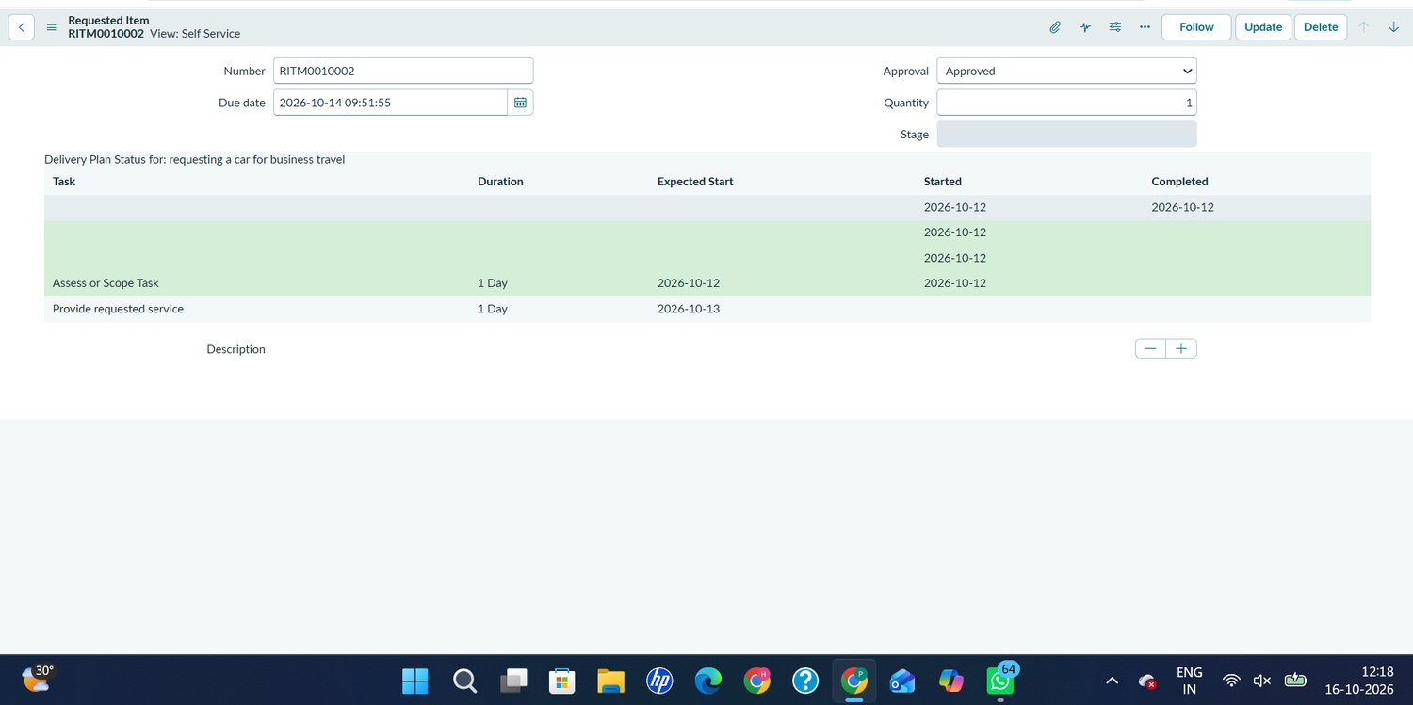  Fig 3. Submit and approval: RITM0010002 approved
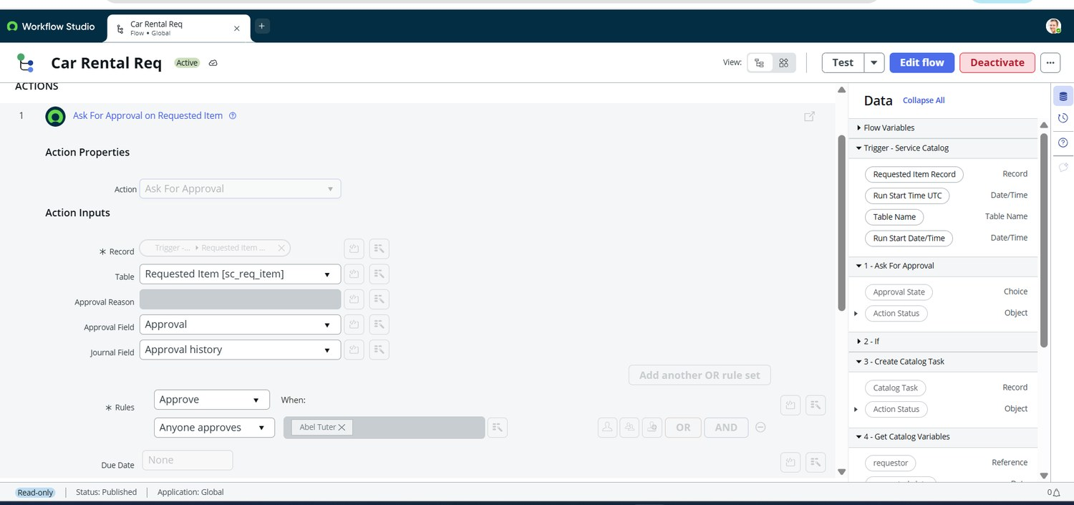  Fig 5. Approval: Ask For Approval action | 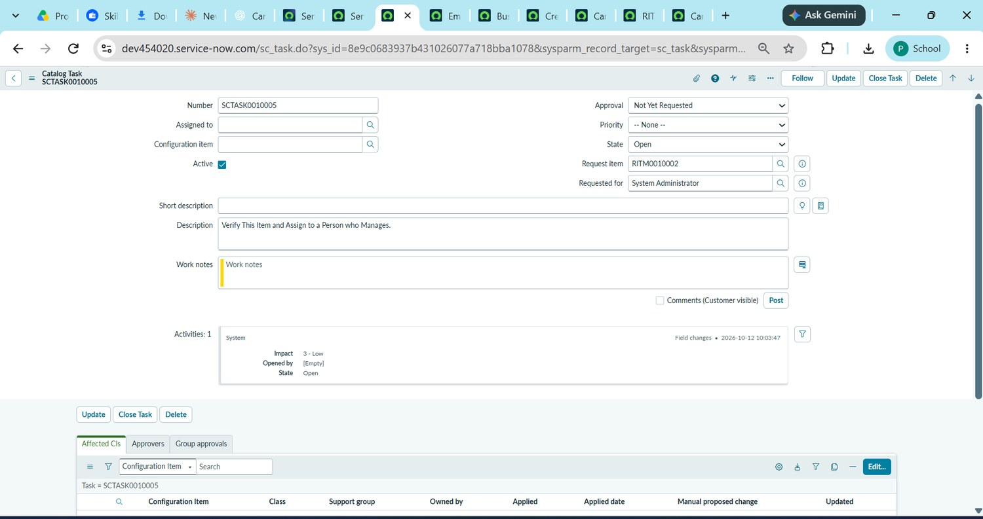  Fig 11. Fulfilment: SCTASK0010005
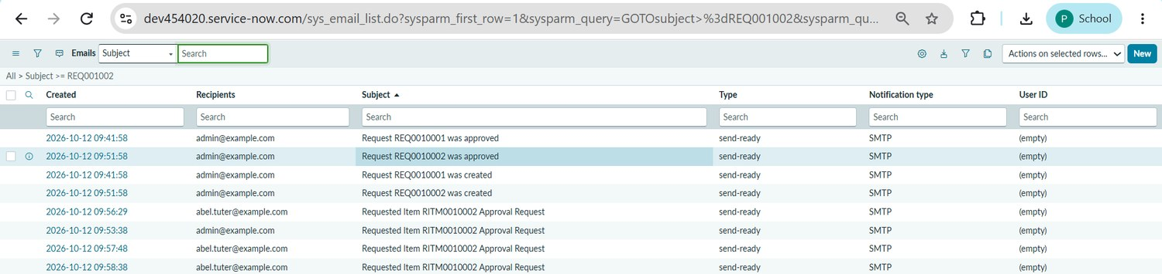  Fig 13. Notify: email log | 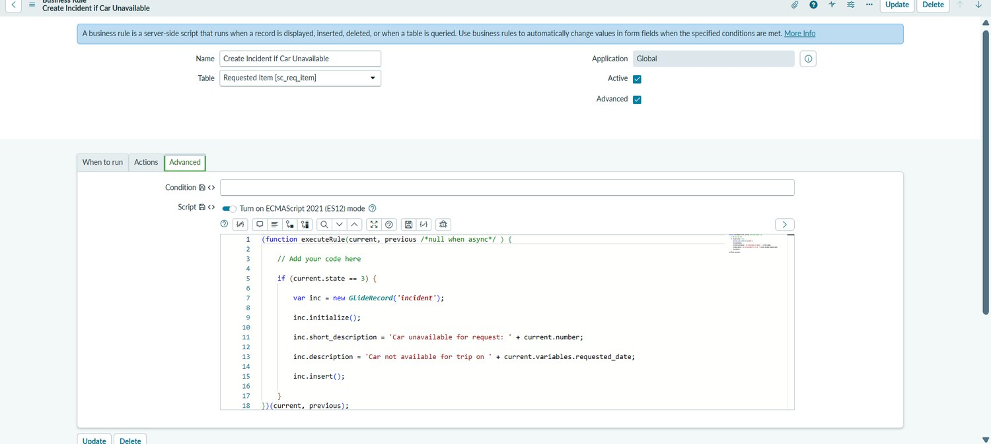  Fig 12. Exception: incident business rule

Priority opportunities
- Mark the key request fields as required so incomplete requests are not submitted.
- Keep the approval and task creation automatic so the Transport Team acts only on approved requests.
- Add the requestor’s name to the approval email greeting.
- Confirm that the Business Rule condition matches the intended unavailable-car state.
- Notify the requestor when a request is rejected (future scope).
Evidence note
This document adapts a one-page journey-map structure to the car rental request flow. Pain points are plausible design risks to validate, not measured findings.

