Project Design Phase-II
Data Flow Diagram & User Stories
Date | 16-10-2026
Team ID | Individual participant - 323103312152@gvpce.ac.in
Project Name | Car Rental Request Automation - ServiceNow
Maximum Marks | 4 Marks

Data Flow Diagrams:
A Data Flow Diagram (DFD) describes how information enters the system, how it is processed, where records are stored, and what is returned to each participant.
Example: DFD Level 0 (Car Rental Request Automation)
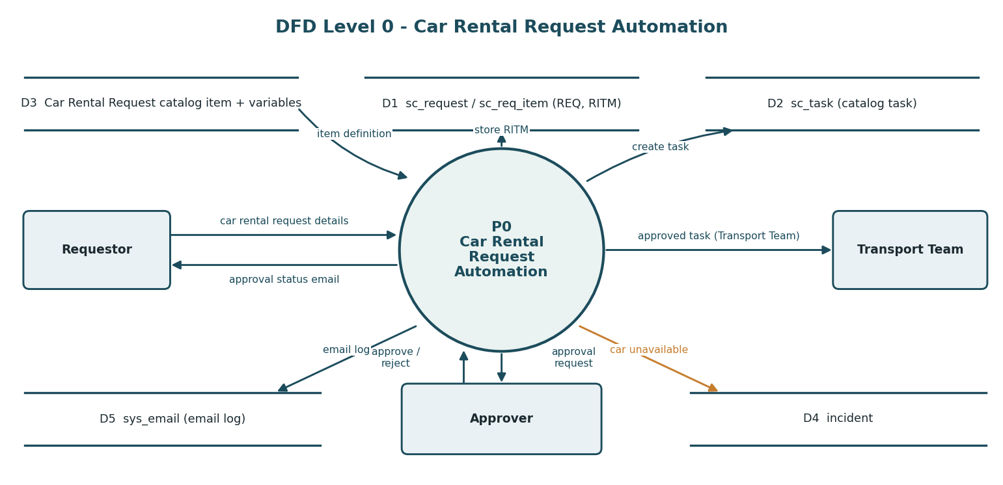
Diagram 1. Level 0 data flow for the Car Rental Request Automation.
The requestor submits the car rental request details. The automation reads the catalog item definition, stores the request and requested item, asks the approver for a decision and, when approved, creates a catalog task for the Transport Team and emails the approval status. If a car is unavailable, an incident is created.

Data stores and key records
Record / table | Role in the flow | Key information
Catalog item - Car Rental Request | Request form definition | Variables: requestor, requested_date, pickup_location, drop_location, duration_hrs, car_type, reason1
Request / Requested Item - sc_request, sc_req_item | Parent request and item instance | Approval, due date, quantity (example: RITM0010002, due 2026-10-14 09:51:55, Approved)
Catalog Task - sc_task | Fulfilment work for the Transport Team | Request item, requested for, state (example: SCTASK0010005, Open)
Incident - incident | Exception record | Short description and description built from the request number and requested date
Email log - sys_email | Notification evidence | Created, approved and approval-request emails (REQ0010001, REQ0010002, RITM0010002)
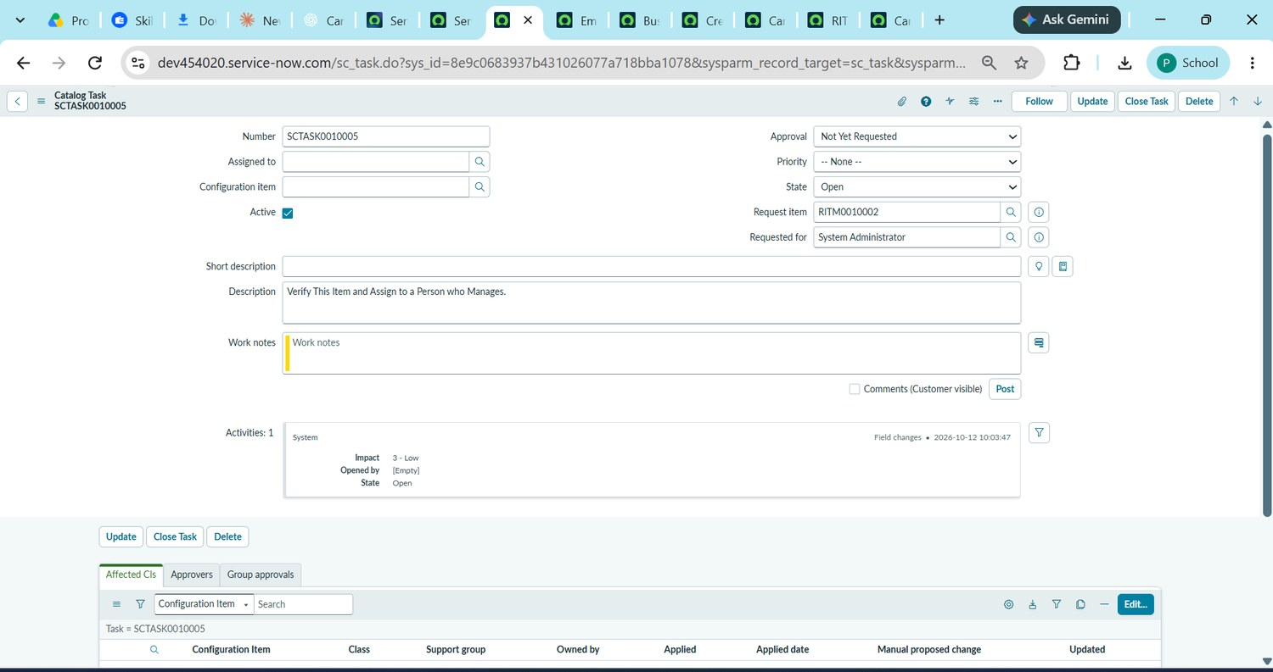
Figure 11. Catalog Task SCTASK0010005 linked to RITM0010002 (State: Open; Requested for: System Administrator).

User Stories
The user stories translate the workflow into user-focused requirements. Acceptance criteria describe expected behaviour; test results are reported separately in the testing documents.
User Type | Functional Requirement (Epic) | Story No. | User Story / Task | Acceptance Criteria | Priority
Requestor | Catalog item | USN-1 | As a requestor, I want a Car Rental Request item so that I can request a car for business travel. | Item appears under Transportation Services. | High
Requestor | Request details | USN-2 | As a requestor, I want to give pickup, drop, duration, car type and reason so that my trip is clear. | Seven variables are captured on the form. | High
Approver | Approval | USN-3 | As an approver, I want to approve the Requested Item so that cars are arranged only for authorised trips. | Approval state is recorded; flow continues only if approved. | High
Transport Team | Fulfilment task | USN-4 | As a Transport Team member, I want a catalog task for each approved request so that I can arrange the car. | Catalog Task is created and assigned to the Transport Team. | High
Requestor | Notification | USN-5 | As a requestor, I want an email when my request is approved so that I know the outcome. | Send Email completes with subject Your car request is approved. | Medium
Administrator | Exception handling | USN-6 | As an administrator, I want an incident when a car is unavailable so that the gap is recorded. | Business Rule creates an Incident with request number and date. | Medium
Administrator | Packaging | USN-7 | As an administrator, I want an Update Set so that the configuration can move to another instance. | Preview and Commit complete with no collisions. | Medium
Tester | Validation | USN-8 | As a tester, I want to verify the flow, task, email and incident so that the workflow behaves as designed. | Each area has a recorded result and evidence. | High

Priority and release note
Priority labels are proposed for planning: High items establish the core submit, approve and fulfil path; Medium items add notification, exception handling and portability. All stories are grouped as Release 1, a suggested grouping and not a verified sprint commitment.

