Ideation Phase
Empathize & Discover
Date | 16-10-2026
Team ID | Individual participant - 323103312152@gvpce.ac.in
Project Name | Car Rental Request Automation - ServiceNow
Maximum Marks | 4 Marks

Empathy Map Canvas
An empathy map organises a user’s likely behaviours, attitudes, goals and barriers so the design can start from the user’s perspective. This canvas focuses on the employee requesting a rental car through the ServiceNow Service Catalog. It is a design hypothesis based on the documented workflow and is not presented as interview data.

Primary persona: Employee requesting a business car
Goal: describe the trip once, get a clear approval decision, and know the car is being arranged.
THINKS & FEELS  • “Has my manager seen this request?”  • “Will a car be ready for my trip date?”  • Wants confidence that the request was received. | SEES  • The Car Rental Request form with Requestor, date, pickup, drop, duration, car type and reason.  • Order Now and Add to Cart on the right.  • An email when the request is approved.
HEARS  • Colleagues describing slow, informal car bookings.  • Updates from the Transport Team about availability. | SAYS & DOES  • Opens Transportation Services and picks Car Rental Request.  • Enters pickup, drop, duration and car type.  • Gives the reason and orders the item.
PAIN  • Not knowing whether the request was approved.  • Repeating trip details to different people.  • No record when a car is not available. | GAIN  • One form and a request number.  • An approval email.  • A task that reaches the Transport Team automatically.
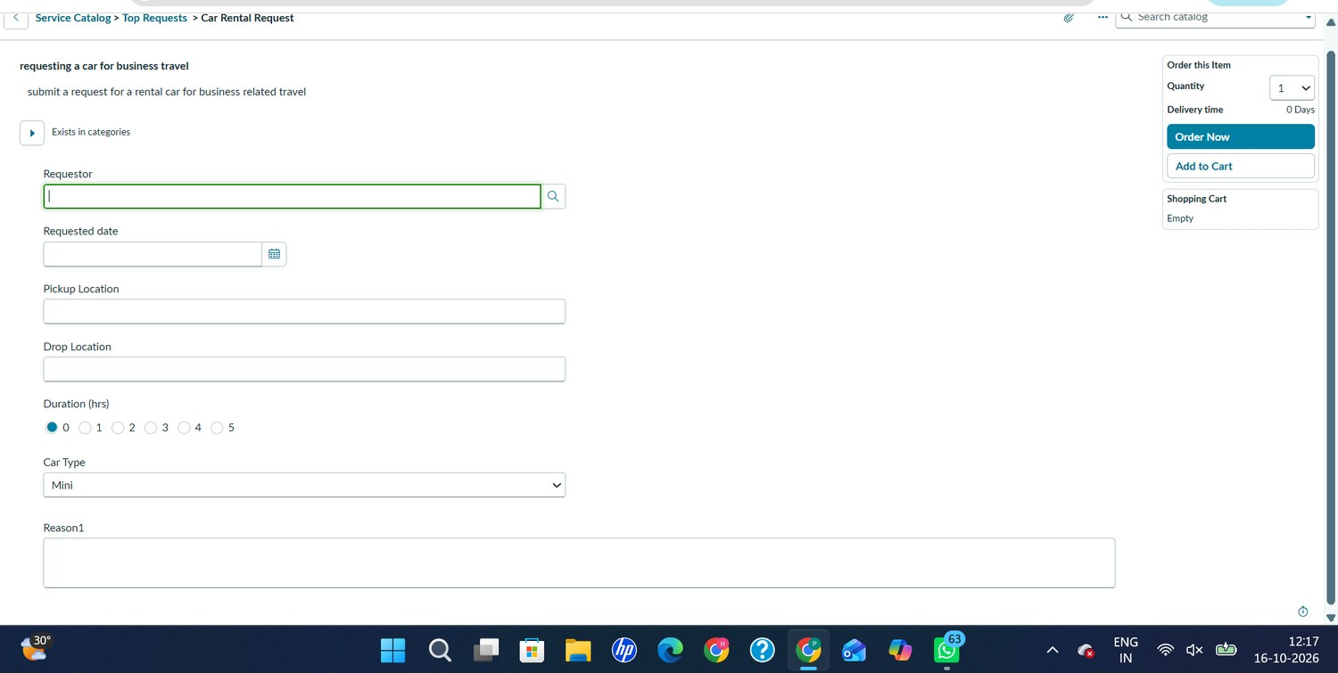
Figure 1. The employee’s starting point: the Car Rental Request catalog form.

Supporting persona: Approver and Transport Team
The second perspective covers the people who act on the request. The notes below are hypotheses to guide design and testing, not measured feedback.
THINKS & FEELS  • “What is this trip for and when?”  • “Who will take this on once it is approved?” | SEES  • An approval request for the Requested Item.  • A catalog task with the instruction to verify the item and assign it to a person who manages it.
HEARS  • Questions from employees about request status.  • Guidance on which trips are authorised. | SAYS & DOES  • Approves or rejects the request.  • Picks up the catalog task and assigns it.
PAIN  • Incomplete trip details.  • Tasks arriving before approval.  • Unavailable cars handled informally. | GAIN  • Approval recorded against the Requested Item.  • Task created only after approval.  • An incident when a car is unavailable.
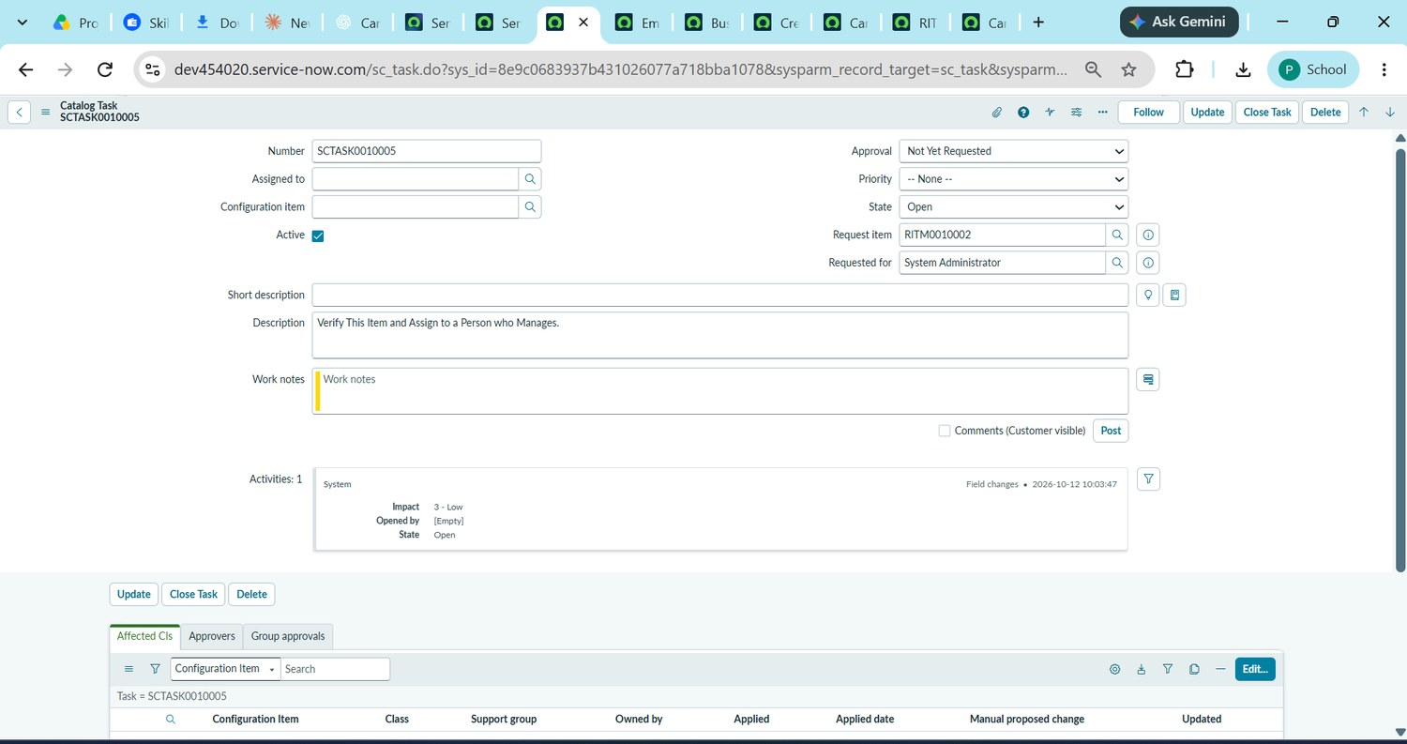
Figure 11. The Transport Team’s view: catalog task SCTASK0010005 for RITM0010002.

Design opportunities derived from the empathy maps
- Capture the full trip in one short form so details are never repeated.
- Enforce approval before any fulfilment task is created.
- Route the catalog task to the Transport Team automatically.
- Tell the requestor by email when the request is approved.
- Record an incident when a car is unavailable so the gap is visible.
Evidence note
The maps synthesise the project’s catalog form, approval flow, catalog task, notification and incident concepts. Thoughts and feelings are design hypotheses and should be validated with real users if user research is carried out.

