PROJECT REPORT
CAR RENTAL REQUEST AUTOMATION
in ServiceNow using Service Catalog and Workflows
Final Project Documentation
Project information | Details
Project name | Car Rental Request Automation - ServiceNow
Participant | Individual participant - 323103312152@gvpce.ac.in
Report date | 16 October 2026
Platform | ServiceNow: Service Catalog, Flow Designer, Business Rules, Catalog Tasks, Email Notifications, Update Sets
Instance | ServiceNow instance (dev454020)
Update Set | Car Rental Request Setup (12 records)
Repository | https://github.com/PHimajasree/Car-Rental-Request-Automation-ServiceNow
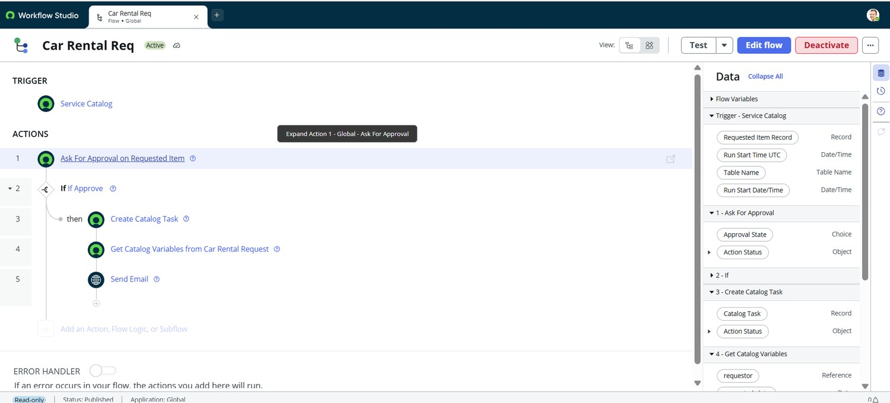
Figure 4. The Car Rental Req flow (project output)

CONTENTS
1. Introduction
1.1 Project Overview
1.2 Purpose
2. Ideation Phase
2.1 Problem Statement
2.2 Empathy Map Canvas
2.3 Brainstorming
3. Requirement Analysis
3.1 Customer Journey Map
3.2 Solution Requirements
3.3 Data Flow Diagram
3.4 Technology Stack
4. Project Design
4.1 Problem-Solution Fit
4.2 Proposed Solution
4.3 Solution Architecture
5. Project Planning and Scheduling
5.1 Project Planning
6. Functional and Performance Testing
6.1 Performance Testing
7. Results
7.1 Output Screenshots
8. Advantages and Disadvantages
9. Conclusion
10. Future Scope
11. Appendix
A. Source Code (Configuration Artifact)
B. Dataset / Data Model
C. GitHub and Project Demo Link
D. Glossary

1. Introduction

1.1 Project Overview
The Car Rental Request Automation is a ServiceNow application that automates requesting, approving and fulfilling car rental requests for business travel. It uses Service Catalog, Flow Designer, Business Rules, Catalog Tasks, Email Notifications and Update Sets to provide a structured request lifecycle.
Users submit a Car Rental Request through the Service Catalog under the Transportation Services category. The form captures Requestor, Requested Date, Pickup Location, Drop Location, Duration, Car Type and Reason. When the request is submitted, the Car Rental Req flow starts. The request is sent for approval and, once approved, ServiceNow creates a Catalog Task for the Requested Item and routes it to the Transport Team. The flow retrieves the catalog variables and an email notification communicates the approval status. A Business Rule, Create Incident if Car Unavailable, creates an Incident when a car is unavailable. The complete configuration is packaged in the Car Rental Request Setup Update Set.
Item | Detail
Catalog item | Car Rental Request (Service Catalog > Transportation Services)
Variables | Requestor, Requested date, Pickup Location, Drop Location, Duration (hrs), Car Type, Reason1
Flow | Car Rental Req: Ask For Approval on Requested Item, If Approve, Create Catalog Task, Get Catalog Variables, Send Email
Approval | Rule Approve, Anyone approves: Abel Tuter
Fulfilment | Catalog Task [sc_task] assigned to the Transport Team
Notification | Send Email: Your car request is approved; email logs
Exception handling | Business Rule Create Incident if Car Unavailable on Requested Item [sc_req_item]
Packaging | Update Set Car Rental Request Setup: 12 records, committed on a second instance

Key features
- Structured request: seven catalog variables captured in one form.
- Approval before fulfilment: the flow continues only if the approval condition is met.
- Automatic routing: a catalog task is created for the Transport Team.
- Notification: an email communicates the approval status.
- Exception handling: an incident is created when a car is unavailable.
- Portability: the configuration moves between instances with an Update Set.

1.2 Purpose
This report documents the project from problem definition through design, build, testing and results. It separates what the project demonstrates (screenshots, a flow test run, a catalog task, email logs and a committed Update Set) from behaviour that still needs testing, such as the reject path and the car-unavailable incident.

Project objectives
- Give employees one guided entry point for requesting a rental car.
- Enforce approval before any fulfilment work is created.
- Route approved requests to the Transport Team through a catalog task.
- Make request details and approval status available through notification and email logs.
- Handle car unavailability by creating an incident.
- Package the work for migration between ServiceNow instances.

2. Ideation Phase

2.1 Problem Statement
How might we let employees request a business rental car in one step, with approval enforced and the Transport Team notified automatically, while exceptions are recorded?
Stakeholder | Problem today | Desired outcome
Requestor | Requests are informal and approval status is unclear. | A guided form, a request number and an approval email.
Approver | Details are scattered and approval is not enforced. | An approval on the Requested Item before fulfilment.
Transport Team | Work arrives unannounced and unavailable cars are handled ad hoc. | A catalog task for each approved request and an incident for unavailable cars.
Administrator | Configuration is hard to move and repeat. | A packaged Update Set.

2.2 Empathy Map Canvas
The map describes the likely experience of the employee and what each point means for the design. It is a design aid based on the project scope, not interview data.
Dimension | Employee perspective | Design response
Says | “Has my car request been approved?” | Approval recorded on the Requested Item and notified by email.
Thinks | “Will a car be ready for my trip?” | Incident raised when a car is unavailable.
Does | Enters pickup, drop, duration, car type and reason. | Short form with a Duration scale and Car Type select box.
Feels | Uncertain when status is unclear. | Request number and email notification.
Pain points | Repeated details and manual follow-up. | One request that drives approval and task creation.
Needs | A simple form and a clear outcome. | Service Catalog item and approval flow.

2.3 Brainstorming
Four ways of delivering the process were compared on consistency, ease of use and feasibility.
Option | Strength | Limitation | Decision
Phone / email requests | Familiar. | No record, approval or routing. | Not the target of this project.
Spreadsheet tracker | Simple to maintain. | No approval, tasks or notifications. | Not selected.
Custom standalone app | Full control. | Needs separate hosting, security and support. | More effort than the problem needs.
ServiceNow catalog + Flow Designer | Uses platform forms, approvals, tasks, email and rules. | Depends on correct configuration. | Selected.
The core design principle is to let one request drive every step: the same Requested Item carries the approval, the catalog task, the variables read for the email, and the incident when needed.

3. Requirement Analysis

3.1 Customer Journey Map
The journey starts when an employee opens the Service Catalog and ends when the request is approved and fulfilment begins. Figure numbers refer to Section 7.1.
Stage | Steps | Touchpoints | User goal | Opportunity
Access | Open Car Rental Request (Fig 1). | Service Catalog | Find the item. | Clear title and description.
Request | Complete the seven variables (Figs 1, 2). | Catalog form | Describe the trip once. | Mark key fields as required.
Submit | Order Now creates REQ and RITM (Figs 3, 13). | Order this Item | Send the request. | Show the request number.
Approval | Approver decides (Figs 4, 5). | Approval request | Authorised decision. | Add a reject path.
Fulfilment | Catalog task for Transport Team (Figs 6, 7, 11). | Catalog Task | Act on approved trips. | Add short description and assignee.
Notify | Variables read and email sent (Figs 8, 9, 13). | Email | Know the outcome. | Include requestor name.
Exception | Incident if car unavailable (Fig 12). | Incident | Record the gap. | Confirm the condition.

3.2 Solution Requirements

Functional requirements
ID | Requirement | How it is checked
FR-01 | Offer a Car Rental Request catalog item under Transportation Services. | Figs 1, 2.
FR-02 | Capture Requestor, Requested date, Pickup, Drop, Duration, Car Type and Reason. | Figs 1, 2.
FR-03 | Trigger the Car Rental Req flow when the item is requested. | Figs 4, 10.
FR-04 | Ask for approval and check the result before continuing. | Figs 3, 5, 10.
FR-05 | Create a Catalog Task assigned to the Transport Team on approval. | Figs 6, 7, 11.
FR-06 | Retrieve the submitted catalog variables. | Fig 8.
FR-07 | Send an email notification of the approval status. | Figs 9, 13.
FR-08 | Create an incident when a car is unavailable. | Fig 12.
FR-09 | Package the configuration in an Update Set and migrate it. | Fig 14.

Non-functional requirements
ID | Area | Requirement
NFR-01 | Usability | A short guided form with labelled fields and quick choices.
NFR-02 | Security | Platform roles and ACLs limit access; only the named approver approves.
NFR-03 | Reliability | No fulfilment task is created before approval.
NFR-04 | Performance | Flow actions complete promptly; the recorded run took 1672 ms and targets are to be measured.
NFR-05 | Availability | Follows the availability of the hosted instance.
NFR-06 | Portability | Configuration packaged as an Update Set.

User stories
ID | User | Story
USN-1 | Requestor | Request a rental car through a catalog item.
USN-2 | Requestor | Provide pickup, drop, duration, car type and reason.
USN-3 | Approver | Approve the Requested Item before fulfilment.
USN-4 | Transport Team | Receive a catalog task for each approved request.
USN-5 | Requestor | Receive an email when the request is approved.
USN-6 | Administrator | Have an incident created when a car is unavailable.
USN-7 | Administrator | Move the configuration with an Update Set.
USN-8 | Tester | Verify the flow, task, email and incident.

3.3 Data Flow Diagram
The requestor submits the request details. The automation reads the catalog item, stores the request and Requested Item, asks the approver for a decision, creates the catalog task for the Transport Team on approval, emails the status and, if a car is unavailable, creates an incident.
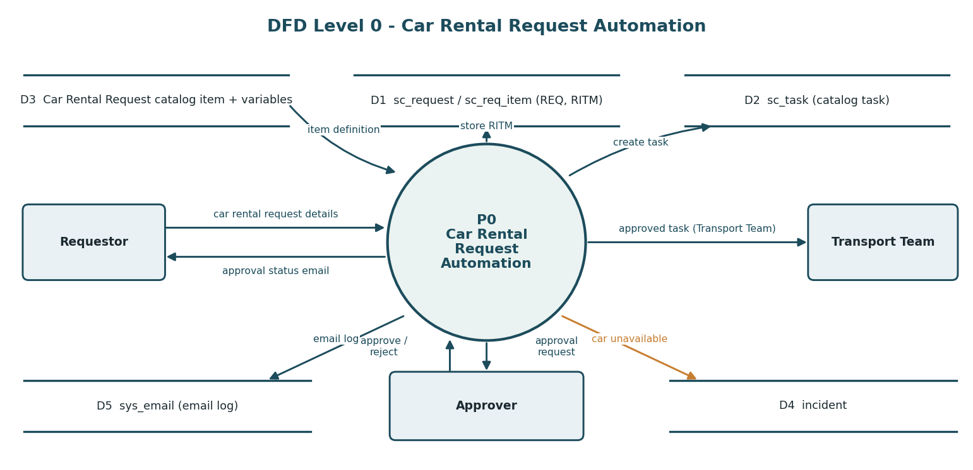
Diagram 1. Level 0 data flow for the Car Rental Request Automation.
Data store | Role in the flow | Key information
Catalog item and variables | Request form definition | Seven variables
sc_request / sc_req_item | Request and Requested Item | Approval, due date (RITM0010002)
sc_task | Fulfilment task | SCTASK0010005, Transport Team
incident | Exception record | Request number and requested date
sys_email | Email log | Created, approved and approval-request emails

3.4 Technology Stack
The solution is built entirely on ServiceNow platform capabilities. No separate server, external API or machine-learning component is used.
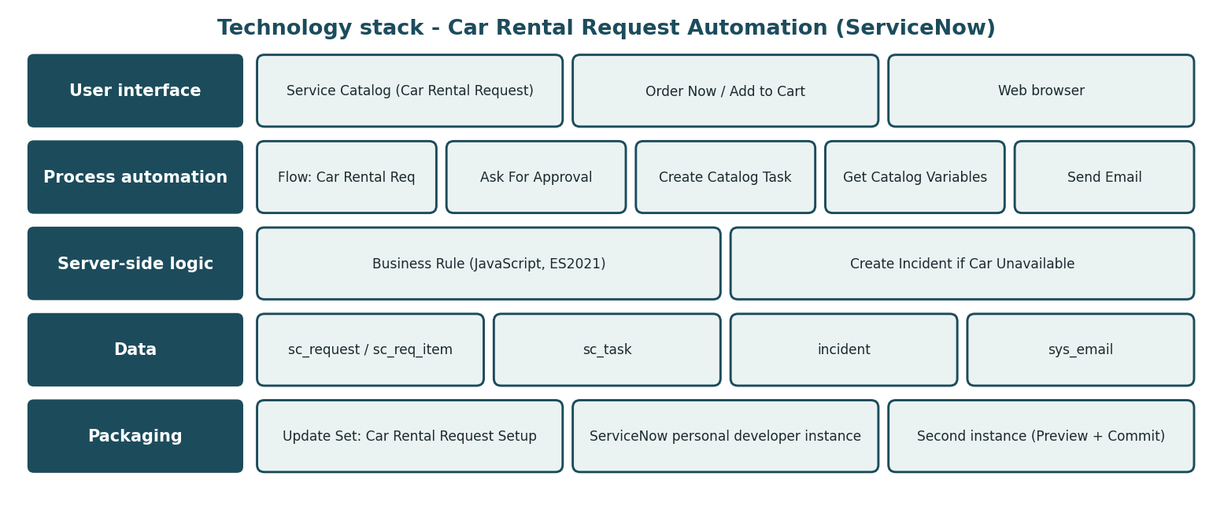
Diagram 2. Technology stack of the Car Rental Request Automation.
Component | Technology | Role
User interface | Service Catalog, web browser | Request form and order panel.
Process automation | Flow Designer | Approval, task creation, variable retrieval, email.
Server-side logic | Business Rule (JavaScript) | Incident creation for unavailable cars.
Data | sc_request, sc_req_item, sc_task, incident, sys_email | Platform-managed records.
Packaging | Update Set | Migration between instances.

4. Project Design

4.1 Problem-Solution Fit
The difficulty is getting an approved request to the right team with its details, not the form itself. A guided form captures the details, the approval gate controls spend, the catalog task routes the work, and the email and incident cover communication and exceptions.
1 TARGET USERS  Employees, approvers, Transport Team  • Need a clear request path.  • Travel for business.  • Approve and fulfil requests. | 2 PROBLEM / FRICTION  Requests and approvals are informal  • Approval status unclear.  • Tasks not routed.  • No record of unavailable cars.
3 PROPOSED SERVICE  Car Rental Request and flow  • Seven variables.  • Approval before fulfilment.  • Task, email and incident rule. | 4 VALUE  A tracked, approved request  • One form for every trip.  • Fulfilment only after approval.  • Notification and exception record.
5 RISKS AND VALIDATION  Depends on correct configuration  • Test approve and reject paths.  • Confirm the unavailable condition.  • Keep assignments current. | NEXT STEP  Validate with users  • Run requests with real employees.  • Collect feedback.
Figure: Problem-solution fit canvas for the car rental request workflow.

4.2 Proposed Solution
Parameter | Description
Problem to solve | Employees need a structured, approved way to request rental cars with automatic routing and exception handling.
Solution | A catalog item captures the trip; a flow asks for approval, creates a Transport Team task, retrieves variables and sends an email; a Business Rule creates an incident when a car is unavailable.
What is distinctive | Integration rather than a new algorithm: all steps run in one platform process.
Benefit to users | Approval before fulfilment, automatic routing and notification. These are expected benefits to be confirmed by user feedback.
Business value | A demonstration of business-travel automation; no revenue model is specified.
Scalability | More car types, approvers, teams and rules can be added through configuration, within instance capacity.

4.3 Solution Architecture
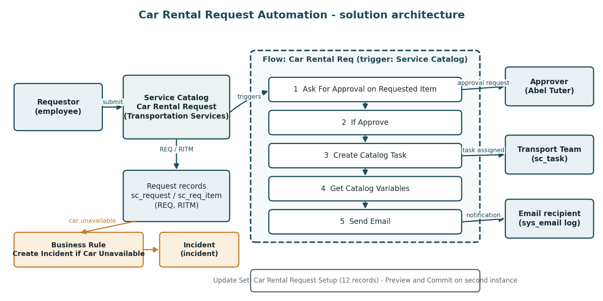
Diagram 3. Conceptual architecture of the Car Rental Request Automation.
- The requestor completes the Car Rental Request form and orders the item.
- The request and Requested Item are created and the Car Rental Req flow starts.
- Ask For Approval sends the approval request.
- If Approve is true, a catalog task is created for the Transport Team.
- Get Catalog Variables reads the submitted values and Send Email notifies the requestor.
- If a car is unavailable, the Business Rule creates an incident.

5. Project Planning and Scheduling

5.1 Project Planning
The plan follows the build order of the project. Story points are planning estimates; no recorded velocity is available.
Phase | Work package | Exit condition | Story points
Phase 1 | Category, catalog item and seven variables. | Form opens. | 5
Phase 2 | Flow trigger, approval, If check and catalog task. | Approved request creates a task. | 6
Phase 3 | Get Catalog Variables, Send Email, incident Business Rule. | Notification and rule configured. | 7
Phase 4 | Testing with Flow Execution Details and email logs. | Results recorded. | 5
Phase 5 | Update Set, migration, GitHub and documentation. | Committed on second instance. | 5
Total |  |  | 28

6. Functional and Performance Testing
Testing was carried out in the project’s ServiceNow instance and covered the catalog form, request submission, approval, catalog task, variable retrieval, email, business-rule configuration and Update Set migration. Evidence figures are in Section 7.1.
ID | Scenario | Expected result | Status
FT-01 | Catalog item and form | Seven variables under Transportation Services. | Passed (Figs 1, 2)
FT-02 | Request submission | Request and RITM created. | Passed (Figs 3, 13)
FT-03 | Approval and validation | Approved; If Approve True. | Passed (Figs 3, 5, 10)
FT-04 | Catalog task and routing | Task created for Transport Team. | Passed (Figs 6, 7, 11)
FT-05 | Variable retrieval | Seven variables retrieved. | Passed (Figs 8, 10)
FT-06 | Email notification | Email action completes; emails logged. | Passed (Figs 9, 10, 13)
FT-07 | End-to-end flow | All actions complete. | Passed (Fig 10)
FT-08 | Business rule configuration | Active rule creates an incident. | Passed - configuration (Fig 12)
FT-09 | Update Set migration | Committed, 12 inserted, 0 collisions. | Passed (Fig 14)
Nine of nine executed functional cases passed, each with a screenshot. The car-unavailable incident and rejected-approval cases are not yet executed.

6.1 Performance Testing
No load or concurrency measurements were recorded. The Flow Execution Details record shows a single test run that completed in 1672 ms (Ask For Approval 183 ms, Create Catalog Task 132 ms, Get Catalog Variables 27 ms, Send Email 1325 ms). This is one observation, not a benchmark, so no performance target is claimed.

Observations from testing
ID | Observation | Suggested action
O-1 | No required markers on the form, Duration defaults to 0 and one label reads Reason1 (Figs 1, 2). | Mark key variables mandatory, validate duration and rename the label.
O-2 | The Business Rule tests current.state == 3 with an empty Condition field (Fig 12). | Confirm the state means a car is unavailable and capture the When to run settings.
O-3 | The catalog task has an empty short description and no assignee (Fig 11); the email greeting lacks a name (Fig 9). | Add a short description, assign a person and personalise the email.

7. Results

7.1 Output Screenshots
The screenshots below were captured from the ServiceNow instance and follow the request from submission to packaging.
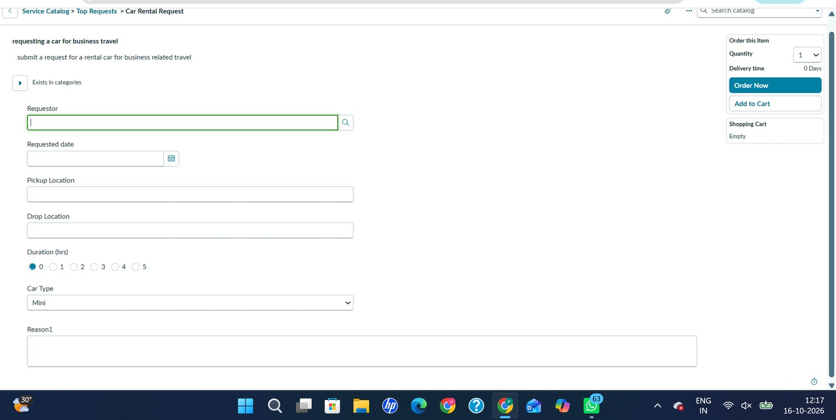
Figure 1. Car Rental Request catalog form: Requestor, Requested date, Pickup Location, Drop Location, Duration (hrs), Car Type and Reason1.
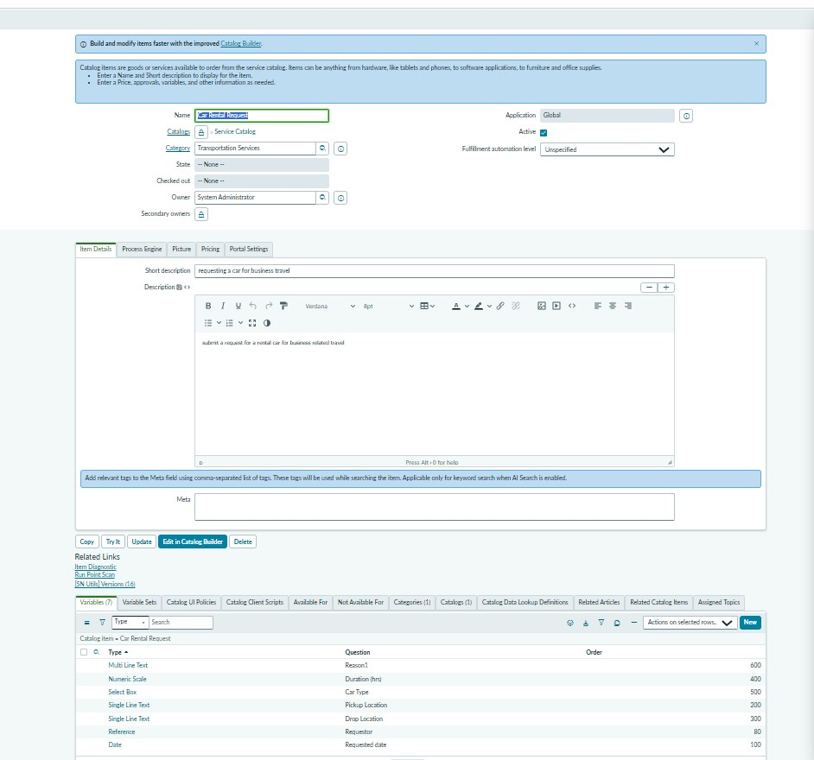
Figure 2. Car Rental Request catalog item record: category Transportation Services, short description and the seven catalog variables.
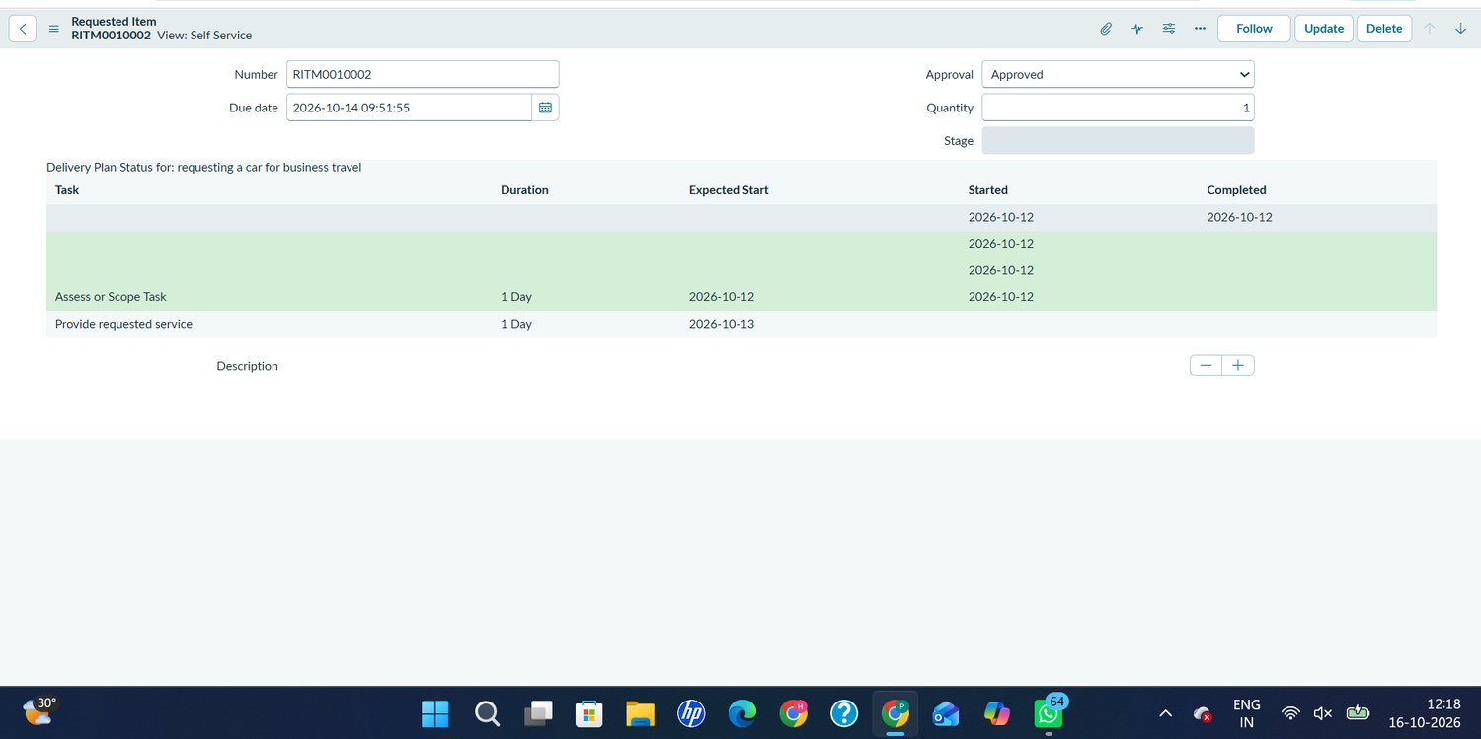
Figure 3. Requested Item RITM0010002: Approval = Approved, due date 2026-10-14 09:51:55 and its delivery plan.
Figure 4. Car Rental Req flow in Workflow Studio: Service Catalog trigger and five actions.
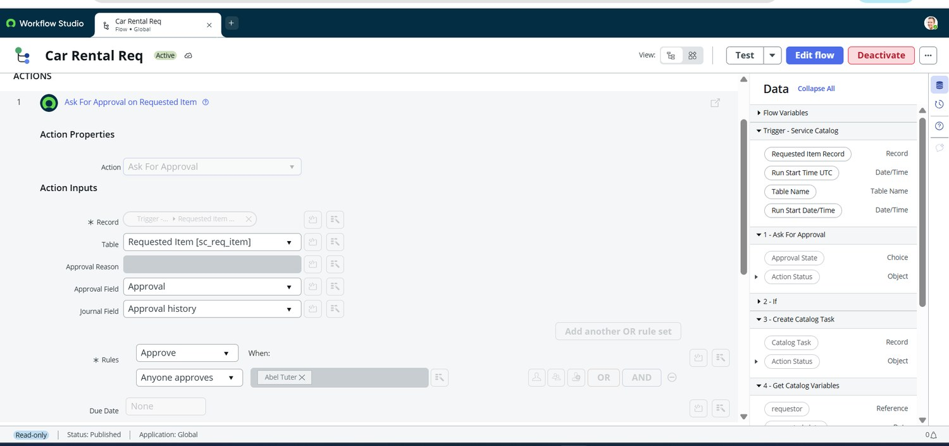
Figure 5. Ask For Approval on Requested Item: rule Approve, Anyone approves, approver Abel Tuter.
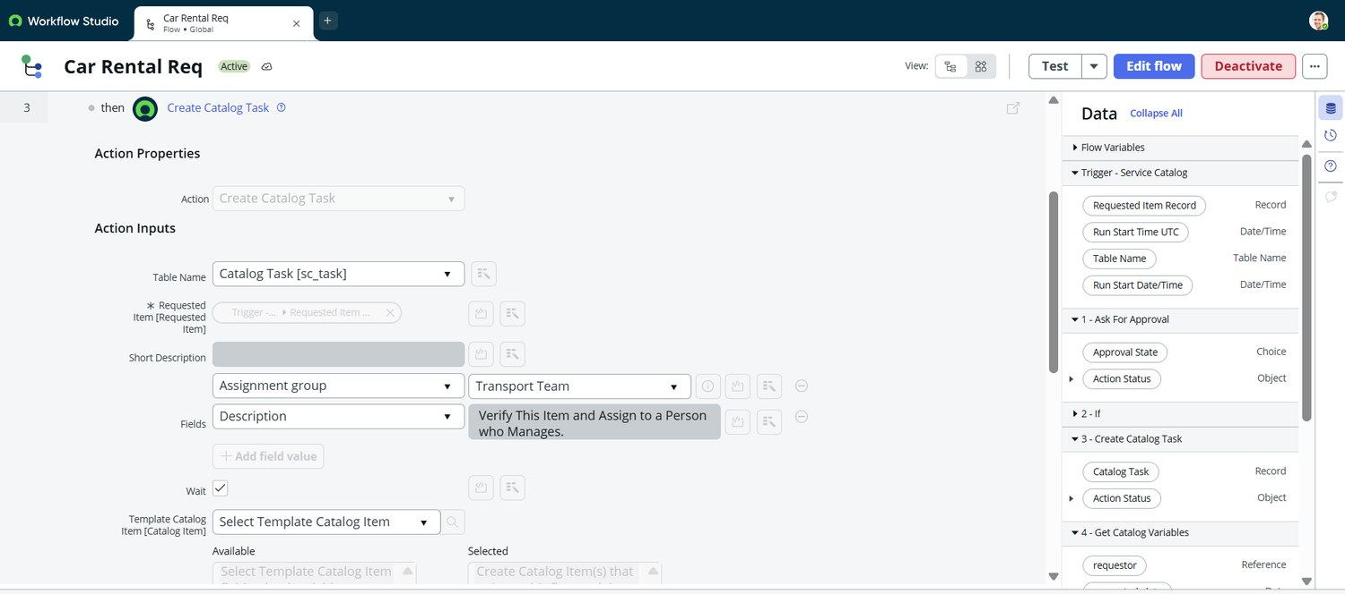
Figure 6. Create Catalog Task action: table Catalog Task [sc_task], assignment group Transport Team, Wait enabled.
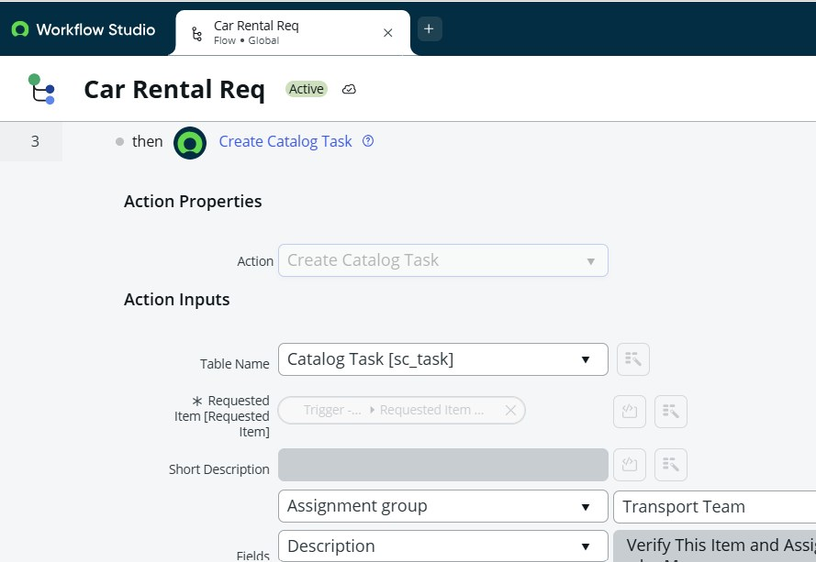
Figure 7. Create Catalog Task (detail): Assignment group = Transport Team; description "Verify This Item and Assign to a Person who Manages."
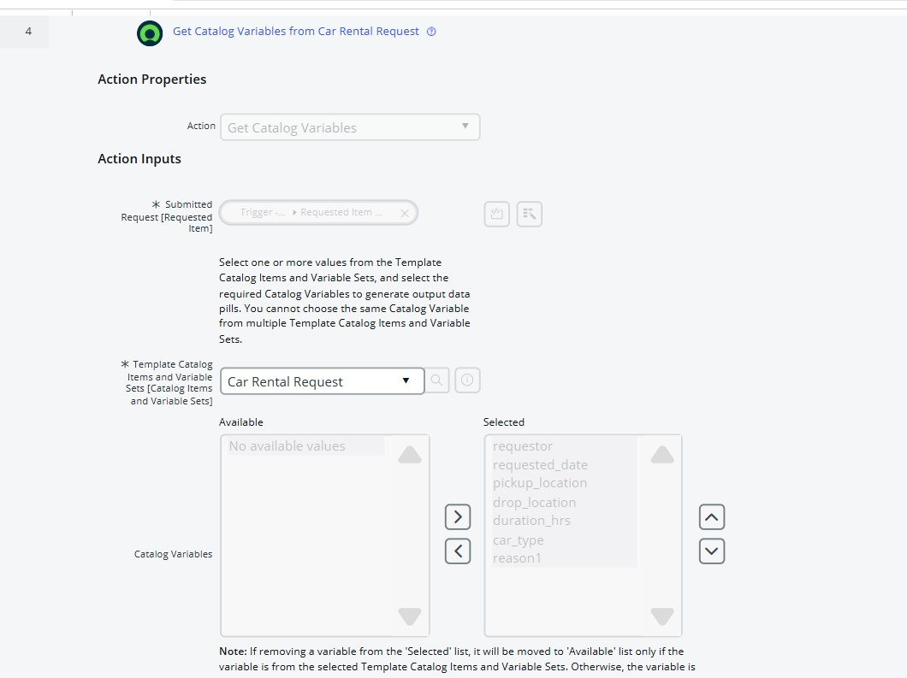
Figure 8. Get Catalog Variables from Car Rental Request: all seven variables selected.
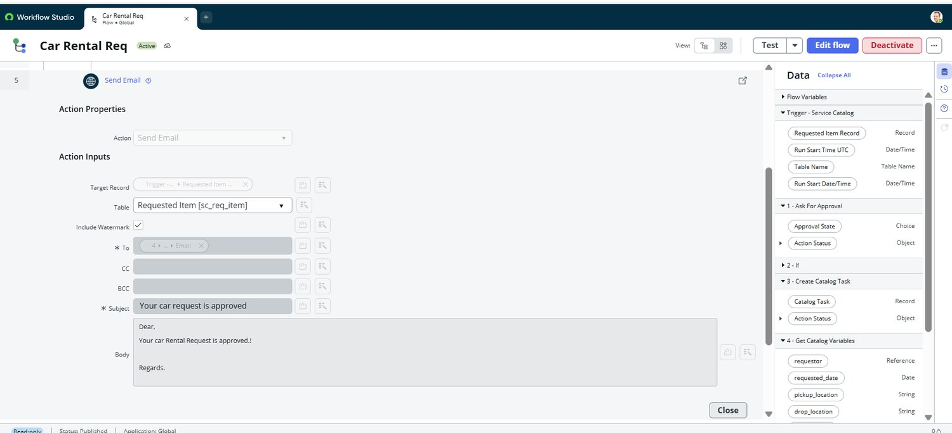
Figure 9. Send Email action on the Requested Item with subject "Your car request is approved".
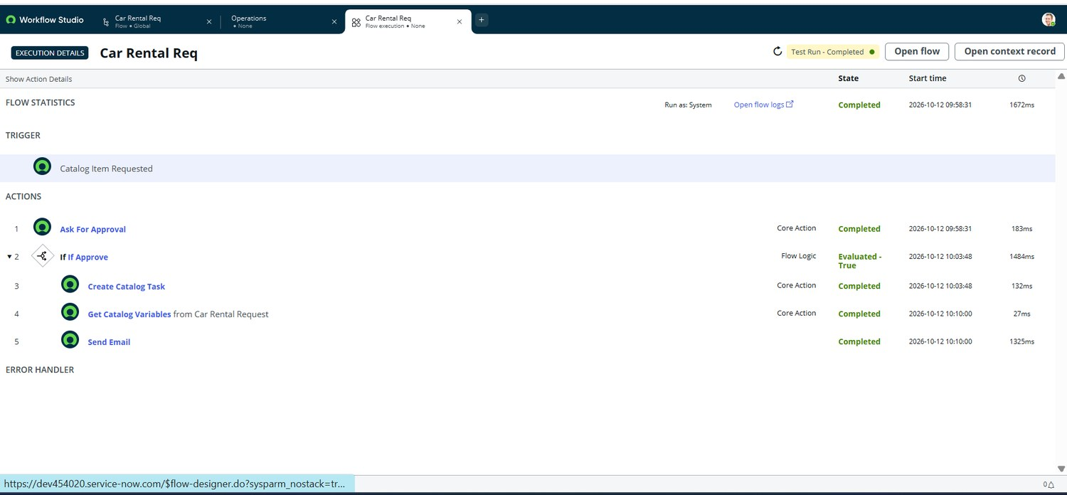
Figure 10. Flow Execution Details: Test Run - Completed on 2026-10-12 (1672 ms); all five steps completed.
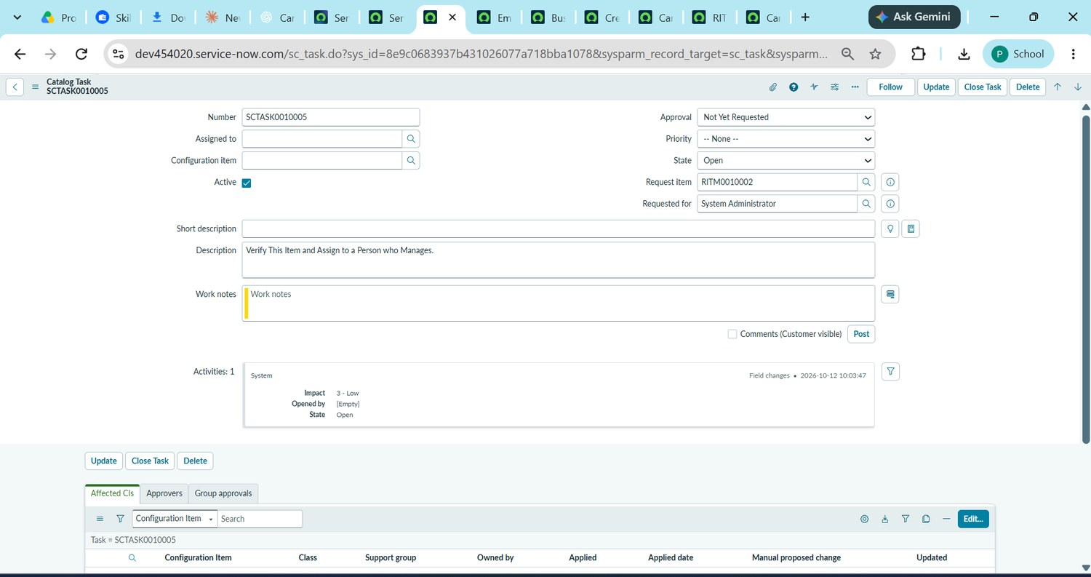
Figure 11. Catalog Task SCTASK0010005 linked to RITM0010002 (State: Open; Requested for: System Administrator).
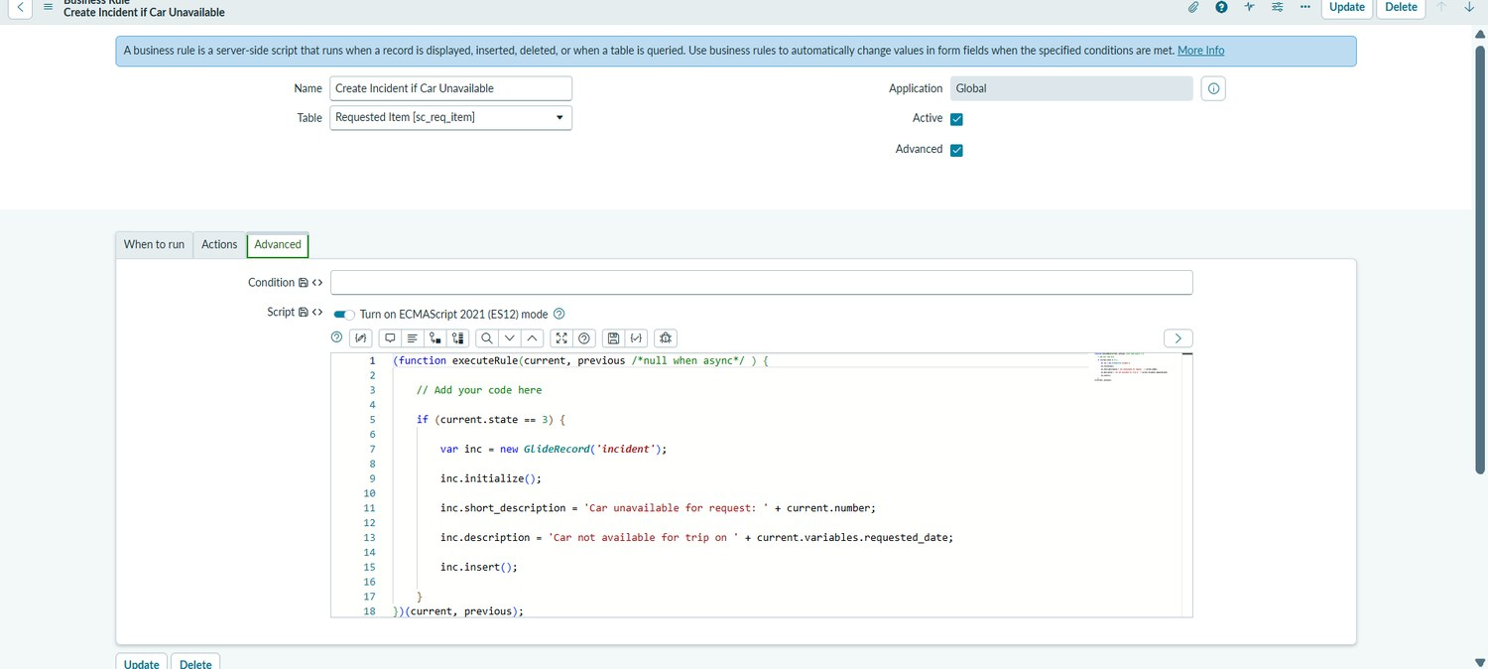
Figure 12. Business Rule "Create Incident if Car Unavailable" on Requested Item [sc_req_item] with its advanced script.
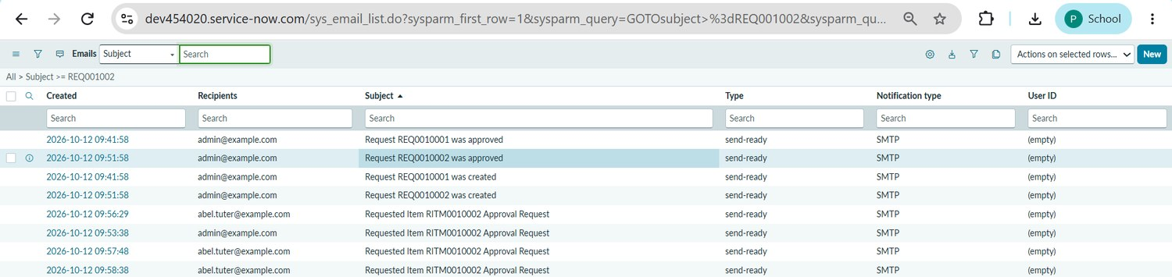
Figure 13. Email log (sys_email): request created, request approved and approval-request emails for REQ0010001, REQ0010002 and RITM0010002.
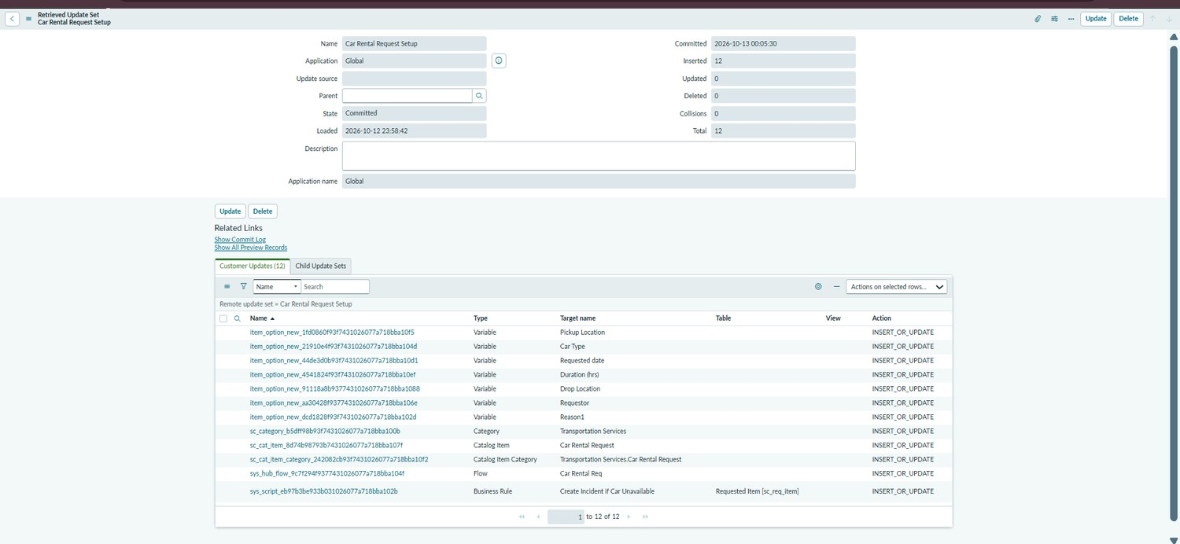
Figure 14. Retrieved Update Set "Car Rental Request Setup": State Committed, 12 records inserted, 0 collisions.

8. Advantages and Disadvantages

Advantages
- One form captures the full trip once.
- Approval is enforced before the catalog task is created.
- The task is routed to the Transport Team automatically.
- The requestor is notified by email and the notification is logged.
- Unavailable cars are recorded as incidents.
- The configuration is portable through an Update Set.

Disadvantages and limitations
- The reject path and the car-unavailable incident have not been executed in testing.
- The business-rule condition (state 3) needs confirmation.
- The form has no required markers and Reason1 needs renaming.
- The catalog task has no assignee or short description.
- No external car-rental provider is integrated.
- The instance is not a production environment with an availability commitment.

9. Conclusion
The Car Rental Request Automation shows that a complete request lifecycle can be built with native ServiceNow capabilities: a Service Catalog item, an approval flow, an automatic Transport Team catalog task, variable retrieval, an email notification, an exception business rule and an Update Set. Flow Execution Details, the catalog task, the email logs and the committed Update Set provide end-to-end evidence. The remaining work is to execute the reject and car-unavailable paths and resolve the three observations.

10. Future Scope
- Add a reject path and notify the requestor when a request is rejected.
- Make key variables mandatory and add date validation.
- Confirm and refine the car-unavailable condition and test incident creation.
- Assign the catalog task to a person automatically and add a short description.
- Personalise the email with the requestor name and trip details.
- Integrate an external car-rental provider.
- Add reporting on requests by car type, location and approval turnaround.

11. Appendix

A. Source Code (Configuration Artifact)
The solution is configuration on the ServiceNow platform. The Update Set Car Rental Request Setup holds 12 records: seven variables, the Transportation Services category, the Car Rental Request catalog item, the catalog item category link, the Car Rental Req flow and the Business Rule.
Artifact | Detail
Catalog item | Car Rental Request (Transportation Services)
Catalog variables | requestor, requested_date, pickup_location, drop_location, duration_hrs, car_type, reason1
Flow | Car Rental Req (sys_hub_flow), Global
Business Rule | Create Incident if Car Unavailable on Requested Item [sc_req_item], Advanced
Category | Transportation Services
Business Rule script (as shown in the evidence):
(function executeRule(current, previous /*null when async*/ ) {

// Add your code here

if (current.state == 3) {

var inc = new GlideRecord('incident');

inc.initialize();

inc.short_description = 'Car unavailable for request: ' + current.number;

inc.description = 'Car not available for trip on ' + current.variables.requested_date;

inc.insert();

}

})(current, previous);

B. Dataset / Data Model
The project does not use an external dataset. The data model is the set of catalog variables below.
Order | Question (label) | Type
80 | Requestor | Reference
100 | Requested date | Date
200 | Pickup Location | Single Line Text
300 | Drop Location | Single Line Text
400 | Duration (hrs) | Numeric Scale (0 to 5)
500 | Car Type | Select Box (default Mini)
600 | Reason1 | Multi Line Text

C. GitHub and Project Demo Link
Item | Link
ServiceNow instance | dev454020.service-now.com
Update Set | Car Rental Request Setup
GitHub repository | https://github.com/PHimajasree/Car-Rental-Request-Automation-ServiceNow
Demo video | To be added by the project owner

D. Glossary
Term | Meaning
Service Catalog | ServiceNow module that lets users order items and services through forms.
Catalog item | An orderable entry in the catalog; here, Car Rental Request.
Flow Designer | Low-code tool for building automated flows.
Catalog Task (sc_task) | A fulfilment task linked to a Requested Item.
Business Rule | Server-side script that runs when a record is displayed, inserted, updated or deleted.
REQ / RITM | Request and Requested Item records created when a catalog item is ordered.
Update Set | A package of configuration changes moved between instances with Preview and Commit.
Incident | A record of an unplanned issue; here, an unavailable car.

