Ideation Phase
Brainstorm & Idea Prioritization Template
Date | 16-10-2026
Team ID | Individual participant - 323103312152@gvpce.ac.in
Project Name | Car Rental Request Automation - ServiceNow
Maximum Marks | 4 Marks

This ideation document frames the problem and compares practical concepts for a ServiceNow-based car rental request process. The aim is to let an employee submit one request, have it approved, and have the Transport Team receive a task automatically, while exceptions are raised as incidents. The ideas are a structured design rationale based on the project build, not a record of a formal workshop or scoring exercise.

Step-1: Team Gathering, Collaboration and Select the Problem Statement

Problem statement
Arranging a rental car for business travel by phone or email is slow and hard to track. Trip details are repeated, approval is informal, the transport team does not know when a request is ready, and a car that cannot be supplied leaves no record. The project proposes a ServiceNow Service Catalog item, Car Rental Request, that captures the trip details, runs an approval flow, creates a Transport Team catalog task on approval, sends an email notification and raises an incident when a car is unavailable.

Stakeholders and needs
Stakeholder | Primary need
Requestor (employee) | Submit pickup, drop, duration, car type and reason once; be told when the request is approved.
Approver | Receive an approval request for the requested item and decide before fulfilment starts.
Transport Team | Receive a catalog task for each approved request with the instruction to assign it to a person who manages it.
ServiceNow administrator | Keep the catalog item, flow, business rule and notifications in one platform and move them between instances with an Update Set.

Solution direction
Use one Service Catalog item as the single entry point. Capture seven catalog variables, trigger the Car Rental Req flow on submission, request approval on the Requested Item, create a catalog task for the Transport Team when approved, read the catalog variables for later steps, send an email, and let a Business Rule raise an Incident for unavailable cars.
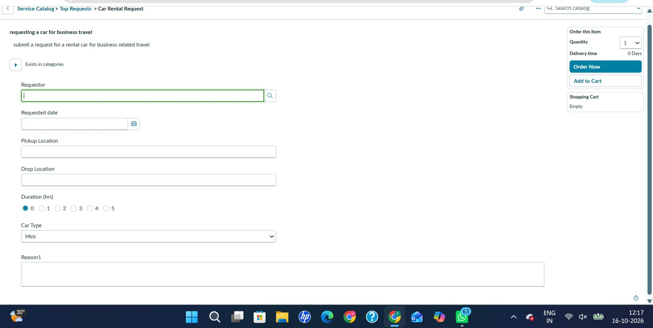
Figure 1. Car Rental Request catalog item form under Service Catalog > Top Requests (project evidence).

Step-2: Brainstorm, Idea Listing and Grouping
The ideas are grouped by the part of the request lifecycle they improve.

A. Request intake
Idea | Description
Guided request form | One catalog item titled Car Rental Request in the Transportation Services category with clearly labelled fields.
Trip detail variables | Requestor (reference), Requested date, Pickup Location, Drop Location, Duration (hrs), Car Type and Reason.
Quick choices | Duration as a 0 to 5 scale and Car Type as a drop-down (default Mini) to keep entries consistent.

B. Approval and fulfilment
Idea | Description
Approval gate | Ask For Approval on the Requested Item with the rule Approve and an Anyone approves condition for the named approver.
Approval check | An If condition on the approval result so work only continues when the request is approved.
Automatic catalog task | Create a Catalog Task for the Requested Item and assign it to the Transport Team.

C. Communication and exceptions
Idea | Description
Variable retrieval | Use Get Catalog Variables so trip details are available to later steps such as the email.
Approval email | Send an email with the subject Your car request is approved.
Unavailable-car incident | A Business Rule creates an Incident with the request number and requested date when a car is unavailable.

D. Administration and portability
Idea | Description
Reusable platform records | Use standard request, requested item and catalog task records rather than a separate database.
Update Set packaging | Package the configuration as Car Rental Request Setup and move it with Preview and Commit.

Step-3: Idea Prioritization
Idea | Impact | Effort | Decision
Catalog item with trip variables | High | Low | Build first; every other feature depends on it.
Approval flow with If check | High | Medium | Core control: no fulfilment without approval.
Catalog task to Transport Team | High | Low | Delivers the work to the fulfilment group.
Email notification | Medium | Low | Quick win using the Send Email action.
Incident business rule | Medium | Low | Handles the car-unavailable exception.
Update Set packaging | Medium | Low | Supports migration and backup.
External car-rental provider integration | Medium | High | Out of scope for this build.
Impact and effort ratings are the author’s planning judgement, not measured scores.

