Project Design Phase
Problem - Solution Fit Template
Date | 16-10-2026
Team ID | Individual participant - 323103312152@gvpce.ac.in
Project Name | Car Rental Request Automation - ServiceNow
Maximum Marks | 2 Marks

Problem - Solution Fit Template:
Problem-Solution Fit means identifying a meaningful customer problem and proposing a solution that addresses the customer’s needs and behaviour. For this project, the fit hypothesis is that one ServiceNow request journey can connect trip details, approval, fulfilment routing, notification and exception handling.

Purpose
- Solve the car rental request problem in a way that fits how employees actually arrange business travel.
- Use the familiar ServiceNow Service Catalog as the access channel.
- Enforce approval before fulfilment and route work to the right team.
- Reduce manual follow-up by linking request, approval, task and email in one flow.
- Understand current friction points and validate whether the workflow improves them.

Problem - Solution Fit Canvas
The canvas below summarises the target users, problem, proposed solution, expected value and assumptions to validate.
1 TARGET USERS  Employees, approvers and the Transport Team  • Need a clear way to request a car.  • Travel for business on varied dates.  • Approve and fulfil requests. | 2 PROBLEM / FRICTION  Requests and approvals are informal  • Approval status unclear.  • Tasks not routed automatically.  • No record when a car is unavailable.
3 PROPOSED SERVICE  Car Rental Request catalog item and flow  • Seven trip variables captured.  • Approval before fulfilment.  • Catalog task to Transport Team, email and incident rule. | 4 VALUE  A tracked, approved request  • One form for every trip.  • Fulfilment only after approval.  • Notification and exception record.
5 RISKS AND VALIDATION  Value depends on correct configuration  • Test approve and reject paths.  • Confirm the unavailable-car condition.  • Keep approver and team assignments current. | NEXT STEP  Validate with users  • Run requests with real employees.  • Collect feedback on clarity and speed.
Figure: Problem-solution fit canvas for the car rental request workflow.

Fit hypothesis and validation
Fit dimension | Project hypothesis | How to validate
Problem | Employees need an approved, trackable car request; approvers and the Transport Team need work routed automatically. | Walk through a request and confirm every needed input is present.
Solution | A catalog item, Flow Designer flow and Business Rule can cover the journey. | Verify flow execution, task creation, email log and incident creation.
Value | Approval before fulfilment and automatic routing should reduce manual chasing. | Check request, task and email records; collect user feedback.
Assumptions | Approver, Transport Team and variables are configured correctly. | Test the approve and reject paths; inspect the catalog task and Update Set.
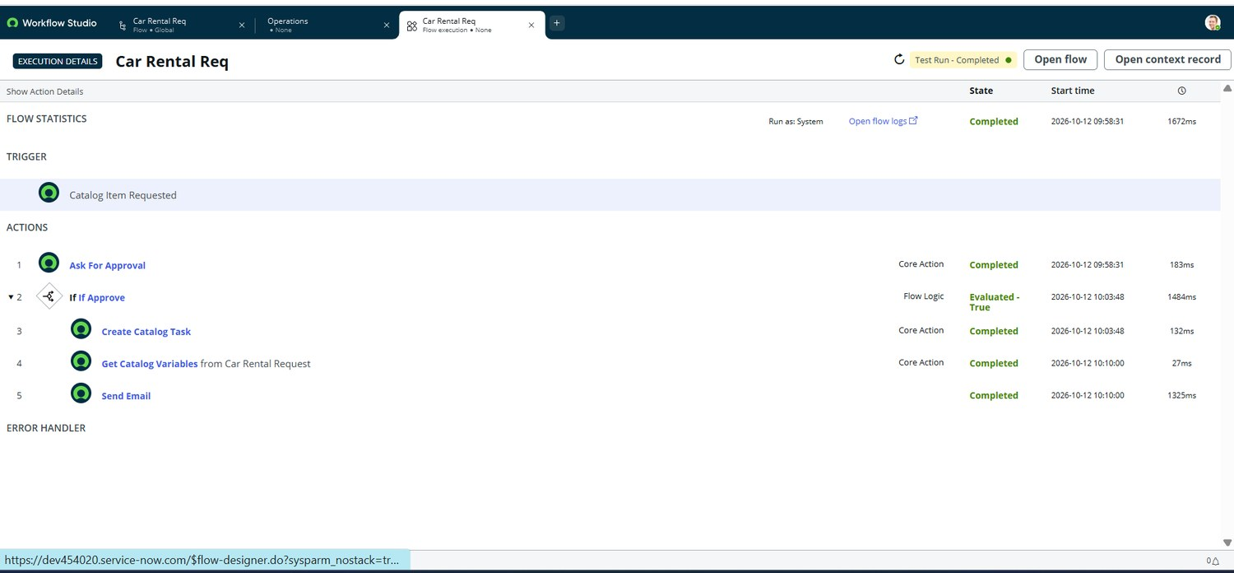
Figure 10. Fit in practice: the flow completed approval, task creation, variable retrieval and email in a single test run.

Conclusion
The solution has a plausible problem-solution fit because it uses native ServiceNow catalog, flow, task and business-rule capabilities to connect request, approval, fulfilment and notification. Fit remains a hypothesis until it is confirmed with real user feedback and wider testing, including the reject and car-unavailable paths.

References
- https://www.ideahackers.network/problem-solution-fit-canvas/
- https://medium.com/@epicantus/problem-solution-fit-canvas-aa3dd59cb4fe

