Project Planning Phase
Project Planning Template - Product Backlog & Schedule
Date | 16-10-2026
Team ID | Individual participant - 323103312152@gvpce.ac.in
Project Name | Car Rental Request Automation - ServiceNow
Maximum Marks | 5 Marks

Planning basis
This plan follows the natural implementation sequence of the project: catalog item and variables, approval flow and task, notification and exception rule, testing, then packaging and documentation. Phase labels and story points are planning estimates; no recorded sprint history or measured velocity is available, so none is claimed.

Product Backlog, Sprint Schedule, and Estimation
Sprint | Functional Requirement (Epic) | Story No. | User Story / Task | Story Points | Priority
Phase 1 | Catalog setup | USN-1 | As an administrator, I want a Transportation Services category and Car Rental Request item so that requests have an entry point. | 2 | High
Phase 1 | Request details | USN-2 | As a requestor, I want seven variables (requestor, date, pickup, drop, duration, car type, reason) on the form. | 3 | High
Phase 2 | Approval flow | USN-3 | As an approver, I want Ask For Approval and an If Approve check so that only approved requests proceed. | 3 | High
Phase 2 | Fulfilment task | USN-4 | As a Transport Team member, I want a catalog task assigned to my team when a request is approved. | 3 | High
Phase 3 | Variable retrieval | USN-5 | As the flow, I want Get Catalog Variables so request details are available later. | 2 | Medium
Phase 3 | Notification | USN-6 | As a requestor, I want an email telling me the request is approved. | 2 | Medium
Phase 3 | Exception handling | USN-7 | As an administrator, I want a Business Rule to create an incident when a car is unavailable. | 3 | Medium
Phase 4 | Testing | USN-8 | As a tester, I want to verify the flow execution, catalog task and email logs. | 5 | High
Phase 5 | Packaging | USN-9 | As an administrator, I want an Update Set migrated to a second instance with Preview and Commit. | 3 | High
Phase 5 | Documentation | USN-10 | As a reviewer, I want documentation, screenshots and a GitHub copy of the Update Set. | 2 | Medium

Phase-level schedule (sequence-based; not historical sprint dates)
Phase | Work package | Dependency / exit condition | Planned story points
Phase 1 | Transportation Services category, Car Rental Request item and seven variables. | Form can be opened. | 5
Phase 2 | Car Rental Req flow: trigger, Ask For Approval, If Approve, Create Catalog Task. | Approved request creates a task. | 6
Phase 3 | Get Catalog Variables, Send Email and the incident Business Rule. | Notification and exception rule configured. | 7
Phase 4 | Testing with Flow Execution Details and email logs. | Results recorded. | 5
Phase 5 | Update Set Car Rental Request Setup, migration, GitHub and documentation. | Committed on the second instance. | 5
Total | Sequence reflects the project build order. | Estimates only; actual velocity is not available. | 28

Risks and controls
Risk | Control
Approval not granted or approver unavailable. | Name the approver in the flow and test the approve path; add a reject path as future scope.
Car-unavailable condition does not match the intended state. | Review the Business Rule condition and confirm which state means unavailable.
Catalog task left unassigned. | Assign to the Transport Team group and confirm a person is assigned.
Instance reclaimed after inactivity or configuration lost. | Keep the Update Set and a GitHub copy; verify with Preview and Commit on a second instance.
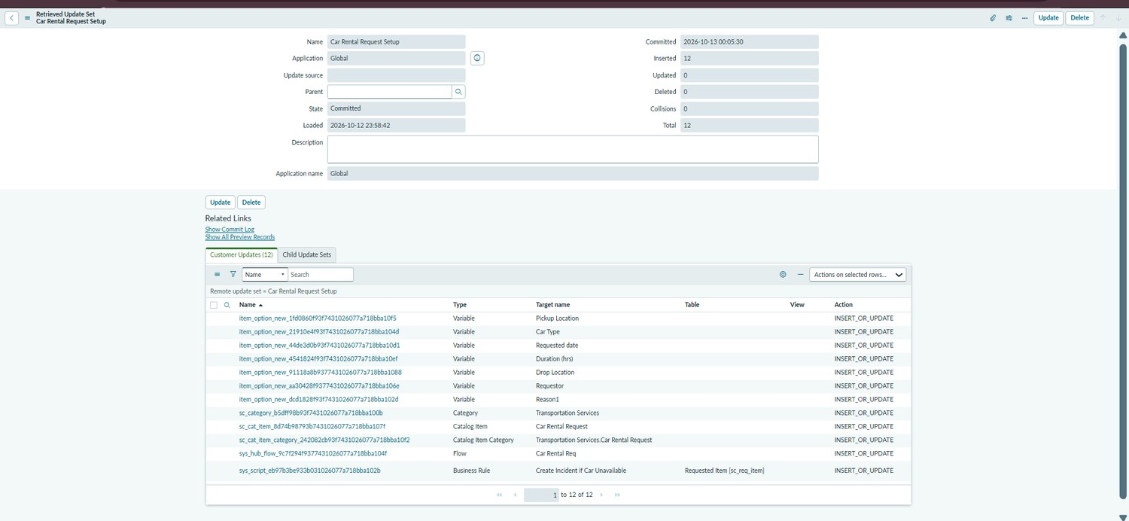
Figure 14. Packaging milestone: Update Set Car Rental Request Setup committed with 12 records.

