Project Design Phase
Proposed Solution Template
Date | 16-10-2026
Team ID | Individual participant - 323103312152@gvpce.ac.in
Project Name | Car Rental Request Automation - ServiceNow
Maximum Marks | 2 Marks

Project team shall fill the following information in the proposed solution template.
S.No. | Parameter | Description
1 | Problem Statement (Problem to be solved) | Employees need a structured way to request a rental car for business travel with approval enforced before fulfilment. Informal requests are slow to track, are not routed to the Transport Team and leave no record when a car is unavailable.
2 | Idea / Solution description | A ServiceNow Service Catalog item, Car Rental Request, in the Transportation Services category captures Requestor, Requested date, Pickup Location, Drop Location, Duration, Car Type and Reason. The Car Rental Req flow asks for approval, checks the result, creates a Catalog Task for the Transport Team, retrieves the catalog variables and sends an email. A Business Rule creates an Incident when a car is unavailable, and an Update Set carries the configuration to another instance.
3 | Novelty / Uniqueness | The value is integration rather than a new algorithm: request, approval, task routing, notification, exception handling and packaging run in one ServiceNow process with no separate application.
4 | Social Impact / Customer Satisfaction | Employees get a single request with an approval email; approvers decide on a recorded request; the Transport Team receives tasks only for approved trips. These are expected benefits and should be validated with user feedback.
5 | Business Model (Revenue Model) | The project demonstrates an internal business-travel automation, not a revenue-generating product. No revenue model is specified.
6 | Scalability of the Solution | Additional car types, locations, approvers or fulfilment teams can be added by extending catalog variables, flow logic and assignment groups. Scalability depends on instance capacity, licensing and configuration quality.

Implementation principle
Keep intake, approval and fulfilment in clear steps: the employee submits the request, the approver decides, the flow creates the catalog task only when approved, and the same request data feeds the notification. Exceptions are recorded as incidents.
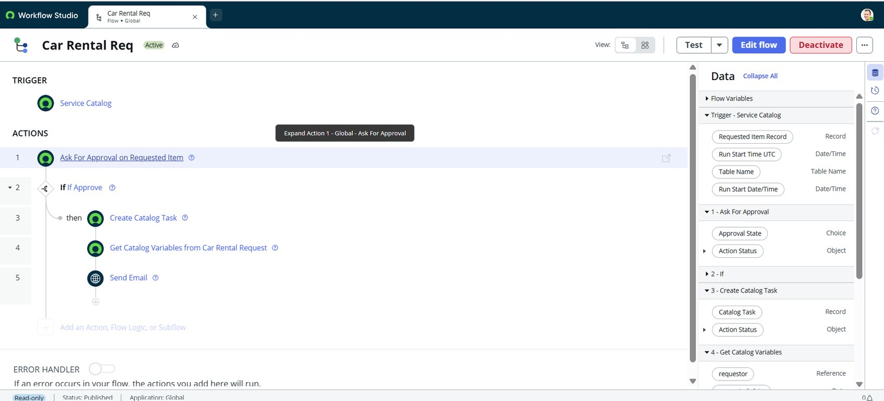
Figure 4. The automation: Service Catalog trigger followed by Ask For Approval, If Approve, Create Catalog Task, Get Catalog Variables and Send Email.

Validation note
This document describes the proposed solution and expected value. It does not claim measured customer satisfaction, verified operational savings or a commercial revenue stream.

