Project Design Phase
Solution Architecture
Date | 16-10-2026
Team ID | Individual participant - 323103312152@gvpce.ac.in
Project Name | Car Rental Request Automation - ServiceNow
Maximum Marks | 4 Marks

Solution Architecture
The solution architecture bridges the car rental business need with ServiceNow platform capabilities. It defines the requestor, the catalog entry point, the approval flow, fulfilment task, notification, exception rule and data records.
- Find the appropriate platform solution for self-service car rental requests.
- Describe the structure and behaviour of the catalog item, flow, business rule and data tables.
- Define the lifecycle from submission to approval, task creation and notification.
- Provide a clear conceptual design for configuration, testing and deployment.

Solution Architecture Diagram
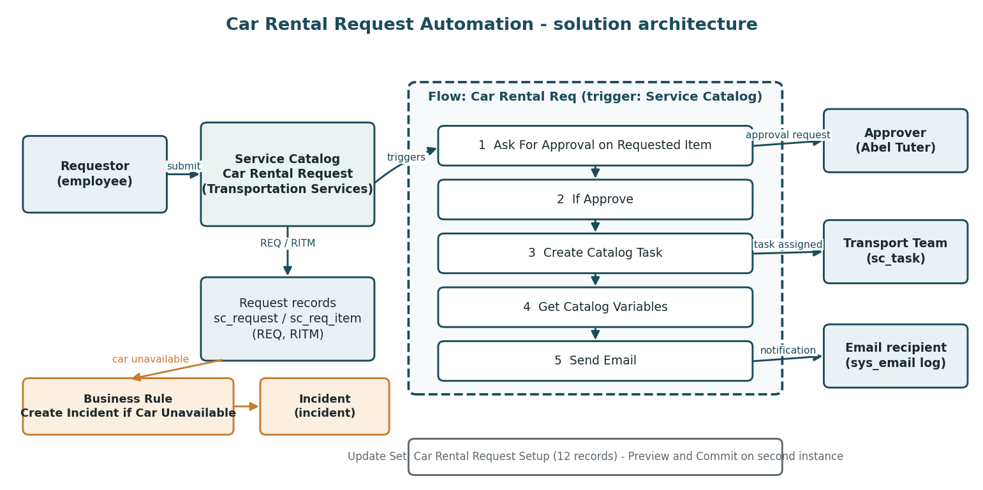
Diagram 1. Conceptual architecture and data flow for the Car Rental Request Automation.

Architecture Components
Component | Responsibility | Key artifacts / data
Requestor | Submits the car rental request. | Browser session; REQ / RITM numbers.
Service Catalog item | Presents the Car Rental Request form. | Variables: requestor, requested_date, pickup_location, drop_location, duration_hrs, car_type, reason1.
Flow: Car Rental Req | Orchestrates approval, task creation, variable retrieval and email. | Trigger: Service Catalog; five actions; Active, Application Global.
Approval | Authorises the request. | Ask For Approval on Requested Item; Approve rule, Anyone approves: Abel Tuter.
Catalog Task | Hands the approved request to fulfilment. | sc_task, assignment group Transport Team.
Get Catalog Variables / Send Email | Reuse the submitted data and notify the requestor. | Subject: Your car request is approved.
Business Rule | Handles car unavailability. | Create Incident if Car Unavailable on sc_req_item; creates an incident.
Update Set | Packages and migrates the configuration. | Car Rental Request Setup: 12 records.
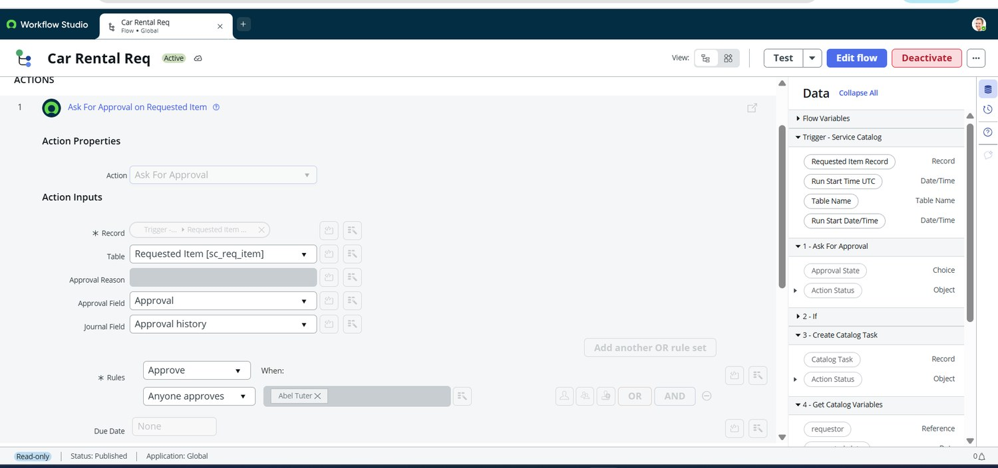
Figure 5. Ask For Approval on Requested Item: rule Approve, Anyone approves, approver Abel Tuter.

Workflow and decision rules
- The requestor opens Car Rental Request and completes the seven variables.
- On Order Now, the request and Requested Item are created and the Car Rental Req flow starts.
- Ask For Approval sends an approval request for the Requested Item to the approver.
- If Approve evaluates true, Create Catalog Task creates a task for the Transport Team.
- Get Catalog Variables reads the submitted values; Send Email notifies the requestor.
- If a car is unavailable, the Business Rule creates an Incident containing the request number and requested date.

Architecture assumptions and validation
This is the intended target architecture, drawn from the build and the screenshots. The business-rule trigger condition, notification settings and roles depend on instance configuration and should be verified during testing. The diagram is conceptual and does not claim that every connection has been validated beyond the tests reported in the testing documents.

