Project Design Phase-II
Solution Requirements (Functional & Non-functional)
Date | 16-10-2026
Team ID | Individual participant - 323103312152@gvpce.ac.in
Project Name | Car Rental Request Automation - ServiceNow
Maximum Marks | 4 Marks

Functional Requirements:
Following are the functional requirements of the proposed solution.
FR No. | Functional Requirement (Epic) | Sub Requirement (Story / Sub-Task)
FR-1 | Catalog item | Provide a Car Rental Request catalog item in the Transportation Services category of the Service Catalog.
FR-2 | Request details | Capture Requestor, Requested date, Pickup Location, Drop Location, Duration (hrs), Car Type and Reason as catalog variables.  Offer Duration as a 0 to 5 scale and Car Type as a select box.
FR-3 | Flow trigger | Start the Car Rental Req flow automatically when the catalog item is requested.
FR-4 | Approval | Ask for approval on the Requested Item.  Check the approval result with an If condition before continuing.
FR-5 | Fulfilment task | When approved, create a Catalog Task for the Requested Item and assign it to the Transport Team.
FR-6 | Variable retrieval | Retrieve the submitted catalog variables so the request information can be used in later steps.
FR-7 | Notification | Send an email notification of the approval status of the request.
FR-8 | Exception handling | Create an Incident with the request number and requested date through the Business Rule Create Incident if Car Unavailable.
FR-9 | Packaging and migration | Package the configuration in the Car Rental Request Setup Update Set and migrate it with Preview and Commit.
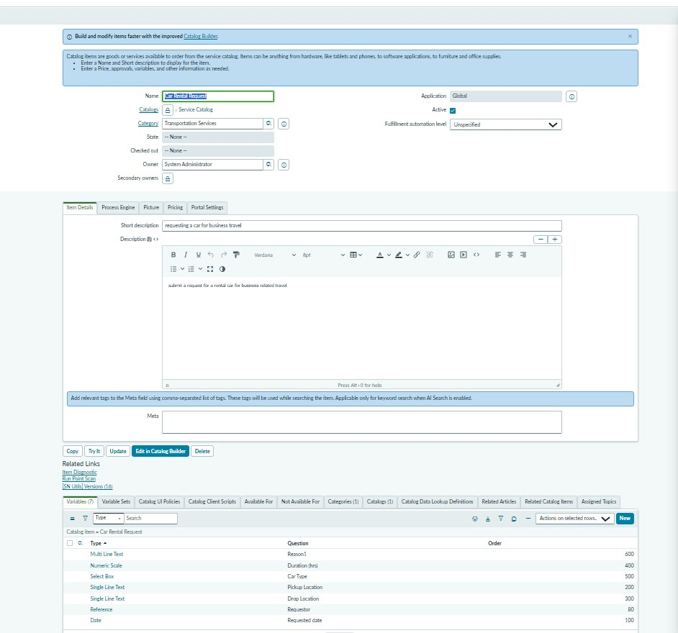
Figure 2. Catalog item and its seven variables, implementing FR-1 and FR-2.

Non-functional Requirements:
Following are the non-functional requirements of the proposed solution.
NFR No. | Non-Functional Requirement | Description
NFR-1 | Usability | A short guided form with labelled fields and quick choices so employees can request a car with minimal effort.
NFR-2 | Security | Use ServiceNow authentication, roles and record permissions; only the named approver can approve the request.
NFR-3 | Reliability | The flow must complete each step in order and never create a fulfilment task before approval.
NFR-4 | Performance | Flow actions should complete promptly; the recorded test run took 1672 ms and further targets are to be defined and measured.
NFR-5 | Availability | The service is available when the underlying ServiceNow instance is available; platform SLA is environment-dependent.
NFR-6 | Portability | Configuration is captured in an Update Set so it can be previewed, committed and moved between instances.
Requirement note
These requirements describe the intended solution behaviour. Security controls, performance targets, availability and scalability must be validated against the configured ServiceNow instance; no unverified measurements are claimed.

