Project Design Phase-II
Technology Stack (Architecture & Stack)
Date | 16-10-2026
Team ID | Individual participant - 323103312152@gvpce.ac.in
Project Name | Car Rental Request Automation - ServiceNow
Maximum Marks | 4 Marks

Technical Architecture:
The solution is built on the ServiceNow hosted platform. Employees use the Service Catalog; Flow Designer provides the approval, task creation, variable retrieval and email steps; a server-side Business Rule raises incidents; and standard platform tables retain request, task, incident and email data.
Architecture diagram: technology layers
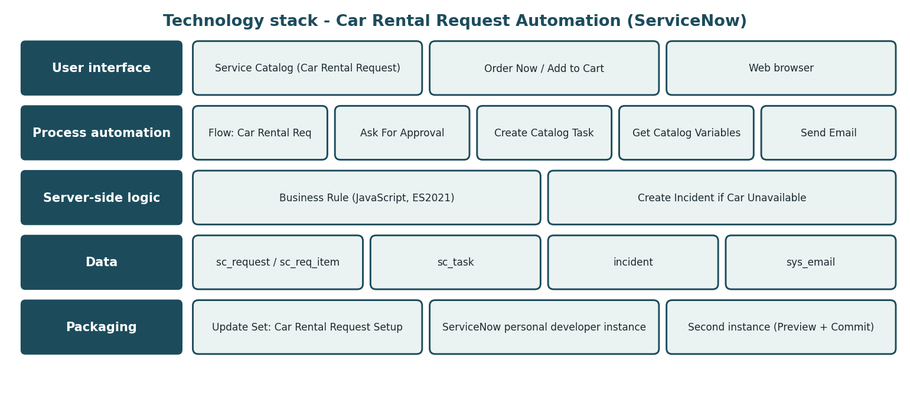
Diagram 1. Technology stack of the Car Rental Request Automation.
Infrastructure demarcation: users access a ServiceNow instance through a web browser. Request and task data are stored in ServiceNow-managed tables. No separate local server, external API or machine-learning model is part of the documented scope.

Table-1: Components & Technologies
S.No | Component | Description | Technology
1 | User Interface | Car Rental Request form with Order Now and Add to Cart. | ServiceNow Service Catalog; web browser
2 | Application Logic-1 | Car Rental Req flow: Ask For Approval, If Approve, Create Catalog Task, Get Catalog Variables, Send Email. | Flow Designer (Workflow Studio)
3 | Application Logic-2 | Create Incident if Car Unavailable on Requested Item. | Business Rule (server-side JavaScript, ES2021)
4 | Application Logic-3 | Email notification of approval status. | Send Email flow action; email logs
5 | Database | Requests, requested items, catalog tasks, incidents and emails. | sc_request, sc_req_item, sc_task, incident, sys_email
6 | Cloud Database | Persistent storage managed by the hosted platform. | ServiceNow-managed data store (engine not specified)
7 | File Storage | No separate file-storage component is required. | Not applicable
8 | External API-1 | No third-party API is identified in the project scope. | None specified
9 | External API-2 | No second external API is identified. | None specified
10 | Machine Learning Model | No ML model is used; the flow follows configured rules. | Not applicable
11 | Infrastructure (Server / Cloud) | Hosted ServiceNow instance accessed through a browser; Update Set migrated to a second instance. | ServiceNow cloud-hosted instance (dev454020)
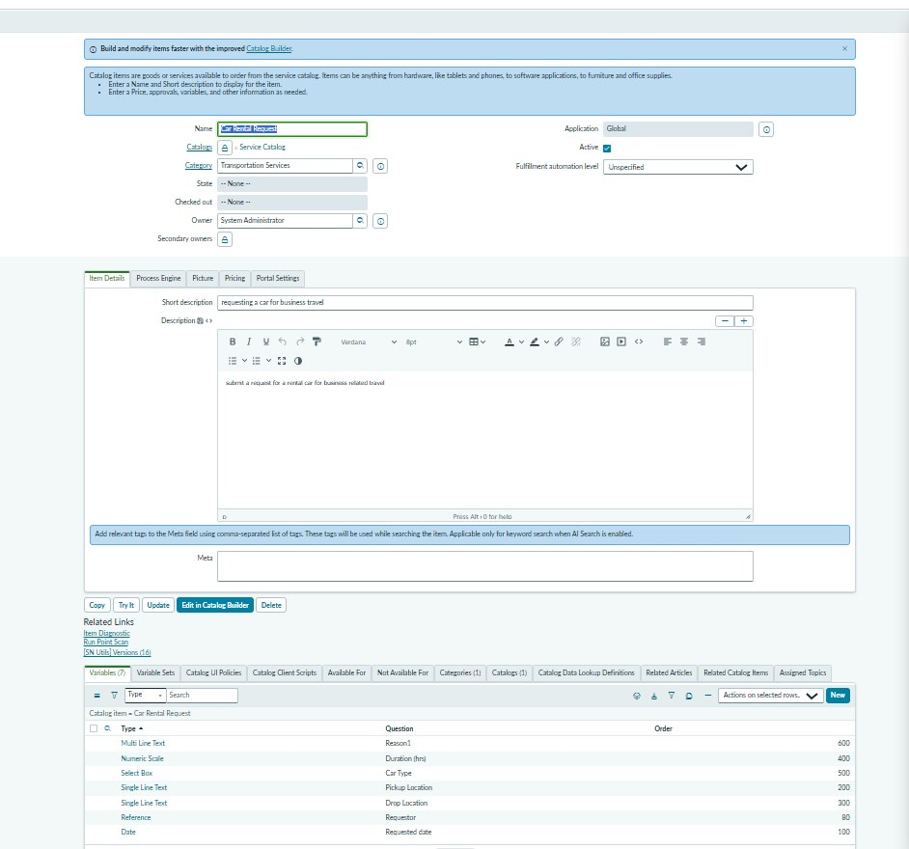
Figure 2. Platform configuration: catalog item and its variables.

Table-2: Application Characteristics
The characteristics below describe the architectural approach. Instance-specific security settings, availability commitments and performance limits must be confirmed in the target ServiceNow environment.
S.No | Characteristics | Description | Technology
1 | Open-Source Frameworks | No separate open-source framework is identified; the solution uses native ServiceNow configuration and scripting. | ServiceNow platform
2 | Security Implementations | Platform authentication, roles and access controls limit who can view and approve records. Exact roles and ACLs must be verified in the target instance. | ServiceNow roles / ACLs
3 | Scalable Architecture | New variables, car types, approvers or teams are added through configuration rather than new infrastructure. | Hosted ServiceNow platform
4 | Availability | Depends on the ServiceNow service and the instance’s commitments; a developer instance has no production SLA. | ServiceNow hosting
5 | Performance | The recorded flow test run completed in 1672 ms; no load-test target is specified. | Flow Designer; validate in testing

Architecture notes
- The diagram is a conceptual representation of the lifecycle, not a claim that every component has been load-tested.
- The underlying database engine is managed by ServiceNow and is not specified by the project.
- No third-party API or machine-learning model is necessary for the documented core workflow.

References
- ServiceNow Product Documentation: Service Catalog, Flow Designer, Business Rules, Email Notifications and Update Sets (docs.servicenow.com).

