Acceptance Testing
UAT Execution & Report Submission
Date | 16-10-2026
Team ID | Individual participant - 323103312152@gvpce.ac.in
Project Name | Car Rental Request Automation - ServiceNow
Maximum Marks | 4 Marks

1. Purpose of Document
This report summarises UAT coverage and observations for the Car Rental Request Automation: catalog access, request submission, approval, catalog task routing, variable retrieval, email notification, exception handling and Update Set migration.
Status: EXECUTED - PARTIAL
Ten of twelve planned cases have been executed and passed, based on the screenshots captured on 12-16 October 2026 and the project owner’s testing summary. Two cases (car-unavailable incident and rejected approval) have not yet been executed. No defects have been logged; three non-blocking observations are listed below. Tester and project-owner sign-off is still to be completed.

2. Defect Analysis
No blocking defects were found. Three observations were noted during review; all are open and none prevented a request.
Resolution | Severity 1 | Severity 2 | Severity 3 | Severity 4 | Subtotal
Open | 0 | 0 | 2 | 1 | 3
Fixed | 0 | 0 | 0 | 0 | 0
By Design | 0 | 0 | 0 | 0 | 0
Duplicate | 0 | 0 | 0 | 0 | 0
Not Reproduced | 0 | 0 | 0 | 0 | 0
Won’t Fix | 0 | 0 | 0 | 0 | 0
Totals | 0 | 0 | 2 | 1 | 3

ID | Observation | Severity | Status / owner
O-1 | No field on the Car Rental Request form shows a required marker, Duration defaults to 0 hours and one label reads Reason1 (Fig 1, Fig 2). | 3 | Open - project owner
O-2 | The Business Rule has an empty Condition field and tests current.state == 3 in its script (Fig 12). Confirm that this value means a car is unavailable, since 3 is normally Closed Complete on a Requested Item. | 3 | Open - project owner
O-3 | The catalog task has an empty short description and no assignee (Fig 11) and the email greeting reads Dear, without the requestor name (Fig 9). | 4 | Open - project owner

3. Test Case Analysis
Section | Total Cases | Not Tested | Fail | Pass
Catalog access & form (UAT-01, 02) | 2 | 0 | 0 | 2
Submission & approval (UAT-03, 04, 05) | 3 | 0 | 0 | 3
Fulfilment task & variables (UAT-06, 07) | 2 | 0 | 0 | 2
Notification (UAT-08, 09) | 2 | 0 | 0 | 2
Update Set migration (UAT-10) | 1 | 0 | 0 | 1
Exceptions (UAT-11, 12) | 2 | 2 | 0 | 0
Totals | 12 | 2 | 0 | 10
Pass rate of executed cases: 10 / 10 = 100%. Pass rate of all planned cases: 10 / 12 = 83.3%.

4. Execution evidence
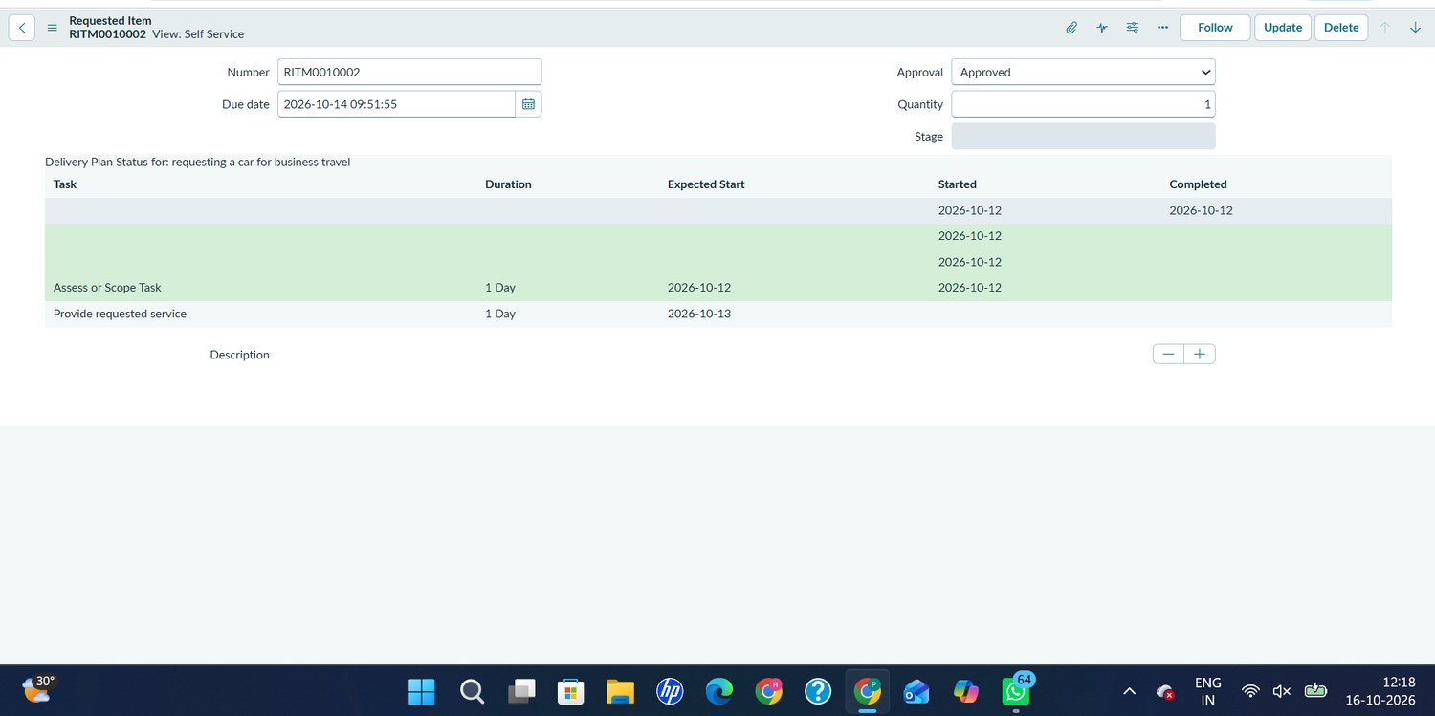  Fig 3. UAT-05: RITM0010002 approved | 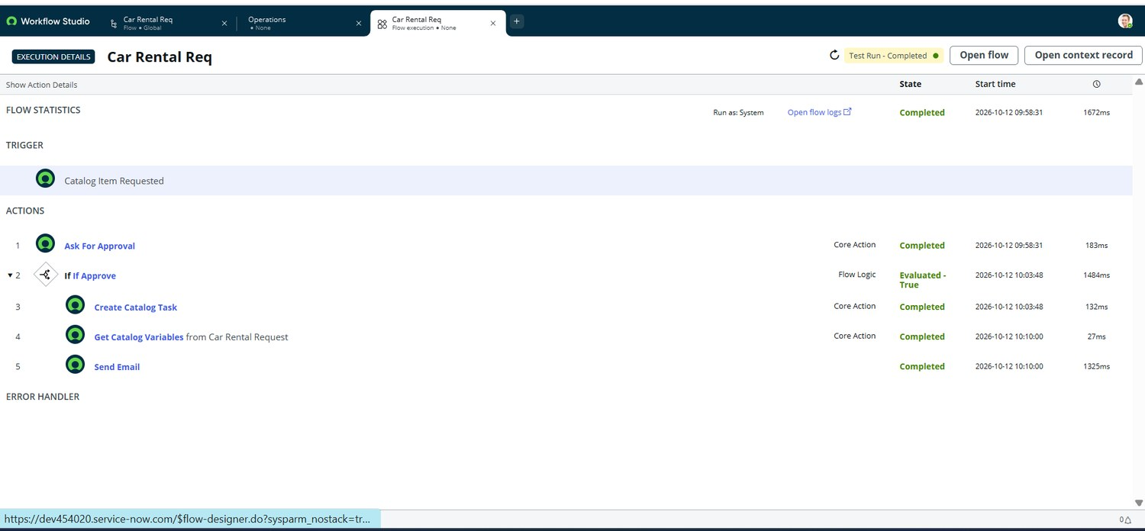  Fig 10. UAT-04 to 08: flow execution
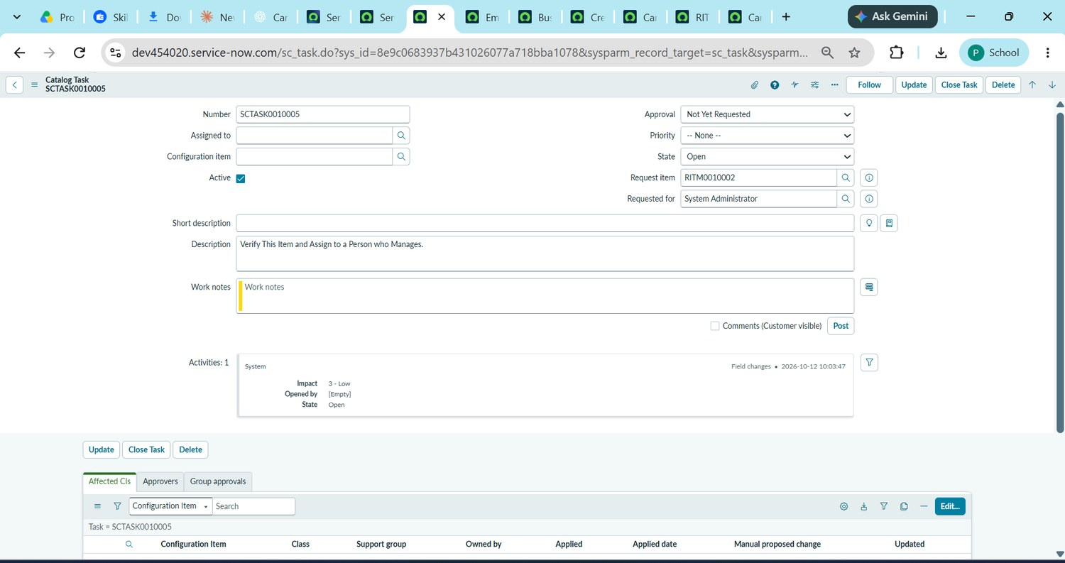  Fig 11. UAT-06: SCTASK0010005 | 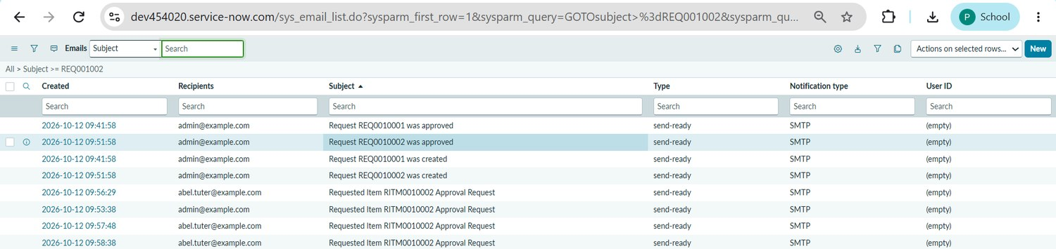  Fig 13. UAT-09: email log
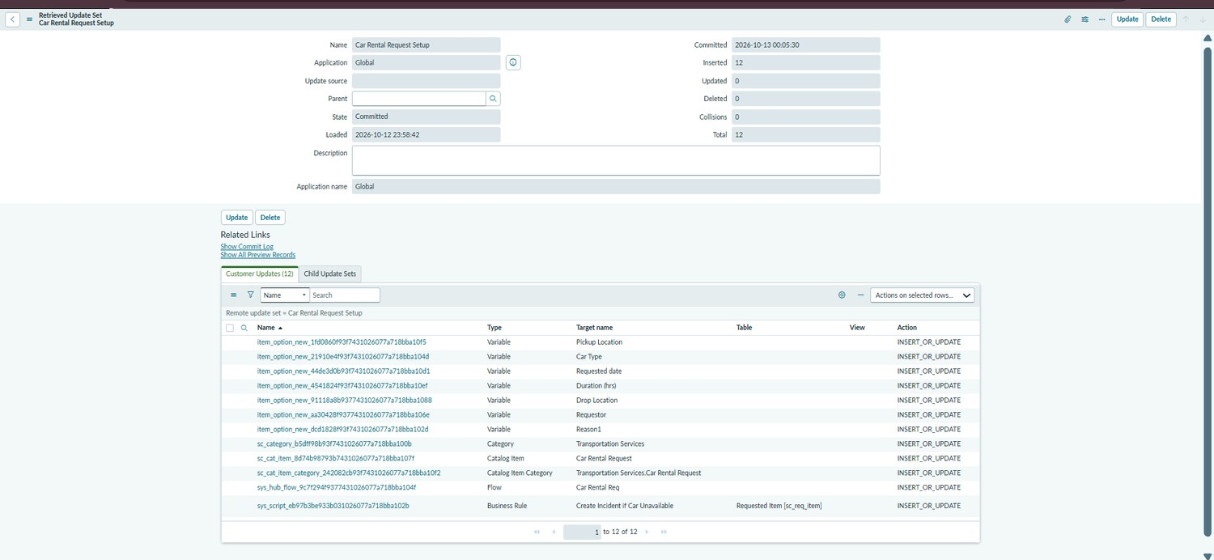  Fig 14. UAT-10: Update Set committed | 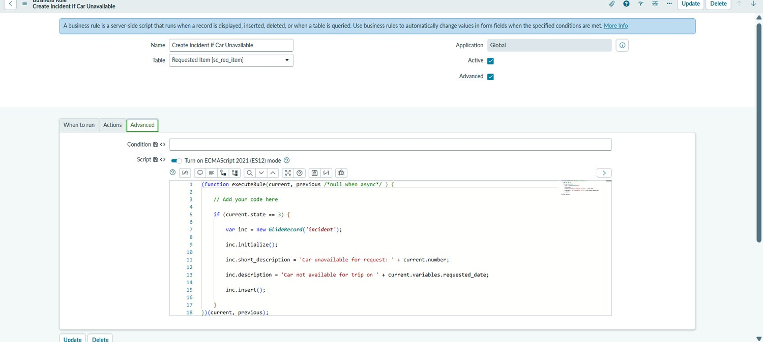  Fig 12. Business rule configuration

