A:
// Test Case: Sinusoidal Signal Generation
// Define parameters
f = 5; // Frequency in Hz
A = 2; // Amplitude
phi = %pi/4; // Phase shift in radians
t = 0:0.001:1; // Time vector from 0 to 1 second with step size 0.001
// Generate the sinusoidal signal
x_t = A * sin(2 * %pi * f * t + phi);
// Plot the signal
clf; // Clear the current figure
plot(t, x_t);
xlabel('Time (s)');
ylabel('Amplitude');
title('Sinusoidal Signal: 5 Hz, Amplitude 2, Phase Shift π/4');
xtitle('Continuous Time Sinusoidal Signal','Time (s)','Amplitude');
OUTPUT:
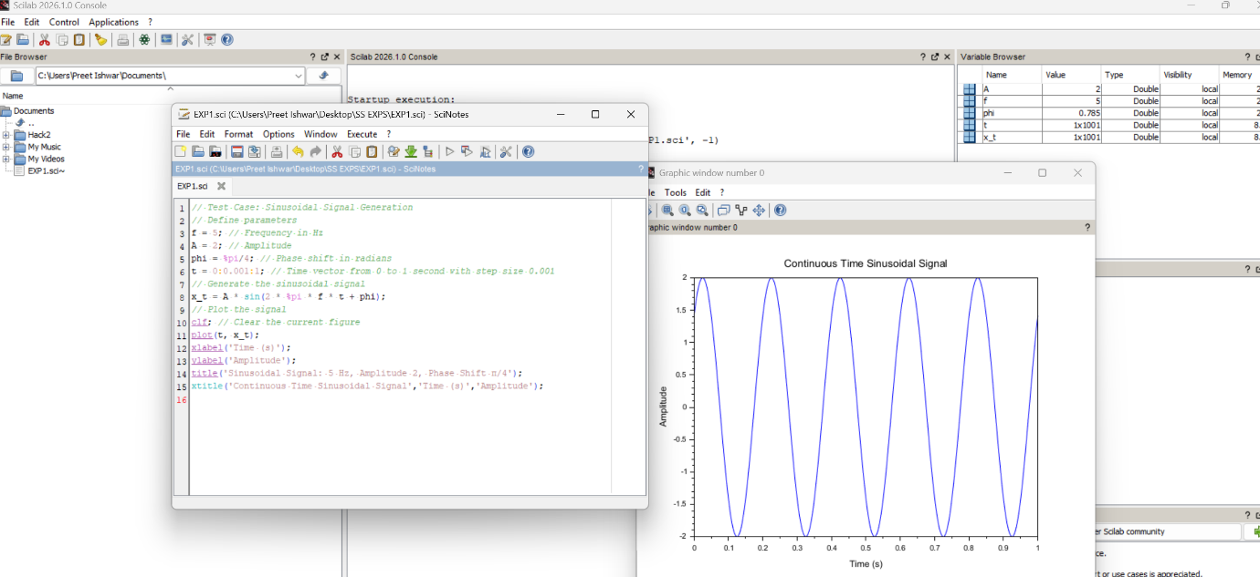

B:
// Test Case: Discrete-Time Unit Impulse Signal Generation
// Define parameters
N = 21; // Length of the signal
n0 = 11; // Index at which the impulse occurs

5

n = 1:N; // Discrete time index vector
// Generate the unit impulse signal
x_n = zeros(1, N); // Initialize signal with zeros
x_n(n0) = 1; // Set the impulse at the desired location
// Plot the signal
clf; // Clear the current figure
plot2d(n, x_n);
xlabel('n (Discrete Time Index)');
ylabel('Amplitude');
title('Discrete-Time Unit Impulse Signal');
xtitle('Discrete-Time Unit Impulse Signal','n (Discrete Time Index)','Amplitude');
OUTPUT:
