A:
// Test Case: Autocorrelation of a Rectangular Pulse Sequence
// Define parameters
N = 20; // Number of samples
x_n = [ones(1,5), zeros(1,N-5)]; // Rectangular pulse sequence with width 5
// Compute the autocorrelation
R_xx = correl(x_n, x_n);
// Create a lag vector for plotting
lags = -N+1:N-1;
// Plot the input sequence
clf; // Clear the current figure
subplot(2,1,1);
bar(0:N-1, x_n, 'b');
xlabel('n (Discrete Time Index)');
ylabel('Amplitude');
title('Input Sequence: Rectangular Pulse Sequence');
// Plot the autocorrelation sequence
subplot(2,1,2);
bar(lags, R_xx, 'r');
xlabel('Lag');
ylabel('Autocorrelation');
title('Autocorrelation of the Rectangular Pulse Sequence');
OUTPUT:
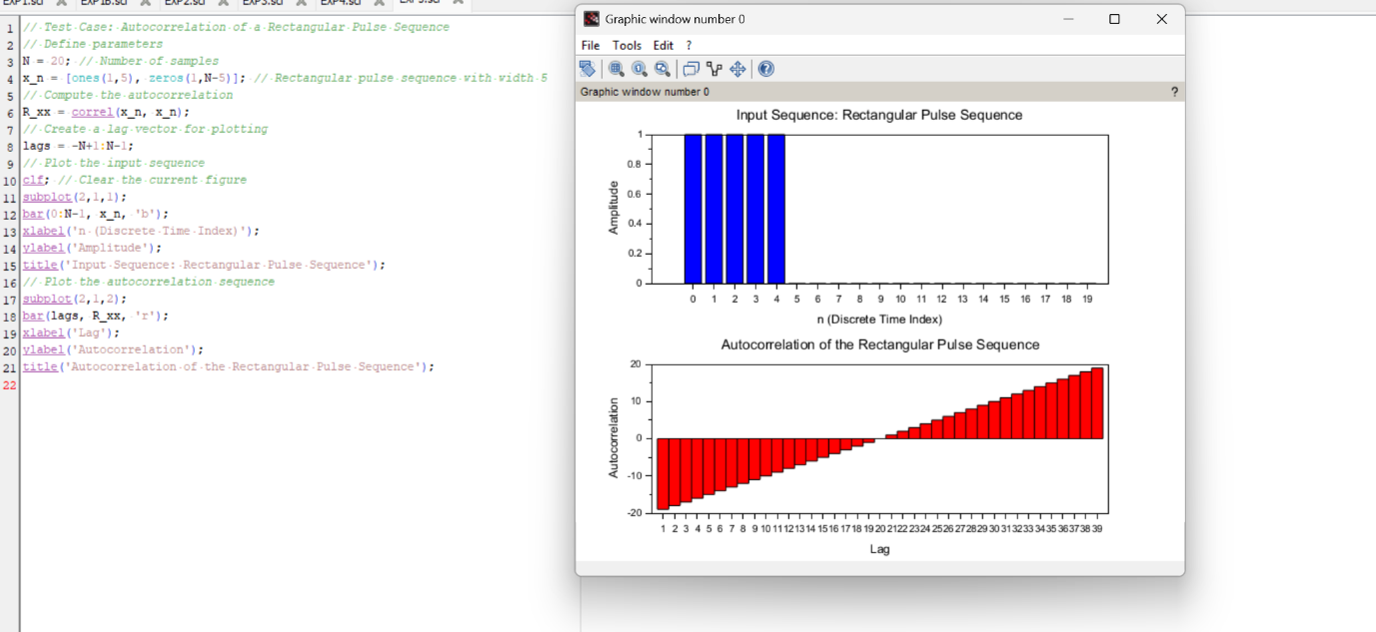

B:
// Test Case: Cross-Correlation of Two Discrete-Time Sequences
// Define parameters
N = 20; // Number of samples
x_n = [ones(1,5), zeros(1,N-5)]; // Rectangular pulse sequence with width 5
delay = 3; // Delay of 3 samples
y_n = [zeros(1,delay), x_n(1:$-delay)]; // Delayed version of x[n]
// Compute the cross-correlation
R_xy = correl(x_n, y_n);
// Create a lag vector for plotting
lags = -N+1:N-1;
// Plot the first sequence
clf; // Clear the current figure
subplot(3,1,1);
bar(0:N-1, x_n, 'b');
xlabel('n (Discrete Time Index)');
ylabel('Amplitude');
title('Sequence 1: Rectangular Pulse Sequence');
// Plot the second sequence
subplot(3,1,2);
bar(0:N-1, y_n, 'g');
xlabel('n (Discrete Time Index)');
ylabel('Amplitude');
title('Sequence 2: Delayed Rectangular Pulse Sequence');

19

// Plot the cross-correlation sequence
subplot(3,1,3);
bar(lags, R_xy, 'r');
xlabel('Lag');
ylabel('Cross-Correlation');
title('Cross-Correlation between Sequence 1 and Sequence 2');
OUTPUT:
